|  |  |
| --- | --- |
| **Product Name** | Applied Degree in Software Engineering (BDSE) |
| **Qualification Name** | Applied Degree in Software Engineering |
| **Product Name** | ABC learning website |
| **Module Name (BDSE)** | Front-End web development |

|  |  |  |  |  |  |  |
| --- | --- | --- | --- | --- | --- | --- |
| **Learner Name** | | | **Assessor Name** | | | |
| Maulana Hafidz Amrullah | | | Ms. Ayesha Shariff | | | |
|  |  | |  | |  | |
| **Date Issued** | | **Completion Date** | | **Submitted On** | |
| February 10, 2023 | | Feb 24, 2023 | | Feb 24, 2023 | |
|  |  |  |  |  |  |  |

|  |  |
| --- | --- |
| **Project Title** | ABC Learning Center Website |

|  |
| --- |
| **Learner Declaration** |
| I certify that the work submitted for this assignment is my own and research sources are fully acknowledged.      Student Signature Date: Feb 24, 2023 |

Formative Assignment 4

Creating the product price based on the currency selected

Currency.json

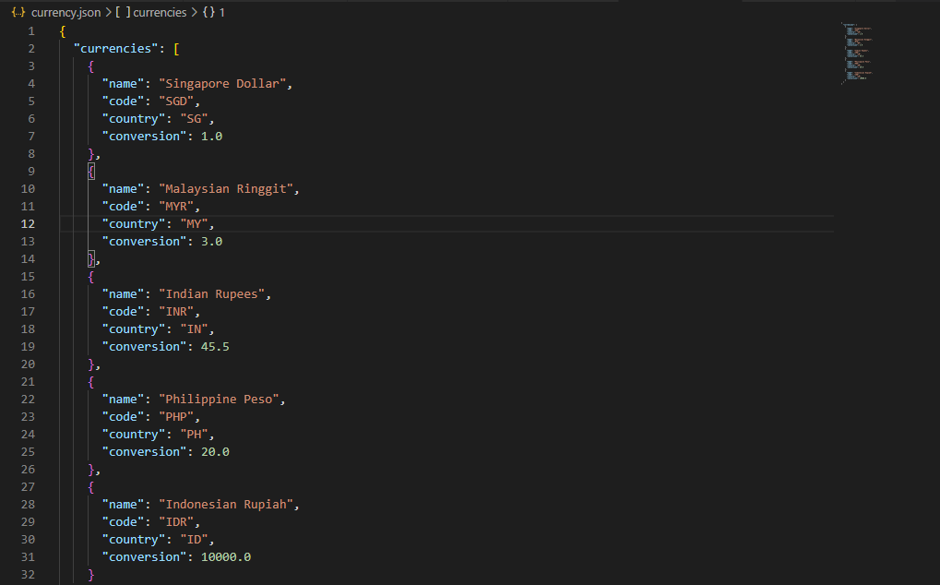

product.json

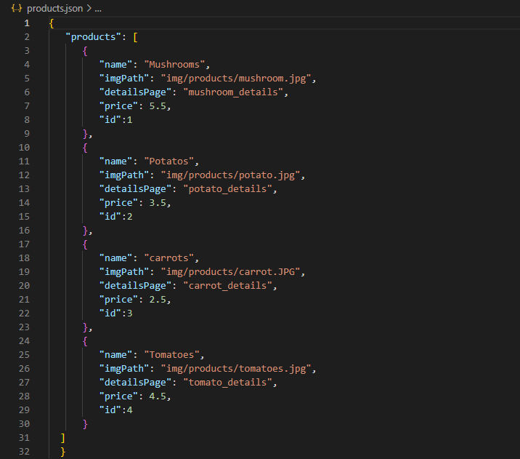

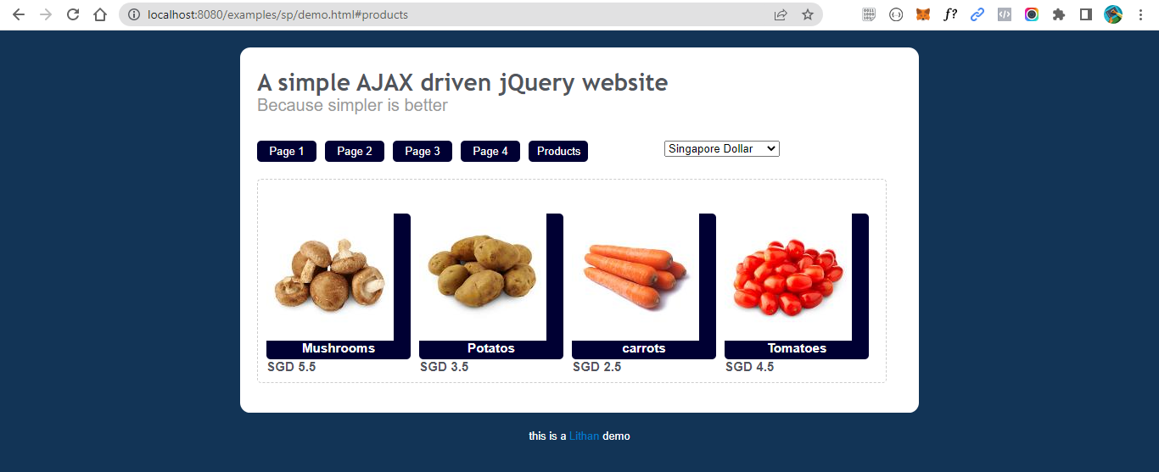

Create own json file for currency conversion

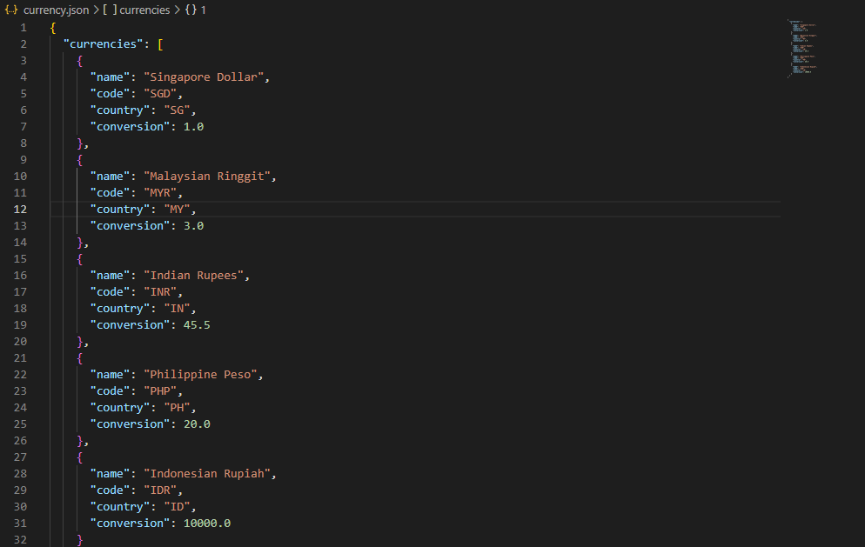

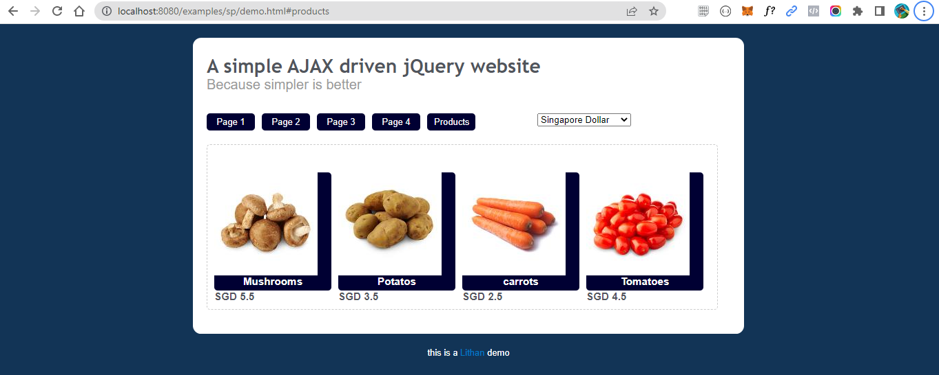

Server-Side Script with product Id

Script.js

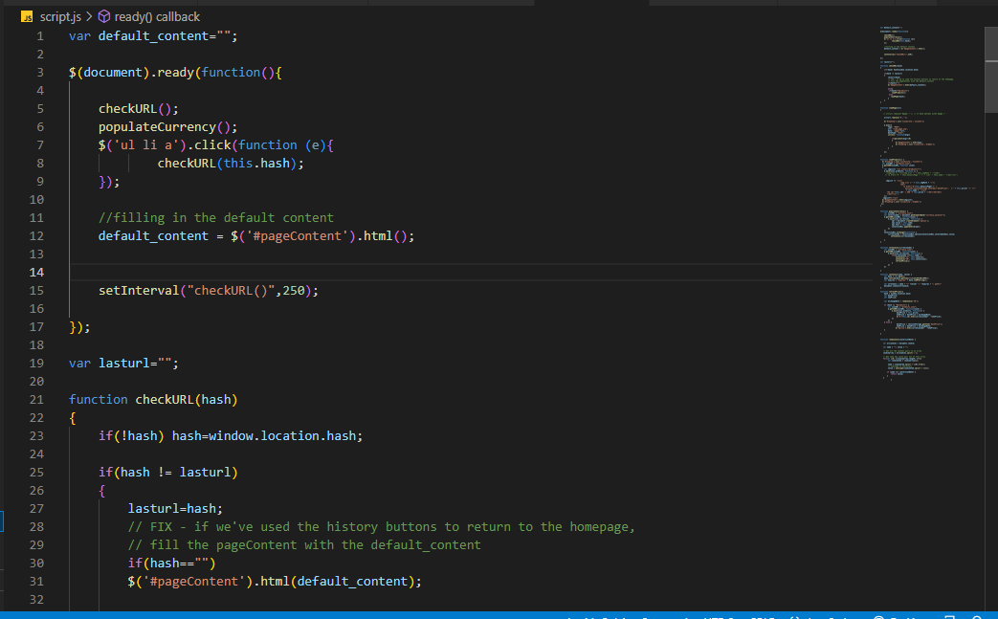

Product.json

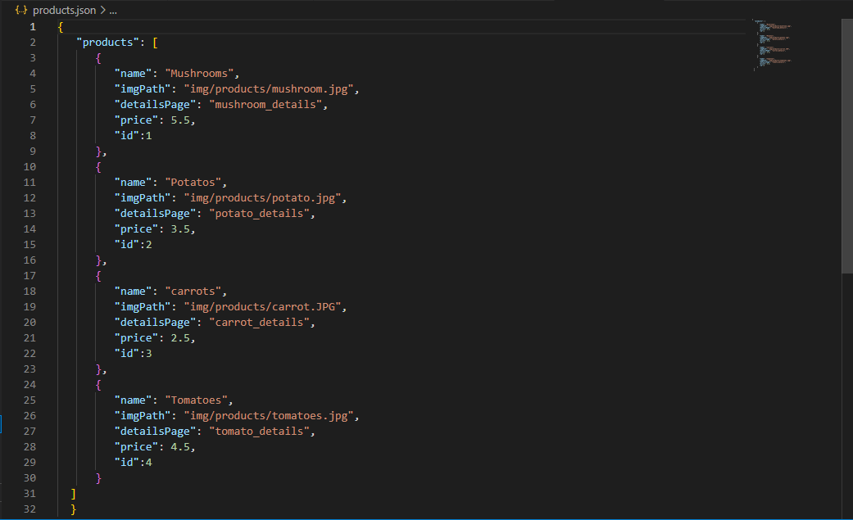

The product page using the server-side script

Mushroom_detail.html

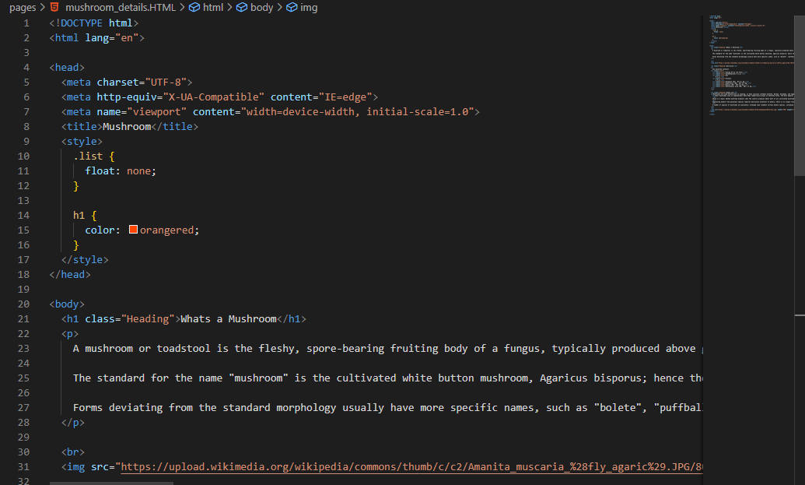

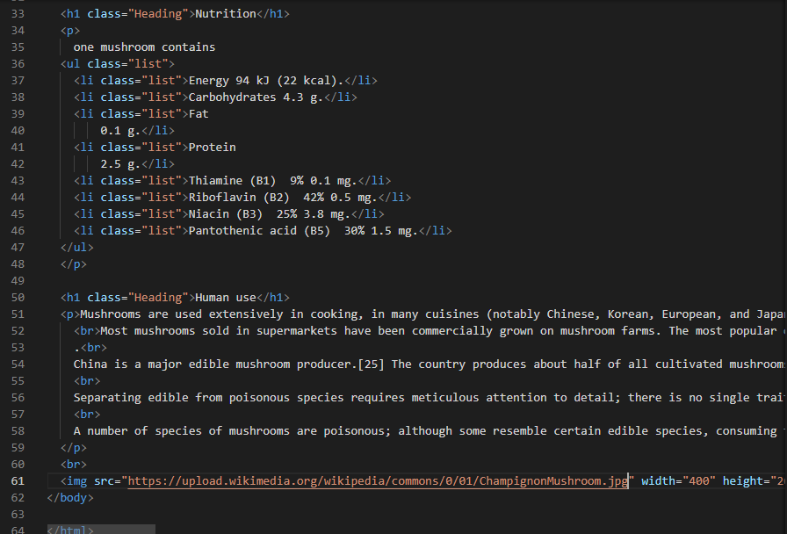

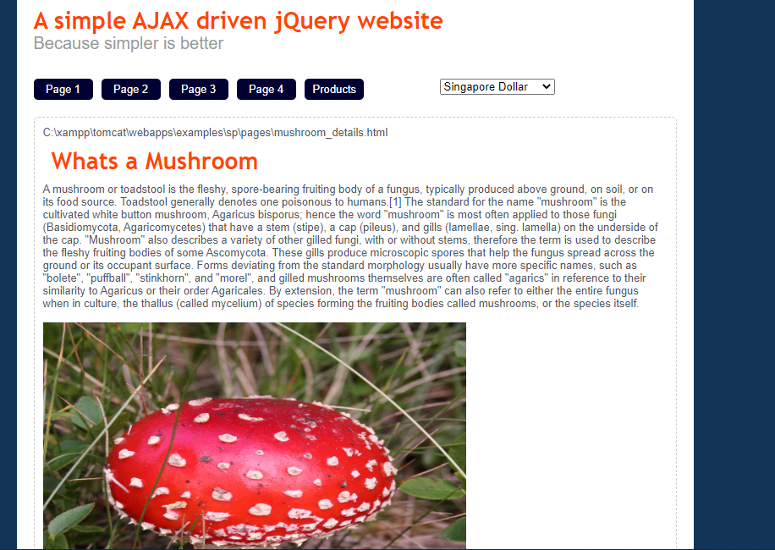

Potato_details.html

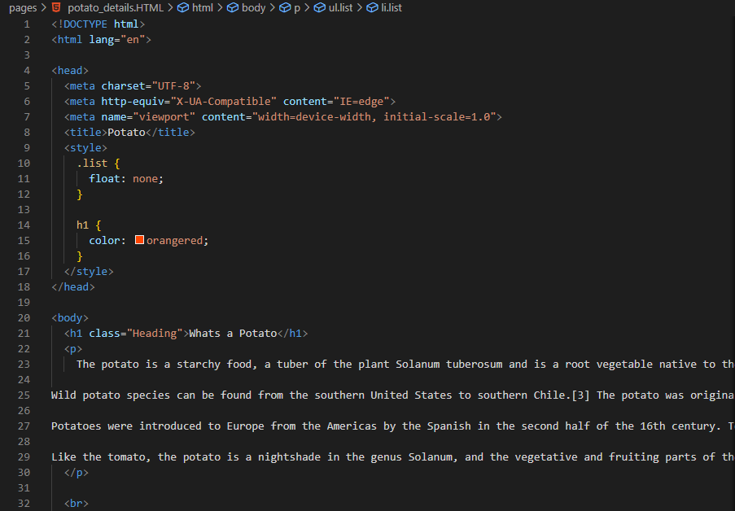

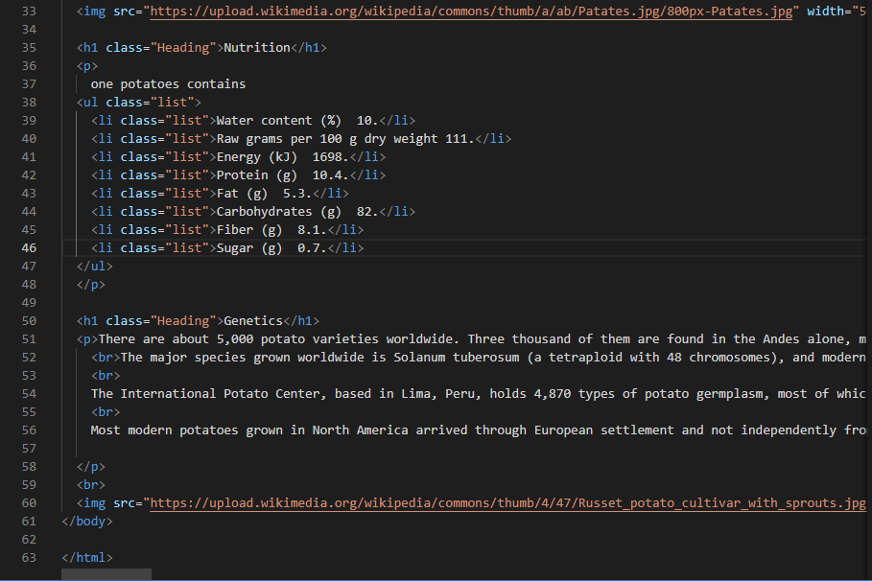

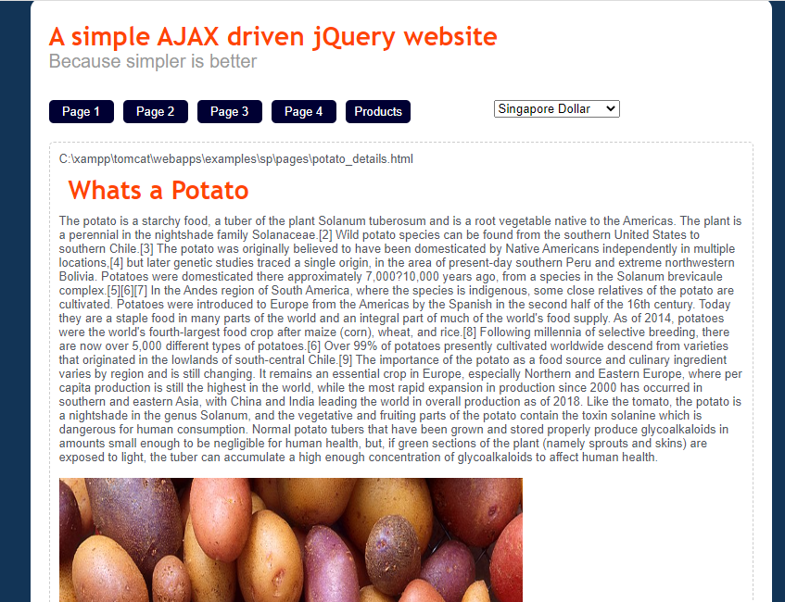

Carrot_details.html

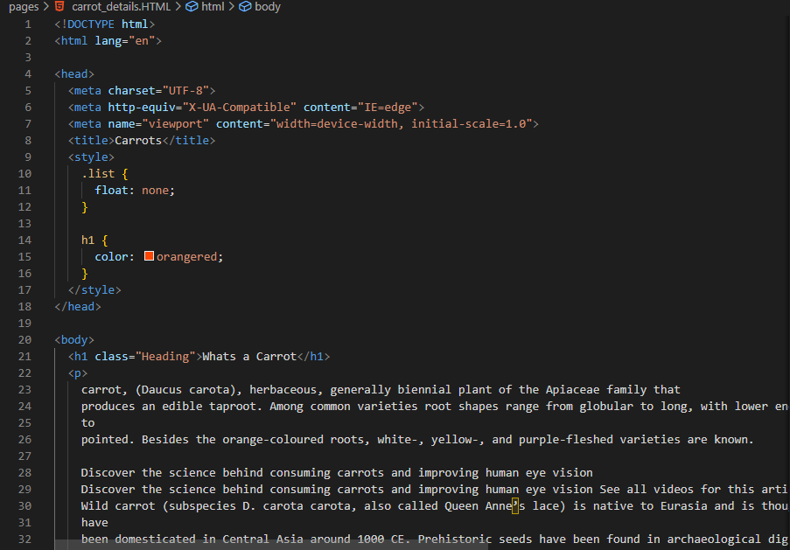

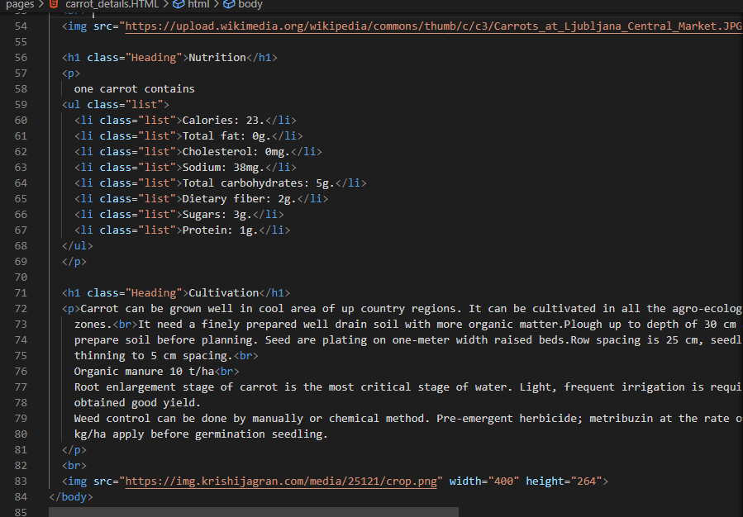

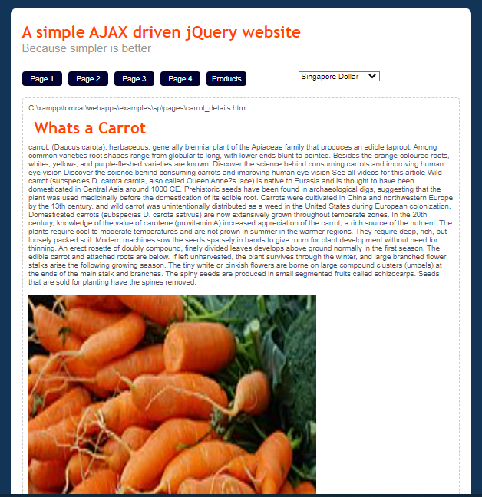

Tomato_details.html

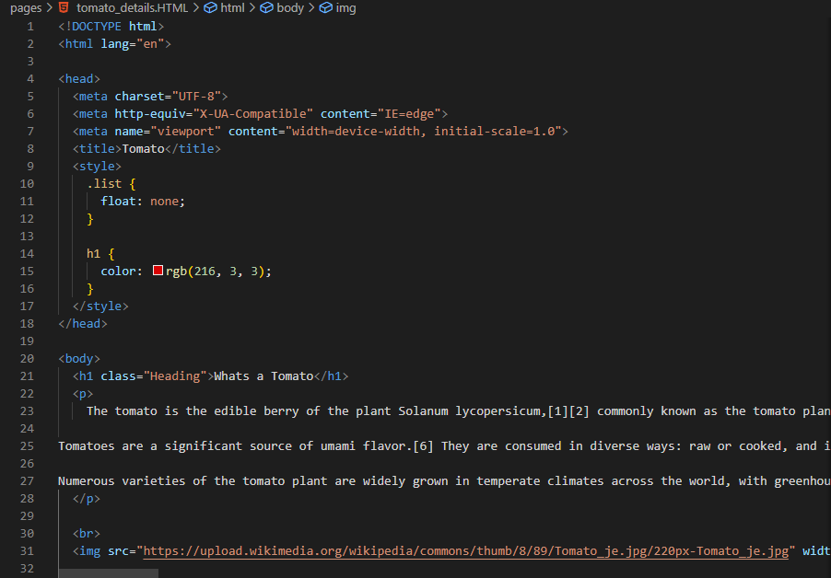

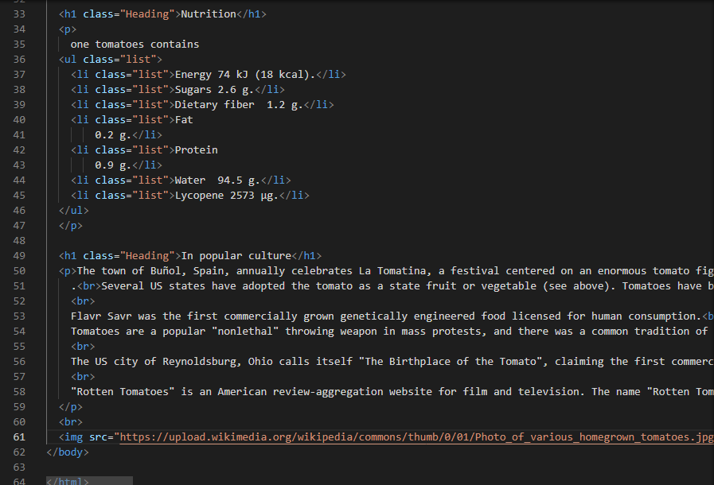

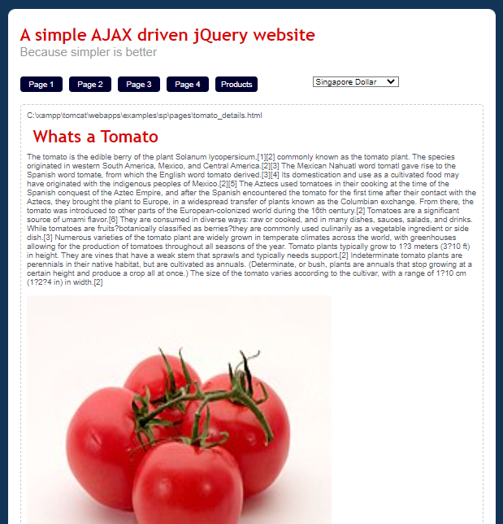

main content area of the demo products page

demo.html

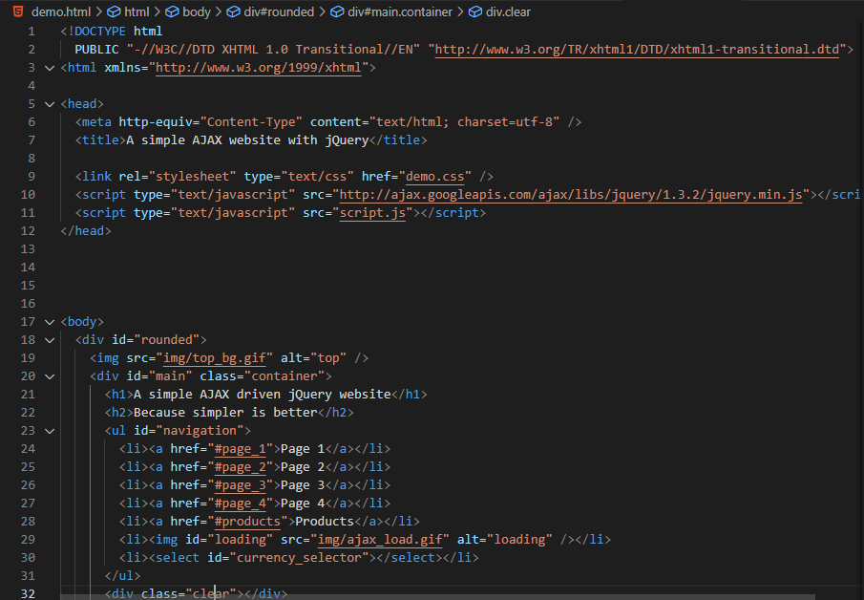

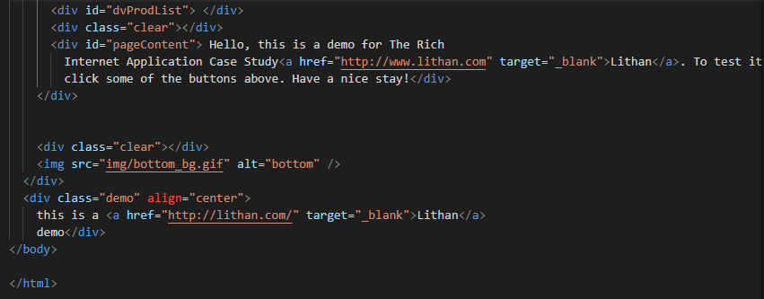



To run the website with localhost, I use XAMPP software for joining Apache and tomcat.

