1.Handle missing value

* Drop missing value:

|  |
| --- |
| missing_rows <- data[!complete.cases(data), ] head(missing_rows) |



* Replace with mean

df_mean <-data

df_mean$person_income[is.na(df_mean$person_income)] <- mean(df_mean$person_income,na.rm=TRUE)

head(df_mean)



* Replace with median

df_median <- df_mean#replace by median

df_median$person_age[is.na(df_median$person_age)] <- median(df_median$person_age,na.rm = TRUE);

head(df_median)



* Replace with mode

mode_val <- mlv(df_mode$loan_status,method = "mfv",na.rm = TRUE);

df_mode$loan_status[is.na(df_mode$loan_status)] <- mode_val

head(as.data.frame(df_mode))



2. see missing values on a graph

vis_miss(data)

3. convert attributes from numeric to categorical or categorical to numeric

df_mode$loan_status <-ifelse(df_mode$loan_status == 1 ,"Yes","No");

head(df_mode)



df_mode$previous_loan_defaults_on_file <- ifelse(df_mode$previous_loan_defaults_on_file == "Yes", 1,0);

head(df_mode)



4.

get_outliers <- function(data, colname) {

if (!colname %in% names(data)) stop("Column not found.")

if (!is.numeric(data[[colname]])) stop("Column must be numeric.")

Q1 <- quantile(data[[colname]], 0.25, na.rm = TRUE)

Q3 <- quantile(data[[colname]], 0.75, na.rm = TRUE)

IQR <- Q3 - Q1

lower <- Q1 - 1.5 * IQR

upper <- Q3 + 1.5 * IQR

# return only the outlier values from dataset

outliers <- data[[colname]][data[[colname]] < lower | data[[colname]] > upper]

return(outliers)

}

outlier_detect<-get_outliers(df, "person_age")

head(outlier_detect)



fix_outliers <- function(data, colname) {

if (!colname %in% names(data)) stop("Column not found.")

if (!is.numeric(data[[colname]])) stop("Column must be numeric.")

Q1 <- quantile(data[[colname]], 0.25, na.rm = TRUE)

Q3 <- quantile(data[[colname]], 0.75, na.rm = TRUE)

IQR <- Q3 - Q1

lower <- Q1 - 1.5 * IQR

upper <- Q3 + 1.5 * IQR

is_outlier <- data[[colname]] < lower | data[[colname]] > upper

n_out <- sum(is_outlier, na.rm = TRUE)

if (n_out > 0) {

data[[colname]] <- pmin(pmax(data[[colname]], lower), upper)

message("Fixed ", n_out, " outliers in ", colname,

" (capped to [", round(lower, 2), ", ", round(upper, 2), "])")

} else {

message("No outliers to fix in ", colname)

}

return(data)

}

df_clean <- fix_outliers(df, "person_age")

head(as.data.frame(df_clean))



Task 5: Normalization method for any continuous attribute.

Code:

|  |
| --- |
| loan2 <- Loan_Datas  loan2$loan_amnt_norm <- (loan2$loan_amnt - min(loan2$loan_amnt, na.rm = TRUE)) /  (max(loan2$loan_amnt, na.rm = TRUE) - min(loan2$loan_amnt, na.rm = TRUE))  print(loan2$loan_amnt_norm) |

**Output:**

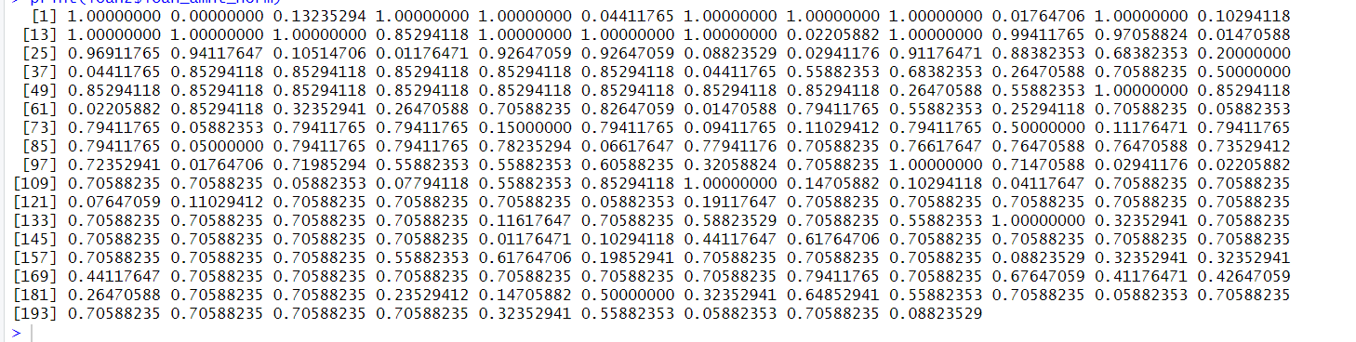

**Description:**

Here used normalization using one equation that is current_value - min_value/ max_value - min_value

Task 6: Find and remove duplicate rows to reduce congestion.

loan3 <- Loan_Datas

library(dplyr)

distinct_data <- distinct(loan3, person_education, .keep_all = TRUE)

print(distinct_data)

**Output:**

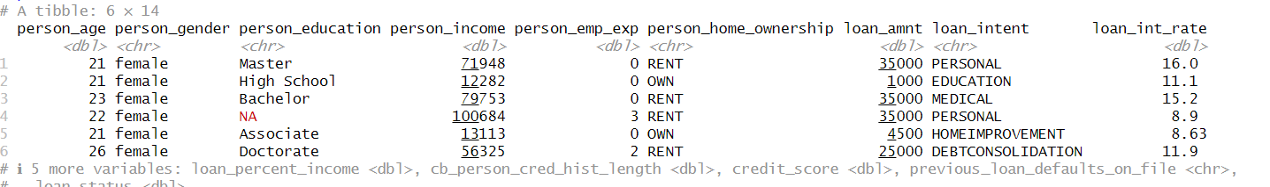

**Description:**

**Task 7**: Filter Data to find specific numerical value , row, categorical value

loan4<-Loan_Datas

filtered_data <- filter(loan3, loan_amnt > 10000)

print(filtered_data)

filtered_data <- filter(loan3, !is.na(person_income) & person_income > 20000)

print(filtered_data)

filtered_data <- filter(loan3, person_education %in% c("Bachelor", "Master"))

print(filtered_data)

**Output:**

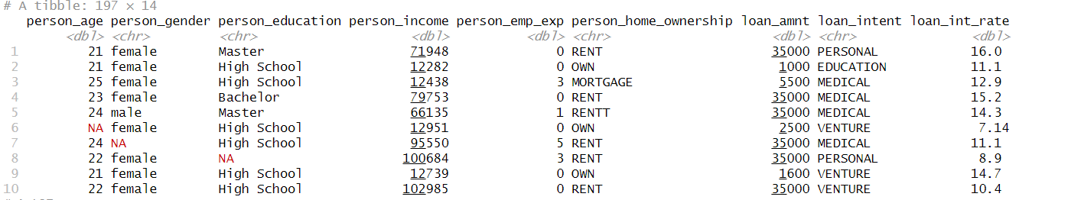

**Description:**

We used filter method we can use multiple operation for filter that is more than 10000 value or whether the value is null or not If is null then delete this row. Then filter only master, bachelor row of person_income column. Also filter more than 20000 of person_income and without null value.

**Task8:** Detect invalid value then remove this row or replace mean value

loans5<-Loan_Datas

loans5 <- na.omit(loans5)

print(nrow(loans5))

print(loans5)

loan5 <- Loan_Datas

loan3_clean <- na.omit(loan5)

print(nrow(loan3_clean))

loan3_clean

num_cols <- sapply(loan5, is.numeric)

cat_cols <- sapply(loan5, is.character)

loan5[num_cols] <- lapply(loan5[num_cols], function(x) {

x[is.na(x)] <- mean(x, na.rm = TRUE)

return(x)

})

loan5[cat_cols] <- lapply(loan5[cat_cols], function(x) {

mode_val <- names(sort(table(x), decreasing = TRUE))[1]

x[is.na(x)] <- mode_val

return(x)

})

print(colSums(is.na(loan5[num_cols])))

print(colSums(is.na(loan5[cat_cols])))

print(loan5)

**Output:**

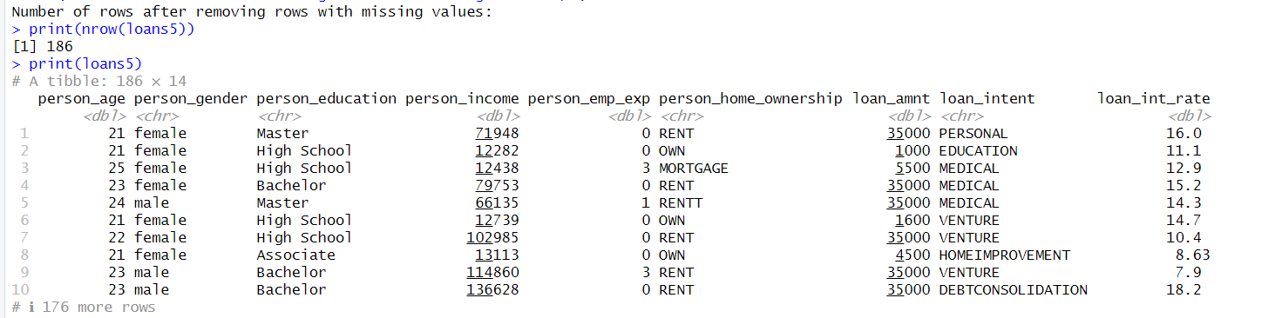

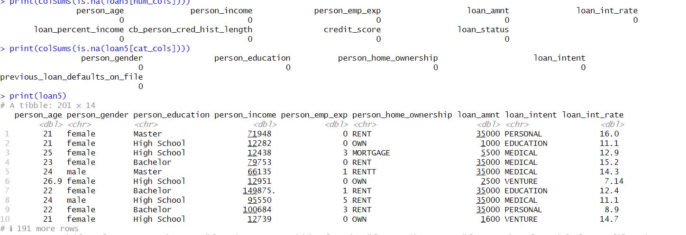

**Description:**

First delete null value . Then assign numeric value in num_cols and categorical value in cat_cols. lapply() applies a function to each element of a list. Then use mean function to find out mean value and replace this all by mean value. Table(x) counts the frequency of each unique value in the column x. Sort( , decreasing = TRUE) sorts the frequencies from highest to lowest. names()[1] extracts the name (value) of the most frequent category, the mode. So mode_val is the most common category in column x.

**Task 10:** Split the dataset for Training and Testing , 70% row for Training data and 30% for Testing data

set.seed(123)

n <- nrow(laons5)

train_index <- sample(1:n, size = 0.7 * n)

train_data <- laons5[train_index, ]

test_data <- laons5[-train_index, ]

dim(train_data)

dim(test_data)

Output:

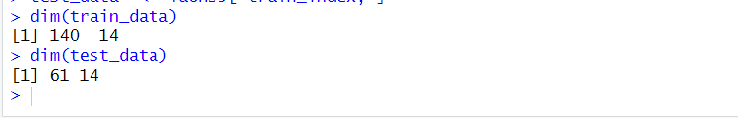

**Description:**

**11.** statistics and interpret the results for the following numerical

variables between two target classes (loan_status = 1 and loan_status = 0)

➢ person_age

➢ Person Income

age_summary <- aggregate(person_age ~ loan_status, data = df,

FUN = function(x) c(mean = mean(x), median = median(x),

sd = sd(x), min = min(x), max = max(x)))

age_summary <- do.call(data.frame, age_summary)

# Create summary table for Income

income_summary <- aggregate(person_income ~ loan_status, data = df,

FUN = function(x) c(mean = mean(x), median = median(x),

sd = sd(x), min = min(x), max = max(x)))

income_summary <- do.call(data.frame, income_summary)

print(age_summary)



print(income_summary)

**Task 12:**

**Code:**

descriptive_stats <- loan5_balanced %>%

group_by(loan_status) %>%

summarise(

mean_age = mean(person_age, na.rm = TRUE),

median_age = median(person_age, na.rm = TRUE),

sd_age = sd(person_age, na.rm = TRUE),

min_age = min(person_age, na.rm = TRUE),

max_age = max(person_age, na.rm = TRUE),

mean_income = mean(person_income, na.rm = TRUE),

median_income = median(person_income, na.rm = TRUE),

sd_income = sd(person_income, na.rm = TRUE),

min_income = min(person_income, na.rm = TRUE),

max_income = max(person_income, na.rm = TRUE),

count = n() # number of rows per class

)

print(descriptive_stats)

Output:



**Description:**

Here group by function used for find out all value such as mean, median, mode, max, min for each group. Here has 0 and 1 group. Summarise function use computing statistics like mean, median, sum, count etc.

**13.** **Compare spread in person_emp_exp for customers with different levels of**

**person_education**

compare_spread <- function(data, group_col, value_col) {

library(dplyr)

if (!group_col %in% names(data)) stop("Group column not found.")

if (!value_col %in% names(data)) stop("Value column not found.")

data %>%

group_by(.data[[group_col]]) %>%

summarise(

count = n(),

mean = mean(.data[[value_col]], na.rm = TRUE),

sd = sd(.data[[value_col]], na.rm = TRUE),

min = min(.data[[value_col]], na.rm = TRUE),

max = max(.data[[value_col]], na.rm = TRUE),

IQR = IQR(.data[[value_col]], na.rm = TRUE),

.groups = "drop"

)

}

aggregate(credit_score ~ loan_status, data = data, mean, na.rm = TRUE)

compare <- compare_spread(df_clean, "person_education", "person_emp_exp")

head(as.data.frame(compare))

