At the forefront of Digital and Cybersecurity Transformation
Bottomline Technologies is one of India’s leading firms that has helped transform the IT Infrastructure for hundreds of clients.

About Us
The customer-friendly company helping businesses accelerate growth Bottomline is a leading global IT services provider, transforming client’s businesses through innovative and advanced technology solutions. Our unique approach to ‘Choosing The Right Technology’ helps clients create competitive advantage through organizational agility and lower total cost of design.

Solution: Hyper Converged Infrastructure
With our rich experience of managing data centers, Bottomline is well positioned to offer enterprises the opportunity to simplify and reduce the TCO of IT infrastructure with Hyper Converged Infrastructure Solutions. As HCI is an integrated solution, it enables enterprises to combine and centralize management of three core elements of a data center: storage, compute and networking. The result: improved scalability and reduced data center complexity
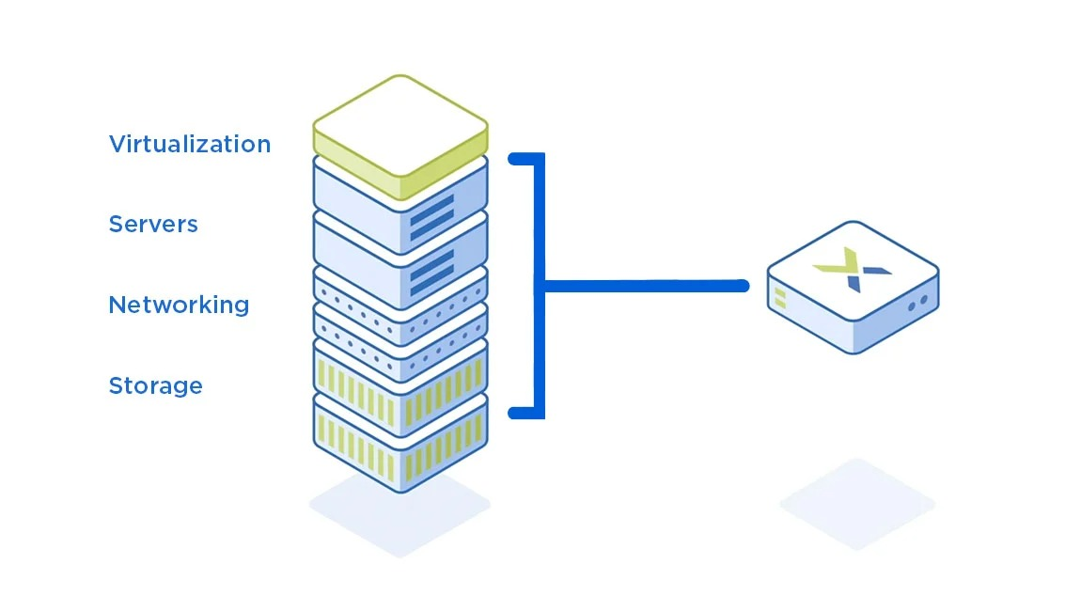
Some of the highlights of our Hyper Converged Infrastructure (HCI) solutions include:

Protection for existing IT investments
Simplified IT operations
Low TCO and high availability
Faster infrastructure deployments
One click provisioning
Intrinsic security across all environments
Centralized management and simpler policy enforcement
Ability to scale on premise and public cloud with simplified disaster recovery capabilities
Proven capabilities for VDI deployments, collaboration tools, core enterprise applications, big data analytics and messaging applications

Networking

Designing and implementing a highly efficient, cost-effective, and future-ready network backbone can significantly streamline an organization’s operations. Our team has extensive experience across various domains, managing daily IT operations. Whether it's creating new infrastructure or optimizing an existing network, we have the capability to design, deploy, test, and commission networks, ranging from single-site to multiple-location environments

Data Centre

Data Centre houses the organisations shared Information Technology equipment that stays backbone to processing, storing, managing, data and applications that are vital to the business continuity. Team Touchline is certified and experienced to design, deploy, optimise and support DCs.

Service

Data Storage

Store your organization’s critical and crucial data to optimally use it as and when needed. PSSPL makes sure that the storage is designed in such a way that the data-driven organizations, while incorporating cloud architecture, also optimize big data. In the process, we also examine your existing investments, plans and business objectives. We enable you to –
- Enhance your backup, archiving, analytical search and recovery capabilities
- Reduce risk and control costs
- Tailored to help you take full advantage of technology

Server Infrastructure

With our proven expertise in technology, we enable you to strategize and deploy IT infrastructure with ease. We work closely with your team to ensure that business demands are fulfilled at every stage. We offer consultation for the following –
- Networking
  - LAN/WAN design
  - Network security
  - Network security architecture design
  - IP communications
  - Business process development and implementation
- Disaster Recovery
With a lot of invaluable information and data within the premises and in virtual environments, a disaster recovery plan in case of a risk is necessary. Resilience is a top priority in case if confidential data and access to various data in the organization. Pentagon offers the following specialized disaster recovery services-
  - IT Disaster Recovery Program Assessment
    - Analyze present recovery strategy
    - Review your program documentation
    - Interview key stakeholders for industry insights
  - IT Disaster Recovery Strategy & Roadmap
    - Assessment of your infrastructure, applications, staff and data
    - Align your Business Continuity program requirements with your IT availability needs
  - IT Disaster Recovery Plan Development
    - Develop plans and procedures in case of crisis
    - Enablement to restore critical IT infrastructure, applications and data
  - IT Disaster Recovery Test Management
    - Plan for Disaster recovery
    - Aligned disaster recovery plan with BCP

Virtualization

. We specialize in providing virtualization and cloud computing solutions that enhance and optimize data backup and recovery, and also streamline the server functions. Our virtualization service is the perfect way to achieve the office of the future—with unparalleled storage capacity and a more efficient server. We offer following services –

. Strategy & Design
The right strategy and a perfect design to match the strategy to enable you to move faster with more accurate IT assessments and an improved visibility and clarity in consolidating opportunities.

- . Operational Management
We help you to build a robust system that enables your organization for consistent management, intelligent management and built-in automation.
- Virtualization Infrastructure
We help you to choose the best fit infrastructure from the available technologies in the market that will enable you to optimize your processes.

Technology

Backup and Disaster Recovery

Having no disaster plan for an organization is the biggest disaster ever!
We understand how important it is for a company to safeguard and backup their resources and sensitive data from unprecedented situations. Hence, there is a dire need to have a strategy that encompasses every aspect of threats and disasters to recover the data as well as keep your IT operations running.
Also, only recovering your data is of no use! The data recovered should be organized and be ready to use at any given instance. Thus, Backup data management is as important as Recovery. For this, PSSPL offers Enterprise Backup Management Plan and Enterprise Backup Management Solutions.

We enable you with

Physical, virtual and cloud server backup software

Robust storage management

Secure file sharing and system deployment

Efficient disaster recovery plans

Storage cost optimization

Effective information management

Migration

Make space for your business growth!
Migrating your company’s crucial data becomes important as your business grows and operations evolve. Any successful business knows the significance of efficiently storing, protecting, and maintaining access to data. Whether you are upgrading your server, relocating your data offsite, or going through database maintenance, successful data migration is done speedily and effectively.
With PSSPL, be assured that your data migration is efficient and successful. We offer reliable and expert data migration services for enterprise businesses. When your organization grows and your data storage needs change, we will help you efficiently and securely migrate your important data.

We help you achieve

Successful transition :

encompassing various applications, physical servers, server locations

Comprehensive migration :

services such as Data center migration, Cloud migration, SMB Cloud migration, Workplace migration etc.

Efficient co-coordination and migration of all IT equipment :

including networks, servers, labs, desktops, printers and MFDs

Mobility

Enable the seamless collaboration for optimum productivity!
The future is here, and you need to scale up to it by providing the agility and flexibility your organization’s associates demand. Boost the level of comfort for employees that will increase their productivity in a conducive and favorable office environment.
We enable you to embrace technologies, including employee’s personal devices and hardware, to enhance workforce mobility and enable ideas to be communicated anytime from anywhere, without slowing down your network, sacrificing security or increasing IT overhead.

BTPL mobility solutions enables you with

Uninterrupted and timely access to all information and applications

Optimized and simplified processes

Enhanced productivity

Intuitive and unique customer experience

Effective knowledge transfer

Security

Keep check on the vulnerabilities and keep away from threats!
With network security experiencing its most critical moments, having confidence in information security services is vital. Businesses are a perfect hub for the hackers and viruses, hence, the IT infrastructure put into place must be secure to protect data. And, with cloud-based privacy, data integrity and business security have to be maintained more than ever.
PSSPL is a trusted IT security provider, offering comprehensive network security services that keeps information safe from unauthorized access. We take an aggressive approach to know every aspect of your IT systems and make sure that we have end-to-end covered your security points and safeguard your network against any possible attack. With this process in place, ensuring your data is protected at every turn.

Our security roadmap offers

Tools and services to make your business secure and most profitable

Superior data security and privacy

Implementation controls and information risk management

Adherence to governance, risk and compliances

Cost optimization

Minimal disruption

Customized solutions

Visibility across traditional and next-generation platforms

Storage

Manage your documents securely and efficiently!
Data is definitely a new age oil, which has to be managed efficiently. A well-organized data lets organizations to access, process and share it hassle-freely. Thus, managing huge data chunks has to be thoroughly planned, implemented and maintained as well.
PSSPL ensures that we strategize and implement data storage that can be easily accessed, processed and shared. The innovative policies and governance we deploy for your business network enhances the overall performance and productivity of the organization. We customize your data storage completely to your business demands, because we understand every business is different!

Our data storage services include

Analysis of data and data resources

Enterprise infrastructure and architecture

Software and storage systems

Data backup

Management analysis and solutions

Virtualization

Optimize the space your IT occupies, and achieve more in less space!
By virtualizing your in-house IT infrastructure, you’ll be able to run more applications by slicing physical infrastructure. Virtualization techniques can be applied to many areas of your IT services, including Servers, Applications, Storage, Networks, Endpoints, etc.
With PSSPL Virtualization Solutions& Services, we enable you to manage your IT capacities to enhance your service levels and streamline your technology processes for optimum business benefits.

Our dynamic virtualization solutions can help you to achieve

Lower complexity and costs of storage

Datacenter automation built on the production-proven virtualization platform

Information Security
- Helps you to understand the most vulnerable assets in your organization, prioritize the vulnerabilities, suggest remediation and continuously measure for gaps in coverage and process improvement.
- Helps you gauge if all your assets are up-to-date with recent patches, get an up-to-date inventory status and if they meet the compliance standards requirements.
- Our data-classification solutions helps to identify, classify, and secure your sensitive data across platforms, devices on both on-premise and cloud.

Thanks & Regards,

Vinayagamoorthy P
Business Head | +91-8525955567

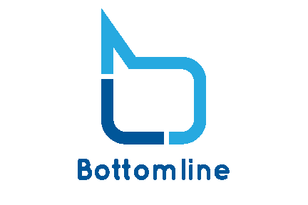
Bottomline Technologies Pvt Ltd.
# 9/8 , ICC, ‘B’ Sector Anna Nagar west Extension 6th Street Chennai - 6000101
Tamilnadu India
www.bottomlinetechnologies.in

