MODELYX: An AI Powered Platform for Jersey Design and Color Matching with Online Ordering and Billing System for ATWU

A Capstone Project Proposal
Presented to the Faculty of the
Information and Communications Technology Program
STI College Sta. Mesa

In Partial Fulfilment
of the Requirements for the Degree
Bachelor of Science in Information Technology
Eduard Estabillo
Jhaxe Axl Iverson Gaetos
Symon Ortega
Stephen Kenneth Sy

May 15 2026
ENDORSEMENT FORM FOR PROPOSAL DEFENSE

TITLE OF RESEARCH: MODELYX: An AI-Powered Platform for Jersey Design and Color Matching with Online Ordering and Billing System for ATWU

NAME OF PROPONENTS: Eduard Estabillo
Jhaxe Axl Iverson Gaetos
Symon Ortega
Stephen Kenneth Sy

In Partial Fulfilment of the Requirements
for the degree Bachelor of Science in Information Technology
has been examined and is recommended for Proposal Defense.

ENDORSED BY:

Mr. John Ralph Reyes
Capstone Project Adviser

APPROVED FOR PROPOSAL DEFENSE:

<Capstone Project Coordinator's Given Name MI. Family Name>
Capstone Project Coordinator

NOTED BY:

Mr. John Ralph Reyes
Program Head

May 15 2026

APPROVAL SHEET
This capstone project proposal titled Modelyx, prepared and submitted by Symon Ortega, Stephen Kenneth Sy, Eduard Estabillo, and Jhaxe Axl Iverson Gaetos, in partial fulfillment of the requirements for the degree of Bachelor of Science in Information Technology, has been examined and is recommended for acceptance and approval.
Mr. John Ralph Reyes
Capstone Project Adviser
Accepted and approved by the Capstone Project Review Panel
in partial fulfillment of the requirements for the degree of
Bachelor of Science in Information Technology

<Panelist's Given Name MI. Family Name> | <Panelist's Given Name MI. Family Name>
Panel Member | Panel Member

<Panelist's Given Name MI. Family Name>
Lead Panelist

Noted:
<Capstone Project Coordinator's Given Name MI. Family Name> | Mr. John Ralph Reyes
Capstone Project Coordinator | Program Head

May 9 2026

Table of Contents
 |  | Page
Title Page |  | i
Endorsement form for Proposal Defense |  | ii
Approval Sheet |  | iii
Table of Contents |  | iv
Introduction |  | 1-9
 | Project Context | 1-2
 | Purpose and Description | 3
 | Objectives | 3-4
 | Scope and Limitations  Review of Related Literature/Studies/Systems | 4-5  6-9
Methodology |  | 10
 | Technical Background | 11-12
 | Requirements Analysis | 13
 | Requirements Documentation | 14
 | Design of Software, System, Product, and/or Processes
References |  | 18
Appendices
 | Resource Persons | 17
 | Personal Technical Vitae

INTRODUCTION

Project Context

Jersey designs are important for teams, organizations, and sports groups because they represent identity, unity, and professionalism. A well designed jersey can boost confidence and leave a strong impression during games, tournaments, and events. However, creating an effective jersey design is not always easy, as it requires proper color matching, balanced layouts, and creativity. Many individuals and teams struggle to create visually appealing designs due to limited design knowledge and experience.

Most users rely on trial and error, templates, social media trends, or existing designs when creating jerseys. Although these methods can provide inspiration, they are often time consuming and may result in mismatched colors, repetitive layouts, or unprofessional designs. As a result, users may experience difficulty in achieving a clean and balanced jersey appearance.

With the continuous advancement of technology, websites and online platforms are now widely used to simplify tasks such as designing and purchasing products. Despite this progress, there are still limited platforms that combine jersey customization, intelligent design assistance, and online ordering within a single system.

To address this problem, the proponents propose Modelyx, an AI powered jersey editing website that helps users create customized jersey designs more efficiently. The system allows users to upload or create their own designs while utilizing artificial intelligence to detect colors and recommend suitable color combinations and styles. In addition, the platform enables users to directly order customized jerseys through partnered sports outfitter clients.

The project aims to make the jersey design and ordering process faster, easier, and more convenient for users, especially for individuals and teams without access to professional designers. By integrating artificial intelligence, customization tools, and e-commerce functionalities into one platform, the system provides a practical and innovative solution for jersey customization.

This project was chosen because it addresses a common problem experienced by teams and individuals while also aligning with the proponents knowledge and skills in website and application development.

Purpose and Description
The main purpose of Modelyx is to design and develop an AI powered website that enables users to design and order customized jerseys in a more efficient, accessible, and user friendly manner. The system allows users to upload existing designs or create their own jerseys using built in editing tools. Through artificial intelligence, the website can detect colors used in the design and recommend suitable color combinations and styles to improve the overall visual appearance of the jersey.
The platform is designed to be simple and easy to navigate, allowing even users without graphic design experience to create appealing jersey designs. Instead of manually experimenting with layouts and color combinations, users receive intelligent suggestions that help them create balanced and visually attractive designs more conveniently.
What makes the system unique is its integration of jersey editing, AI based color detection, and online ordering into a single platform. Unlike traditional systems that focus only on design or product selling, the website provides an all in one solution where users can create, enhance, and order customized jerseys in one place. The personalized AI suggestions also improve the user experience by adapting recommendations based on the uploaded or created design.
Additionally, the system supports individuals and teams who may not have access to professional designers by providing guidance that minimizes common design issues such as poor color matching and unbalanced layouts.
Objectives
Overall, the project aims to save time, improve jersey design quality, and simplify the customization and ordering process through the integration of artificial intelligence, design tools, and e-commerce functionalities.

Objectives
General Objective
The main objective of this study is to design and develop a website that can assist users in jersey designing and color matching using AI technology integrated with online ordering and billing functionalities that will enable customers to transact efficiently.
Specific Objectives
- To design and develop an Image Capture and Upload Module that can capture or upload images of jersey layout.
This module of the system enables the user to take a photo or upload an existing jersey layout for customization. This feature will help users easily provide a design reference and make the jersey customization process faster and more convenient.
- To design and develop a Color Detection Module that can identify the color of the selected jersey layout and use it to apply for customizing jerseys.
This module of the system helps the user identify the dominant colors from the uploaded jersey image. This feature will help users choose matching color combinations and create a more appealing jersey design.
- To create and develop a simple interface that helps users navigate the website effectively.
This will enable users to browse the website smoothly through clear buttons, simple page layouts, readable text, organized menus, easy to understand functions, and a clean design that makes the system easier to use.
- To design and develop an Online Ordering Module that helps users place their orders online.
This module lets users order online, customize their jersey design, choose sizes and quantities, submit order details, track order status, and receive updates until the order is completed.
- To design and develop a Billing and Payment Module that assists users with their payment of orders.
This module of the system will provide an accurate computation of the total bills, giving users a clear breakdown of costs and helping them avoid payment errors. Also, this module allows users to select modes of payment such as cash on delivery, GCash, or bank transfer. This will give users convenience in doing transactions.

Scope
The study focuses on developing Modelyx, a web based system that provides outfit suggestions based on clothing color.
The system allows users to:
- Capture a color using a webcam or camera – Allows users to scan colors from real objects using a camera for jersey design and matching.
- Upload an existing image – Lets users upload images from their device for color analysis.
- Receive recommended color combinations for outfits – Provides suggested matching colors based on detected colors.
The target users are:
- Sports teams and athletes – Can design and order customized team jerseys.
- Customers looking for personalized apparel – Can create unique and customized jersey designs.
- Business owners and administrators – Manage orders, products, customers, and system operations.
System Feature:
Customer Side Modules
- User Registration and Login Module – Allows users to create accounts and log in securely.
- Image Capture and Upload Module – Enables users to capture or upload images for color detection.
- Smart Color Detection Module – Detects and identifies colors from uploaded or captured images.
- AI Recommendation Module – Suggests matching color combinations for better designs.
- Jersey Customization Module – Allows users to edit jersey colors, text, logos, and layouts.
- 3D and 360° Jersey Preview Module – Shows a realistic preview of the jersey from different angles.
- Save and Edit Design Module – Lets users save and modify their jersey designs later.
- Online Ordering Module – Allows customers to place jersey orders online.
- Automatic Price Quotation Module – Automatically calculates the estimated order price.
- Order Tracking and Status Module – Lets users monitor the progress of their orders.
- Notification and Update Module – Sends updates about orders and system announcements.
- Customer Support and Inquiry Module – Allows users to contact support or ask questions.
- Design History and Records Module – Stores previous jersey designs and order history
- Customer Information Management Module – Manages customer personal and delivery information.
Admin Side Modules:
- These modules can only be accessed by the administrator or business owner.
- Admin Login Module – Provides secure access for administrators only.
- Product and Template Management Module – Allows admins to manage jersey templates and products.
- Inventory or Product Listing Management Module – Helps manage available products and stock.
- Order Management and Approval Module – Allows admins to approve and manage customer orders.
- Analytics and Sales Dashboard Module – Displays sales reports and business analytics.
- E-Commerce Management Module – Manages online transactions and product listings.
- Database Management Module – Stores and organizes system data and records.
- Secure Data Management Module – Protects customer and business information.
- Notification Management Module – Allows admins to send updates and announcements.
- Customer Management Module – Helps admins manage customer accounts and records.

Limitations
The system is limited to:
- Color Detection Accuracy. The color scanning and palette suggestion feature may vary depending on the user’s camera quality and lighting conditions.
- Limited to Sports Apparel customization. The website mainly focuses on customizing sportswear such as jerseys and warmers only.
- Internet dependency. Users must have a stable internet connection to access the website, upload design, and use 3D viewing features.
- Limited administrative features. Admin dashboard may only provide basic analytics, order monitoring, and customer management functionalities.
- Limited payment and E-commerce features. The study may only include basic ordering and quotation functions and may not fully support online payment.

Review of Related Literature/Studies/Systems
Local Studies

The study explored the development of a localized online sportswear ordering platform for small printing businesses in the Philippines. The proponents emphasized the growing demand for digital ordering systems among sports teams and organizations. The system allowed customers to upload designs, choose jersey colors, and submit customized orders online. Findings revealed that online customization systems improved customer convenience and business efficiency. This literature is relevant because it supports the integration of jersey customization and online ordering in one platform.

Reyes (2022) examined digital color-matching technologies used in local apparel printing businesses. The study found that accurate color management significantly affects customer satisfaction and product quality. The research highlighted the importance of automated color recommendation systems in customized apparel production. This literature supports the proposed system because AI-based color matching can improve jersey aesthetics and printing consistency.

This study investigated how customized apparel businesses in Metro Manila adopted e-commerce systems during the digital transformation era. The proponents discovered that online ordering platforms increased sales, customer reach, and operational efficiency. Customers preferred businesses that provided easy-to-use customization interfaces and digital payment systems. This literature is significant because the proposed AI-powered jersey platform also focuses on online accessibility and customer convenience.

Torres (2020) evaluated the effectiveness of web-based jersey customization systems used by university athletes. Results showed that users preferred systems with interactive design previews, color customization, and fast ordering processes. The study emphasized that digital jersey platforms improve communication between customers and suppliers. This literature supports the proposed study because it highlights the importance of usability and customer-centered design in online jersey systems.

The study discussed the growing use of artificial intelligence in the Philippine fashion and apparel industry. AI technologies were found to improve product recommendations, automate design generation, and enhance customer engagement. The proponents concluded that AI-based systems help local businesses compete in the digital market by providing innovative and personalized services. This literature is directly relevant because the proposed platform combines AI, customization, and online ordering into one intelligent system.
Foreign Studies
Huang (2024) discussed how artificial intelligence transforms apparel and fashion design by automating creative processes such as pattern generation, style recommendation, and clothing visualization. The study emphasized that AI technologies help designers create customized apparel faster and with higher accuracy. Through machine learning and image-generation models, fashion systems can produce unique clothing concepts based on customer preferences. This literature is relevant to the proposed AI-powered jersey platform because it supports the idea that AI can improve creativity, reduce manual labor, and increase personalization in sportswear design. The research also highlighted how AI-based systems enhance customer satisfaction by providing modern and interactive customization tools.

This systematic review explored intelligent algorithms used in textile color management and prediction systems. The proponents explained how AI technologies improve color matching accuracy in clothing and textile production. The study emphasized that AI can identify color combinations, predict customer preferences, and reduce errors in printing and dyeing processes. This literature is highly connected to the proposed system because jersey design heavily depends on proper color coordination and visual appeal. The findings suggest that AI-driven color matching can improve user experience and ensure consistency in jersey customization.
The study focused on consumer preferences toward AI-driven apparel customization in online shopping platforms. The proponents found that customers prefer systems that provide personalized design suggestions, accurate color recommendations, and easy customization features. AI technologies increased user confidence in online purchases because they improved product visualization and recommendation accuracy. This literature supports the proposed platform because it proves that customers are more likely to purchase customized clothing when AI personalization is available. It also highlights the importance of integrating online ordering systems with smart recommendation features.

Lu (2026) developed an intelligent clothing customization system using deep learning technologies. The platform integrated body measurement extraction, design recommendation, virtual try-on, and personalized apparel generation. The study demonstrated that deep learning can improve customization accuracy and customer satisfaction in online clothing platforms. This literature is important to the proposed jersey platform because it validates the use of AI for creating automated and personalized jersey designs. The research also highlighted how AI systems streamline online ordering processes and reduce production inefficiencies.

The MYCloth system introduced an AI-assisted online T-shirt customization platform that uses text prompts and generative AI to create clothing designs. The proponents explained that the system allows users to preview and modify customized apparel interactively before ordering. AI technologies such as Stable Diffusion and ChatGPT were used to enhance design generation and user interaction. This literature is directly related to the proposed study because jerseys and T-shirts share similar customization requirements. The study proves that AI can simplify the customization process and provide a more engaging online ordering experience for customers.

Synthesis

The reviewed local and foreign studies show that online customization systems and artificial intelligence significantly improve the apparel and sportswear industry. Local studies emphasized the importance of online ordering platforms, interactive customization tools, and digital color matching systems in improving customer convenience, operational efficiency, and communication between customers and suppliers. The studies also revealed that businesses adopting e-commerce and AI technologies gained better customer reach, increased sales, and improved service quality.
On the other hand, foreign studies focused on the use of artificial intelligence, machine learning, and deep learning in apparel customization and fashion design. Proponents found that AI technologies can automate design generation, improve color coordination, provide personalized recommendations, and enhance product visualization. Customers preferred systems with intelligent customization features because they increased confidence, accuracy, and overall user satisfaction during online purchases.
Overall, the reviewed literature and studies strongly support the development of the proposed AI powered jersey customization and ordering platform. The findings confirm that integrating AI based color recommendation, interactive jersey editing, and online ordering features can improve customization quality, simplify the design process, and provide a more efficient experience for customers and sportswear businesses.

METHODology
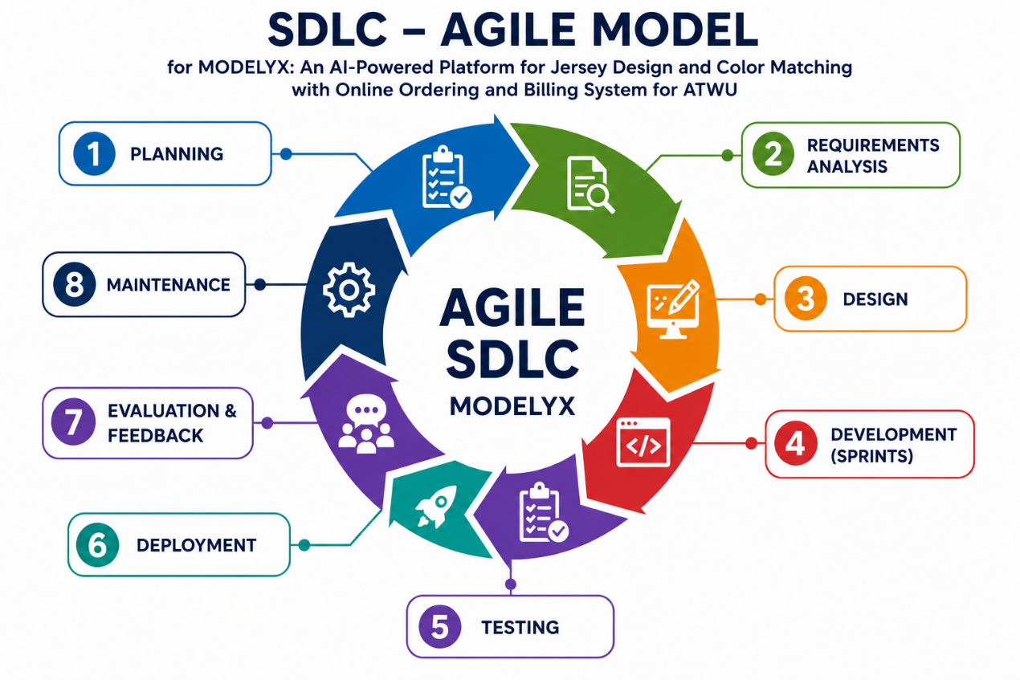

Figure 1. Agile SDLC Model for the Development of MODELYX

The proponents will use the Agile SDLC Model in developing the MODELYX system. This model is suitable for the project because it allows the system to be developed in small phases called sprints, making it easier to improve features continuously based on testing and feedback. The Agile process starts with Planning and Requirements Analysis to identify the needs, objectives, and system features of the project. After that, the Design phase is conducted to create the interface, database, and system structure.
During the Development phase, the proponents will build and integrate the major modules of the MODELYX system such as the jersey customization module, smart color detection module, AI recommendation module, online ordering and billing module, payment features, customer dashboard, and admin dashboard. The team will develop the system gradually through small iterations or sprints to ensure that each feature functions properly before proceeding to the next task.
The proponents will create the website interface, develop the customization tools, implement image upload and color detection features, and build the ordering and payment processes. Admin functions such as managing customers, orders, templates, and notifications will also be included. Lastly, the front end, back end, database, and AI-related functions will be integrated to make the system responsive, interactive, and fully functional.
After the development process, the system will undergo the Testing phase to identify possible errors, bugs, and performance issues. The proponents will conduct functional testing, usability testing, and system testing to ensure that the features such as image uploading, color detection, jersey editing, order processing, and billing computation work accurately and efficiently. Errors identified during testing will be corrected and improved before the system is deployed.
Once the testing process is completed, the system will proceed to the Deployment phase where the MODELYX website will be made accessible to users. This phase includes configuring the database, preparing the server environment, and ensuring that the website operates properly online. After deployment, the Evaluation and Feedback phase will allow users, clients, and advisers to assess the functionality, usability, and performance of the system. Their comments and suggestions will help the proponents identify areas that require improvement.
Lastly, the Maintenance phase ensures that the system remains updated, secure, and fully functional even after deployment. The proponents may continue improving the website by fixing issues, enhancing existing features, improving AI color recommendations, adding new jersey templates, and optimizing the overall performance of the platform. Through the Agile SDLC Model, the proponents can continuously improve the MODELYX system and effectively meet the needs of customers, teams, athletes, and business owners.

Technical Background
Technologies to be Used
The development of Modelyx will use different technologies and tools to create a functional, responsive, and intelligent web based jersey customization and ordering platform.
For the front end development, the proponents will use HTML, CSS, and JavaScript to create the user interface of the system. HTML will be used to structure the content of the website, CSS will improve the visual design and responsiveness of the platform, while JavaScript will provide interactive functions such as jersey customization, button actions, dynamic content, and user interactions. These technologies are selected because they are reliable, widely used, and compatible with different web browsers and devices.
For the back end development, the proponents will use Python 3 together with the FastAPI Framework. Python 3 is chosen because it supports image processing, artificial intelligence functions, and efficient system development. FastAPI will handle user requests, manage API communication, process system operations, and connect the front end interface to the database. These technologies are suitable for the system because they provide fast performance, flexibility, and scalability for web based applications.
For database management, the proponents will use MySQL and MySQL Server. These technologies will manage the storage, retrieval, and organization of important system data such as customer accounts, jersey designs, order details, payment information, detected colors, and AI generated recommendations. MySQL is selected because it is secure, reliable, and capable of handling large amounts of data efficiently.
The proponents will also use image processing and artificial intelligence technologies to support the smart color detection and recommendation features of the system. Python libraries and JavaScript based tools will analyze uploaded images, identify dominant jersey colors, and generate suitable color combinations and design recommendations. These technologies are necessary to improve the accuracy and quality of jersey customization.
Additionally, APIs and image processing libraries may be integrated into the system to support automated color detection, recommendation generation, and image enhancement features. These tools will help improve system functionality and provide a better user experience.
Overall, the combination of HTML, CSS, JavaScript, Python 3, FastAPI, MySQL, and image processing technologies will enable the proponents to develop a responsive, intelligent, and efficient web based jersey customization platform for Modelyx.

Gannt Chart of Activities in Documents
MONTH | FEBRUARY |  |  |  | MARCH |  |  |  | APRIL |  |  |  | MAY |  |  |  | JUNE |  |  |  | JULY |  |  |  |  | AUGUST |  |  |  |  | SEPTEMBER |  |  |  |  | OCTOBER |  |  |  |  | NOVEMBER
ACTIVITY
Project Context
Statement of the Problem
Objectives
Scope, Limitations
Related Literature (Foreign, 2 per theme) (5)
Related Literature (Local, 2 per theme) (5)
Related Studies and/or Systems (Foreign, 2 per theme) (5)
Related Studies and/or Systems (Local, 2 per theme) (5)
Synthesis
Calendar of Activities
Resources
Requirements Analysis
Requirements Documentation
Design of Software, System, Product, and/or Processes
References
Resource Persons
Personal Technical Vitae

Figure 2. Gantt Chart of Activities in Documents

Calendar of Activities

MONTH | April |  |  |  | May |  |  |  | June |  |  |  | July |  |  |  | Aug |  |  |  |  | Sep |  |  |  |  | Oct |  |  |  |  | Nov |  |  |  |  |  |  | Dec
SYSTEM AND INTERFACE DESIGN
DATABASE DESIGN
LANDING PAGE
LOGIN/ REGISTRATION
CUSTOMER DASHBOARD
IMAGE UPLOAD MODULE

COLOR DETECTION MODULE
3D LAYOUT/DESIGN
(TEMPORARY)
JERSEY CUSTOMIZATION MODULE
PROFILE
SETTING
ORDER
BILLING AND PAYMENT MODULE
FAVORITES
ADMIN DASHBOARD
JERSEY GALLERY
ORDER ANALYSTICS
DATABASE

Figure 3. Calendar of Activities

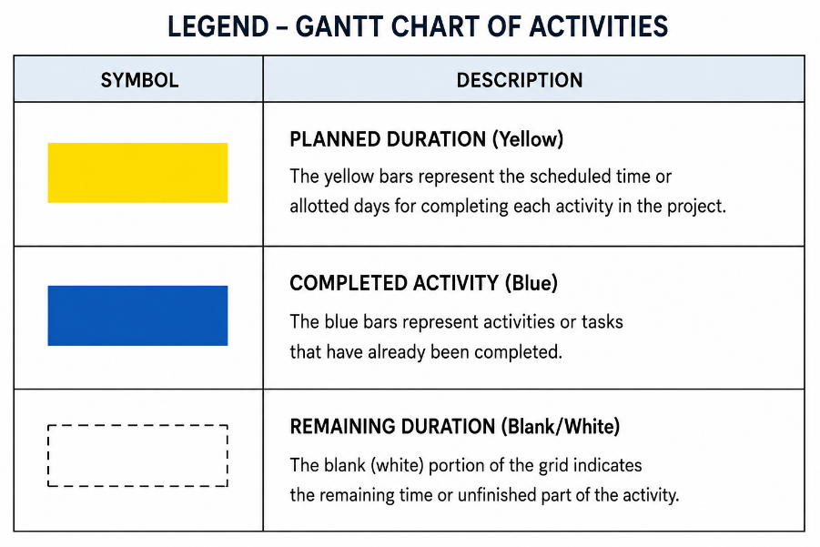
Resources
Hardware
Mobile phone Android/IOS | Android and iOS mobile phones with camera support are required for the system because users will use their devices to capture or upload jersey images for customization. The mobile device will also allow users to browse the website, edit jersey layouts, track orders, and access the system conveniently.
Laptop | A laptop with at least an Intel Core i5 processor, 8GB RAM, 256GB storage, and stable internet connection is needed for system development, testing, database management, and documentation. The laptop will be used by the researchers to develop and maintain the MODELYX system efficiently.
Webcam/Camera | A webcam or mobile camera with clear image quality is necessary for capturing jersey layouts and detecting colors accurately. This hardware supports the color detection feature of the system, which helps users create better jersey designs and color combinations.
Software
HTML | HTML (HyperText Markup Language) is used to create and structure the web pages of the MODELYX system. It serves as the foundation of the website interface and organizes the contents displayed to users.
Visual studio code | Visual Studio Code is the primary code editor used for developing and managing the source code of the system. It provides tools for coding, debugging, and organizing the development process efficiently.
CSS | CSS (Cascading Style Sheets) is used to improve the design and appearance of the website. It helps create a clean, organized interface that allows users to navigate the system easily.
JavaScript | JavaScript is used to provide interactive functions within the website such as customization tools, buttons, dynamic content, and user interactions. It improves the responsiveness and functionality of the MODELYX system.
Python3 | Python 3 refers to both a major version of the Python programming language and the specific command line instruction used to run its interpreter.
MySQL | MySQL is used as the database management system of MODELYX. It stores customer accounts, jersey designs, order details, payment records, and other important system data securely and efficiently.
MySQL Server | The MySQL Server is the core software component of the MySQL database system that manages the storage, organization, and retrieval of data. It is a Relational Database Management System (RDBMS) that operates using a client server architecture.
FastAPI | FastAPI is used as the backend framework of the system. It handles API requests, manages communication between the frontend and database, and processes system operations efficiently.

Requirements | Login Module | Dashboard Module | Color Detection Module | Jersey Editing Module | 3D preview module | Contact Module | About Us Module | Logout Module
This feature allows the user to log in to their account. | ✔
This feature allows the system to display the main interface and navigation. |  | ✔
This feature allows the system to capture/upload images and detect dominant colors. |  |  | ✔
This feature allows the system to analyze colors using color harmony principles |  |  |  | ✔ | ✔
This feature allows the user to create their own design |  |  |  | ✔ | ✔
This feature allows the user to preview customized jersey in 3D and 360◦ view |  |  |  |  | ✔
This feature provides assistance or contact support for users. |  |  |  |  |  | ✔
This feature allows the system to display mission, vision, and team information. |  |  |  |  |  |  | ✔
This feature allows the user to log out of the system. |  |  |  |  |  |  |  | ✔

The table presents the functional requirements of the Modelyx system and the corresponding modules responsible for each feature. It shows that the Login Module handles user authentication, while the Dashboard Module manages the main interface and navigation. The Color Detection Module is responsible for capturing or uploading images and detecting dominant colors. The Jersey Editing Module and 3D Preview Module work together to analyze colors, apply design customization, and provide a 3D/360° preview of the jersey. Meanwhile, the Contact Module offers customer assistance and support, the About Us Module displays company and team information, and the Logout Module allows users to securely exit the system.

USECASE DIAGRAM

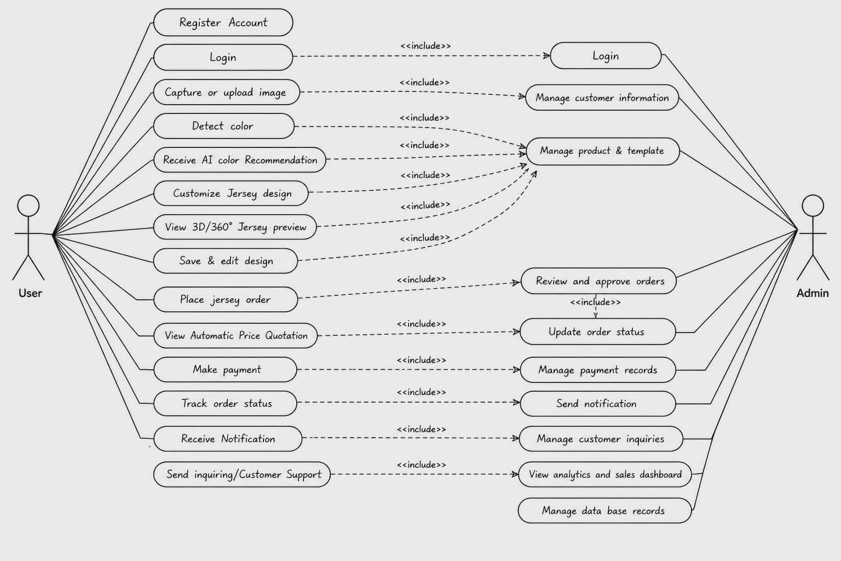
Figure 4. Use Case Diagram

The diagram presents the Use Case Diagram of the MODELYX system. It shows the different functions and interactions available for both the User and the Admin within the platform.

The first diagram represents the User side of the system. It shows that users can register an account and log in to access the features of the platform. Users can capture or upload jersey images, detect colors, and receive AI color recommendations to help improve the appearance of their jersey designs. The system also allows users to customize jerseys, preview designs in 3D or 360° view, and save or edit their designs before placing an order. In addition, users can view automatic price quotations, make payments, track their order status, receive notifications, and send inquiries or contact customer support when needed. These functions are designed to make jersey customization and online ordering easier, faster, and more convenient for customers.

The second diagram represents the Admin side of the system. It shows the functions that can only be accessed by the administrator or business owner. The admin can log in securely and manage customer information, products, and jersey templates. The administrator is also responsible for reviewing and approving orders, updating order status, and managing payment records. Other functions include sending notifications, managing customer inquiries, viewing analytics and sales dashboards, and managing database records. These features help administrators monitor system operations, organize records, manage transactions, and ensure that the platform operates efficiently and securely.

Requirement Analysis

Who | Developers: Ortega, Symon  Sy, Stephen Kenneth  Estabillo, Eduard  Gaetos, Jhaxe Axl Iverson
What | MODELYX is an interactive AI powered jersey editing website designed to help users create and customize jersey designs using digital tools and intelligent features. The system allows users to modify colors, patterns, and design elements while applying basic to intermediate design principles such as color harmony and visual balance.
Where | F. Roxas st, Brgy 892, Manila City
When | The system will operate in real time while users interact with the website. It will process uploaded images, detect colors, generate recommendations, update jersey previews, save designs, provide quotations, and monitor order status when connected to the database.
How | Users will interact with Modelyx through a website interface. Customers can register or log in, upload or create jersey designs, use color detection, receive AI based color recommendations, edit their jersey, view the design in 3D or 360 degree preview, submit orders, and track their order status. Administrators can manage customer information, monitor orders, update product listings, review quotations, and view analytics through the admin dashboard.

System Design Specification Flowchart
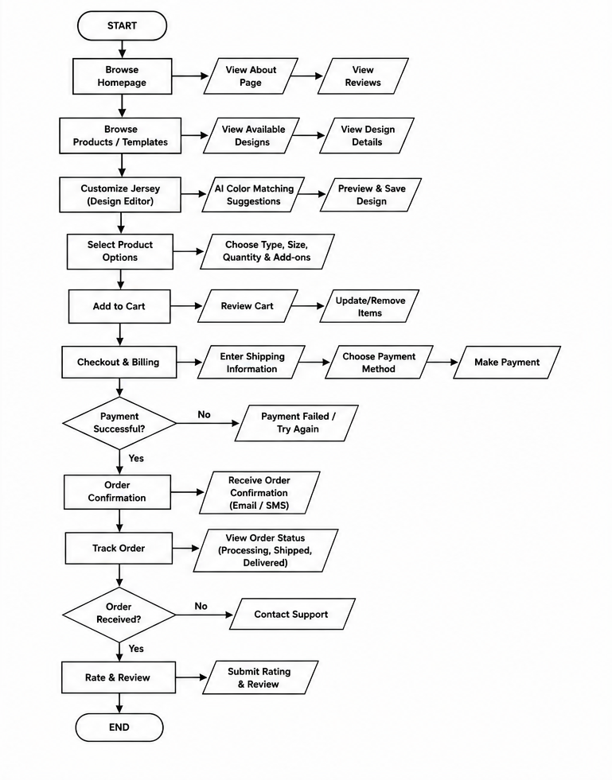
Figure 5. Customer Flowchart Diagram

The process begins when the administrator logs in to the MODELYX system using an admin account. The system checks whether the entered credentials are valid. If the credentials are incorrect, the process ends. If the credentials are correct, the administrator gains access to the dashboard where different management modules are available.
From the dashboard, the administrator can manage customers, products and templates, orders, payments, and inventory. These modules allow the admin to view, add, edit,
delete, approve, and update important records within the system. The administrator can also manage notifications, generate reports, analyze sales and system performance, update system settings, and control user roles and permissions.
After completing the necessary tasks, the administrator can access the audit logs to review system activities and monitor records. Finally, the administrator logs out of the system. The process ends once the logout action is confirmed.

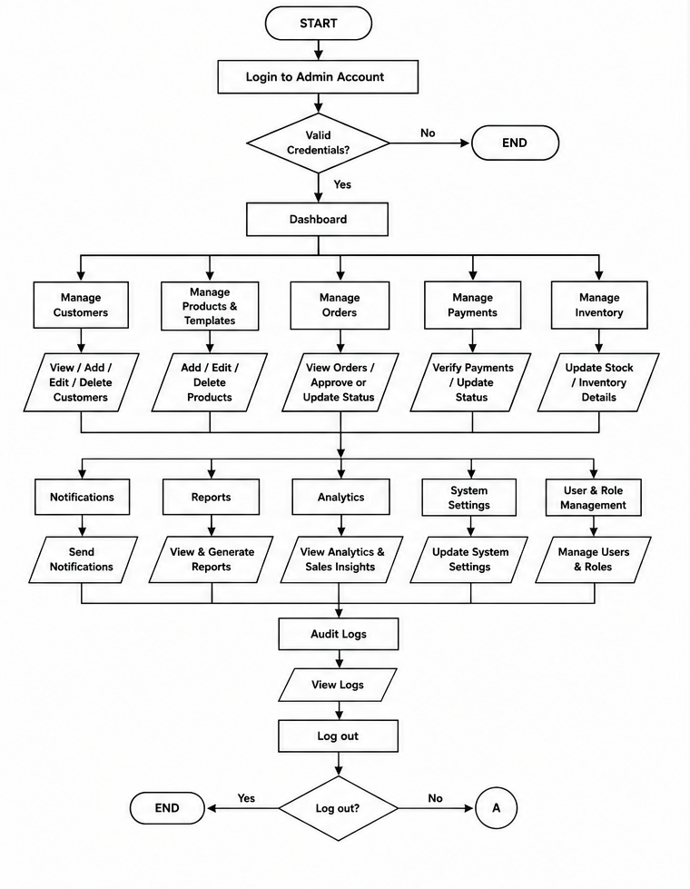
Figure 6. Admin Flowchart Diagram

The process begins when the customer accesses the MODELYX website and browses the homepage. The customer may view the About Page, read reviews, and explore available jersey products and templates before checking the design details.
After selecting a preferred design, the customer proceeds to the jersey customization section where they can edit the jersey using the design editor. The system provides AI color matching suggestions to help create a more balanced and visually appealing design. Once satisfied, the customer can preview and save the customized jersey.
Next, the customer selects product options such as jersey type, size, quantity, and additional add-ons before adding the item to the cart. The customer can review the cart and update or remove items if necessary.
The process then continues to checkout and billing where the customer enters shipping information, selects a payment method, and completes the payment. If the payment fails, the customer is asked to try again. If the payment is successful, the system generates an order confirmation and sends a confirmation message through email or SMS.
After placing the order, the customer can track the order status such as processing, shipped, or delivered. If the order has not yet been received, the customer may contact support for assistance. Once the order is successfully received, the customer can submit ratings and reviews regarding the product and service. Finally, the process ends.

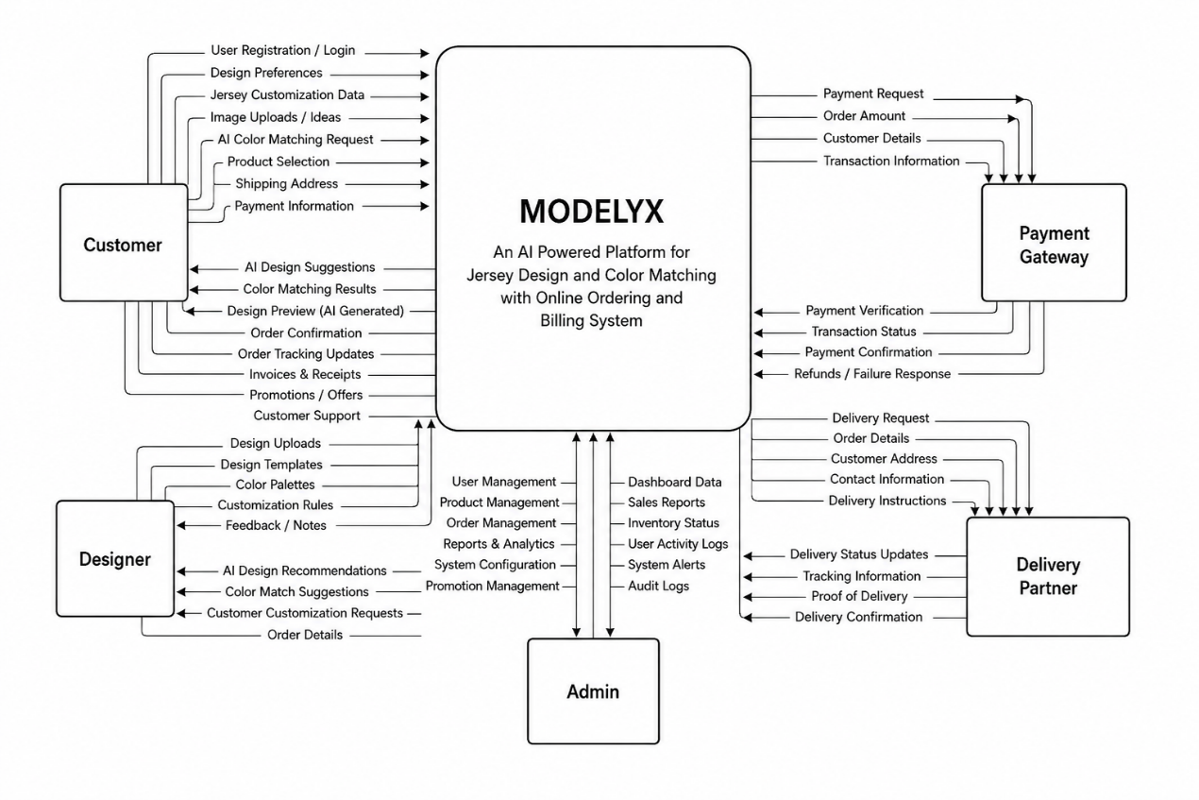

Figure & Context Diagram

The Context Diagram illustrates the overall flow of information in the MODELYX: An AI Powered Platform for Jersey Design and Color Matching with Online Ordering and Billing System. It shows how different external entities interact with the system and exchange data.

At the center of the diagram is the MODELYX System, which serves as the main platform responsible for AI-powered jersey customization, color matching, online ordering, billing, and order management. The system connects with four major external entities: the Customer, Designer, Admin, and Payment Gateway/Delivery PPartner.

The Customer interacts with the system by registering an account, uploading jersey ideas or designs, selecting products, requesting AI color matching, entering shipping details, and making payments. In return, the system provides AI-generated design suggestions, color matching results, design previews, invoices, order confirmations, and order tracking updates.

The Designer collaborates with the system by uploading templates, color palettes, and customization rules. The system sends customer customization requests, AI recommendations, and order details to assist designers in improving and finalizing jersey outputs.

The Admin manages the overall operations of the platform. Through the system, the admin can monitor users, products, orders, inventory, reports, analytics, and promotional management. The system also provides dashboard data, activity logs, audit logs, and system alerts for easier monitoring and decision-making.
The Payment Gateway handles payment processing and transaction verification. The system sends payment requests and transaction information, while the payment gateway returns payment confirmations, transaction status, and refund responses.

Lastly, the Delivery Partner manages shipping and delivery services. The system sends delivery requests and customer information, while the delivery partner provides tracking updates, proof of delivery, and delivery confirmations.

Overall, the context diagram demonstrates how MODELYX acts as a centralized platform that connects users, administrators, payment processing, and delivery services into one integrated AI-powered jersey customization and ordering system.

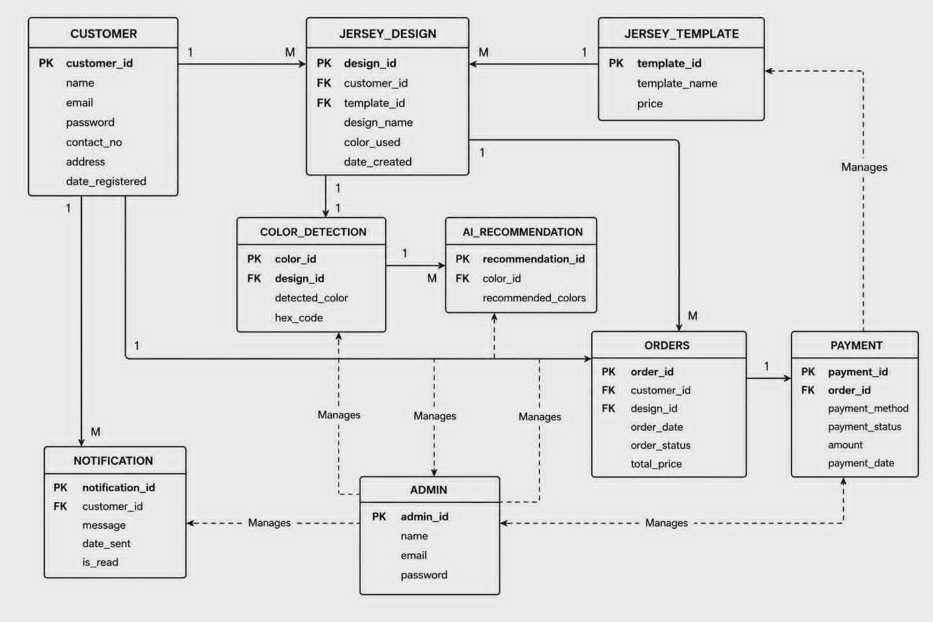
The Entity Relationship Diagram (ERD) illustrates the overall database structure of the MODELYX system and shows how the different entities or tables interact with one another to support the platform’s functions. It serves as the foundation of the system by organizing and managing important information related to jersey customization, AI color matching, online ordering, payment processing, and administrative management.
The CUSTOMER entity stores the personal information of users who register in the system. This includes details such as the customer’s name, email address, password, contact number, address, and registration date. Customers are considered one of the main users of the platform because they are responsible for creating jersey designs, placing orders, making payments, and receiving notifications from the system. The CUSTOMER entity is also connected to the ADMIN entity since administrators manage customer records and account information.
The JERSEY_DESIGN entity manages all customized jersey designs created by customers. It stores information such as the design name, selected colors, and the date the design was created. This entity is connected to the CUSTOMER table because each design belongs to a specific customer. It is also linked to the JERSEY_TEMPLATE entity since customers may use predefined templates as the basis for their jersey customization. In addition, the ADMIN entity is connected to the JERSEY_DESIGN table because administrators can review and manage customer designs.
The JERSEY_TEMPLATE entity contains available jersey templates provided and managed by the administrator. These templates serve as starting layouts that customers can customize according to their preferences. The table stores template names and pricing information for easier product and template management. Since templates are maintained by administrators, the ADMIN entity is directly related to this table.
To support the AI-powered color matching feature, the system uses the COLOR_DETECTION and AI_RECOMMENDATION entities. The COLOR_DETECTION entity stores detected colors and corresponding hex codes extracted from uploaded or customized jersey designs. These detected colors are then used by the AI_RECOMMENDATION entity to generate suggested color combinations that help users create more balanced and visually appealing jersey designs. These entities work together to improve the overall customization experience of the customer.
The ORDERS entity handles customer transactions and stores order-related information such as order date, order status, selected design, and total price. This entity connects customers and jersey designs to ensure that every order is properly linked to the correct user and customized product. The ADMIN entity is also related to the ORDERS table because administrators monitor, approve, and update customer orders.
Connected to the ORDERS entity is the PAYMENT entity, which manages billing and payment details including payment method, payment status, amount paid, and payment date. Administrators are also connected to this table because they verify and manage customer payments and transaction records. These entities help the system organize online ordering and billing processes efficiently.
The NOTIFICATION entity is responsible for managing updates and announcements sent to customers. It stores notification messages, dates sent, and read status to ensure that users receive important information such as order confirmations, payment updates, and delivery notifications. Since notifications are managed and sent by administrators, the ADMIN entity is also connected to this table.
Lastly, the ADMIN entity represents the administrator or business owner who manages the overall operations of the MODELYX system. Administrators are responsible for handling jersey templates, reviewing customer designs, monitoring orders, verifying payments, sending notifications, and maintaining customer records. Through these relationships, the ADMIN entity is connected to multiple tables within the database to ensure that the system remains organized, secure, and properly maintained.
Overall, the ERD demonstrates how the MODELYX system integrates jersey customization, AI-powered color recommendation, online ordering, billing, and administrative management into one connected and efficient database structure.

REFERENCE

Huang, G. (2024). Artificial intelligence enabled apparel design research. Applied Mathematics and Nonlinear Sciences, 9(1).
Liu, S., Liu, Y. K., Lo, K., & Kan, C. (2024). Intelligent techniques and optimization algorithms in textile colour management: A systematic review of applications and prediction accuracy. Fashion and Textiles, 11(13).
James, S. K., Sahni, S., Punekar, S., Behl, G., & Nikam, A. V. (2024). Consumer preferences and AI-driven personalization in the online apparel market: A study on customization, fit, and colour recommendations for clothing. African Journal of Biomedical Research, 27(5S), 1069–1075.
Lu, Y. (2026). Research and implementation of intelligent clothing personalized customization system based on deep learning. Scientific Reports, 16, 12080.
Liu, Y., & Wang, L. (2024). MYCloth: Towards intelligent and interactive online T-shirt customization based on user's preference. arXiv.
Liu, Y., & Wang, L. (2024). MYCloth: Towards intelligent and interactive online T-shirt customization based on user's preference. arXiv.
Dela Cruz, M., & Santos, R. (2023). Development of an online customized sportswear ordering system for local printing shops. Philippine Journal of Information Technology, 15(2), 45–58.
Reyes, J. P. (2022). Digital color matching techniques for textile printing in Philippine apparel businesses. Asia Pacific Journal of Multidisciplinary Research, 10(4), 120–128.
Garcia, L., & Mendoza, K. (2021). E-commerce adoption among customized apparel businesses in Metro Manila. Journal of Business and Technology Studies, 8(1), 88–101.
Torres, A. B. (2020). User satisfaction on web-based jersey customization systems among university athletes in the Philippines. Philippine Computing Journal, 5(3), 34–46.
Villanueva, P., & Ramos, E. (2024). Artificial intelligence applications in Philippine fashion and apparel industries. Journal of Emerging Technologies and Innovation, 12(1), 55–70.

Curriculum Vitae of
<GIVEN NAME MI. FAMILY NAME>
<complete address>
<email address>
contact number either cellular phone or landline or both

EDUCATIONAL BACKGROUND
Level | Inclusive Dates | Name of school/ Institution
Tertiary | month year
Vocational/Technical | month year
High School | month year
Elementary | month year

PROFESSIONAL OR VOLUNTEER EXPERIENCE
Inclusive Dates | Nature of Experience/  Job Title | Name and Address of Company or Organization
month year
month year
month year
month year
Listed in reverse chronological order (most recent first).

AFFILIATIONS
Inclusive Dates | Name of Organization | Position
month year
month year
month year
month year
Listed in reverse chronological order (most recent first).

SKILLS
SKILLS | Level of Competency | Date Acquired
 |  | month year
 |  | month year
 |  | month year

TRAININGS, SEMINARS, OR WORKSHOPS ATTENDED
Inclusive Dates | Title of Training, Seminar, or Workshop
month year
month year
month year
month year
Listed in reverse chronological order (most recent first).

