**SUPPOSE WE HAVE AN ARRAY OF 1000000 ELEMENTS AR[1000000]**

|  |  |  |  |  |  |  |  |  |  |
| --- | --- | --- | --- | --- | --- | --- | --- | --- | --- |
| 23 | 43 | 82 | 94 | 57 | 97 | 48 | 65 | …… | 55 |
| AR[0] | AR[1] | AR[2] | AR[3] | AR[4] | AR[5] | AR[6] | AR[7] | ……. | AR[n] |
|  |  |  |  |  |  |  |  |  |  |

* We aim to calculate twice of each element in an array of user defined size.
* We populate this array with random numbers.
* We use help from multiple threads.
* We can use threads which are dynamically assigned members.
* Each thread calculates the twice (*2) for each value assigned to it.
* Results are saved to a file.
* All threads perform independently (without depending on each other)
* Each thread completes its job.

**SCREEN SHOTS**

1. **Run make to compile the mycthreads.c file. This is done using the Makefile.**

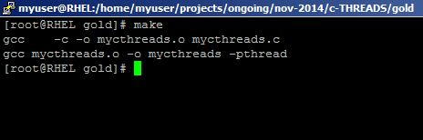

1. **Screenshot of a successful run**

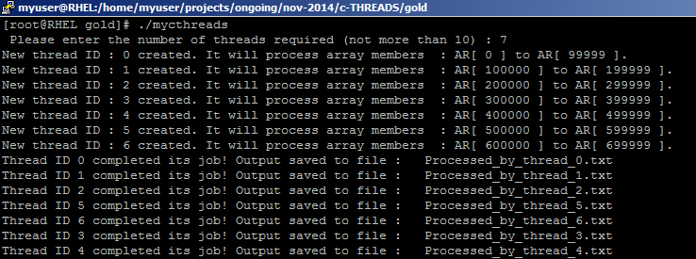

1. **List of output files generated by each thread:**

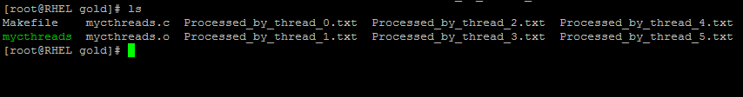

INITIAL FLOW CHART

Threads required?

segment size

Write output to file4

Write output to file

Write output to file

Write output to file

Write output to file

Write output to file