***Zipper***

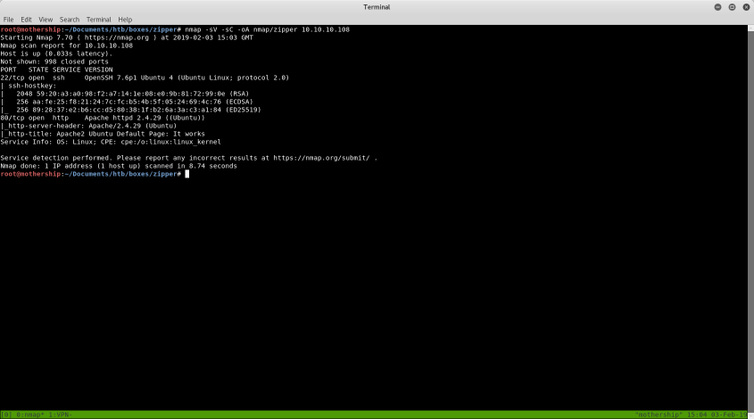*Enumeration*

After doing the following; nmap –sV –sC –oA nmap/zipper 10.10.10.108 I recived the following result*s*

*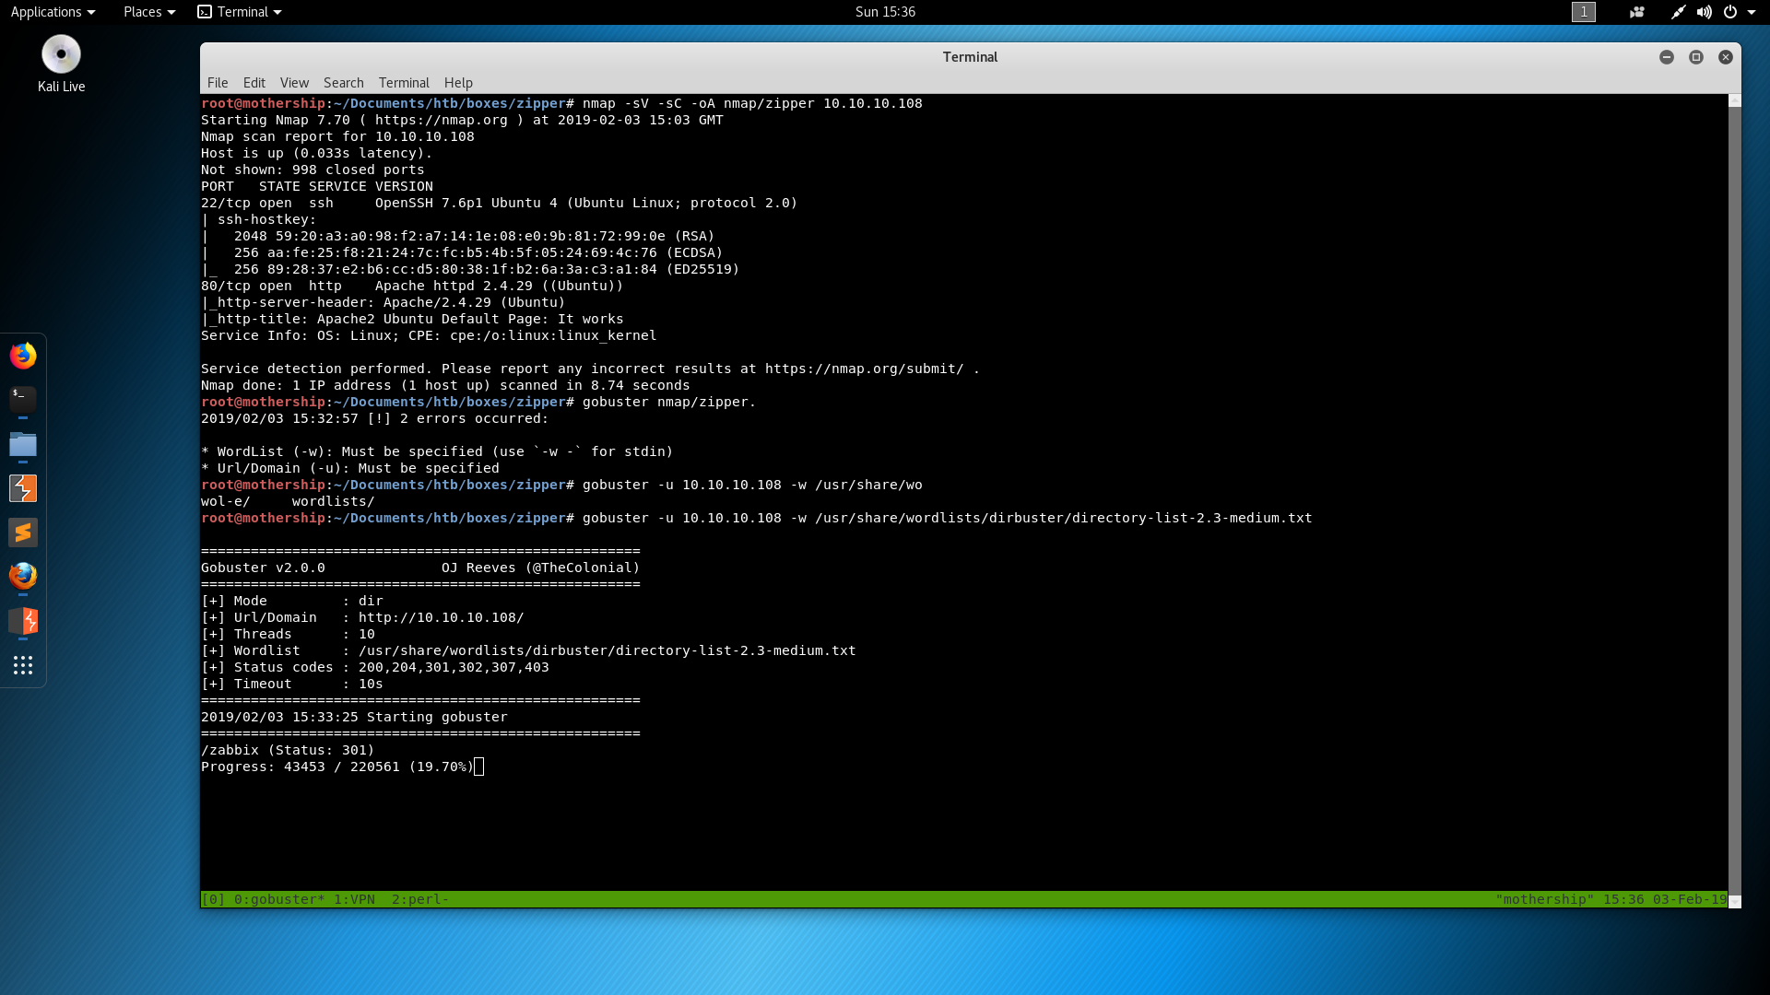The next step is to check what is on port 80. After going to* [*http://10.10.10.108*](http://10.10.10.108) *I found that it was just hosting a defualt apache page. After doing some enumerating with gobuster I found that there is a directory called /zabbix.*