University of Washington
  - IT Foundations 130

Module07-Functions
In this module you will learn about how to uses SQL Functions to retrieve information from a database.
Module07-Functions 1
Aggregate Functions (Review) 1
Selecting with Common Functions 4
Partitioned or Windowed Functions 11
Using Functions for Reporting 15
User Defined Functions 18
Using UDFs for Check constraints 19
Creating Advanced GitHub Pages 21
Creating a Markdown File 21
Formatting the Page 22

Aggregate Functions (Review)
"Aggregate functions perform a calculation on a set of values and return a single value. Except for COUNT, aggregate functions ignore null values. Aggregate functions are frequently used with the GROUP BY clause of the SELECT statement." (https://docs.microsoft.com/en-us/sql/t-sql/functions/aggregate-functions-transact-sql, 2017)

These functions are some of the most useful ones. They include Max, Min, Avg, Sum, and Count.
This example shows who placed orders on the most recent recorded day.
USE Northwind
SELECT OrderID, CustomerID
FROM Orders
WHERE OrderDate = (SELECT MAX(OrderDate) FROM Orders);

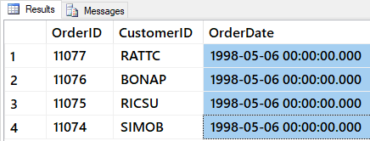
Figure: Result of previous SQL query
Most aggregate functions exclude Null values.
SELECT ShippedDate FROM dbo.Orders;
SELECT MAX(ShippedDate) FROM dbo.Orders;
SELECT MIN(ShippedDate) FROM dbo.Orders;

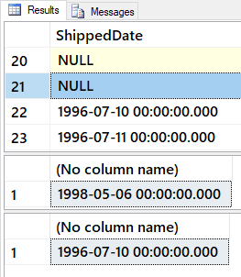
Figure: Result of previous SQL query

Count All (*) is the exception.
SELECT Count(*) as [All Orders] FROM dbo.Orders; -- INCLUDES nulls
SELECT Count(ShippedDate) as [ShippedOrders] FROM dbo.Orders; -- does NOT include nulls

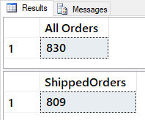
Figure: Result of previous SQL query

Determining the average of the UnitPrice for all products in the Products table can be done with the AVG function.
SELECT AVG(Price) as [avg price] FROM Pubs.dbo.Titles;

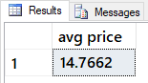
Figure: Result of previous SQL query

You can also use multiple functions in one Select statement.
SELECT
[grand total] = SUM(ytd_sales),
[average sales] = AVG(ytd_sales),
[number of sales] = COUNT(ytd_sales),
[number of entries] = COUNT(*)
FROM Pubs.dbo.Titles;

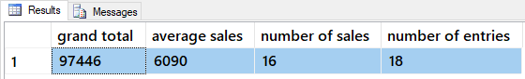
Figure: Result of previous SQL query

You can create your own calculations as well by combining them, like this:
SELECT
[Custom Average Sales] = SUM(ytd_sales) / COUNT(*),
[Standard Average Sales] = AVG(ytd_sales)
FROM pubs.dbo.titles;

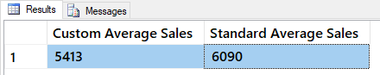
Figure: Result of previous SQL query

Grouping for Sub-Totals
"The GROUP BY statement is often used with aggregate functions (COUNT, MAX, MIN, SUM, AVG) to group the result-set by one or more columns." (https://www.w3schools.com/sql/sql_groupby.asp, 2017)
To understand group by, let's first look at some results without it:
SELECT * FROM Pubs.dbo.Titles WHERE title_id = 'BU1032';

SELECT * FROM Pubs.dbo.Sales WHERE title_id = 'BU1032';

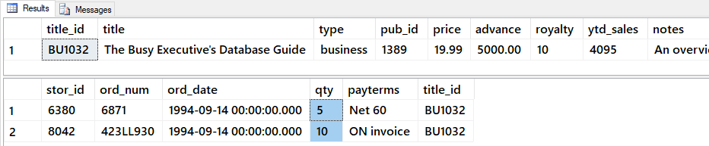
Figure: Result of previous SQL queries

Now, let's add the Group By clause and note how it returns totals.
SELECT Title_id, SUM(qty) AS 'Quantity'
FROM Pubs.dbo.Sales
WHERE title_id = 'BU1032'
GROUP BY Title_id;

Having
After data has been grouped, you can add a filter on the results using the Having option. This placement in the Select statement is different from Where clause it is applied after the grouped totals are created.
SELECT Stor_id, Title_id, SUM(qty) AS 'Quantity'
FROM Pubs.dbo.Sales
GROUP BY Stor_id,Title_id
WITH Cube
HAVING sum(Qty) > 100
ORDER BY Stor_id, Title_id -- Order by is always last

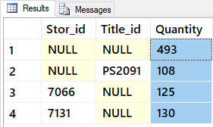
Figure: Result of previous SQL query

Selecting with Common Functions
Functions are a named collection of SQL programming code. All RDMS include built-in functions, and some even let you create your own. We will see how to make your own custom MS SQL functions in a later module, but for now, let's look at some built-in MS SQL functions as examples.
Most SQL functions return a single value.
Select GetDate(), IsNull(null,0);

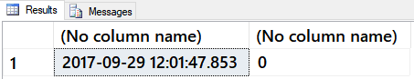
Figure: Result of previous SQL query
But, you can use them in a Select-From statement to apply the function to many rows.
Select GetDate(), IsNull(Price, 0), Title
From Pubs.dbo.Titles;

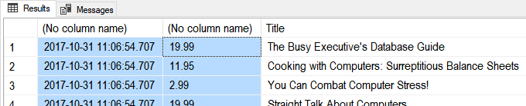
Figure: Result of previous SQL query
You can combine functions to create better looking results:
Select
Cast(GetDate() as Date) as [TodaysDate]
, IsNull(Price, 0) as [CurrentPrice]
, IsNull(Cast(Price as varchar(50)), 'Not For Sale!') as [CurrentPriceAsTEXT]
, Title
From Pubs.dbo.Titles
Go

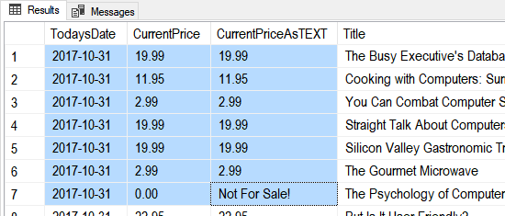
Figure: Result of previous SQL query

Cast and Convert
Cast and Convert are both conversion functions.
Select Cast('1' as int), Cast('1' as decimal(3,2)), Cast(1 as nVarchar(50));
Select Convert(int,'1'), Convert(decimal(3,2),'1'), Convert(nVarchar(50), 1);

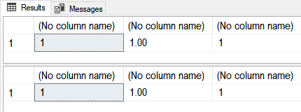
Figure: Result of previous SQL query
Convert has more features than Cast.
Select
[Simple Cast] = Cast(GetDate() as Date)
,[Simple Convert] = Convert(Date, GetDate())
,[US with Slash] = Convert(varchar(50), GetDate(), 101)
,[US with Dash] = Convert(varchar(50), GetDate(), 110)
,[ANSI YearMonthDay] = Convert(varchar(50), GetDate(), 112)
;
Go

Figure: Result of previous SQL query
Logical Functions allow you to look for a condition the evaluates to true or false and then return an appropriate value.

The String Function:
SELECT STR(3.147);
SELECT STR(3.147, 5, 2);
SELECT STR(3.147, 3, 3);
SELECT STR(123.456, 3, 0);
Go
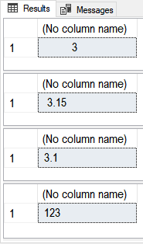
Figure: Result of previous SQL query
Str() is similar to CONVERT(char(15), 123.456), but if you do not allow enough room Convert() will throw an error, while str() will not.
SELECT CONVERT(char(3), 123.456)
Msg 8115, Level 16, State 5, Line 18 Arithmetic overflow error converting numeric to data type varchar.

CONCAT
-- https://docs.microsoft.com/en-us/sql/t-sql/functions/concat-transact-sql
Select CONCAT(1, 'a', Cast('1/1/2020' as date), 5.6); -- Different data types
go
Select CONCAT(rtrim(ltrim(str((3 * 100 / 9),5,2) )), '%') union
Select CONCAT(rtrim(ltrim(str((3 * 100 / 3.21),5,2) )), '%');
go

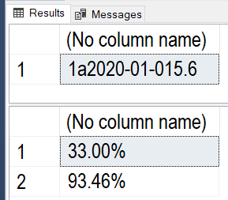
Figure: Result of previous SQL query

The Format Function
Select Format(GetDate(), 'd', 'en-US' ) AS 'US Result'
,Format(GetDate(), 'd', 'en-gb' ) AS 'Great Britain Result'
,Format(GetDate(), 'd', 'de-de' ) AS 'Germany Result'
,Format(123.456, 'C', 'en-US') AS 'US Format'
,Format(123.456, 'C', 'en-gb') AS 'Great Britain Format'
,Format(123.456, 'C', 'de-de') AS 'Germany Format'
;
go
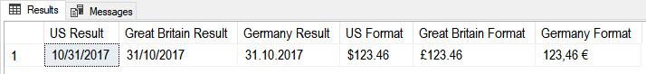
Figure: Result of previous SQL query

The Immediate IF function
Select IIF(5 = 5, 'T', 'F');
Select
[ProductName] = IIF(ProductID = 3, ProductName + ' (Not For Sale!)', ProductName)
From Northwind.dbo.Products;
go

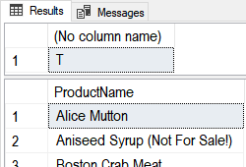
Figure: Result of previous SQL query

The Case Function (directive)
Select Case (5 + 5)
When 10 Then 'Ten'
When 9 Then 'Nine'
End;
Select
ProductName
,[Category] = Case CategoryID
When 1 Then 'A'
When 2 Then 'B'
When 3 Then 'C'
End
From Northwind.dbo.Products;
go

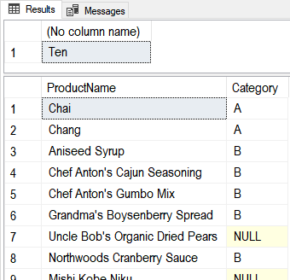
Figure: Result of previous SQL query
A better use of Case would be when you need to do a comparison between two columns and generate a third one. For example, say we have the following shipping data and want to see if orders shipped before their due date.
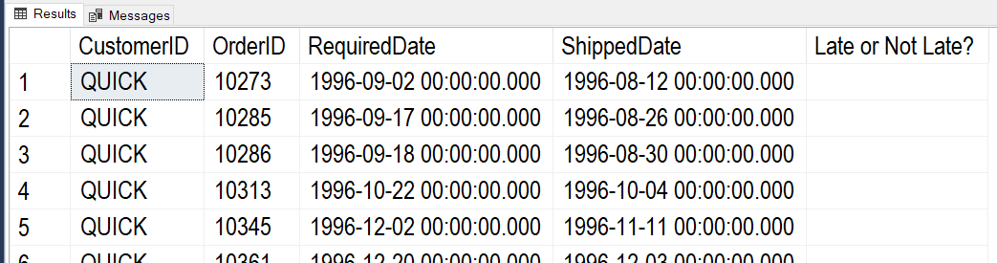
Figure: Result of previous SQL query
Using a "Select – Case" statement will make this easy!
Select
CustomerID
,OrderID
,RequiredDate
,ShippedDate
,[OnTime] = Case
When RequiredDate > ShippedDate Then 'Early'
When RequiredDate = ShippedDate Then 'On Time'
When RequiredDate < ShippedDate Then 'Late'
Else 'No Info Yet'
End
From Northwind.dbo.Orders
Where CustomerID = 'QUICK'
Order by [OnTime];
Go

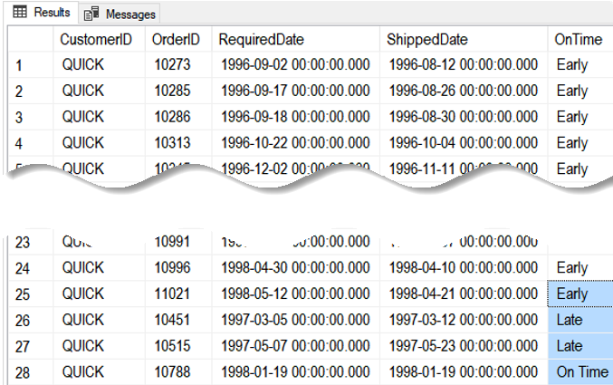
Figure: Result of previous SQL query

The IsNumeric Funtion:
Select IsNumeric('1'), IsNumeric('a1'), IsNumeric('1.23');

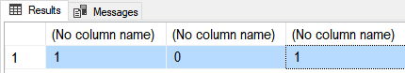
Figure: Result of previous SQL query

The IsDate Function:
Select
IsDate('1/1/2001')
,IsDate('01-01-2001')
,IsDate('20010101')
,IsDate('Jan,01,2001')
,IsDate('1st of Jan,2001');

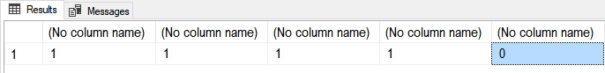
Figure: Result of previous SQL query

The Left and Right Functions
DECLARE @string varchar(100) = 'This is some data'
SELECT [Left] = Left(@string,4),[Right] = Right(@string,4)
;
Go

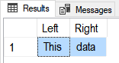
Figure: Result of previous SQL query

The LTrim and RTrim Functions
DECLARE @string_to_trim varchar(100) = ' This is some data '
SELECT
[Without spaces] = '|' + LTrim(RTrim(@string_to_trim)) + '|'
,[With spaces:] = '|' + @string_to_trim + '|'
;
go

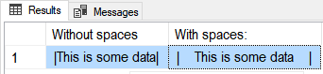
Figure: Result of previous SQL query

The REPLACE Function
( string_expression , string_pattern , string_replacement )
Select Replace('Bob Smith','Bob','Robert');
Select Replace('Bob Jim-Bob Smith','Bob','Robert');
go

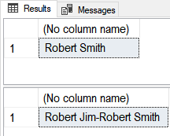
Figure: Result of previous SQL query

The PATINDEX Function
( '%pattern%' , expression )
Declare @Email varchar(50) = 'BSmith@MyCo.com';
SELECT
[Name Ends] = PatIndex('%@%', @Email)
,[Domain Starts] = PatIndex('%.%', @Email)
;
go

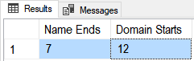
Figure: Result of previous SQL query

The SUBSTRING Function
( expression ,start , length )
Declare @Email varchar(50) = 'BSmith@MyCo.com';
SELECT
[Name] = SubString(@Email,0,PatIndex('%@%',@Email))
,[Company] = SubString(@Email,PatIndex('%@%',@Email) + 1, patindex('%.%',@Email) - patindex('%@%',@Email) - 1)
,[Domain] = SubString(@Email,PatIndex('%.%',@Email) + 1,20)
go

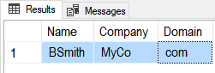
Figure: Result of previous SQL query

Date/Time Functions
Declare @Date as DateTime = GetDate();
Select
[Isdate()] = Isdate(@Date)
,[Datename()] = DateName(mm,@Date) + ', ' + DateName(Weekday,@Date)
,[Datepart()] = str(DatePart(mm, @Date)) + ', ' + str(DatePart(Weekday,@Date))
,[Dateadd()] = DateAdd(mm, 1, @Date)
,[Datediff()] = DateDiff(yy, '20000101', @Date)
,[Day()Month()Year()] = str(Day(@Date)) + ', ' + str(Month(@Date)) + ', ' + str(Year(@Date));

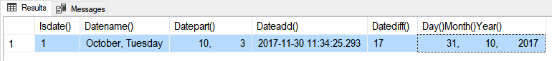
Figure: Result of previous SQL query

Soundex()
Often you need to clean-up incorrect data. Soundex() is an one function that can help you do a clean-up task that would normally be difficult for humans to do quickly.
https://docs.microsoft.com/en-us/sql/t-sql/functions/soundex-transact-sql

Select SOUNDEX ('Patient'), SOUNDEX ('Pateint'), SOUNDEX ('Peteint'), SOUNDEX ('Patint'), SOUNDEX ('Patit');
go
If Exists(Select Name from Sys.tables where Name = 'LookupBySound')
Drop Table LookupBySound
go
Create Table LookupBySound
(ID int Primary Key Identity,[SoundExValue] nvarchar(100), Word nvarchar(100))
go
Insert Into LookupBySound Values ('P353', 'Patient');
go
If Exists(Select Name from Sys.tables where Name = 'DirtyData') Drop Table DirtyData
Create Table DirtyData
(ID int Primary Key Identity, DirtyDataValue nvarchar(100))
go
Insert Into DirtyData
Values
('Patient'), ('Pateint'), ('Peteint'), ('Patint'), ('Patit'), ('test');
go
Select * from LookupBySound;;
Select * from DirtyData;
go
Select DirtyData.DirtyDataValue, LookupBySound.Word
From DirtyData
Left Join LookupBySound
ON Soundex(DirtyData.DirtyDataValue) = LookupBySound.SoundExValue

Partitioned or Windowed Functions
https://docs.microsoft.com/en-us/sql/t-sql/queries/select-over-clause-transact-sql
Partitioned or Windowed Functions allow you to group data differently than the standard Group By clause. Here is an example of a simple select statement with a Group By clause.
Select
stor_id
,[store min was] = min(qty)
,[store max was] = max(qty)
From Pubs.dbo.sales
Group By stor_id
Order By stor_id;

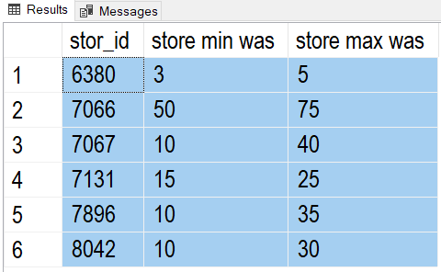
Figure: Result of previous SQL query
Note how just adding Qty doesn't work correctly, because each line becomes part of its own group
Select
stor_id
,qty -- does not work correctly
,[store min was] = min(qty)
,[store max was] = max(qty)
From Pubs.dbo.sales
Group By stor_id, qty -- qty is used for grouping
Order By stor_id;

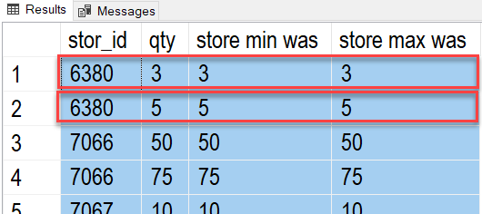
Figure: Result of previous SQL query
Using the Over-Partition function lets you group by only some of the columns.
Select
stor_id
,qty
,[store min was] = min(qty) over(partition by stor_id)
,[store max was] = max(qty) over(partition by stor_id)
From Pubs.dbo.sales
Order By stor_id;

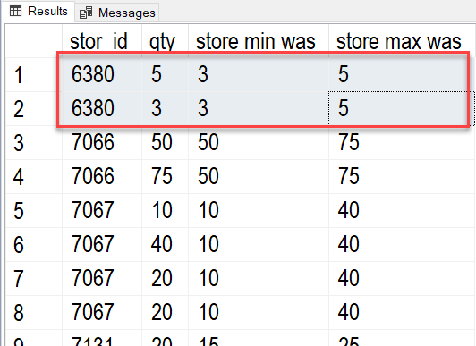
Figure: Result of previous SQL query
If I add both stor_id and qty to the partition the results are the same as Group By.
Select
stor_id
,qty
,[store min was] = min(qty) over(partition by stor_id, qty)
,[store max was] = max(qty) over(partition by stor_id, qty)
From Pubs.dbo.sales
Order By stor_id;

Ranking Functions
"Ranking functions return a ranking value for each row in a partition. Depending on the function that is used, some rows might receive the same value as other rows." -- https://docs.microsoft.com/en-us/sql/t-sql/functions/ranking-functions-transact-sql

SELECT o.OrderID, o.CustomerID, od.Quantity,
-- Ignore duplicate Values in the (Quantity) column
ROW_NUMBER() OVER(ORDER BY od.Quantity) AS rownum,
-- Group duplicate Values in the (Quantity) column and tells how many rows have come before it
RANK() OVER(ORDER BY od.Quantity) AS rank,
-- Groups duplicate Values in the (Quantity) column and tells what the last row NUMBER came before it
DENSE_RANK() OVER(ORDER BY od.Quantity) AS dense_rank,
-- Divide rows into groups based in the number of groups you ask for. Ntile(2) would be 2 groups.
NTILE(2) OVER(ORDER BY od.Quantity) AS ntile
FROM Northwind.dbo.Orders as o Join Northwind.dbo.[Order Details] as od
On o.OrderID = od.OrderID
Where CustomerID = 'ALFKI'
ORDER BY od.Quantity;

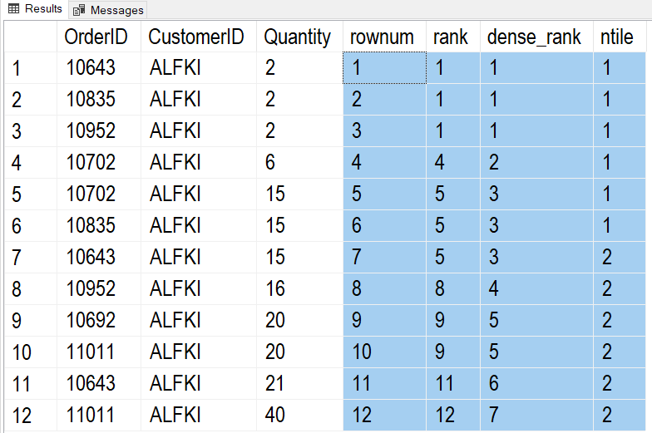
Figure: Result of previous SQL query

Extracting a Percentage
A common task is the calculate the percentage of one value compared to another. Here is how it can be done with SQL code.
Tip: Creating an artificial column just for sorting my data is useful in reporting!
Select [sortcolumn] = 'a', [result] = (3 / 9) Union
Select 'b', (3 * 100 / 9) Union
Select 'c', Cast((3 * 100 / 9) as float) Union
Select 'd', (1. * 3 * 100 / 9) Union -- No need to cast to float now!
Select 'e', (1. * 12 * 100 / 706) – Ex. 12 products of 706 total products
Order By [sortcolumn]
Go

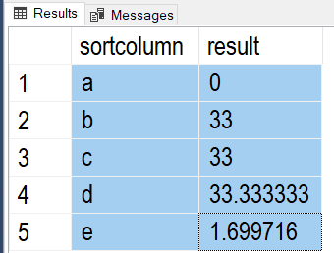
Figure: Result of previous SQL query

Here is an example of how that code could be used.

Select
[stor_id]
,[title_id]
,[QtyByTitle] = Sum(Qty) Over(Partition By [stor_id])
,[QtyByStoreAndTitle] = Sum(Qty) Over(Partition By [title_id], [stor_id]) -- The Order Matters here!
,[Title Percent Per Store] = Cast( (1. * (Sum(Qty) Over(Partition By [title_id], [stor_id])) * 100) /
Sum(Qty) Over(Partition By [stor_id]) as decimal(10,2))
From pubs.dbo.sales
Order By 1;
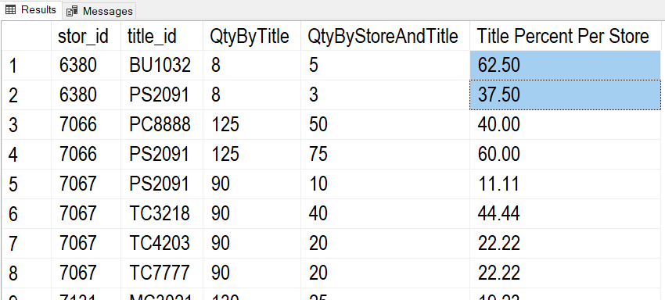
Figure: Result of previous SQL query

Lag and Lead
These functions are very useful in reporting! It shows the previous or following values based on a given group of values.
Here is an example that shows the following year's values.
Select
[OrderYear] = Year(OrderDate)
,[YearlyTotalQty] = Sum(Quantity)
,[PreviousYearlyTotalQty] = lead(Sum(Quantity)) Over(Order By Year(OrderDate))
From Northwind.dbo.Orders as O
Join Northwind.dbo.[Order Details] as OD
On o.OrderID = o.OrderID
Group By Year(OrderDate);
Go

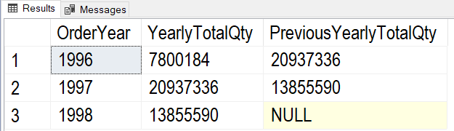
Figure: Result of previous SQL query

Here is another example that shows the shows the previous year's values.
Select
[OrderYear] = Year(OrderDate)
,[YearlyTotalQty] = Sum(Quantity)
,[PreviousYearlyTotalQty] = Lag(Sum(Quantity)) Over(Order By Year(OrderDate))
From Northwind.dbo.Orders as O
Join Northwind.dbo.[Order Details] as OD
On o.OrderID = o.OrderID
Group By Year(OrderDate);
go

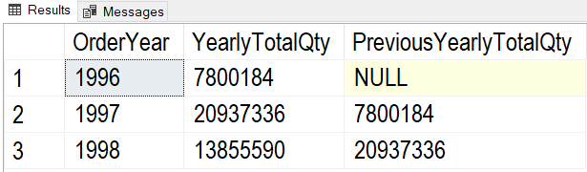
Figure: Result of previous SQL query

Using Functions for Reporting
To create reporting queries, you start off with a simple Select statement and then build on it by adding more and more detailed code to finally get what you want as a result.
To create reporting queries, you start off with a simple Select statement like this one.
Select Distinct
OrderDate
From Northwind.dbo.Orders;

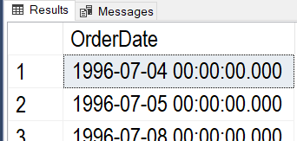
Figure: Result of previous SQL query

Next, add simple functions and test the results!
Select Distinct
[OrderYear] = Year(OrderDate)
From Northwind.dbo.Orders;

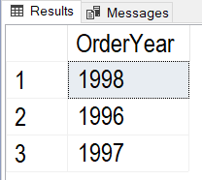
Figure: Result of previous SQL query

Then, add more columns, functions, or tables as needed.
Select Distinct
[OrderYear] = Year(OrderDate)
,[YearlyTotalQty] = Sum(Quantity)
From Northwind.dbo.Orders as O
Join Northwind.dbo.[Order Details] as OD
On o.OrderID = o.OrderID
Group By Year(OrderDate);

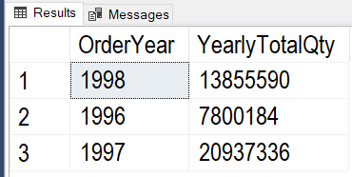
Figure: Result of previous SQL query

Keep adding more complex function as needed (like using the Lag Function).
Select
[OrderYear] = Year(OrderDate)
,[YearlyTotalQty] = Sum(Quantity)
,[PreviousYearlyTotalQty] = Lag(Sum(Quantity)) Over(Order By Year(OrderDate))
From Northwind.dbo.Orders as O
Join Northwind.dbo.[Order Details] as OD
On o.OrderID = o.OrderID
Group By Year(OrderDate);
go

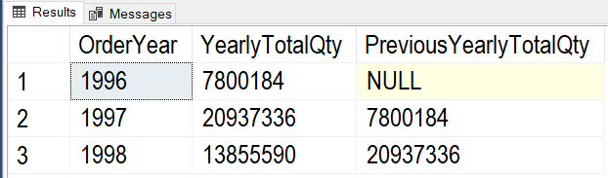
Figure: Result of previous SQL query

Continue adding more features until you get what you are looking for.
Select
ProductName
,[OrderYear] = Year(OrderDate)
,[YearlyTotalQty] = Sum(Quantity)
,[PreviousYearlyTotalQty] =
IIF(Year(OrderDate) = 1996, 0, Lag(Sum(Quantity)) Over (Order By ProductName,Year(OrderDate)))
,[Bad-PreviousYearlyTotalQty] = IsNull(Lag(Sum(Quantity)) Over (Order By ProductName,Year(OrderDate)), 0) -- Don't use Is Null!
From Northwind.dbo.Orders as O
Join Northwind.dbo.[Order Details] as OD
On o.OrderID = o.OrderID
Join Northwind.dbo.Products as P
On OD.ProductID = P.ProductID
Group By ProductName, Year(OrderDate);
go

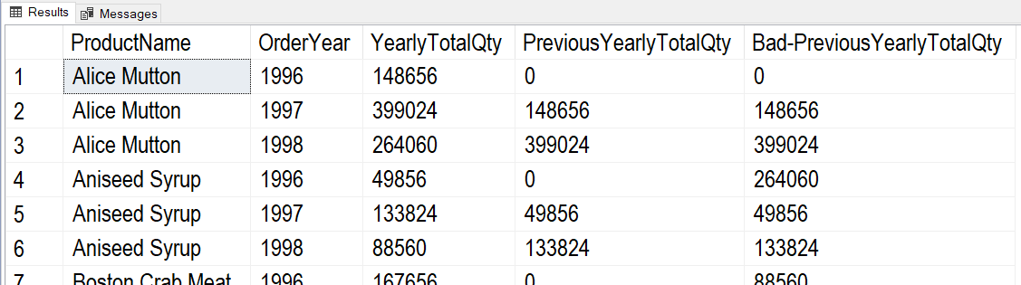
Figure: Result of previous SQL query

Once you feel getting too complex or if you think you might reuse the results, create a reporting View like this one.
Create -- Drop
View vProductOrderQtyByYear
AS
Select
ProductName
,[OrderYear] = Year(OrderDate)
,[YearlyTotalQty] = Sum(Quantity)
,[PreviousYearlyTotalQty] = IIF(Year(OrderDate) = 1996, 0, Lag(Sum(Quantity)) Over (Order By ProductName,Year(OrderDate)))
From Northwind.dbo.Orders as O
Join Northwind.dbo.[Order Details] as OD
On o.OrderID = o.OrderID
Join Northwind.dbo.Products as P
On OD.ProductID = P.ProductID
Group By ProductName, Year(OrderDate);
Go

When using the View, you can always add on more functions -- as needed. For example, our current view makes it easy to create a Key Performance Indicators (KPIs) report
Select
ProductName
,[OrderYear]
,YearlyTotalQty
,PreviousYearlyTotalQty
,[QtyChangeKPI] = Case
When YearlyTotalQty > PreviousYearlyTotalQty Then 1
When YearlyTotalQty = PreviousYearlyTotalQty Then 0
When YearlyTotalQty < PreviousYearlyTotalQty Then -1
End
From vProductOrderQtyByYear
Go

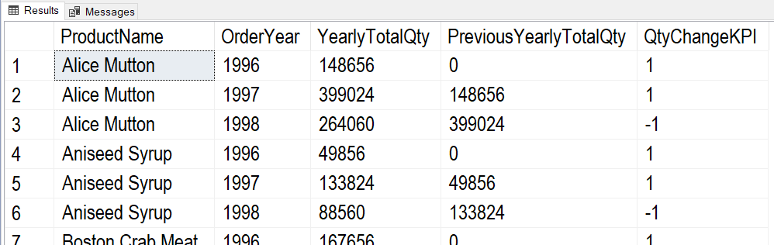
Figure: Result of previous SQL query

User Defined Functions
In addition to SQL Server's built-in functions, you can create custom functions. These are often called User Defined Functions or just UDFs. There are two basic types of functions; functions that return a table of values and functions that return a single value.

Scalars Functions
You can create UDFs to return a single (scalar) value as an expression. (Note: In MS SQL, you must use include the schema name in scaler UDFs, in this case, dbo).
Unlike parameters in table functions, parameters in scalar functions are very useful!
Create Function dbo.MultiplyValues(@Value1 Float, @Value2 Float)
Returns Float
As
Begin
Return(Select @Value1 * @Value2);
End
go
-- Calling the function
Select Tempdb.dbo.MultiplyValues(4, 5);
go

If you want to apply the function to each row of a result set, you use the new function like this:
Create table dbo.SalesDetails
( SalesId int, SalesLineItemId int
, ProductId int
, SalesPrice money
, SalesQty int,
Primary key(SalesId, SalesLineItemID)
);
go
Insert Into dbo.SalesDetails
(SalesId,SalesLineItemId,ProductId,SalesPrice,SalesQty)
Values
(1,1,100,$9.99,10)
,(1,2,200,$1.00,5)
Go

Select
SalesId
,SalesLineItemId
,ProductId
,SalesPrice
,SalesQty
,dbo.MultiplyValues(SalesPrice,SalesQty) as ExtendedPrice
From dbo.SalesDetails
Here are the results:
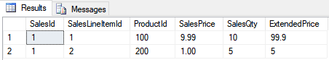
Figure: Results of using the Multiply-Values function in a query

Using UDFs for Check constraints
Custom Scalar functions are sometimes used for Check constraints because you cannot otherwise reference a column in another table. Here is an example
Set NoCount ON; -- Turns of the (1 row affected) messages
Go
Use TempDB;
Go
If Exists (Select Name From Sys.Tables where Name = 'SignupForMeetings')
DROP TABLE SignupForMeetings;
Go
If Exists (Select Name From Sys.Tables where Name = 'Meetings')
DROP TABLE Meetings;
Go

-- Make dependent tables.
CREATE TABLE Meetings (MeetingID int Primary Key, MeetingDateAndTime datetime);
Go
INSERT INTO Meetings (MeetingID, MeetingDateAndTime)
VALUES (1,'1/1/2020 10:00:00');
Go

CREATE TABLE SignupForMeetings
( SignupID int PRIMARY KEY
, SignupDateTime datetime
, MeetingID int Foreign Key References Meetings(MeetingID)
);
Go
INSERT INTO SignupForMeetings (SignupID, SignupDateTime, MeetingID)
VALUES (1, '1/1/2020 11:00:00', 1) -- Opps! This is One hour AFTER the meeting
Go

SELECT MeetingID, MeetingDateAndTime From Meetings;
SELECT SignupID, SignupDateTime, MeetingID From SignupForMeetings;
Go

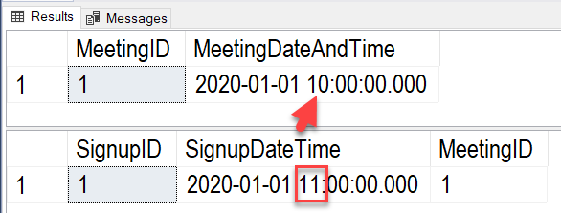
Figure: Incorrect meeting signup data is allowed

-- Remove that row and work on a way to Fix this issue!
DELETE FROM SignupForMeetings WHERE SignupID = 1;
Go

-- Make a function that will get the meeting date and time based on a meeting ID
CREATE or ALTER FUNCTION dbo.fGetMeetingDateTime (@MeetingId int)
RETURNS DATETIME
AS
BEGIN
RETURN (SELECT MeetingDateAndTime
FROM Meetings
WHERE Meetings.MeetingID = @MeetingID);
END
Go

-- Test the function
SELECT dbo.fGetMeetingDateTime(1);
SELECT IIF(CAST('1/1/2020 07:00:00' as datetime) < dbo.fGetMeetingDateTime(1), 'TRUE', 'FALSE'),'Before Start';
SELECT IIF(CAST('1/1/2020 11:00:00' as datetime) < dbo.fGetMeetingDateTime(1), 'TRUE', 'FALSE'), 'After Start';
Go

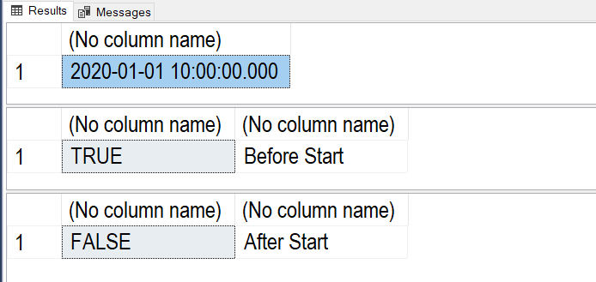
Figure: Results of the function test

-- Now, create a constraint that checks that a signup is before the meeting time
ALTER TABLE SignupForMeetings
ADD CONSTRAINT ckSignupVsMeetingDateTime
CHECK(SignupDateTime < dbo.fGetMeetingDateTime(MeetingID));
Go

-- Test the check constraint
INSERT INTO SignupForMeetings
(SignupID, SignupDateTime, MeetingID)
VALUES
(1, '1/1/2020 9:00:00', 1) -- One hour BEFORE the meeting
Go

INSERT INTO SignupForMeetings
(SignupID, SignupDateTime, MeetingID)
VALUES
(1, '1/1/2020 11:00:00', 1) -- One hour AFTER the meeting
Go
Msg 547, Level 16, State 0, Line 69
The INSERT statement conflicted with the CHECK constraint "ckSignupVsMeetingDateTime". The conflict occurred in database "tempdb", table "dbo.SignupForMeetings".
The statement has been terminated.

SELECT MeetingID, MeetingDateAndTime From Meetings;
SELECT SignupID, SignupDateTime, MeetingID From SignupForMeetings;
Go

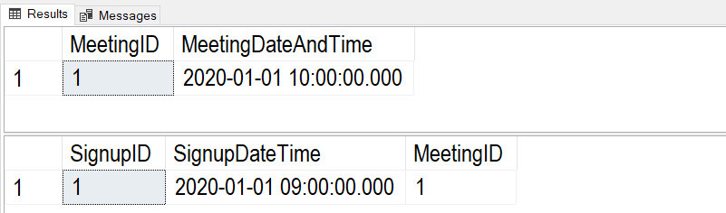
Figure: Results of the previous statements.

Creating Advanced GitHub Pages
In this module's assignment, you create a GitHub webpage. This web page should be like the Word documents you created in previous assignments. To create your page, you need to know some basic commands in a language called "markdown."
"GitHub combines a syntax for formatting text called GitHub Flavored Markdown with a few unique writing features.
Markdown is an easy-to-read, easy-to-write syntax for formatting plain text.
We've added some custom functionality to create GitHub Flavored Markdown, used to format prose and code across our site." (https://help.github.com/en/github/writing-on-github/about-writing-and-formatting-on-github, 2019)

Creating a Markdown File
To demonstrate an example, I create a new GitHub repository called "ITFnd100-Mod07" as shown in this figure:
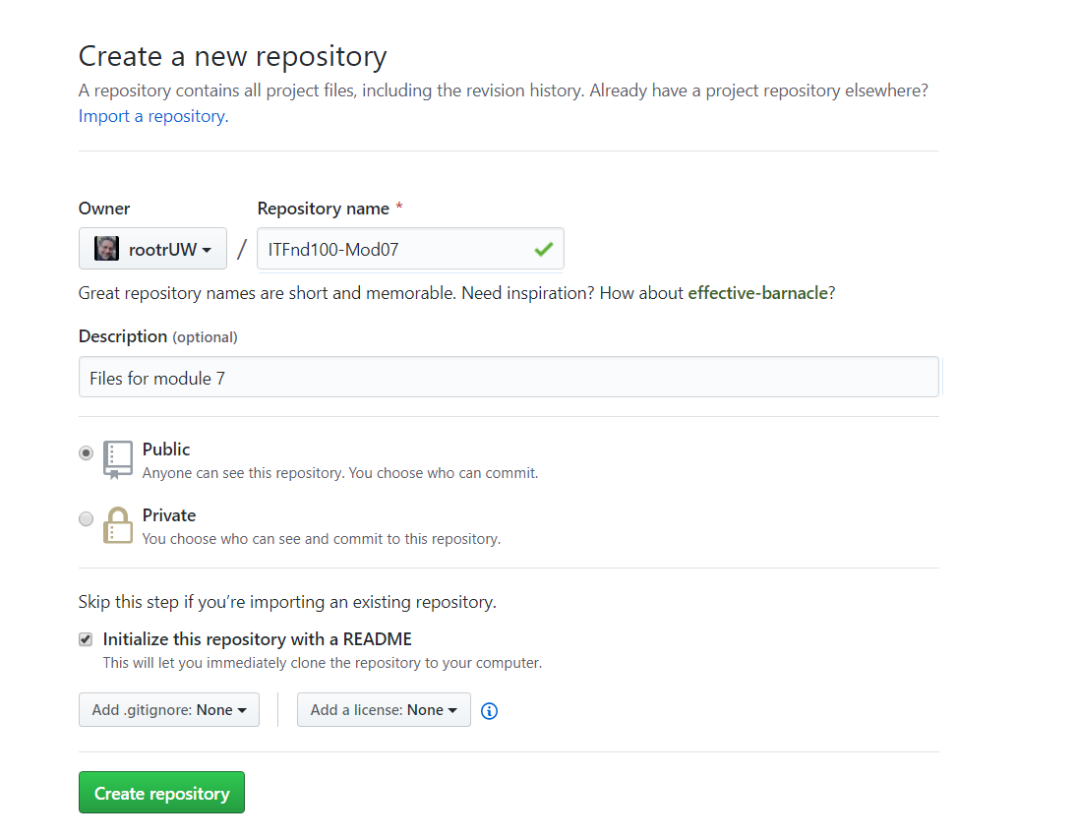
Figure. Creating a new GitHub repository

Next, I create a new "docs" folder with a file called "index.md" inside of it. When I do, I need to type or paste in some text for the new file before it is created in the folder. In Figure 17, I have typed in some simple markdown commands to format my document. Once I have at least some text in the file I can create the folder and file on my repository.
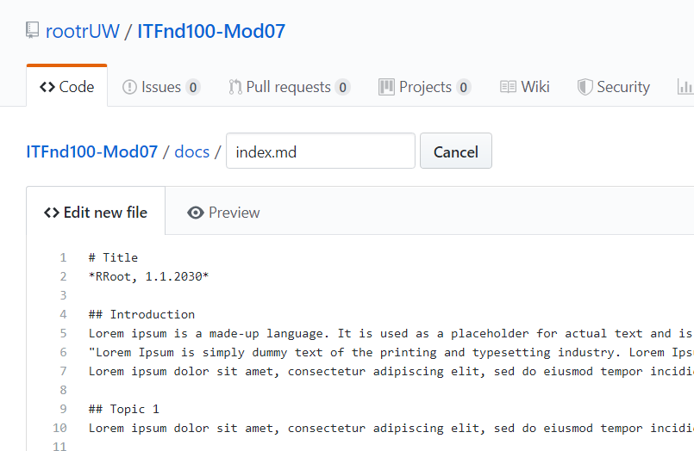
Figure. Creating a new Index.md file in the "docs" folder

Formatting the Page
I use the "Preview" tab to see what my new markdown file looks like each time I modify the text (Figure 18). The look changes based on what markdown commands I use. While there are lots of commands available, let's focus on the ones you need for the assignment.

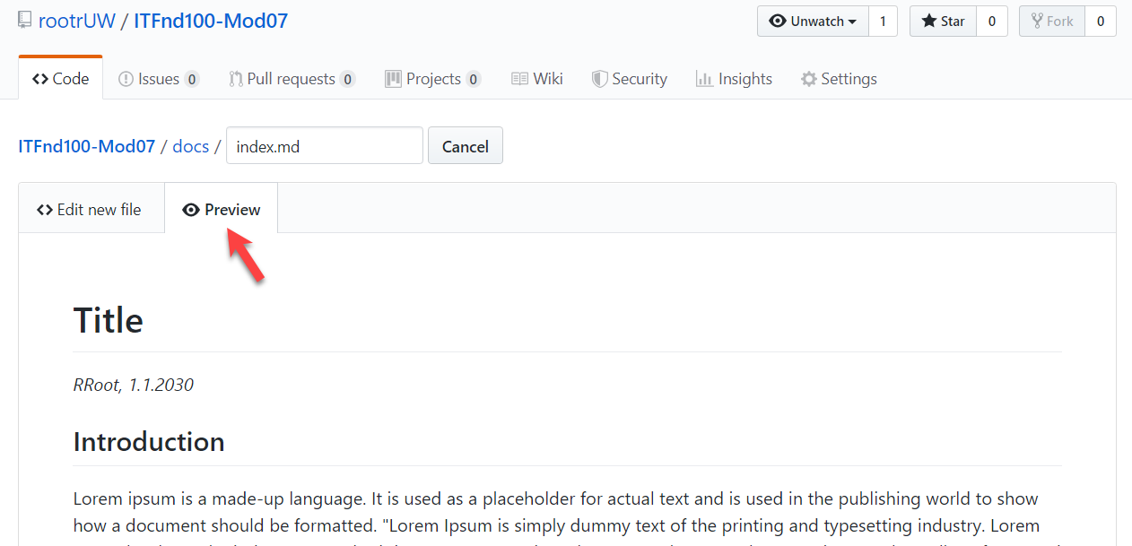
Figure. Previewing a GitHub page

Creating Text Headers
The hash, "#" symbol, indicates a header. You use one or more hash symbols to define the level of the header. Oddly, the more hash marks you use, the smaller the header size.
# Title
## Introduction
## Topic 1
### Subtopic
## Summary
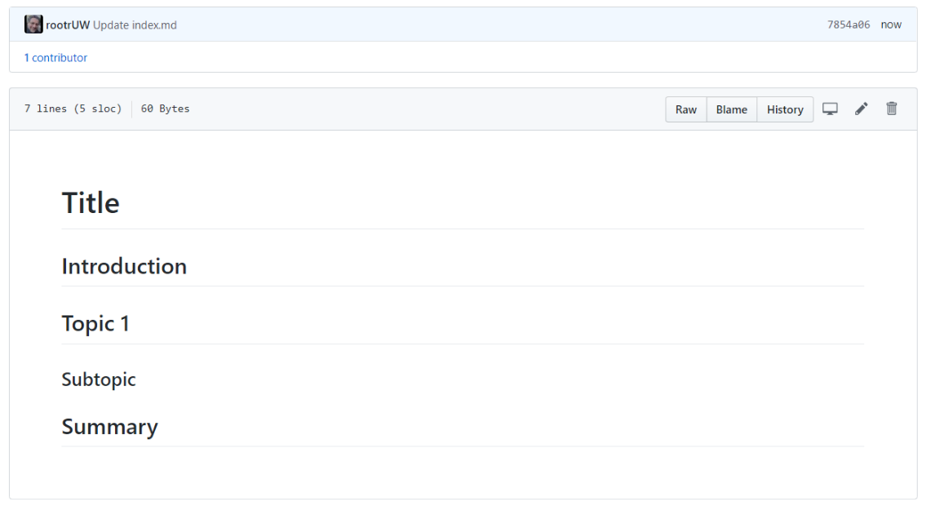
Figure. The results use header markdown commands

Formatting Text
You can make text bold using two Astrid "**" symbols or italic using a single Astrid.
**Dev:** *RRoot*
**Date:** *1.1.2030*
Listing 17
Note: There are two invisible space characters after the text "*RRoot* that force a newline into the page. Newlines can be tricky in this language, and you may need to experiment to style the page to your liking.
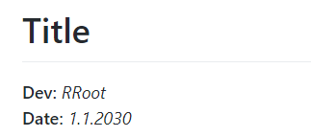
Figure. Creating told text

Adding Code Samples
To add some sample code to the page, you use the backtick (`) symbol, as shown in Listing 18.
# Title
**Dev:** *RRoot*
**Date:** *1.1.2030*

## Structured Error Handling (Try-Except)
When you are programming, you fix your bugs immediately and make sure the code runs smoothly. However, it often happens that other people introduce new bugs when they use your program.

### Raising Custom Errors
Python automatically generates errors based on conditions defined by the Python Runtime. However, you can also "raise" errors based on custom conditions (Listing 13).

```
# ------------------------------------------------- #
# Title: Listing 13
# Description: A try-catch with manually raised errors
# ChangeLog: (Who, When, What)
# RRoot,1.1.2030,Created Script
# ------------------------------------------------- #

try:
new_file_name = input("Enter the name of the file you want to make: ")
if new_file_name.isnumeric():
raise Exception('Do not use numbers for the file\'s name')
except Exception as e:
print("There was a non-specific error!")
print("Built-In Python error info: ")
print(e, e.__doc__, type(e), sep='\n')
```
#### Listing 13
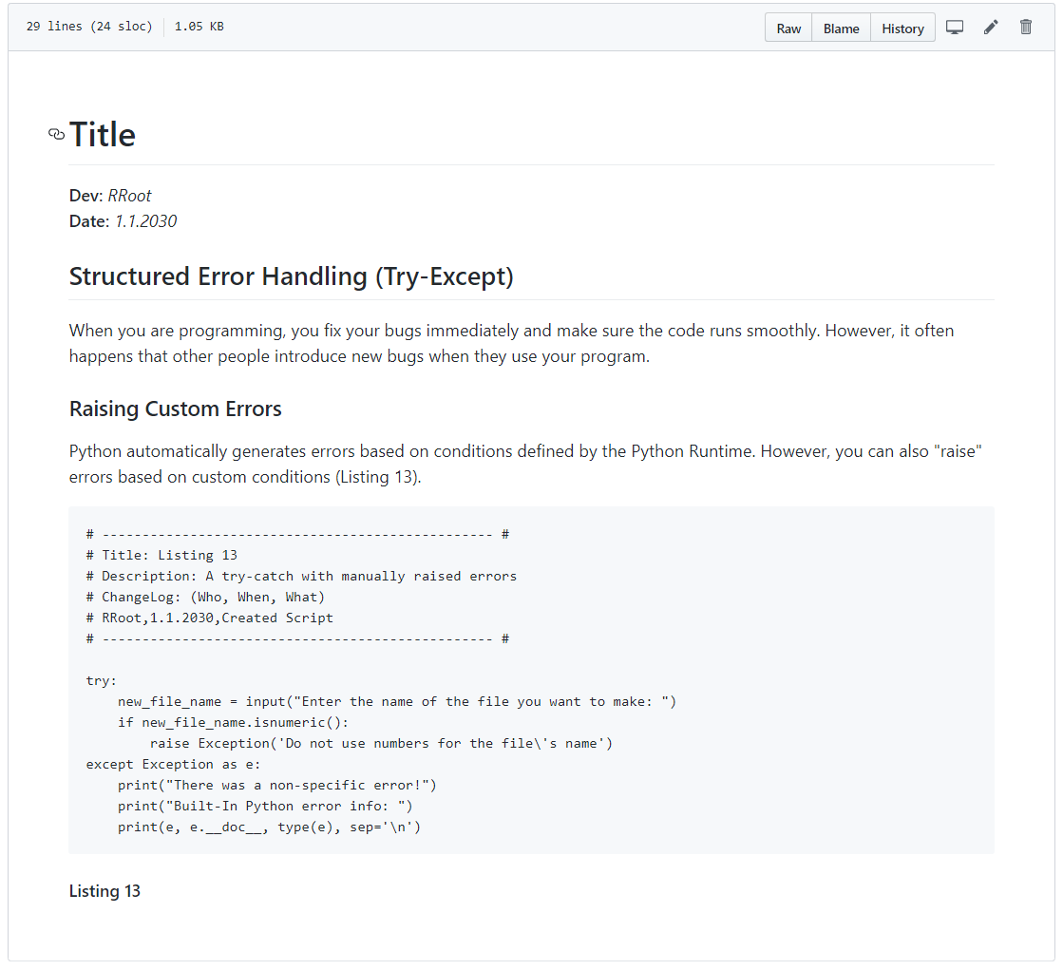
Figure. The results of adding code to the page

Tip: The keyboard key for the backtick symbol (`) is shared with the tilde symbol (~) above the Tab key on both a Windows and Mac keyboard.

Adding Images
To add an image to a page, perform the following steps.
1. Save image to your computer's hard drive. In MS Word, you do this by right-clicking the image and using the "Save as Picture…" option of the context menu.
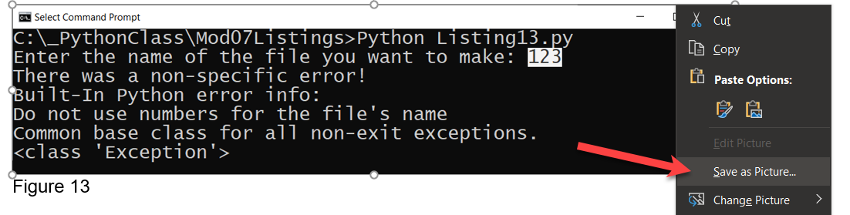
Figure. Saving an image from Word to a drive

2. Upload the image to your GitHub repository's "docs" folder (or a subfolder if you wish to be more organized.
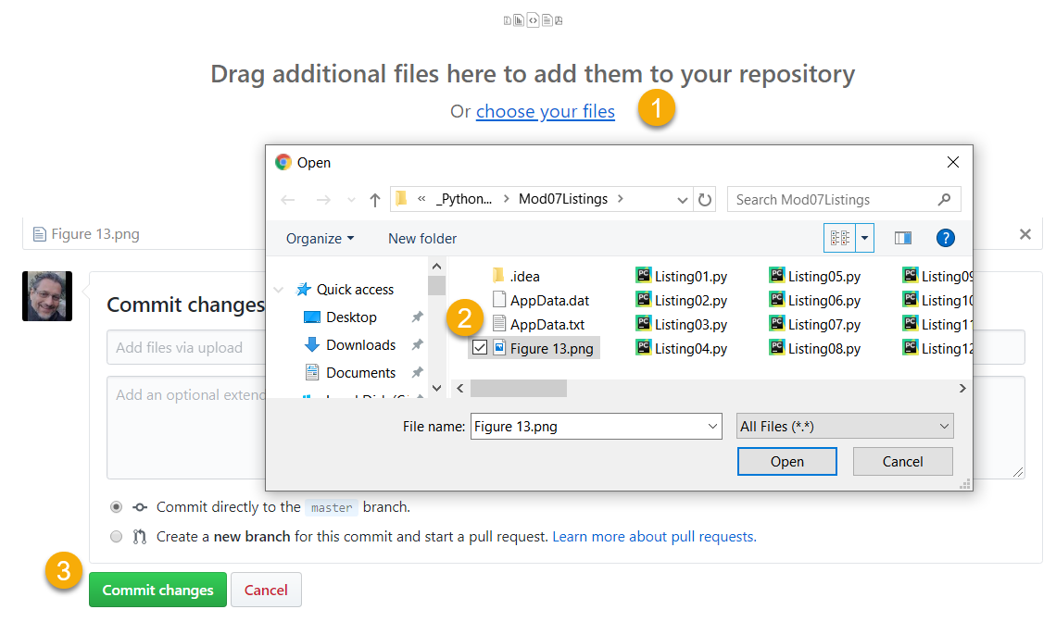
Figure. Uploading the saved image file to GitHub

3. Copy the web address for the file, by locating your file on the GitHub page, then right-clicking it to access the context menu. From there, use the "Copy link address" option, or an equivalent one if you are using a browser other than Chrome.
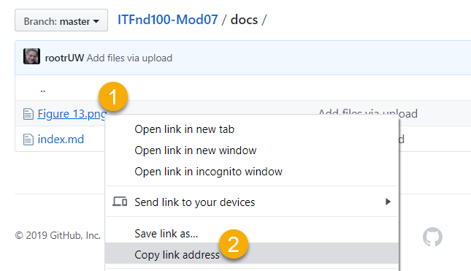
Figure. Copying the file's URL on GitHub with a Chrome browser

4. Link your image to your page using an image link code. The syntax for the image link is:
![alt text](web address "tooltip text")

Here is an example:
print("Built-In Python error info: ")
print(e, e.__doc__, type(e), sep='\n')
```
#### Listing 13

![Results of Listing 13](Figure13.png "Results of Listing 13")#### Figure 13. The results of Listing 13

Note: If you cannot get the images to work, try using HTML tags instead. https://www.w3schools.com/tags/tag_img.asp
The first part of command indicates the alternate text use by screen readers. The second part of the command indicates the URL to the file. The third part of the command indicates the text you want a tool tip to display. Figure 24 shows the results of the command.
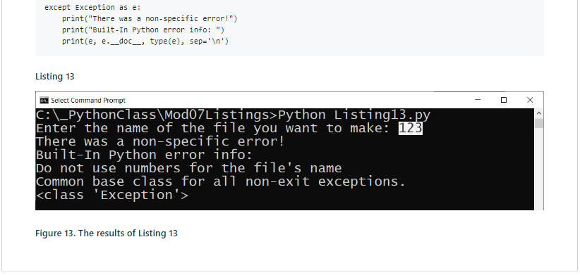
Figure. The results of using a Markdown image link on a GitHub page

Important: It is best to use a relative path for files that are in your folder, and only use the "hard coded" physical path for files outside of your website.

Learning More
There is much information on the Internet about the Markdown language, but you should find all you need for this course on this one webpage:
https://help.github.com/en/github/writing-on-github/basic-writing-and-formatting-syntax
Important: Learning to use Markdown and Jekyll could well be the topic of a complete course, but in this course, you do NOT need to know much about Markdown programming. Please use only the basics shown in this module instead of more advanced features and do not worry about getting the format perfect!

