University of Washington
  - IT Foundations

Views, Functions, and Stored Procedures
As your SQL Select statements become more complex, you may decide to save them in a text file for reuse and use them repeatedly. (A text file with SQL code in it is called a SQL Script!) Alternatively, you can save your Select statements within a database's file as a SQL View, Function, or Stored Procedure.
SQL Views and Functions are "Named" Select statements whose code is stored in a database. Stored Procedures are similar, but they are not restricted to just Select statements. In this module looks at how you create and use these tools for selecting report data.

Views
Any view that is used to extract data for reporting purposes is called a "Reporting View." They can save simple or complex Select statements, but more complex ones are more typical.
Here is an example of a view saving a complex select statement. The select statement includes a join, column aliases, concatenation, and the choose function. Note that creating the view does not run the select code, so the results you get from the Create statement is that it was successful.
Create -- Drop
View vAuthorsByTitles
AS
Select
[Title] = T.title
,[Author]= A.au_fname + ' ' + A.au_lname
,[Order On Title] = Choose(TA.au_ord, '1st', '2nd', '3rd')
From pubs.dbo.titles as T
Join pubs.dbo.titleauthor as TA
On T.title_id = TA.title_id
Join pubs.dbo.authors as A
On TA.au_id = A.au_id

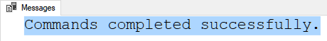
Figure: The results of the previous SQL statement
However, we can run the saved code using only a simple Select statement, which makes complex SQL code much easier to use.
Select * from vAuthorsByTitles;

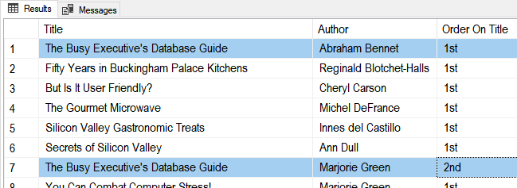
Figure: The results of the previous SQL statement

Views and the Order By Clause
By design, views cannot dictate how that data is sorted. In some RDMS you can use the TOP clause to trick the system into allowing the Order By clause like this example:
Alter View vAuthorsByTitles
AS
Select TOP 1000000000 --< You Need this,
[Title] = T.title
,[Author]= A.au_fname + ' ' + A.au_lname
,[Order On Title] = Choose(TA.au_ord, '1st', '2nd', '3rd')
From pubs.dbo.titles as T
Join pubs.dbo.titleauthor as TA
On T.title_id = TA.title_id
Join pubs.dbo.authors as A
On TA.au_id = A.au_id
Order By T.title, TA.au_ord; --< if you want to use this!
go

go
Select * from vAuthorsByTitles
However, this MAY NOT be considered a best practice. Instead, you can always use the Order By clause when you select from the View like this:
Select * from vAuthorsByTitles Order By Title, Author;
Note: I have seen this trick used so often in the industry that you should know what it does and how to use it. Just remember to ask if your organization does or does not want to use it.
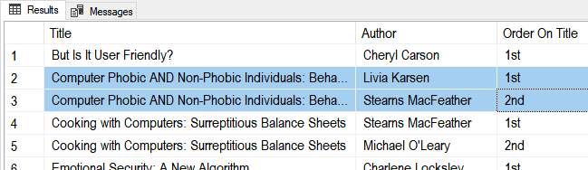
Figure: The results of the previous SQL statement

Partitioning Data with Views
Views allow you to "split" data by rows (horizontal partitioning) stored in one table (At least from a visual aspect). You can divide data by rows by using a Where clause. This is using when creating specialized reports.
Select * from Pubs.dbo.Sales;

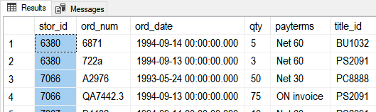
Figure: The results of the previous SQL statement

Create View Store6380Sales AS
Select St.stor_name as Store, S.*
From Pubs.dbo.Sales as S Join Pubs.dbo.stores as St
On S.stor_id = St.stor_id Where S.stor_id = 6380;
go

Create View Store7066Sales AS
Select St.stor_name as Store, S.*
From Pubs.dbo.Sales as S Join Pubs.dbo.stores as St
On S.stor_id = St.stor_id Where S.stor_id = 7066;
go

Select * From Store6380Sales;
Select * From Store7066Sales;

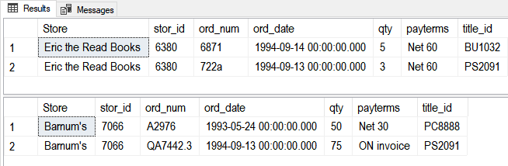
Figure: The results of the previous SQL statements

You can also divide data by Columns (vertical partitioning) too like this:
Select * From Northwind.dbo.Employees;

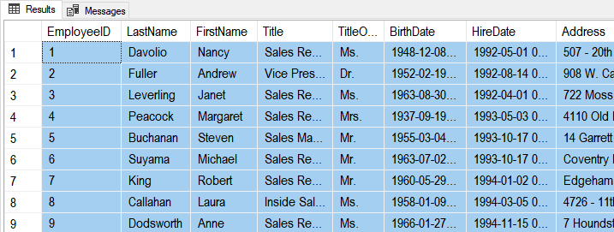
Figure: The results of the previous SQL statement

Create View vPublicEmployeeInfo
As
Select
TitleOfCourtesy
,FirstName
,LastName
,Title
From Northwind.dbo.Employees;
go

Create View vPrivateEmployeeInfo
As
Select
EmployeeID
,LastName
,FirstName
,Title
,TitleOfCourtesy
,BirthDate
,HireDate
,Address
,City
,Region
,PostalCode
,Country
From Northwind.dbo.Employees;
Go

Select * From vPublicEmployeeInfo;
Select * From vPrivateEmployeeInfo;
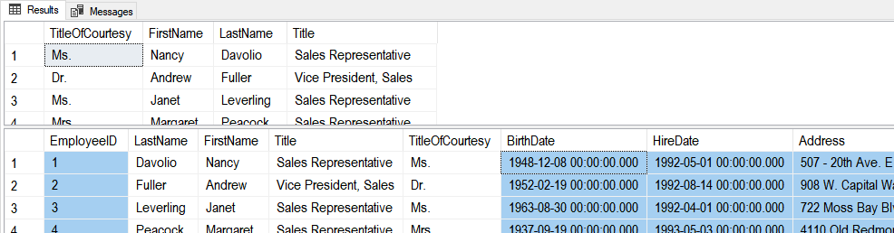
Figure: The results of the previous SQL statement

Now you would protect the private data with permissions and allow people to only access that employees table data through the appropriate views.
Use Northwind;
Deny Select On Employees to Public;

Use Module06Demos;
Deny Select vPrivateEmployeeInfo to Public;
Grant Select On vPublicEmployeeInfo to Public;
Grant Select vPrivateEmployeeInfo to HR;

Lab 1: Creating Reporting Views
In this lab, you create views using the Northwind database from your own lab database.

Step 1: Review Database Tables
Run the following code in a SQL query editor and review the names of the tables you have to work with.
Select * From Northwind.Sys.Tables Where type = 'u' Order By Name;

Step 2: Create a Lab Database
Create a new database for this lab called Mod06LabsYourNameHere (using your own name, of course!) Modify and use the following code to accomplish this:
Create Database Mod06LabsYourNameHere;
go
Use Mod06LabsYourNameHere;
go

Step 3: Create a Query
Answer the following questions by writing and executing SQL code.
Question 1: How can you create a view to show a list of customer names and their locations? Use the IsNull() function to display null region names as the name of the customer's country? Call the view vCustomersByLocation.
Select * From vCustomersByLocation Order By CustomerName;

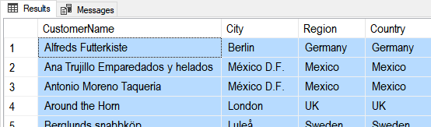
Figure: The query results of question 1

Question 2: How can you create a view to show a list of customer names, their locations, and the number of orders they have placed (hint: use the count() function)? Call the view vNumberOfCustomerOrdersByLocation.
Select * From vNumberOfCustomerOrdersByLocation Order By CustomerName;
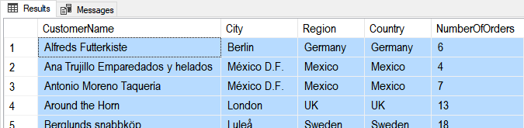
Figure: The query results of question 2

Question 3: How can you create a view to shows a list of customer names, their locations, and the number of orders they have placed (hint: use the count() function) on a given year (hint: use the year() function)? Call the view vNumberOfCustomerOrdersByLocationAndYears.
Select * From vNumberOfCustomerOrdersByLocationAndYears Order By CustomerName, OrderYear;
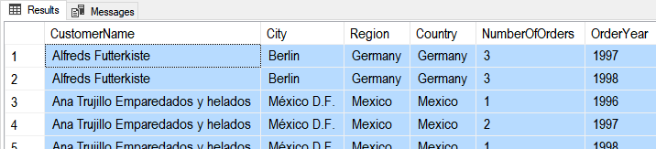
Figure: The query results of question 3

Step 4: Review Your Work
Now, you will review your work with your instructor.

Creating Base Views
In addition to any reporting views you create, each table in a database should have a "Base" view to show data from that table. When you make a table, you create a base view and then restrict access to the table while allowing access to the View. This forces people to use your data in the "Abstract."
Create -- Drop
Table tblCustomers -- Note: "tbl" is a common prefix in some databases
(CustomerID int Identity Primary Key, CustomerName nVarchar(100));
go
Insert Into tblCustomers (CustomerName) Values ('Bob Smith'),('Sue Jones');
go

-- Make a matching view!
Create View Customers
AS
Select CustomerID, CustomerName From dbo.tblCustomers;
go

-- Without a prefix in the name, like vCustomers, people may think your View is a table!
Select * from Customers;

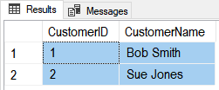
Figure: The results of the previous SQL statement

Abstraction layer objects, like views, make changes to a table design easier. They help you maintain the way applications access the data. When a database table needs to be changed, applications that use the View can continue to work, if you modify the code in the View to hide those changes.
-- Step 1) Make a backup code of the data and drop the existing table
Select * Into #TempCustomers from tblCustomers;

-- Step 2) Make the changes to the original table and replace its data
-- 2.1
Drop Table tblCustomers;
go
-- 2.2
Create Table tblCustomers
( CustomerID int Identity Primary Key
, CustomerFirstName nVarchar(100)
, CustomerLastName nVarchar(100)
);
go
-- 2.3
Insert Into tblCustomers (CustomerFirstName, CustomerLastName)
Select
CustomerFirstName = Substring(CustomerName, 1,3) -- use a function to split the data
,CustomerLastName = Substring(CustomerName, 4,100) -- use a function to split the data
From #TempCustomers;
go
-- Step 3) Make it look like the data was not split!
Alter
View Customers
AS
Select CustomerID, CustomerName = CustomerFirstName + ' ' + CustomerLastName
From dbo.tblCustomers;
go
-- Step 5) Also, add a new view to show the new design changes
Create
View CustomersNormalized
AS
Select CustomerID, CustomerFirstName, CustomerLastName
From dbo.tblCustomers;
go

-- Step 6) You set permissions to force developers into using the View and not the actual table
Deny Select On tblCustomers to Public;
Grant Select On Customers to Public;

-- Step 7) Verify the changes
Select * From tblCustomers;
Select * From Customers;
Select * From CustomersNormalized;
go

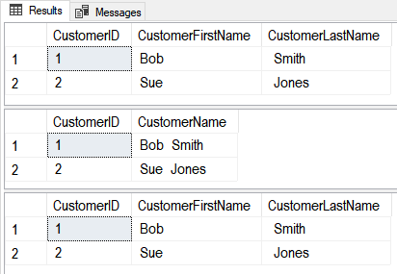
Figure: The results of the previous SQL statements

Schema Binding
Foreign Keys will not protect a Parent table from being Dropped, so some developers will create Views using the Schema Binding option, which keeps tables from changing so much the View does not work anymore!
Use Northwind;
go
Create -- Drop
View vCategories
WITH SCHEMABINDING -- this Requires you to use the table's 2-part name!
AS
Select CategoryID, CategoryName as [CatName] From dbo.Categories; --<< 2-part name
go

Select * From Categories;
Select * From vCategories;
go

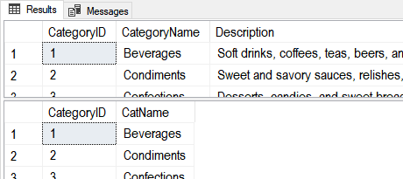
Figure: The results of the previous SQL statements

If a table's changes will not break its View, then the change is allowed...
Alter Table Categories Add IsDiscontinued int; -- SYNTAX: Don't use the word "Column"
go
Select * From Categories;
Select * From vCategories;
go

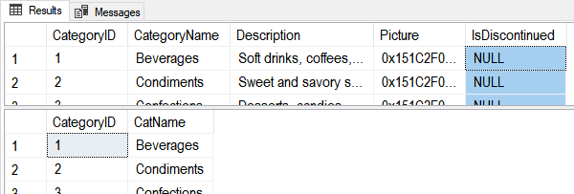
Figure: The results of the previous SQL statements

..., but changes that would break the table's views are not allowed.
Alter Table Categories Drop Column CategoryName; -- SYNTAX: Use the word "Column"
go

Msg 5074, Level 16, State 1, Line 15
The object 'vCategories' is dependent on column 'CategoryName'.
Msg 5074, Level 16, State 1, Line 15
The index 'CategoryName' is dependent on column 'CategoryName'.
Msg 4922, Level 16, State 9, Line 15
ALTER TABLE DROP COLUMN CategoryName failed because one or more objects access this column.

Nor can you cannot drop the whole table!
Alter Table Products Drop Constraint [FK_Products_Categories];
Drop Table Categories;

Msg 3729, Level 16, State 1, Line 26
Cannot DROP TABLE 'Categories' because it is being referenced by object 'vCategories'.

Functions
In addition to SQL Server's built-in functions, you can create your own custom functions. These are often called User Defined Functions or just UDFs.
Functions and Views similar. Here are two examples that show how similar:
-- View
Create View vProducts
AS
Select ProductID, ProductName,CurrentPrice = UnitPrice, CategoryID, Discontinued
From Northwind.dbo.Products;
go
Select * from vProducts; -- 77rows
Go

-- Function
Create Function dbo.fProducts() # Using the dbo prefix is common in Microsoft SQL Server
Returns Table
AS
Return(
Select ProductID, ProductName, CategoryId, Discontinued
From Northwind.dbo.Products
);
go
Select * from dbo.fProducts(); -- 77rows
go
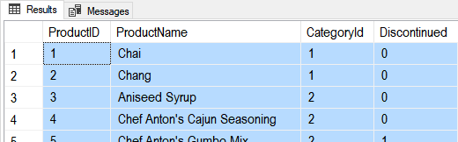
Figure: The results of the previous SQL statements

Functions with Parameters
Unlike views, function can use parameters to change the results of the query as it is executed like this:
Alter Function dbo.fProducts(@CategoryId int)
Returns Table
AS
Return(
Select ProductID, ProductName
From Northwind.dbo.Products
Where CategoryID = @CategoryId
);
go
Select * From dbo.fProducts(1); -- 12 rows
go

While this may seem like a big advantage, but remember that you can always apply a where clause when using a View like this:
Select * From vProducts Where CategoryID = 1; -- 12 rows

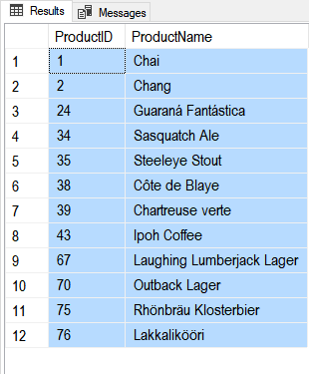
Figure: The results of the previous SQL statements

TIP: Since table functions are more complex and provide similar functionality, use Views to 'Keep It Simple' when you can!

Scalars Functions
Unlike views, you can create UDFs to return a single (scaler) value as an expression. (Note: In MS SQL you must use include the schema name in scaler UDFs, in this case dbo).
Create Function dbo.MultiplyValues(@Value1 Float, @Value2 Float)
Returns Float
As
Begin
Return(Select @Value1 * @Value2);
End
go
-- Calling the function
Select Tempdb.dbo.MultiplyValues(4, 5);
go

If you want to apply the function to each row of a result set, you use the new function like this:
Create table dbo.SalesDetails
(SalesId int, SalesLineItemId int, ProductId int, SalesPrice money, SalesQty int,
Primary key(SalesId, SalesLineItemID)
);
go
Insert Into dbo.SalesDetails (SalesId,SalesLineItemId,ProductId,SalesPrice,SalesQty)
Values (1,1,100,$9.99,10),(1,2,200,$1.00,5)
Go

Select
SalesId
,SalesLineItemId
,ProductId
,SalesPrice
,SalesQty
,dbo.MultiplyValues(SalesPrice,SalesQty) as ExtendedPrice
From dbo.SalesDetails
Here are the results:
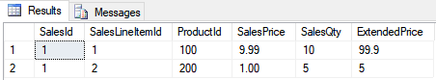
Figure: Results of using the Multiply-Values function in a query

NOTE: Custom Scalar functions are sometimes used for Check constraints because you cannot otherwise reference a column in another table; here is a video of an example (https://youtu.be/NxNJJvG7FzU).

Lab 2: Creating Reporting Functions
In this lab, you create reporting functions using the code you created in lab 1.

Step 1: Complete Lab 1
You must complete lab 1 before you continue with this lab.

Step 2: Copy and Convert
Using the same Select code you created lab1, create three functions in the Mod06LabsYourNameHere database (using your own name, of course!) Call the functions dbo.fCustomersByLocation, dbo.fNumberOfCustomerOrdersByLocation, and dbo.fNumberOfCustomerOrdersByLocationAndYears
Select * From dbo.fCustomersByLocation() Order By CustomerName;

Figure: The query results of question 1
Select * From dbo.fNumberOfCustomerOrdersByLocation() Order By CustomerName;

Figure: The query results of question 2
Select * From dbo.fNumberOfCustomerOrdersByLocationAndYears() Order By CustomerName, OrderYear;

Figure: The query results of question 3

Step 4: Review Your Work
Now, you will review your work with your instructor.

Stored Procedures
Like Views or Functions, Stored Procedures (Sprocs or Procs) are a Named Set of SQL Statements. Creating Views, Functions, and Stored Procedures are all similar as shown in these three examples:
-- View
Create View vProducts
AS
Select ProductID, ProductName,CurrentPrice = UnitPrice, CategoryID, Discontinued
From Northwind.dbo.Products;
go
Select * from vProducts; -- 77rows
Go

-- Function
Create Function dbo.fProducts() # Using the dbo prefix is common in Microsoft SQL Server
Returns Table
AS
Return(
Select ProductID, ProductName, CategoryId, Discontinued
From Northwind.dbo.Products
);
go
Select * from dbo.fProducts(); -- 77rows
Go

-- Stored Procedure
Create Procedure pProducts()
AS
Select ProductID, ProductName, CategoryId, Discontinued
From Northwind.dbo.Products;
go
Execute pProducts(); -- 77rows
Go


Figure: The results of the previous SQL statements

Lab 3: Creating Reporting Stored Procedures
In this lab, you create reporting stored procedures using the code you created in lab 1.

Step 1: Complete Lab 1
You must complete lab 1 before you continue with this lab.

Step 2: Copy and Convert
Using the same Select code you created lab1, create three stored procedures in the Mod06LabsYourNameHere database (using your own name, of course!) Call the stored procedures pCustomersByLocation, pNumberOfCustomerOrdersByLocation, and pNumberOfCustomerOrdersByLocationAndYears
Exec pCustomersByLocation;

Figure: The query results of question 1
Exec pNumberOfCustomerOrdersByLocation;

Figure: The query results of question 2
Exec pNumberOfCustomerOrdersByLocationAndYears;

Figure: The query results of question 3

Step 4: Review Your Work
Now, you will review your work with your instructor.

GitHub
Even when your code is safely stored in a database as a view, function, or stored procedure, you should still save the script file you used for your code.
In fact, it has always been a good idea to make backups of your code files and to make them available for others to access. Traditional this has been accomplished using a network share on an organization's server. While this is still a common practice, more and more organizations have embraced storing this code on the Internet via source control software.
One of the most popular source control software is Git, which can store your files on the Internet at GitHub.com. Here is an excerpt from an article on what GitHub is:
"Version control systems keep these revisions straight, storing the modifications in a central repository. This allows developers to easily collaborate, as they can download a new version of the software, make changes, and upload the newest revision. Every developer can see these new changes, download them, and contribute.
…
Git is the preferred version control system of most developers, since it has multiple advantages over the other systems available. It stores file changes more efficiently and ensures file integrity better. If you're interested in knowing the details, the Git Basics page has a thorough explanation on how Git works."
(http://www.howtogeek.com/180167/htg-explains-what-is-github-and-what-do-geeks-use-it-for/)

To get started using GitHub.com, you will need an account. This process is like creating most web software accounts and is tied to an email account.
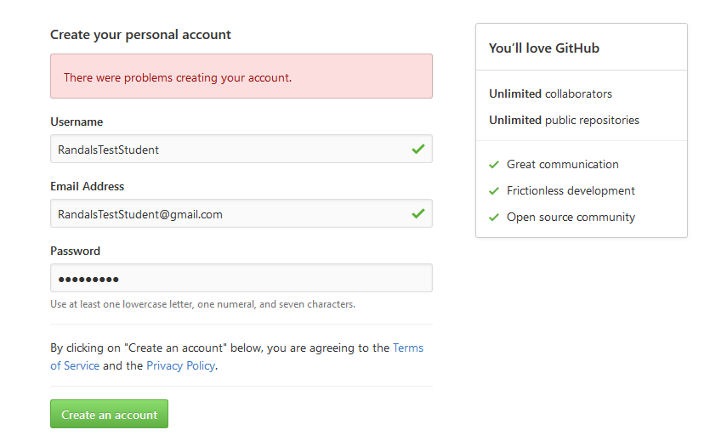
Figure: Creating an account on GitHub

You can set up multiple user accounts and each account can have multiple repositories. You can think of a repository as a set of shared folders where your files are stored and managed through GitHub's web server.
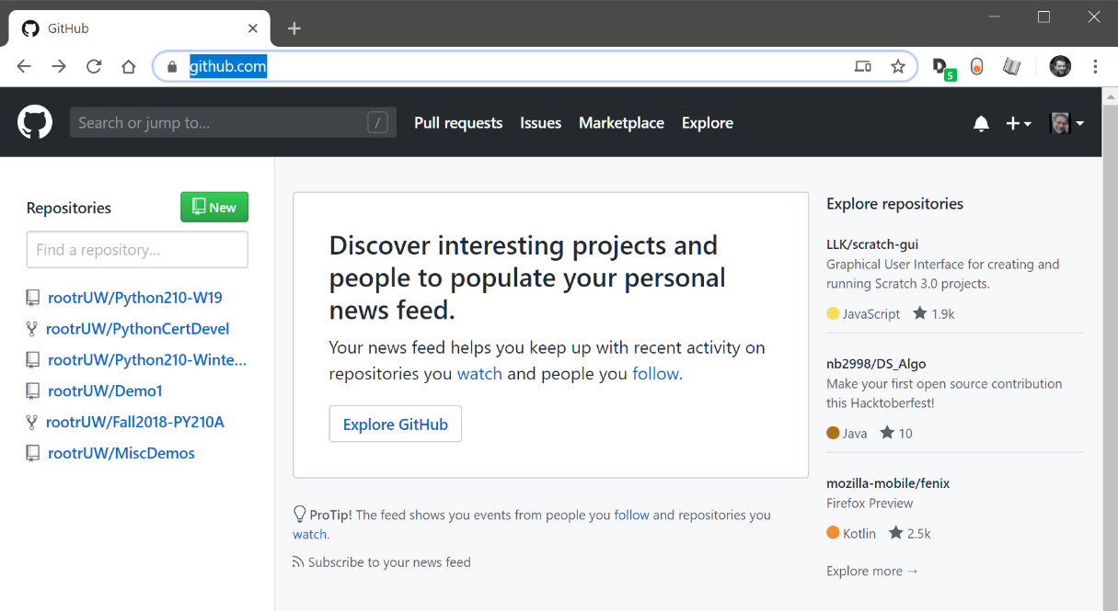
Figure: A list of repositories on the GitHub website

To create a repository, you need to supply its name and configure it to be either private or public. If the repository is public, it can easily be seen and shared with other people.
You should include a starting readme file in the repository. If you don't, you will not see the repository folders materialize until you start loading files into it via the Git command-line tool.
Note: In this course, we use the Web UI to make using GitHub more accessible; however, using the Git command tool is the preferred method used in the industry.
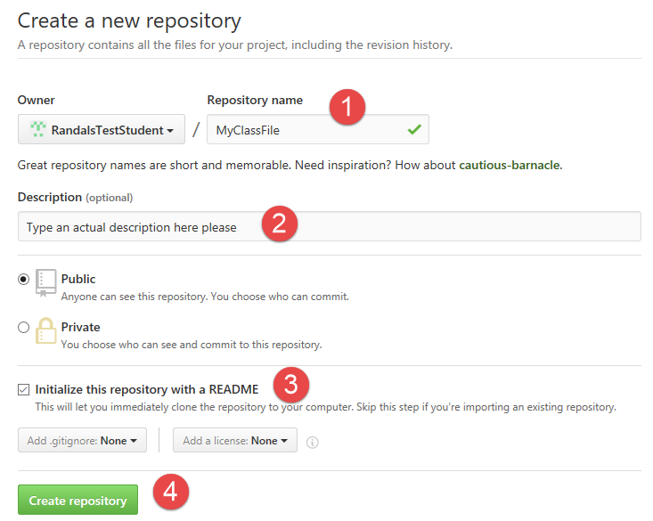
Figure: Creating a repository using the GitHub.com web interface

Once you create the repository, you upload files to it. These files can be viewed, downloaded, and modified by anyone with a link, so be careful what you upload!
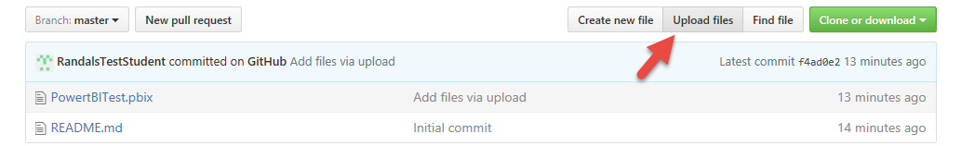
Figure: Using the GitHub.com web interface to upload files

You can store many different types of files on a GitHub repository and use subfolders to organize them. In each folder, including the main repository folder, you should make a ReadMe.md markdown file with notes about the folder's contents.

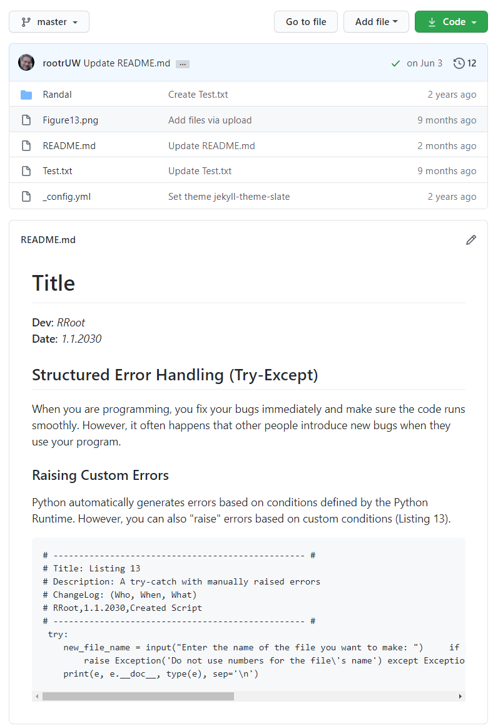
Figure: A ReadMe file in a repository folder

Files stored on GitHub can then be shared with co-workers, friends, or anyone in the World! They can even make their own copy of the files as a "Forked" Repository, which can be used to suggest, make, or track changes over time.

