Assignment 06

In module 06, you learn about Views. This assignment reinforces your knowledge as you perform the following steps:

1. Watch the course videos
2. Read web articles and perform their examples.
3. Watch some web videos
4. Create Views in a database.
5. Submit your work to the Canvas site.

This activity will take you about 6 to 8 hours, so plan accordingly!

# Watch the course Videos

Please watch the following Videos:

1. Module 06 Zoom session (See Canvas)
2. [Module 06 Playlist](https://youtube.com/playlist?list=PLfycUyp06LG8cefs0gA38wO7nFrRjD5Ad)

# Read Web articles

Please read the following web articles.

1 - W3Schools.com's SQL Tutorial

* [SQL Views](https://www.w3schools.com/sql/sql_view.asp)

2 - TutorialPoint SQL Tutorial

* <https://www.tutorialspoint.com/sql/sql-using-views.htm>

# Create Views in a Database

**Open the Assignment06.sql** File, **locate** the Question and Answers section at the bottom of the file, and **create** SQL code that will answer the questions. (Full points are only given if your code if well-formatted, consistent, and produces the same result!)

**Notes**:

1. By now, you should be able to complete these questions without pictures of the results (as is done in real-life). However, I have copied and pasted a few rows of results in the assignment06.sql files to guide you.

-- Here is an example of some rows selected from the view:

-- Manager, Employee

-- Andrew Fuller, Andrew Fuller

-- Andrew Fuller, Janet Leverling

-- Andrew Fuller, Laura Callahan

2. Make sure to use the base views for questions 3 through 10.

## Assignment Document

Write a one-page document that articulates the answer to the following questions. Use at least one well-formed paragraph per question. Using only a sentence or two is fine, but it must make sense and be well-formed. (Please use MS Word or a compatible word processor)

1. Explain when you would use a SQL View.
2. Explain are the differences and similarities between a View, Function, and Stored Procedure.

***Important:*** *Your document must look professional to get full points! Use my example template and video, in the General Files and Topics module, as a guide for what I expect a professional paper to look like. Make sure you format it like a college paper instead of the text message. Things like your name, date, class, citations, introductory and summary paragraphs are always expected! Not putting these in the document you will cost you!*

## Step 7 - Post your Files to GitHub

In this module, you need to **post** your files on a public **GitHub repository** so that others may review it. Please post **both your Word document and your SQL file**.

Here are some videos to help you **learn** what GitHub is and how to use it.

* Introduction - Git and GitHub: <https://youtu.be/BCQHnlnPusY>
* How to use GitHub for Beginners: <https://youtu.be/E8TXME3bzNs>
* Setting up a GitHub Account: <https://youtu.be/Sk1_DU2ky48>

Once you understand how it works, perform the following to **create** a repository for your code:

a. **Login** to <https://github.com> (*Make a new account if needed!*)

**Important: GitHub requires an email account for your login.** You may use a **new made-up email account** with a made-up name **if you are concerned about security**. If you need more safeguards than that, please talk to your instructor.

b. **Create** a repository called **"*DBFoundations" under your account. Figure 1 shows the steps.***

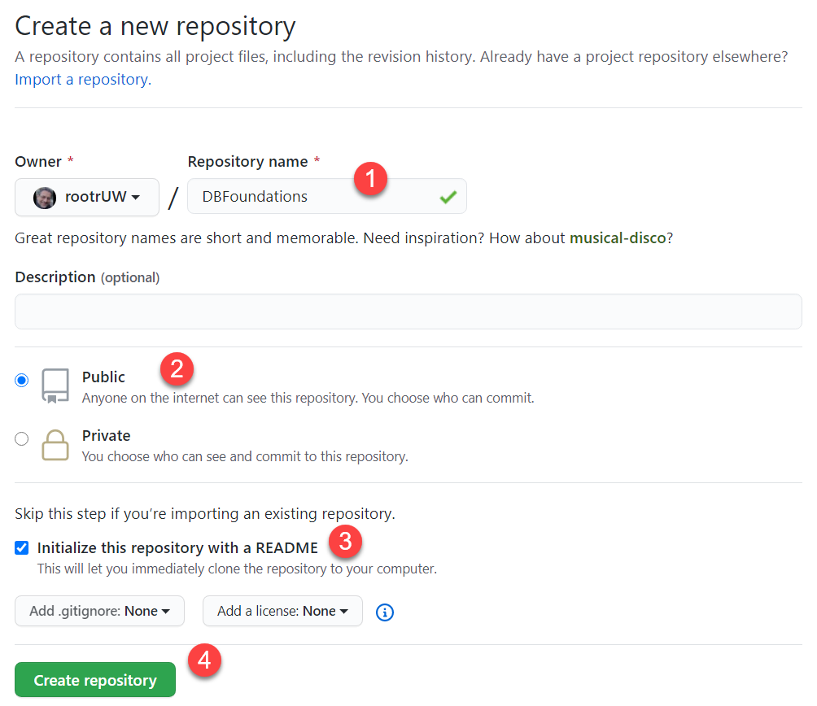

Figure 1. Creating a GitHub repository

c. Upload both of your SQL and Word files to the repository.

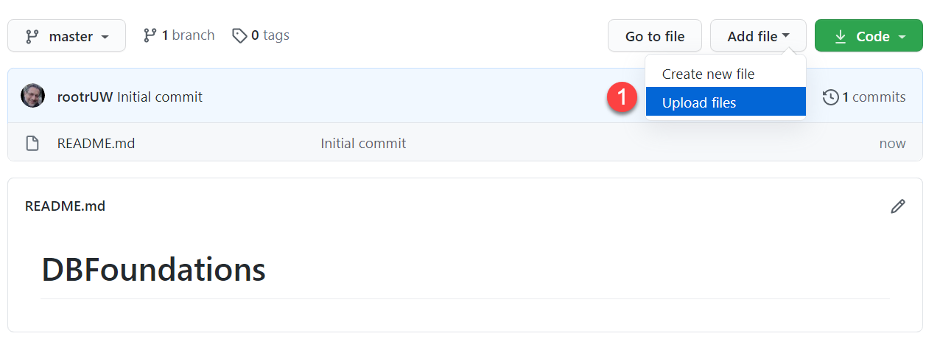

Figure 2. Uploading to a GitHub repository

d. Commit the changes to save your work.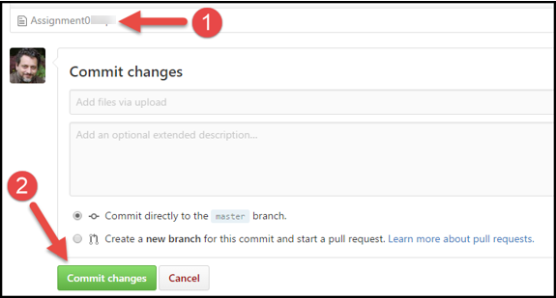

Figure 3. Committing the changes in a GitHub repository

## Step 8 - Post a Link to GitHub

You will share your work using the Canvas discussion board called **Module06 GitHub Links**. To do so, you must create a post with a link to your GitHub site. Other students will use this link to perform a peer review.

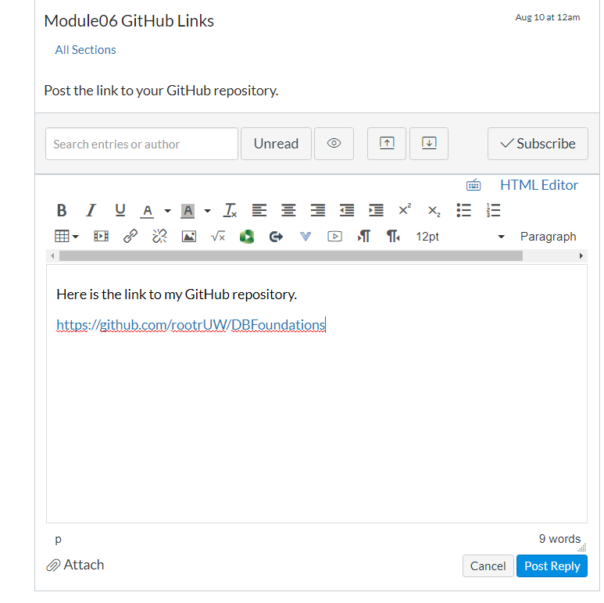

Figure 4. Posting a link to your GitHub repository

***Important:***

1. *Post only on the special discussion board called "Module06 GitHub Links"*
2. *Please copy and paste the URL for your new GitHub site into your MS Word knowledge document (Figure 2). This make grading a lot easier and is a big help! Thanks!!*

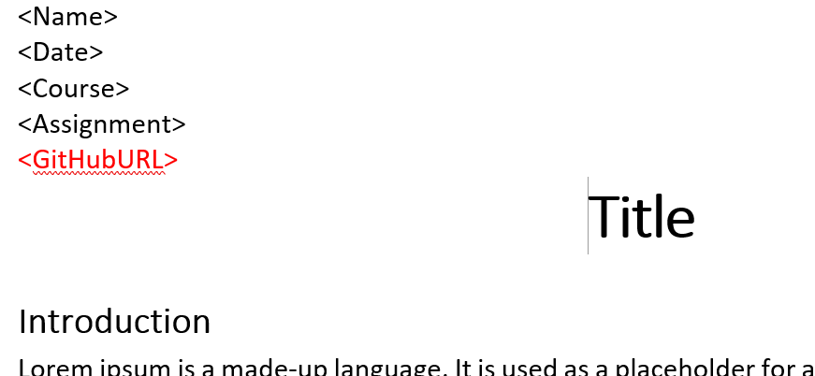

Figure 2. Adding your GitHub URL to your Word document

## Submit your work

Even though you have posted your file on GitHub, **you still need to submit them as a Canvas assignment** for grading. So, place your document and SQL script in the Assignment06 folder. Zip this folder into a ".zip" file, then upload the .zip file to the class assignment page.

***Important:***

*1.* ***Upload*** *your work* ***to the Canvas*** *assignment's as a* ***Zip file****.*

*2.* ***Post*** *a link to your GitHub site* ***on the******assignment textbox****.*

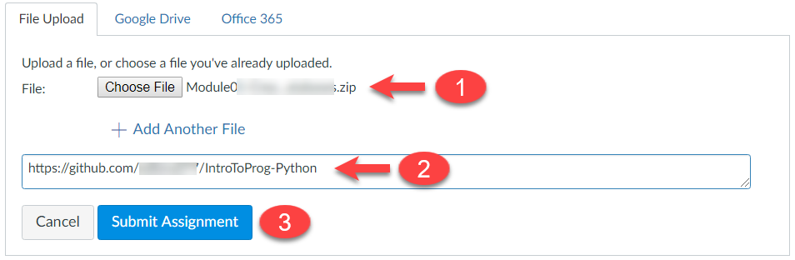

# Perform a Peer Review (Not Graded!)

After you have posted your link to GitHub and submitted your assignment, go to the "Module07 GitHub Links" discussion board and **select another student's post and review.** Follow the link they posted and review their files on GitHub. **This is an informal review** that **does** **not affect** either your or their **grade**. **Try to pick someone's link that has NOT been reviewed yet, even if you have to wait a few days for one to appear!**

NOTES:

* **Post** your comments as a reply to their posting so the review will be nested under the other student's posting.
* **Make sure** to say **two things that you liked** about their work
* **Make sure** to say **one thing** **that could make the work better**

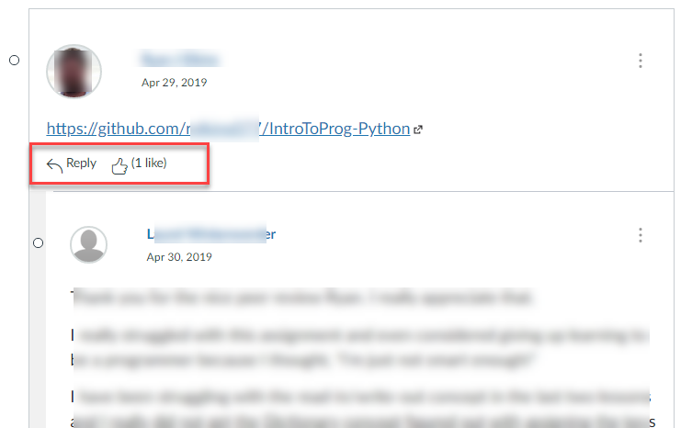

Figure. Doing a peer review