Assignment 07

In module 07, you learn about Functions. This assignment will reinforce your knowledge as you perform the follow steps:

1. Watch the course videos
2. Read web articles and perform their examples.
3. Watch Course Videos
4. Write SQL Code.
5. Write a Document.
6. Post to GitHub.
7. Create a GitHub WebPage.
8. Submit Your Work.
9. Perform a Peer Review

This activity will take you about 6 to 8 hours, so plan accordingly!

# Watch the Course Videos

Please watch the following Videos:

1. Module 07 Zoom session (See Canvas)
2. [Module 07 Playlist](https://youtube.com/playlist?list=PLfycUyp06LG9wAGPKBZ7poKBcbDZrmXpi)

# Read Web articles

Please read the following web articles.

2 - Introduction to Transact SQL User-Defined Functions

1. [Table-valued functions in SQL](https://www.wiseowl.co.uk/blog/s347/table-valued-functions.htm)
2. [Simple (in-line) table-valued functions](https://www.wiseowl.co.uk/blog/s347/in-line.htm)
3. [Multi-Statement Table-Valued Functions](https://www.wiseowl.co.uk/blog/s347/multi-statement.htm)
4. [Limitations of table-valued functions](https://www.wiseowl.co.uk/blog/s347/limitations.htm)

1 - W3Schools.com's SQL Tutorial (*Just take a quick look at what is available*)

* [MySQL Functions](https://www.w3schools.com/sql/sql_ref_mysql.asp)
* [MS Access Functions](https://www.w3schools.com/sql/sql_ref_msaccess.asp)
* [SQL Server Functions](https://www.w3schools.com/sql/sql_ref_sqlserver.asp)
* [SQL Null Functions](https://www.w3schools.com/sql/sql_isnull.asp)

# Write SQL Code

Run the code found in the Assignment07.sql file to create a simple database for this assignment.

**Note:** Make sure to change the name of the database to include your name.

Locate the Question and Answers section at the bottom of the file and create SQL code that will answer the questions. (Full points are only given if your code is well-formatted, consistent, and produces the same result!)

* You must **use the** **BASE views for each table.**
* Remember that Inventory Counts are Randomly Generated. So, your counts may not match mine
* To make sure the Dates are sorted correctly, you can use Functions in the Order By clause!

To help you, here are the results you want.

-- Question 1 (5% of pts):

-- show a list of Product names and the price of each product.

-- Use a function to format the price as US dollars.

-- Order the result by the product name.

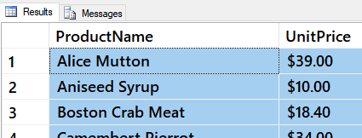

Figure 1: Results of Question 1

-- Question 2 (10% of pts):

-- Show a list of Category and Product names, and the price of each product.

-- Use a function to format the price as US dollars.

-- Order the result by the Category and Product.

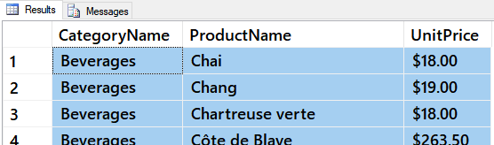

Figure 2: Results of Question 2

-- Question 3 (10% of pts):

-- Use functions to show a list of Product names, each Inventory Date, and the Inventory Count.

-- Format the date like 'January, 2017'.

-- Order the results by the Product and Date.

Figure 3: Results of Question 3

-- Question 4 (10% of pts):

-- CREATE A VIEW called vProductInventories

-- Shows a list of Product names, each Inventory Date, and the Inventory Count.

-- Format the date like 'January, 2017'.

-- Order the results by the Product and Date. (Note: The result is the same as the previous question)

-- Check that it works: Select * From vProductInventories;

Figure 4: Results of Question 4

-- Question 5 (10% of pts):

-- CREATE A VIEW called vCategoryInventories.

-- Shows a list of Category names, Inventory Dates, and a TOTAL Inventory Count BY CATEGORY.

-- Format the date like 'January, 2017'.

-- Order the results by the Category and Date.

-- Check that it works: Select * From vCategoryInventories;

Figure 5: Results of Question 5

-- Question 6 (15% of pts):

-- CREATE ANOTHER VIEW called vProductInventoriesWithPreviouMonthCounts.

-- Show a list of Product names, Inventory Dates, Inventory Count, AND the Previous Month Count.

-- Use functions to set any January NULL counts to zero.

-- Order the results by the Product and Date.

-- This new view must use your vProductInventories view.

Figure 6: Results of Question 6

-- Question 7 (15% of pts):

-- CREATE a VIEW called vProductInventoriesWithPreviousMonthCountsWithKPIs.

-- Show columns for the Product names, Inventory Dates, Inventory Count, Previous Month Count.

-- The Previous Month Count is a KPI. The result can show only KPIs with a value of either 1, 0, or -1.

-- Display months with increased counts as 1, same counts as 0, and decreased counts as -1.

-- Varify that the results are ordered by the Product and Date.

-- Important: This new view must use your vProductInventoriesWithPreviousMonthCounts view!

-- Check that it works: Select * From vProductInventoriesWithPreviousMonthCountsWithKPIs;

Figure 7: Results of Question 7

-- Question 8 (25% of pts):

-- CREATE a User Defined Function (UDF) called fProductInventoriesWithPreviousMonthCountsWithKPIs.

-- Show columns for the Product names, Inventory Dates, Inventory Count, the Previous Month Count.

-- The Previous Month Count is a KPI. The result can show only KPIs with a value of either 1, 0, or -1.

-- Display months with increased counts as 1, same counts as 0, and decreased counts as -1.

-- The function must use the ProductInventoriesWithPreviousMonthCountsWithKPIs view.

-- Varify that the results are ordered by the Product and Date.

-- Check that it works:

Select * From fProductInventoriesWithPreviousMonthCountsWithKPIs(1);

Select * From fProductInventoriesWithPreviousMonthCountsWithKPIs(0);

Select * From fProductInventoriesWithPreviousMonthCountsWithKPIs(-1);

Figure 8: Results of Question 8

# Write a Document

Write a one-page document that articulates the answer to the following questions. Use at least one well-formed paragraph per question. Using only a sentence or two is fine, but it must make sense and be well-formed. (Please use MS Word or a compatible word processor)

1. Explain when you would use a SQL UDF.
2. Explain are the differences between Scalar, Inline, and Multi-Statement Functions.

# Post To GitHub

In this module, you need to **post** your files on a public **GitHub repository** so that others may review it. Please post **both your PDF document and your SQL file**.

***Note:*** *This module requires that you created a GitHub in Assignment 06! You can watch this video if you need help creating one:* [*https://youtu.be/Sk1_DU2ky48*](https://youtu.be/Sk1_DU2ky48) *.*

1. **Login** to <https://github.com> (*Make a new account if needed!*)

2. **Create** a new repository called **"*DBFoundations-Module07."***

3***.* Upload** both of your files to the repository.

4. **Commit** the changes to save your work.

***Important:*** *You are creating a* ***new GitHub repository*** *in assignment 7. Using a different repository gives you practice managing multiple repositories and* ***is part of the assignment****.*

# Create a GitHub Webpage

You need to **add a GitHub webpage to your repository**. In this assignment, so you use the following code to get you started (Listing 1).

**Important:** GitHub made changes to the process of creating a web page. Please follow the instructions in this link:

<https://docs.github.com/en/pages/getting-started-with-github-pages/creating-a-github-pages-site>

# Module07 Website

---

[Google Homepage](https://www.google.com "Google's Homepage")

[GitHub Webpage Code CheatSheet](https://github.com/adam-p/markdown-here/wiki/Markdown-Cheatsheet)

There is much information on the Internet about the Markdown language, but you should find all you need for this course on this one webpage: <https://help.github.com/en/github/writing-on-github/basic-writing-and-formatting-syntax>

***Important:*** *Learning to use Markdown and Jekyll could well be the topic of a complete course, but in this course, you do NOT need to know much about Markdown programming. Please use only the basics shown in this module instead of more advanced features, and* ***do not worry about getting the format perfect!***

# Post a Link to GitHub

You will share your work using the Canvas discussion board called **Module07 GitHub Links**. To do so, you must create a post with a link to your GitHub site. Other students will use this link to perform a peer review.

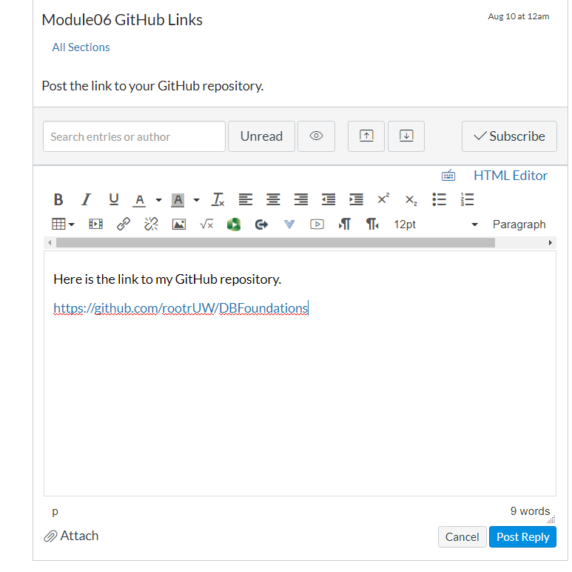

Figure: Posting a link to your GitHub repository

***Important:***

1. *Post only on the special discussion board called "Module06 GitHub Links"*
2. *Please copy and paste the URL for your new GitHub site into your MS Word knowledge document (Figure 2). This make grading a lot easier and is a big help! Thanks!!*

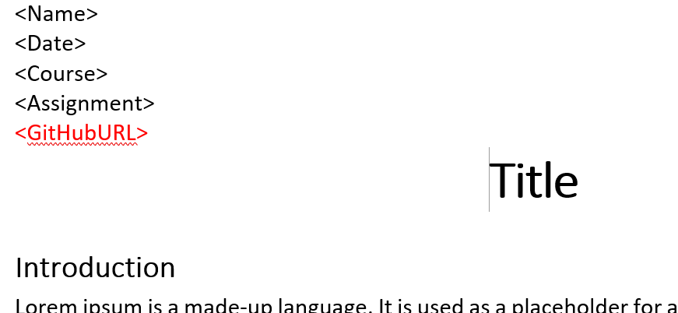

Figure: Adding your GitHub URL to your Word document

# Submit Your Work

Even though you have posted your file on GitHub, you still need to submit them as a Canvas assignment for grading. So, place your document and SQL script in the Assignment06 folder. Zip this folder into a ".zip" file, then upload the .zip file to the class assignment page.

***Important:***

*1.* ***Upload*** *your work* ***to the Canvas*** *assignment's as a* ***Zip file****.*

*2.* ***Post*** *a link to your GitHub site* ***on the******assignment textbox****.*

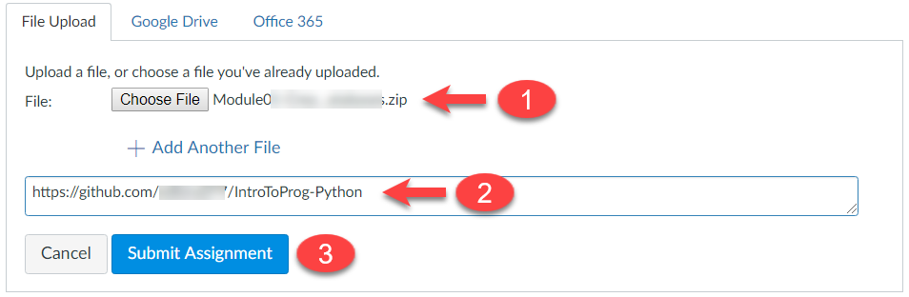

Figure: Submitting your zip file to Canvas

# Perform a Peer Review (Not Graded!)

After you have posted your link to GitHub and submitted your assignment, go to the "Module07 GitHub Links" discussion board and **select another student's post and review.** Follow the link they posted and review their files on GitHub. **This is an informal review** that **does** **not affect** either your or their **grade**. **Try to pick someone's link that has NOT been reviewed yet, even if you have to wait a few days for one to appear!**

NOTES:

* **Post** your comments as a reply to their posting so the review will be nested under the other student's posting.
* **Make sure** to say **two things that you liked** about their work
* **Make sure** to say **one thing** **that could make the work better**

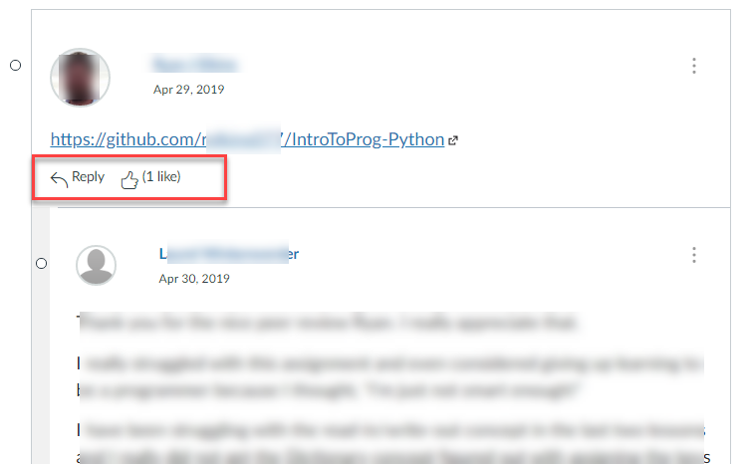

Figure. Doing a peer review

You are done!