**Name: Amar Dagaura, ID: 210129**

1. Text

   Description automatically generatedGraphical user interface, text, website

   Description automatically generatedNetcat Prot scanning
2. 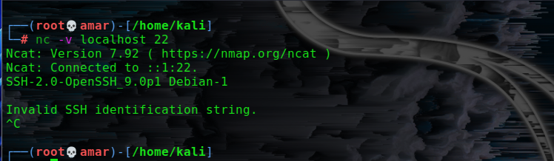banner grabbing
3. 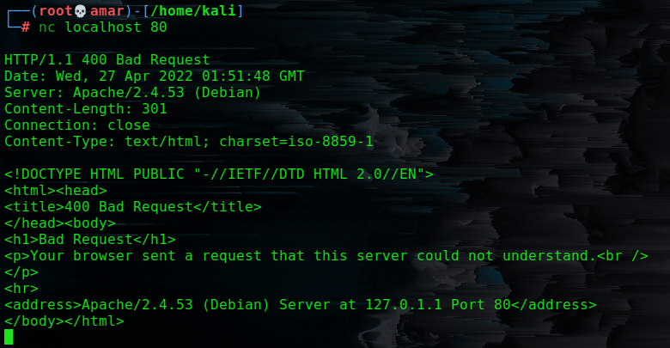web server banners HTTP/1.0 200
4. 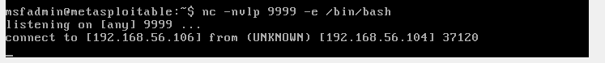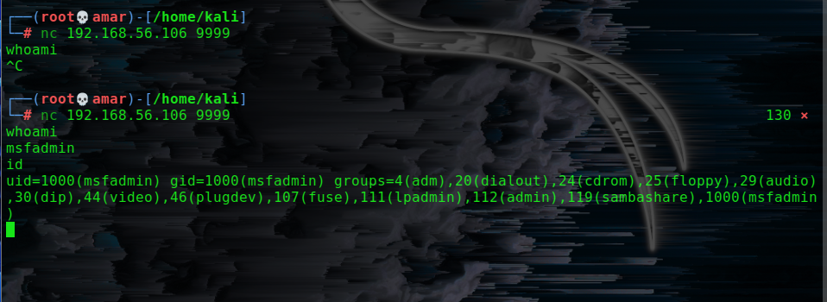Bind shell
5. 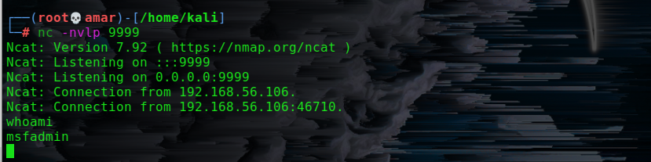reverse shell
6. 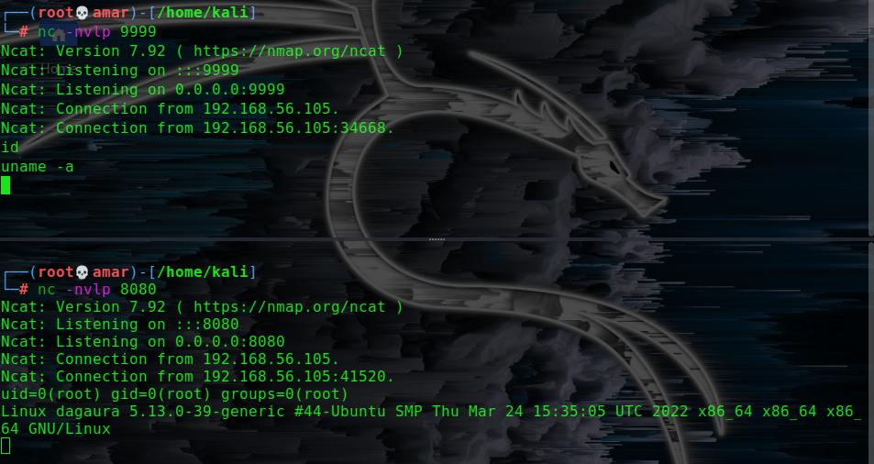what if no -e option
7. 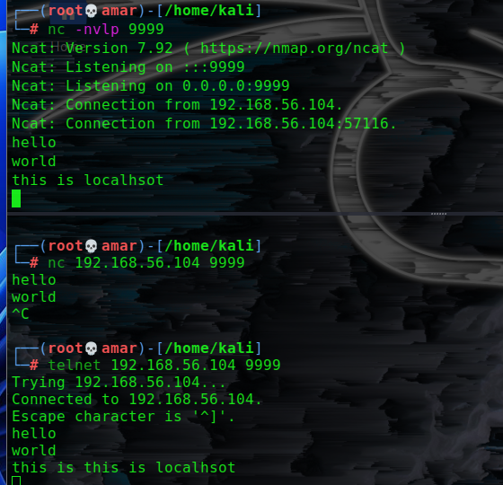what if no netcat in the target machine
8. 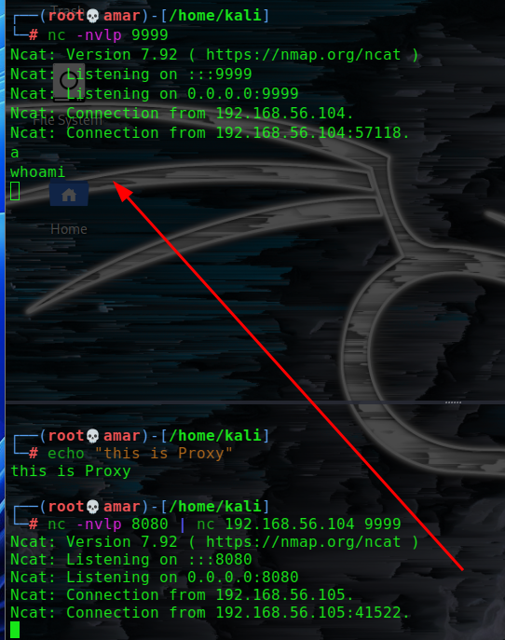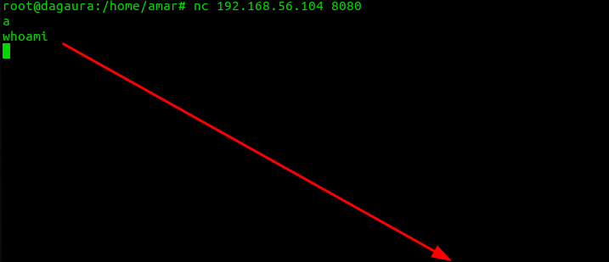proxy relay using netcat