The repo is committed and the remote is configured. To push, run this
in the terminal:

! cd /media/Shared/sharedcloud/projects/simpath/ver-4 && git push -u
origin main

Git will prompt for your GitHub username (rooz5002) and password — use
a Personal Access Token (not your GitHub password). To generate one:

1. Go to https://github.com/settings/tokens/new
2. Select scope: repo (full control)
3. Generate and copy the token
4. Paste it when git asks for password

---
What was set up:
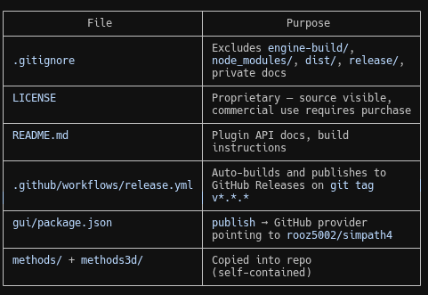

For auto-update to work, add one GitHub Actions secret after you push:
- Go to github.com/rooz5002/simpath4 → Settings → Secrets → Actions
- Add SIMPATH_HMAC_SECRET with your production secret value

To release a new version:
git tag v0.2.0
git push --tags
GitHub Actions will build the AppImage and create a release. The
running app will detect and install it on next startup.

