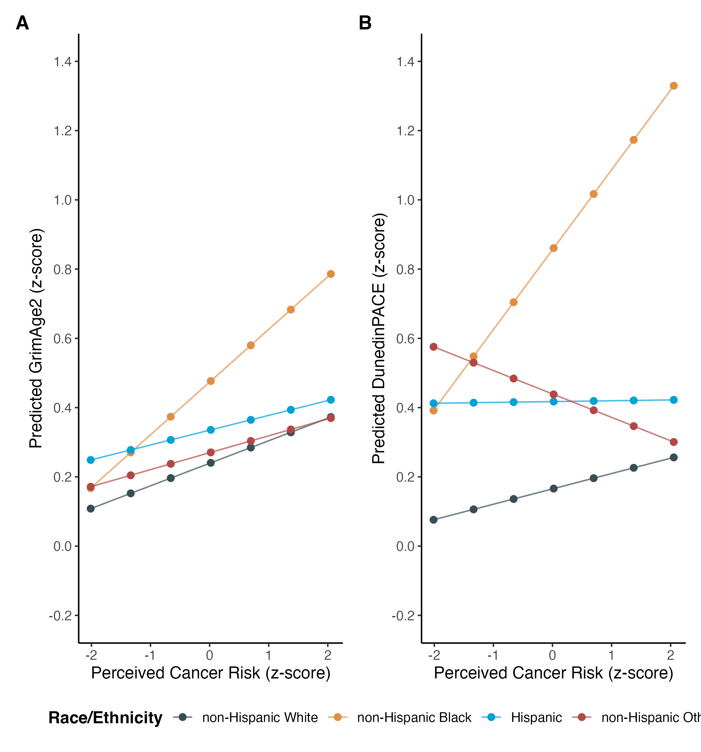
Figure 1: Differential association between perceived cancer risk and aging outcomes by race/ethnicity among middle-aged adults, Midlife United States study.

