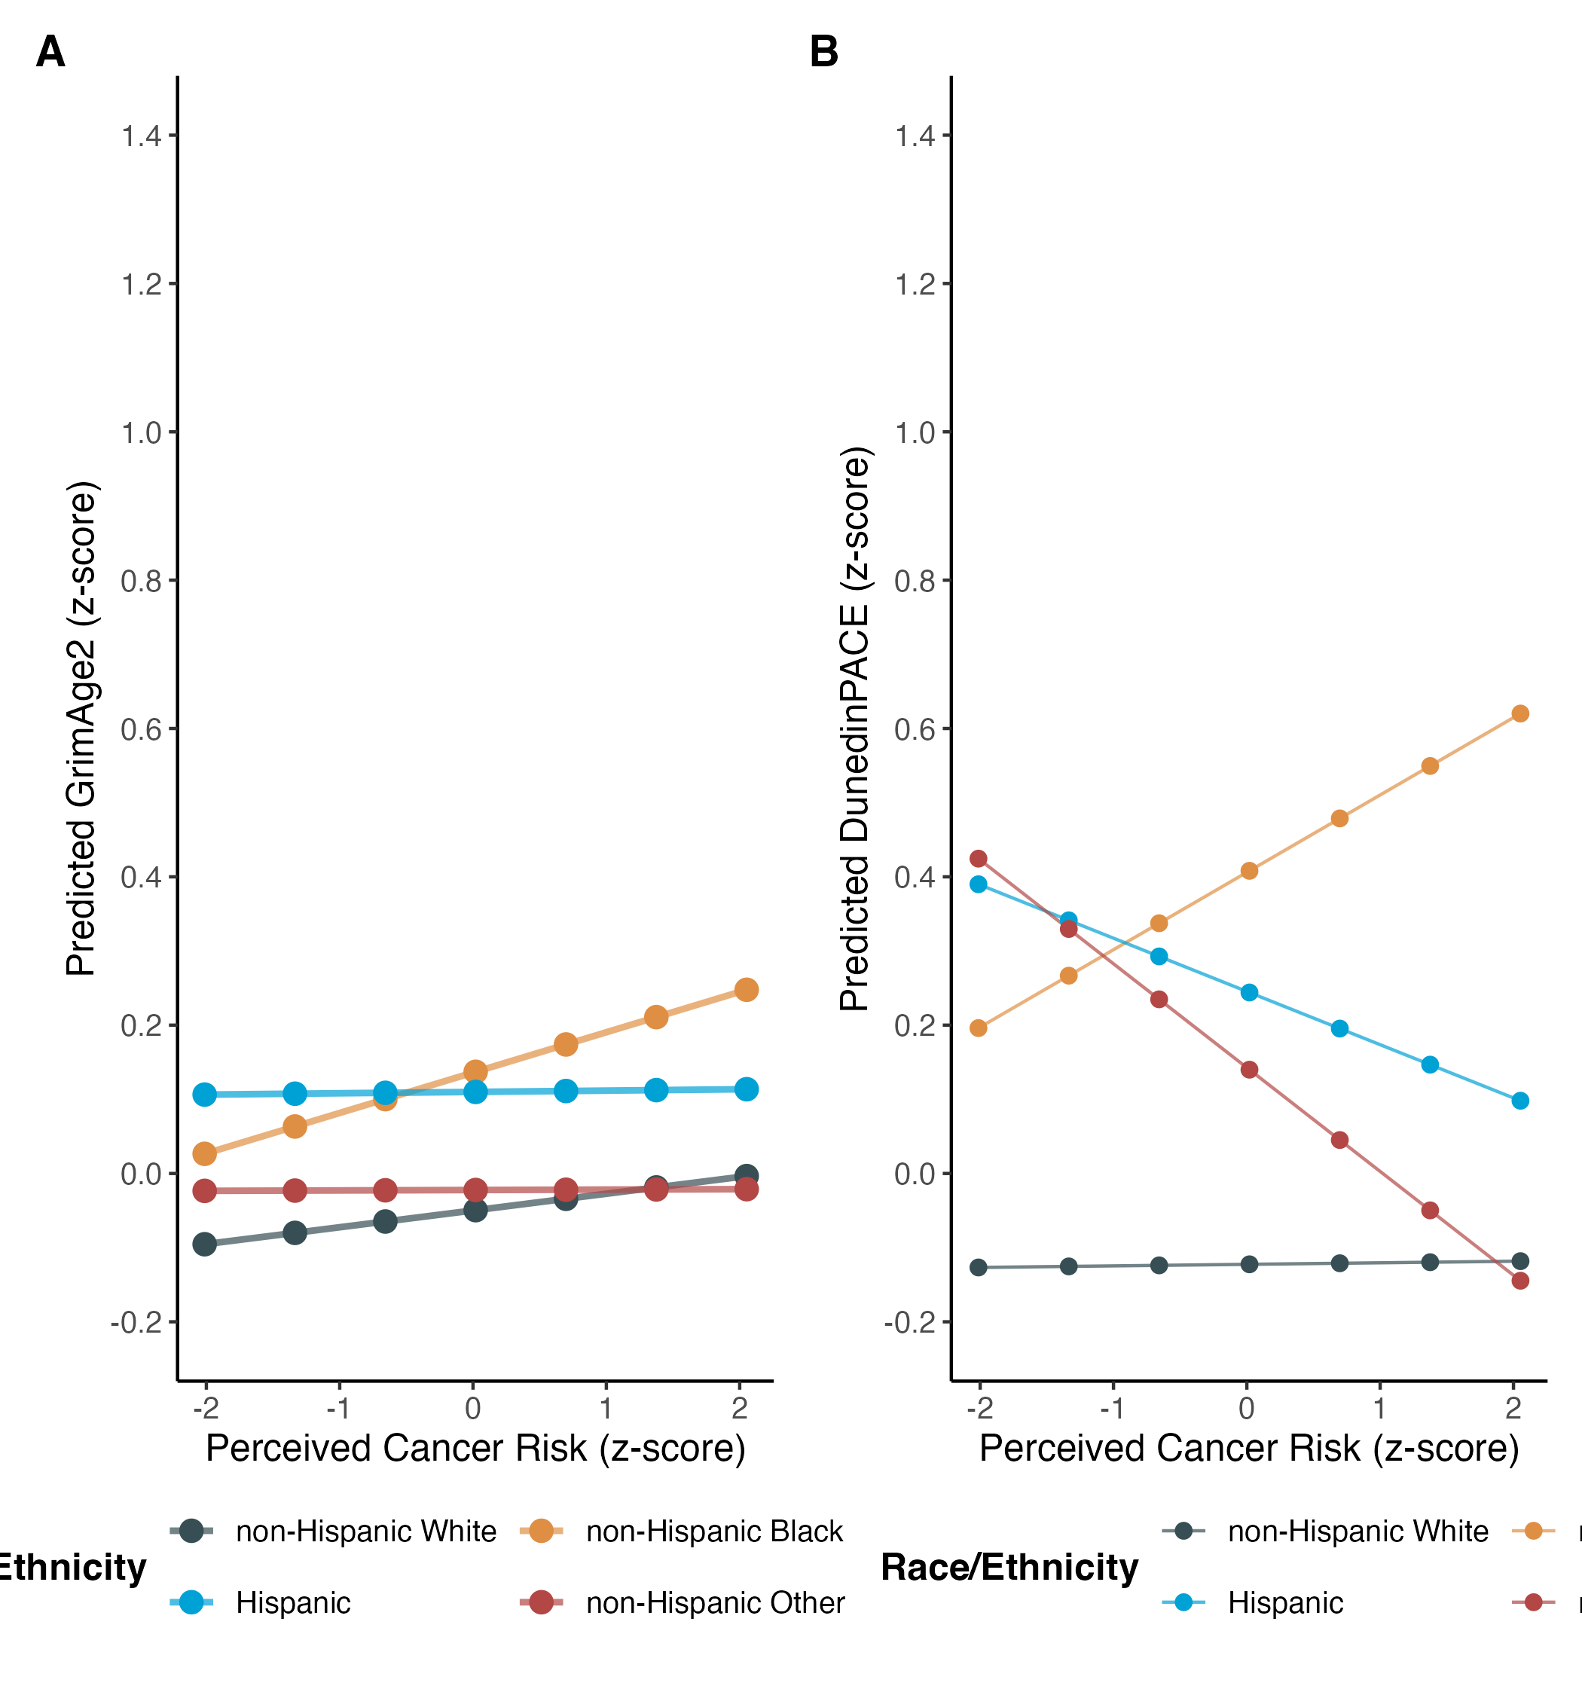
Figure 2: Differential association between perceived cancer risk and aging outcomes by race/ethnicity among middle-aged adults with lifestyle considerations, Midlife United States study.

