# Requirements

To develop a python code for execute OCR on provided image and then parse the data into specified formats:

## Input

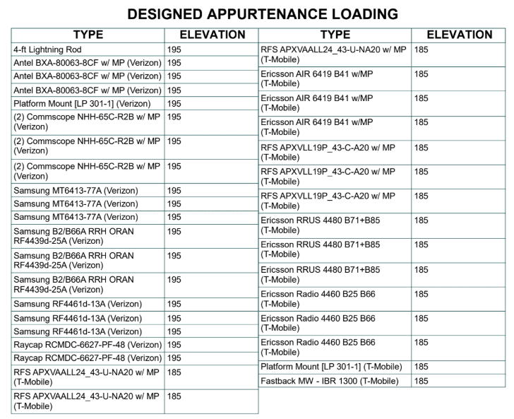

The data from the 3rd (“TYPE”) and 4th (“ELEVATION”) columns (if present) will be appended to the end of the list from the 1st and 2nd columns.

## Output

Excel AND JSON

If no (X) in front of it, then Qty = 1

# Deliverable:

Complete working Python code

More Sample Images:

