R11 1
R12 1
R11 1
R12 1
clc;
clear;
%Variables
% N = Neutral : White
% L = Left : Red
% R = Right : Blue
fs = 200; % sesuai ganglion pakai 200Hz
% ambil data dan buang N pertama (pemanasan)

R11
load('D:\Jaler\OpenBCI_GUI\_DataSkripsi\R11.txt'); data_raw = R11;

R12
load('D:\Jaler\OpenBCI_GUI\_DataSkripsi\R12.txt');
data_raw = R12;
% step 2. Notch 50Hz
[b,a] = butter(2,[49 51]/(fs/2), 'stop');
% bandpass Filter
[d,c] = butter(2,[0.5 50]/(fs/2), 'bandpass');
for i=1:4
data_raw(:,i)=filter(b,a,data_raw(:,i));
data_raw(:,i)=filter(d,c,data_raw(:,i));
end
for i=1:4

R11
% N{i} = [{data_raw(1616:2222,i)};{data_raw(3238:4053,i)};{data_raw(5065:5673,i)};...
% {data_raw(6691:7492,i)};{data_raw(8504:9106,i)}];
% L{i} = [{data_raw(607:1615,i)};{data_raw(4054:5064,i)};{data_raw(7493:8503,i)}];
% R{i} = [{data_raw(2223:3237,i)};{data_raw(5674:6690,i)};{data_raw(9107:10123,i)}];

R12
N{i} = [{data_raw(1616:2224,i)};{data_raw(3242:4045,i)};{data_raw(5059:5665,i)};...
{data_raw(6679:7482,i)};{data_raw(8498:9102,i)}];
L{i} = [{data_raw(607:1621,i)};{data_raw(4046:5058,i)};{data_raw(7483:8497,i)}];
R{i} = [{data_raw(2225:3241,i)};{data_raw(5666:6678,i)};{data_raw(9103:10113,i)}];
end
for i=1:4
n{1,i} = N{1,i}{1,1}(1:400,1);
n{2,i} = N{1,i}{1,1}(201:600,1);
n{3,i} = N{1,i}{2,1}(1:400,1);
n{4,i} = N{1,i}{2,1}(201:600,1);
n{5,i} = N{1,i}{2,1}(401:800,1);
n{6,i} = N{1,i}{3,1}(1:400,1);
n{7,i} = N{1,i}{3,1}(201:600,1);
n{8,i} = N{1,i}{4,1}(1:400,1);
n{9,i} = N{1,i}{4,1}(201:600,1);
n{10,i} = N{1,i}{4,1}(401:800,1);
n{11,i} = N{1,i}{5,1}(1:400,1);
n{12,i} = N{1,i}{5,1}(201:600,1);
l{1,i} = L{1,i}{1,1}(1:400,1);
l{2,i} = L{1,i}{1,1}(201:600,1);
l{3,i} = L{1,i}{1,1}(401:800,1);
l{4,i} = L{1,i}{1,1}(601:1000,1);
l{5,i} = L{1,i}{2,1}(1:400,1);
l{6,i} = L{1,i}{2,1}(201:600,1);
l{7,i} = L{1,i}{2,1}(401:800,1);
l{8,i} = L{1,i}{2,1}(601:1000,1);
l{9,i} = L{1,i}{3,1}(1:400,1);
l{10,i} = L{1,i}{3,1}(201:600,1);
l{11,i} = L{1,i}{3,1}(401:800,1);
l{12,i} = L{1,i}{3,1}(601:1000,1);
r{1,i} = R{1,i}{1,1}(1:400,1);
r{2,i} = R{1,i}{1,1}(201:600,1);
r{3,i} = R{1,i}{1,1}(401:800,1);
r{4,i} = R{1,i}{1,1}(601:1000,1);
r{5,i} = R{1,i}{2,1}(1:400,1);
r{6,i} = R{1,i}{2,1}(201:600,1);
r{7,i} = R{1,i}{2,1}(401:800,1);
r{8,i} = R{1,i}{2,1}(601:1000,1);
r{9,i} = R{1,i}{3,1}(1:400,1);
r{10,i} = R{1,i}{3,1}(201:600,1);
r{11,i} = R{1,i}{3,1}(401:800,1);
r{12,i} = R{1,i}{3,1}(601:1000,1);
end
for i=1:4
n_cat{i} = cat(2,n{:,i});
n_mean{i} = mean(n_cat{i},2);
l_cat{i} = cat(2,l{:,i});
l_mean{i} = mean(l_cat{i},2);
r_cat{i} = cat(2,r{:,i});
r_mean{i} = mean(r_cat{i},2);
end
lw = 3;
figure(1);
title('Focus Putih - R12');
hold on
plot(n_mean{1},'color',[1, 0.364, 0.337],'linewidth',lw);
plot(n_mean{2},'color',[1, 0.776, 0.254],'linewidth',lw);
plot(n_mean{3},'color',[0.654, 0.823, 0],'linewidth',lw);
plot(n_mean{4},'color',[0.227, 0.760, 0.917],'linewidth',lw);
legend('CH1','CH2','CH3','CH4')
hold off
figure(2);
title('Focus Merah - R12');
hold on
plot(l_mean{1},'color',[1, 0.364, 0.337],'linewidth',lw);
plot(l_mean{2},'color',[1, 0.776, 0.254],'linewidth',lw);
plot(l_mean{3},'color',[0.654, 0.823, 0],'linewidth',lw);
plot(l_mean{4},'color',[0.227, 0.760, 0.917],'linewidth',lw);
hold off
legend('CH1','CH2','CH3','CH4')
figure(3);
title('Focus Biru - R12');
hold on
plot(r_mean{1},'color',[1, 0.364, 0.337],'linewidth',lw);
plot(r_mean{2},'color',[1, 0.776, 0.254],'linewidth',lw);
plot(r_mean{3},'color',[0.654, 0.823, 0],'linewidth',lw);
plot(r_mean{4},'color',[0.227, 0.760, 0.917],'linewidth',lw);
hold off
legend('CH1','CH2','CH3','CH4')
snapnow
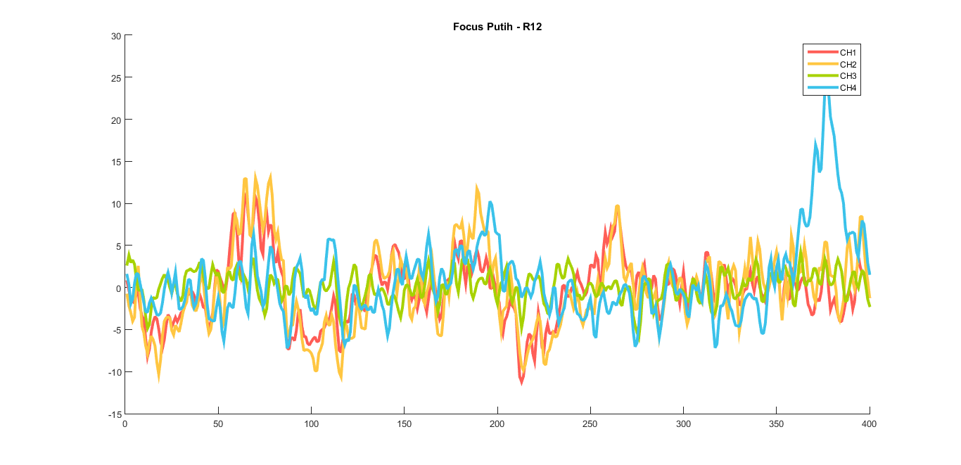
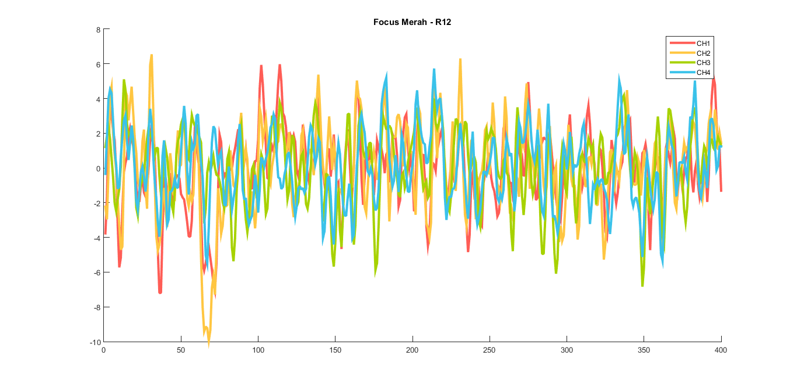
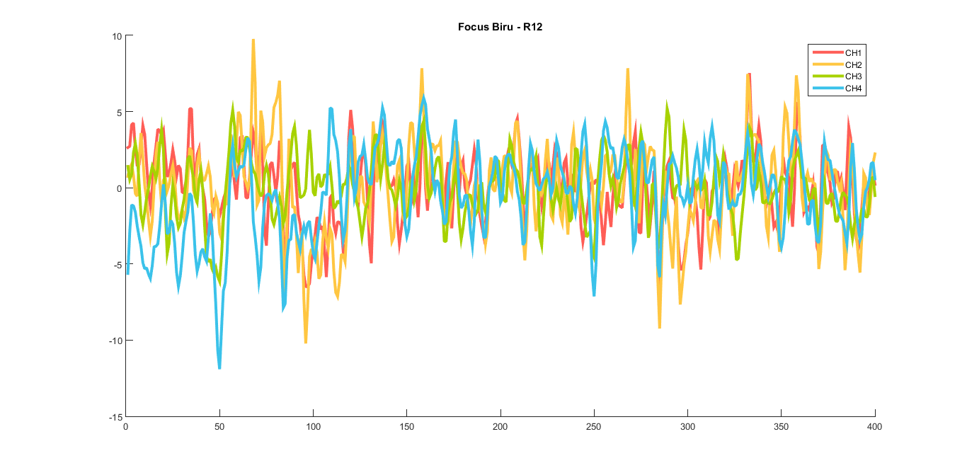
Published with MATLAB® R2015a

