Recommendation Letter
Date: 2-1-2025
To: Turkish Scholarship Committee
Subject: Scholarship Recommendation for Noor Abu Maileq
Dear Members of the Scholarship Committee,
Greetings,
I am writing to you as Jamalat Hammada, an engineer supervising the Summer Vocational Camp, where I train youth in web applications and technical skills. During my work at the camp, I met the outstanding student Noor Abu Maileq, whom I consider one of the most ambitious young women I have worked with. I strongly recommend her for a scholarship to pursue higher education in Interior Design in Turkey.
Academic and Practical Excellence:
Noor participated in the web applications section of the camp and demonstrated remarkable proficiency in technical tools. For her final project, she designed a simple website showcasing Palestinian heritage, combining aesthetic and functional elements to present history and culture interactively. She used innovative programming tools and engaging visual materials, highlighting her ability to innovate under time and resource constraints.
Leadership and Community Impact:
Beyond her technical skills, Noor possesses inspiring leadership qualities. She organized workshops to enhance girls’ digital design skills and raised awareness of Palestinian heritage by presenting her project to the local community. She also volunteered to help peers improve their projects, reflecting her collaborative spirit and commitment to teamwork.
Motivation and Ambition:
Noor aspires to specialize in Interior Design, aiming to integrate modern technology with cultural identity preservation in her designs. She believes studying in Turkey will provide her a unique opportunity to explore the blend of contemporary and heritage-inspired design, a hallmark of Turkish universities.
Why Turkey?
Noor chose Turkey due to its pioneering role in interior design that harmonizes culture and modernity, aligning with her passion for preserving heritage through design. She also hopes to join research projects focused on sustainable and socially impactful design.
In conclusion, I am confident that Noor will enrich Turkey’s academic community and return with expertise to bridge Palestinian heritage and global design. For further inquiries, please contact me at:
jam-hamada@hotmail.com
+9732598283202
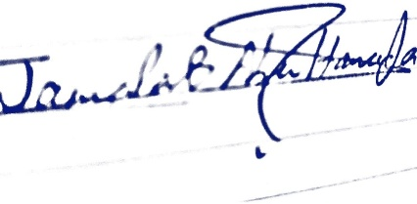
Sincerely,
Jamalat Hammada
Engineer and Supervisor at Summer Vocational Camp

