# Product/Service Marketplace

# Competitors

## African Drought Monitoring and Advisory (ADMA)

African Drought Monitoring and Advisory (ADMA) is a near-real-time system that uses Earth Observation and Weather information to monitor drought condition in Africa (African Drought Monitoring and Advisory, 2024).

Website link: <https://ada.acmad.org/>

The advantages of ADMA are:

* Near-real-time Monitoring
* Integration of multiple data sources
* Visualization Tools
* Easy access using Web based Interface.
* Covers 54 countries.
* Easy to use interface.

Disadvantages of ADMA are:

* Experimental AI Incorporation.
* No Visualization for AI

## African Flood and Drought Monitoring

The African Flood and Drought Monitor (AFDM) is a sophisticated system developed by the Princeton Climate Institute (PCI) in collaboration with the University of Southampton and Princeton University. It aims to provide early warning for flood and drought conditions across Africa. The system utilizes a combination of ground observations, satellite data, and modelled datasets to generate real-time hydrological assessments and forecasts (African Flood and Drought Monitor, 2024). PCI also offers other drought monitoring services covering other areas of Africa, such as the South Africa Flood and Drought Monitor (SAFDM).

Website link: <https://hydrology.soton.ac.uk/apps/afdm/>

The Advantages of AFDM:

Early Warning

* Comprehensive Data Integration: combining ground observations, satellite data, and modelled datasets.
* Real-Time Updates: The system is operational and updated daily, albeit slightly behind real-time, ensuring timely information for decision-making.
* High Resolution: The use of a 5km resolution hydrological model allows for detailed assessments of streamflow and hydrological conditions.
* Seasonal Forecasting.
* Bias Correction: Bias correction techniques are applied to remove any biases from the climate forecast model, improving the accuracy of forecasts.
* Probability Estimates.

The Disadvantages of AFDM:

* Operational Lag: The system operates with a slight delay of 1-2 days behind real-time, which may impact the timeliness of response for urgent situations.
* Limited user configurability.
* No AI

# ICPAC

ICPAC is a service that provides climate services to easter Africa (ICPAC, 2024).

Website link: <https://eahazardswatch.icpac.net/map/ea/?mainMap=eyJzaG93QW5hbHlzaXMiOnRydWV9&map=&mapMenu=eyJtZW51U2VjdGlvbiI6ImRhdGFzZXRzIiwiZGF0YXNldENhdGVnb3J5IjoiQWdyaWN1bHR1cmUifQ%3D%3D>

The Advantages of ICPAC:

* Weekly Forecasting
* Monthly Forecasting
* Seasonal Forecasting
* Climate monitoring
* Food Security Statements
* Visualization analysis
* User Friendly Interface
* User configurability

Disadvantages:

* Beta version.

# Target Market

The product we are offering is a web base drought monitoring system tailored for farmers, policymakers, and other stakeholders to track drought conditions. It is distinguished using AI algorithms to process and analyse gathered data and employing AI machine learning models to interpret both sensor-based and remote sensing data. This enables the system to monitor and forecast agricultural land fertility and productivity effectively.

Our product is mainly targeting farmers, policymakers, and other stakeholders. However, it would be beneficial to understand our competitors target audience to gain insight. Figure 1 shows the target audience of each of the competitors. ADMA partners are ACMAD, European Commission, Norwegian Capacity, IGAD (African Drought Monitoring and Advisory, 2024). ICPAC partners where European Commission, African development bank group, Norwegian refugee council, Met Office, NASA harvest (ICPAC, 2024). African Flood and Drought Monitor has the following funding support form UNESCO Internation Hydrology Programme (IHP) and International Centre for Integrated Water Resources Management (ICIWaRM) (United Nations, 2024). Relevant partners discovered during the market analysis was between competitors where EU, and Norwegian refugee council. The partners of each competitor can be grouped in the following areas: farmers, research and institutions, policymakers, governments, banks, and world health unions.

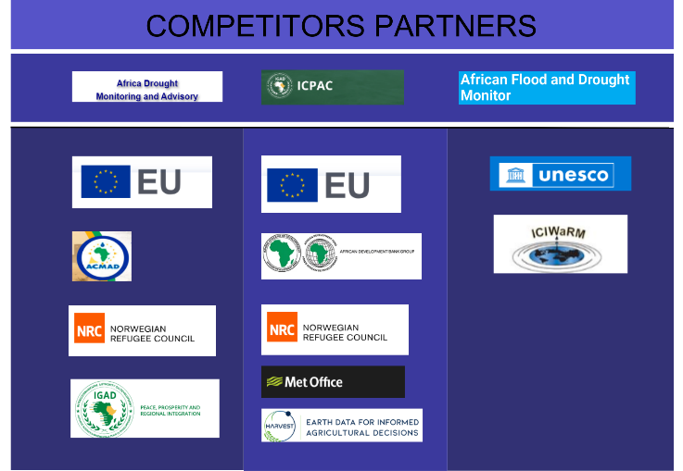

## Condition

The market condition is proven fruitful since each competitor have more than one partner/sponsor. Some sponsors are members of government, banks, or even high market value organizations such as Nasa. The reason why members of high power are aiding in these systems is because drought has an impact on the condition of food supply, which is a necessity to human well-being.

## Demand

The demand for drought monitoring services also proves to be fruitful:

* The competitors are funded, an example would be African Drought Monitoring which is funded by UNESCO Internation Hydrology Programme (IHP) and International Centre for Integrated Water Resources Management (ICIWaRM) (United Nations, 2024).
* User off the systems require it to be effective in their career, the users of ICPAC said this:
  + “We really appreciate ICPAC timely forecasts. The monthly and seasonal forecasts are especially relevant to us to advise farmers” (ICPAC, 2024).
  + Another user in BBC Media Action stated this: “ICPAC has been very instrumental in breaking down weather information for our media partners using simplified visuals like maps and icons. This has in turn helped our media partners to better understand how to communicate and package weather and climate content to the end users. (ICPAC, 2024)”
* Government relies on these types of systems to predict drought, to effectively recover and prepare for these natural occurrences, for example African Drought Monitoring which is funded by UNESCO (which is an intergovernmental Hydrological Program) (United Nations, 2024).

The system we are proposing will be similar in functionality to the competitors mentioned with one critical distinction, the implementation of AI. With the use of AI algorithms to process and analyse gathered data and employing AI machine learning models to interpret both sensor-based and remote sensing data could prove to be an advantage because of more effective and fast analysis and use of the data.

# References

African Drought Monitoring and Advisory. 2024. Drought Situation in Africa. <https://ada.acmad.org/home#:~:text=ADMA%20is%20a%20near%2Dreal,monitor%20drought%20conditions%20in%20Africa>. Date of access: 27 April. 2024.

African Drought Monitoring and Advisory. 2024. Our Partners. <http://ada.acmad.org:8100/main/partners/> Date of access: 27 April. 2024.

African Flood and Drought Monitor. 2024. About. <https://hydrology.soton.ac.uk/apps/afdm/> Date of access: 27 April. 2024.

United Nations. 2024. <https://www.unccd.int/land-and-life/drought/toolbox/african-flood-and-drought-monitor> Date of access: 27 April. 2024.

ICPAC. 2024. Delivering Climate Services to Eastern Africa. <https://www.icpac.net/> Date of access: 27 April. 2024.