Assignment 03

肖阳 201918008629001

# 1

1. Firstly, sort the positions of bananas and the positions of monkeys. It’s not hard to find out that assigning the monkey with the maximum index to the banana with the maximum index must be involved in the best solution of minimize the time. Assume T(i) is the time it takes to assign the monkey at index i to the banana at index i , and OPT(n) is the minimized time it takes to assign the n monkeys to n bananas which are not assigned. So we get $OPT\left(N\right)=max⁡(OPT\left(N-1\right),T\left(N,N\right))$. Further, every monkey can be assign to the banana which is at the same index, and the minimum amount of time is the maximum $T(i,i)(1≤i≤N)$.

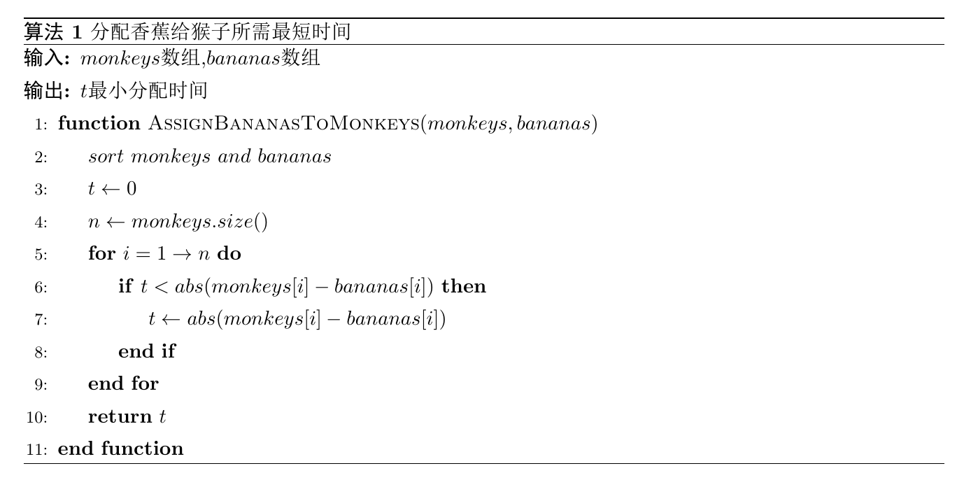

1. Assume two array bananas and monkeys are sorted.

**Greedy-choice property**: We only need to assign every monkey to the banana which has the same index as the monkey.

**Optimal structure**: $OPT\left(N\right)=max⁡(OPT\left(N-1\right),T(N,N))$

T(N,N) represent the time assigning monkey N to banana N cost.

1. **Prove the correctness**

Assume that OPT(N)=T(j,j) has a better value OPT’(N)=T(j,k) , where $1≤k<j≤N$, that means the monkey with index j is assigned to the banana with index k. There are two situations for the solution OPT’(N) :①T(j,k)<T(j,j), there must exist a monkey $t(1≤t<j)$, so that T(t,j)>T(j,j)>T(j,k), contradiction occur! ②T(j,k)>T(j,j), that means banana k is not the best choice to monkey j, contradiction occur! In sum, the correctness is proved!

1. Time complexity: O(nlogn)

Space complexity: O(1)

# 2

1. Given that the supercomputer can only work on serial mode and the n PCs can be regarded as parallel operation, the best choice of each decision is to let PC to process the task i with the longest processing time $f_{i}$ on PC.

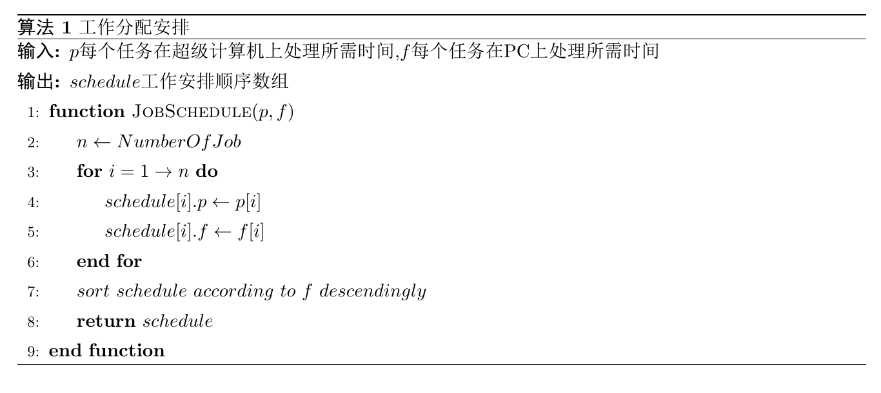

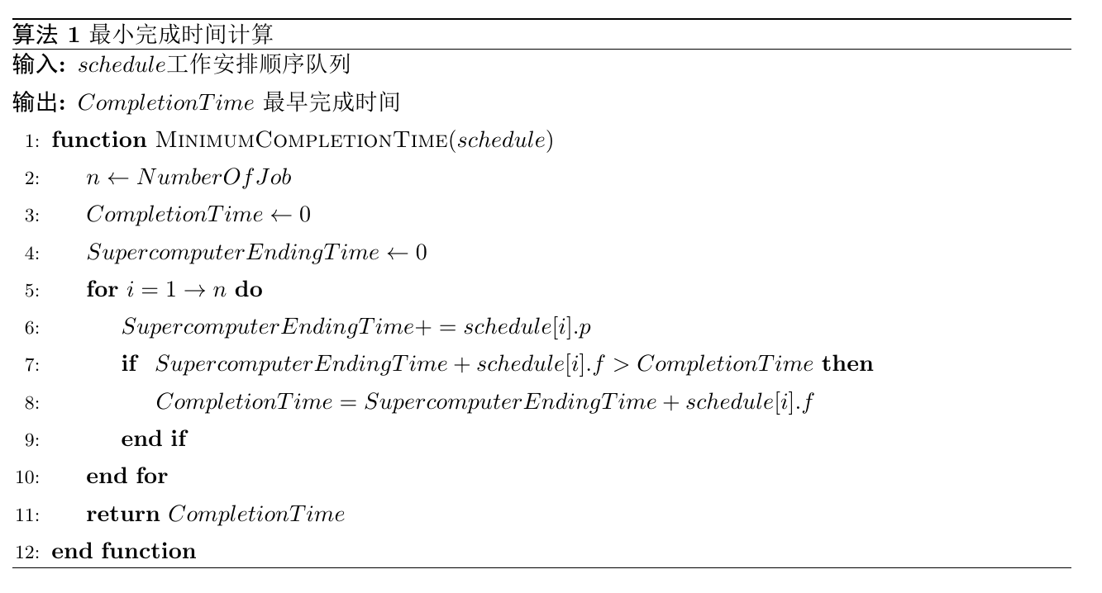

1. Assume the job queue is sorted according to PC processing time descendingly.

**Greedy-choice property**: We only need to choose the job from schedule queue with the longest PC processing time on each decision.

**Optimal structure**:

$$OPT\left(k\sim N\right)=max\left\{\begin{aligned}p_{top}+f_{top} \\ p_{top}+OPT((k+1)\sim N)\end{aligned}\right.$$

$p_{top}$ denotes the supercomputer processing time of the top job in schedule queue.

$f_{top}$ denotes the PC processing time of the top job in schedule queue.

$OPT\left(k\sim N\right)$ denotes the minimum completion time of the job set $\left\{k,…,N\right\},1≤k≤N$. and I use OPT(1~N) to represent the question.

Every job will be poped from the schedule queue after being processed by the supercomputer.

1. **Prove the correctness**

Assume we only have 2 job .First Job $J_{1}$ has $\{p_{1},f_{1}\}$, Second job $J_{2}$ has $\{p_{2},f_{2}\}$. Let $f_{1}>f_{2}$. If we start from $J_{2}$, and the completion time will be $p_{1}+p_{2}+f_{1}$. If we start from $J_{1}$ and the completion time will be $max\left\{\begin{aligned}p_{1}+f_{1} \\ p_{1}+p_{2}+f_{2}\end{aligned}\right.$. Obviously, starting from $J_{1}$ can complete the job earlier.

1. Time complexity: O(nlogn)

Space complexity: O(1)