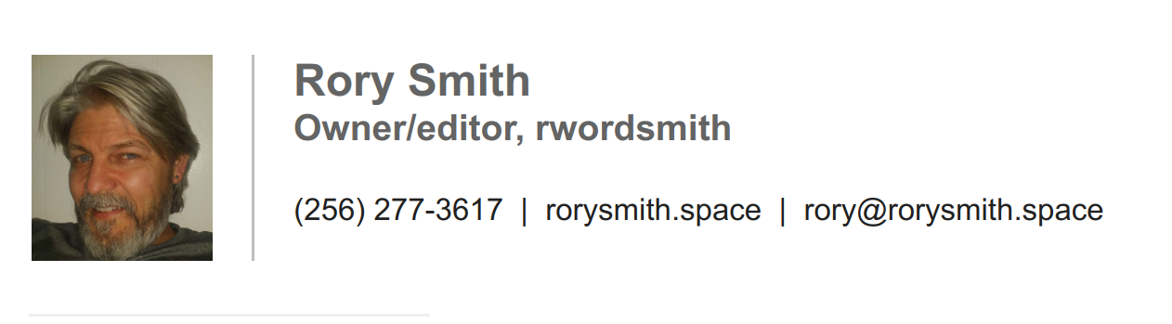  EXPERIENCE  RwordSmith – Online business  Freelance Business Owner  June 2022 to Present  I work online as a freelance writer, proofreader and editor with web hosting and design soon to follow.  After my mothers death in 2022, I moved back to Alabama to help my elderly father and am looking for part-time work until my freelance business picks up.  Uber driver – Las Vegas, NV  Independent Contractor  Feb 2019 to Jul 2021  Quit driving after I was hospitalized for COVID  in July of 2021  Dr. Rory Smith, Walmart optometrist – Pulaski, TN  googIndependent Contractor  Apr 2006 to Oct 2016  I quit working as an optometrist to pursue online freelance employment in web development but then my mother became ill so I put that on hold to be her caretaker in Las Vegas.  EDUCATION  Southern California College of Optometry – Fullerton, CA  BS in Vision Science and OD doctoral degree  Aug 1992 - May 1996  University of Nevada, Las Vegas – Las Vegas, NV  MONTH 20XX - MONTH 20XX | 1706 County Road 559  Rogersville, Al 35652  256 277-3617  rwordsmith@proton.me  SKILLS  Writing, editing, markdown, html, css and some javascript. Elementor and Wordpress design.

