REVATURE – 18-09-2023 COHORT

L3-ASSIGNMENT – **COBOL-DB2**

**Prepared by : Alwyn Micaiah T**

**TOUR – 3A**

Naming Convention:

PDS name: **HLQ.L3.TOUR.PDS**

DBRM name: **HLQ.L3.TOUR.DBRM**

LOADLIB name: **HLQ.L3.TOUR.LOADLIB**

**HLQ 🡪 Mainframe Userid.(OZAGS1)**

Member names:

JCL(VSAM) : JA01YYZZ

COMPILE JOB : COBCOMP

RUNJOB :JA03YYZZZ

COBOL MAIN PROGRAM MEM NAME: CA01YYZZ

SPUFI : SBXXYYZZ

DCLGEN :DCXXYYZZ

XX🡪 SEQUENCE NUMBER eg: 01,02,etc

YY🡪 QUESTION NUMBER . 3A as mentioned in line 4.

ZZ 🡪 The last 2 chars of your userid. Eg:”S1” if user id is OZAGS1.

* + DATABASE: as it is.
  + TABLESPACE: as it is.
  + PLAN: as it is.

The Tour Details System maintains the Tour related records in the database TOUR_DETAILS for the ease of access and maintenance. The system reads the list of guide, language and other tour details from the tour details data base and updates and maintains the required details accordingly. To make this optimized, perform these operations and achieve its requirements, develop the below modules:

**Note: Define the tables as per the naming convention instructed in the requirement. Do not prefix any values during the table creation.**

**DB2:**

1. Using SPUFI, create a table TOUR_DETAILS with the below columns, to store the tour details. Naming convention for SPUFI query member is **SB01YYZZ.** Member **should not contain** any **commented queries**.

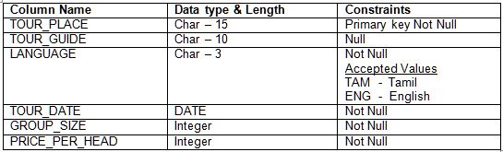

2.  Using SPUFI, create a table SEASON_DISCOUNT with the below columns, to store the Tour season details. Naming convention for SPUFI query member is **SB02yyyZZ.** Member **should not contain** any **commented queries**.

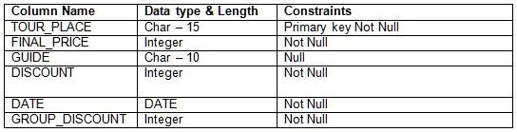

3.  Using SPUFI, insert the below sample values into the TOUR_DETAILS table. Naming convention for SPUFI query member is **SB02yyZZ. All Char field data to be inserted in CAPITAL letters & NULL** denotes null value to be inserted**.** Member **should not contain** any **commented queries**.

Sample Values:

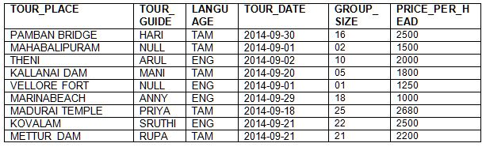

**COBOL:**

**Input:**                           **Data fetched from table** TOUR_DETAILS

**Output File:                  <HLQ>.L2.TOUR.PS, record length is 80**

**DD name to be used:**    **OUTTOUR**

**Output File:                  <HLQ>.L2.ODEL.PS, record length is 80**

**DD name to be used:**    **OUTODEL**

**Output Table:               SEASON_DISCOUNT   &   TOUR_DETAILS**

**Note: Please use only the above mentioned DD names. Do not use COPYBOOKs for declaring output file layout in COBOL program.**

Write a COBOL program to perform the below actions.

a. Using cursor, select the records - TOUR_PLACE, TOUR_GUIDE,LANGUAGE,TOUR_DATE, GROUP_SIZE and PRICE_PER_HEAD from the TOUR_DETAILS which GROUP_SIZE is greater than 1 & PRICE_PER_HEAD is greater than 1000.

b. For the fetched records, perform the following process

            i.    Using null value handling technique, verify whether the field TOUR_GUIDE holds any null value. If any null values present then do the below

a. Move **YTD** to TOUR-GUIDE field and write the record into **OUTODEL** in the below format ,

**NOTE: One space filler to be inserted between each field.**

https://assessment.cognizant.com/assessment/file.php?file=%2F326%2F2L_OCT14%2FLab2_2L_OCT14_5.JPG

b. Delete the same record from the table TOUR_DETAILS

For records without null values in TOUR_GUIDE field, continue the below processing.

           i.    Calculate DISCOUNT and FINAL_PRICE as follows.

DISCOUNT Calculation:

a)     If GROUP_SIZE = 5 then DISCOUNT calculation will be

DISCOUNT = PRICE_PER_HEAD * 0.01

b)    If GROUP_SIZE > 5 and <= 10 and LANGUAGE = “ENG” then

DISCOUNT = PRICE_PER_HEAD * 0.02

c)     If GROUP_SIZE > 10 and <=20 then

DISCOUNT = PRICE_PER_HEAD * 0.03

d)    If GROUP_SIZE > 20 and <= 30 and LANGUAGE = “ENG” then

DISCOUNT = PRICE_PER_HEAD * 0.018

e)     If GROUP_SIZE > 20 and <= 30 and LANGUAGE = “TAM” then

DISCOUNT = PRICE_PER_HEAD * 0.015

ii. FINAL_PRICE Calculation:

f)     If DISCOUNT >= 10 and < =20

FINAL_PRICE = PRICE_PER_HEAD – (GROUP_SIZE * DISCOUNT) -10

g)    If DISCOUNT > 20 and < =40

FINAL_PRICE = PRICE_PER_HEAD – (GROUP_SIZE * DISCOUNT) -12

h)     If DISCOUNT > 40 and < =50

FINAL_PRICE = PRICE_PER_HEAD – (GROUP_SIZE * DISCOUNT) -13

i)      If DISCOUNT > 50 and < 100

FINAL_PRICE = PRICE_PER_HEAD – (GROUP_SIZE * DISCOUNT) - 9

iii. Group discount calculation will be

GROUP_DISCOUNT = GROUP_SIZE * DISCOUNT

iv. Using the above calculated values namely DISCOUNT, FINAL_PRICE & GROUP_DISCOUNT along with TOUR_PLACE, TOUR_GUIDE, TOUR_DATE fetched from  TOUR_DETAILS, insert the values into the table SEASON_DISCOUNT.

v. Write the processed records in to the output file in the below format.

**NOTE: One space filler to be inserted between each field.**

https://assessment.cognizant.com/assessment/file.php?file=%2F326%2F2L_OCT14%2FLab2_2L_OCT14_6.JPG

**JCL:**

Compile and execute the above COBOL program.

**SPUFI:**

Naming convention for SPUFI query member is **SB04yyZZ.**  Member **should not contain** any **commented queries**.

Using SPUFI, write a select query to fetch the records with LANGUAGE as ENG and GROUP_SIZE greater than 10 from the two tables TOUR_DETAILS and SEASON_DISCOUNT using LEFT OUTER JOIN operation. Order the resultant table by TOUR_PLACE. Expected fields from the query are TOUR_PLACE, TOUR_GUIDE, LANGUAGE, TOUR_DATE, GROUP_SIZE, GROUP_DISCOUNT

**SPUFI:**

Naming convention for SPUFI query member is **SB05yyZZ.** Member **should not contain** any **commented queries**.

Using SPUFI, write a select query to fetch all the records from SEASON_DISCOUNT with which record is having DISCOUNT less than or equal to 20 with converting the TOUR_PLACE & GUIDE to lower case.