library(readr)  
maize_data <- read_csv("maize_data.csv")

##   
## -- Column specification --------------------------------------------------------  
## cols(  
## `Mycorrhizal treatment` = col_character(),  
## `Soil P addition treatment` = col_character(),  
## Combination = col_character(),  
## Rep = col_double(),  
## `aboveground biomass (g dry weight)` = col_double(),  
## `belowground biomass (g dry weight)` = col_double(),  
## `Root:shoot ratio` = col_double()  
## )

View(maize_data)  
glimpse(maize_data)

## Rows: 24  
## Columns: 7  
## $ `Mycorrhizal treatment` <chr> "Mycorrhizal", "Mycorrhizal", "My~  
## $ `Soil P addition treatment` <chr> "Low", "Low", "Low", "Low", "Low"~  
## $ Combination <chr> "ML", "ML", "ML", "ML", "ML", "ML~  
## $ Rep <dbl> 1, 2, 3, 4, 5, 6, 1, 2, 3, 4, 5, ~  
## $ `aboveground biomass (g dry weight)` <dbl> 7.5, 6.8, 5.3, 6.0, 6.7, 7.0, 12.~  
## $ `belowground biomass (g dry weight)` <dbl> 3.0, 2.4, 2.0, 4.0, 2.7, 3.6, 7.9~  
## $ `Root:shoot ratio` <dbl> 0.40, 0.35, 0.38, 0.67, 0.40, 0.5~

summary_table <- maize_data %>%   
 group_by(`Mycorrhizal treatment`,`Soil P addition treatment`) %>%   
 summarise(Mean = mean(`Root:shoot ratio`, na.rm = TRUE),  
 n = sum(!is.na(`Root:shoot ratio`)),  
 sd = sd(`Root:shoot ratio`, na.rm = TRUE),  
 SE = sd/sqrt(n))

## `summarise()` has grouped output by 'Mycorrhizal treatment'. You can override using the `.groups` argument.

summary_table

## # A tibble: 4 x 6  
## # Groups: Mycorrhizal treatment [2]  
## `Mycorrhizal treatment` `Soil P addition treatment` Mean n sd SE  
## <chr> <chr> <dbl> <int> <dbl> <dbl>  
## 1 Mycorrhizal High 0.737 6 0.0935 0.0382  
## 2 Mycorrhizal Low 0.452 6 0.120 0.0490  
## 3 Non-mycorrhizal High 0.717 6 0.112 0.0457  
## 4 Non-mycorrhizal Low 1.08 6 0.344 0.141

maize.aov <- lm(`Root:shoot ratio` ~ `Combination`,  
 data = maize_data,  
 contrasts = list(`Combination` = "contr.sum"))  
maize.aov

##   
## Call:  
## lm(formula = `Root:shoot ratio` ~ Combination, data = maize_data,   
## contrasts = list(Combination = "contr.sum"))  
##   
## Coefficients:  
## (Intercept) Combination1 Combination2 Combination3   
## 0.745833 -0.009167 -0.294167 -0.029167

resid_panel(maize.aov, plots = c("resid", "qq"))

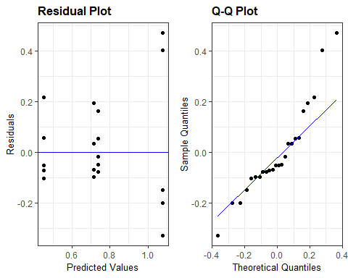

Anova(maize.aov)

## Anova Table (Type II tests)  
##   
## Response: Root:shoot ratio  
## Sum Sq Df F value Pr(>F)   
## Combination 1.18815 3 10.279 0.0002634 ***  
## Residuals 0.77063 20   
## ---  
## Signif. codes: 0 '***' 0.001 '**' 0.01 '*' 0.05 '.' 0.1 ' ' 1

maize.aov <- lm(`Root:shoot ratio` ~ `Combination`,  
 data = maize_data,  
 contrasts = list(`Combination` = "contr.sum"))  
  
means <- emmeans(maize.aov, specs = "Combination")  
means

## Combination emmean SE df lower.CL upper.CL  
## MH 0.737 0.0801 20 0.570 0.904  
## ML 0.452 0.0801 20 0.285 0.619  
## NMH 0.717 0.0801 20 0.550 0.884  
## NML 1.078 0.0801 20 0.911 1.245  
##   
## Confidence level used: 0.95

pairs(means, adjust = "tukey")

## contrast estimate SE df t.ratio p.value  
## MH - ML 0.285 0.113 20 2.515 0.0880  
## MH - NMH 0.020 0.113 20 0.176 0.9980  
## MH - NML -0.342 0.113 20 -3.015 0.0319  
## ML - NMH -0.265 0.113 20 -2.338 0.1227  
## ML - NML -0.627 0.113 20 -5.530 0.0001  
## NMH - NML -0.362 0.113 20 -3.191 0.0219  
##   
## P value adjustment: tukey method for comparing a family of 4 estimates

summary_table %>%   
 ggplot(aes(`Soil P addition treatment`, `Mean`, ymin = (`Mean`-`SE`), ymax = (`Mean`+`SE`), colour = `Mycorrhizal treatment`)) +  
 geom_pointrange(position = "jitter") +  
 theme_bw() +  
 ylab("Mean Root:shoot ratio")

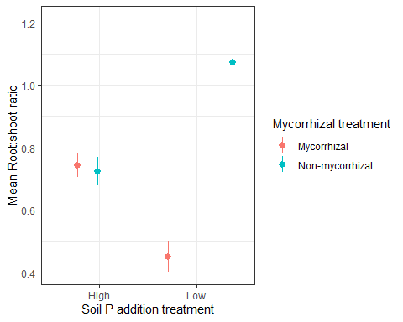

maize_data %>%   
 ggplot(aes(`Combination`, `Root:shoot ratio`, colour = `Mycorrhizal treatment`)) +  
 geom_boxplot()+  
 theme_bw() +  
 xlab(label = "Treatment")

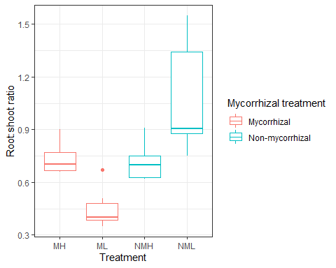

maize_data %>%   
 ggplot(aes(`Mycorrhizal treatment`, `Root:shoot ratio`, `Soil P addition treatment`)) +  
 geom_boxplot()+  
 theme_bw()

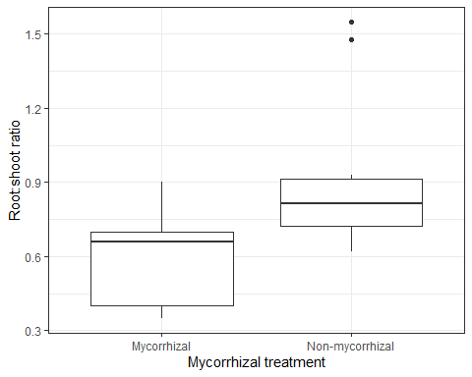

test2 <- maize_data %>%   
 group_by(`Mycorrhizal treatment`,`Soil P addition treatment`)  
  
test2 %>%   
 ggplot(aes(`Mycorrhizal treatment`, `Root:shoot ratio`)) +  
 geom_boxplot()+  
 theme_bw()

