Information Management II Project

Rory Goodman 14316993

For my design I decided to design a database for Arnotts department store. I chose this as I felt that it would be an interesting and complex subject to design a database around. It proved to be a challenge but I was able to overcome most of the issues I came across during the design and testing phases. I would have preferred to design the database based upon Arnotts existing system, but after researching I was unable to unearth any information on it and decided to start from scratch.

I designed the table to have 9 tables. This was not an exhaustive list but I felt that any additional tables would have been excessive. My main goal within the table was to avoid redundancies, unnecessary null values and to have clear attribute semantics. I feel that I was able to achieve this by designing my database carefully with an Entity Relationship Diagram and a Relational Schema before attempting to write the SQL script to implement it.

Entity Relationship Diagram

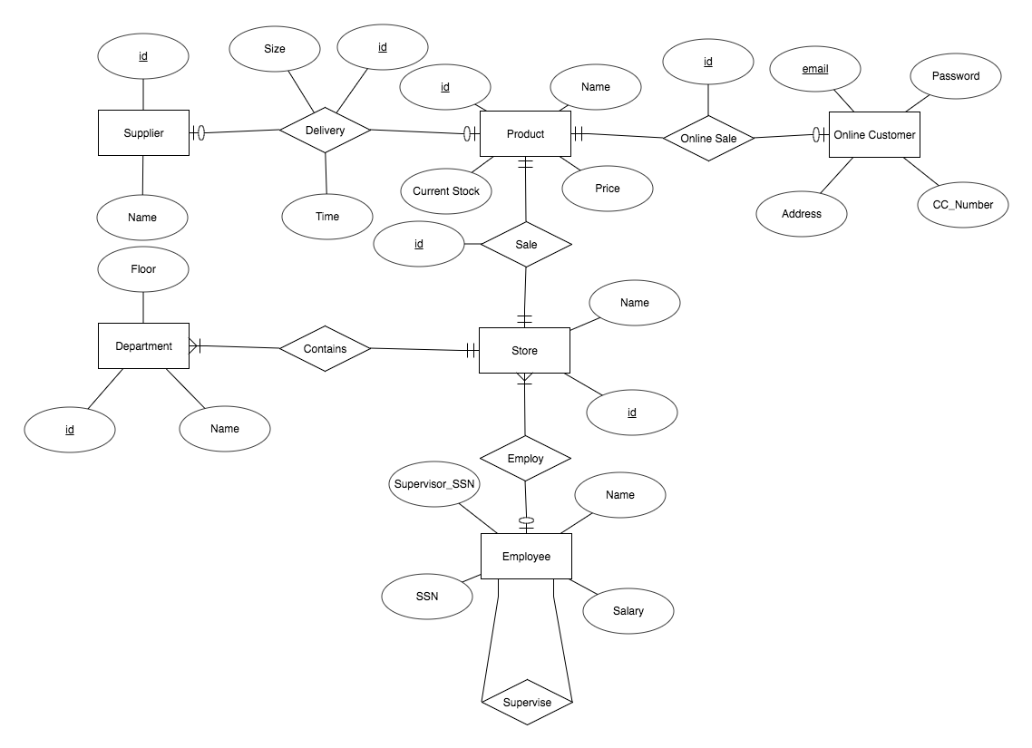

Relational Schema

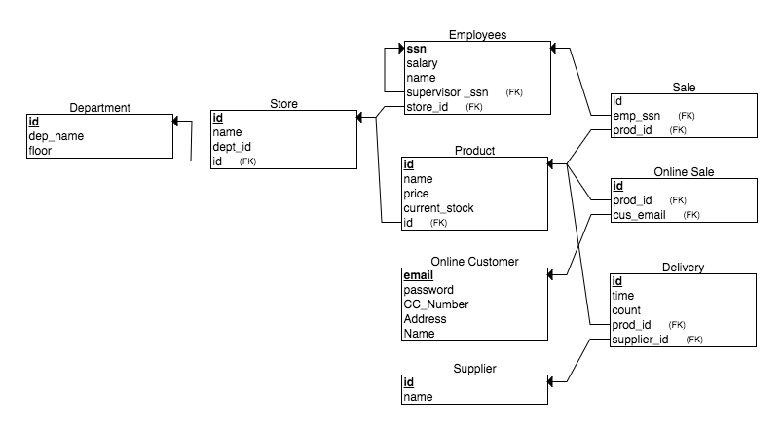

I also created two triggers to update the Product table whenever a Sale or an Online_Sale was made. These were added to ensure data integrity and concurrency throughout the database. Otherwise the Product table would have to be updated either manually or through some other third party application.

CREATE TRIGGER update_stock_sale

AFTER INSERT ON Sale FOR EACH ROW

DECLARE var_id INT;

BEGIN

var_id:=NEW.prod_id;

UPDATE Product

SET current_stock =current_stock-1;

WHERE Product.id:=NEW.prod_id

END update_stock_sale;

run;

CREATE TRIGGER update_ol_stock_sale

AFTER INSERT ON Online_Sale FOR EACH ROW

DECLARE var_id INT;

BEGIN

var_id:=NEW.prod_id;

UPDATE Product

SET current_stock =current_stock-1;

WHERE Product.id:=NEW.prod_id

END update_ol_stock_sale;

run;

2 views were also created for the database. Views are virtual tables formed from SELECT statements called on existing tables and columns. They are generally used for specific use cases but can also be used to protect sensitive data in the database. I created one of each. One was simply a view of all employees who’s salaries are above 50000 which could be used for a specific use case. The other view was created for security purposes. It was called on the Online_Customer table and returned only the customers email and name, excluding the sensitive columns password and credit card number. This would be useful if Arnotts or any specific Store within a department wanted to send customer emails or add them to a mailing list.

CREATE VIEW Admin_View_Accounts (customer_name,customer_email)

AS SELECT name,email

FROM Online_Customer;

CREATE VIEW Head_Supervisors(ssn,name,store_id,salary)

AS SELECT ssn,name,store_id,salary

FROM Employee

WHERE Employee.ssn=NULL;

Drop tables were also put at the beginning of the script so that I could run the script in SQL Plus without any CREATE TABLE statements failing to execute due to existing tables.

FULL SQL

DROP TABLE Sale;

DROP TABLE Online_Sale;

DROP TABLE Delivery;

DROP TABLE Supplier ;

DROP TABLE Employee;

DROP TABLE Online_Customer;

DROP TABLE Product;

DROP TABLE Store;

DROP TABLE Department;

DROP VIEW Admin_View_Accounts;

DROP VIEW Head_Supervisors;

CREATE TABLE Department (id INT NOT NULL,dep_name VARCHAR2(50) NOT NULL,floor INT NOT NULL,PRIMARY KEY(id));

CREATE TABLE Supplier (id INT NOT NULL,sup_name VARCHAR2(50) NOT NULL, PRIMARY KEY(id));

CREATE TABLE Delivery (id INT NOT NULL, sup_id INT NOT NULL, prod_id INT NOT NULL, count INT NOT NULL,

time INT NOT NULL, PRIMARY KEY(id));

CREATE TABLE Sale (id INT NOT NULL, prod_id INT NOT NULL, emp_ssn INT NOT NULL,PRIMARY KEY(id));

CREATE TABLE Online_Customer (name VARCHAR2(50) NOT NULL, email VARCHAR2(50) NOT NULL,password VARCHAR2(50),cc_number INTEGER NOT NULL, address VARCHAR2(100),PRIMARY KEY (email));

CREATE TABLE Online_Sale (id INT NOT NULL, prod_id INT NOT NULL,cus_email VARCHAR2(50) NOT NULL,PRIMARY KEY(id));

CREATE TABLE Employee(ssn INT NOT NULL, name VARCHAR2(50) NOT NULL,store_id INT NOT NULL, salary INT NOT NULL, supervisor_ssn INT NULL

,PRIMARY KEY(ssn),CONSTRAINT check_ssn CHECK( ssn > 99999999 AND ssn<1000000000));

CREATE TABLE Product (id INT NOT NULL, name VARCHAR2(50) NOT NULL,price INT NOT NULL,current_stock INT NOT NULL,store_id INT NOT NULL,

PRIMARY KEY(id));

CREATE TABLE Store (id INT NOT NULL,name VARCHAR2(50) NOT NULL,dept_id INT NOT NULL,PRIMARY KEY(id));

CREATE TRIGGER update_stock_sale

AFTER INSERT ON Sale FOR EACH ROW

DECLARE var_id INT;

BEGIN

var_id:=NEW.prod_id;

UPDATE Product

SET current_stock =current_stock-1;

WHERE Product.id:=NEW.prod_id

END update_stock_sale;

run;

CREATE TRIGGER update_ol_stock_sale

AFTER INSERT ON Online_Sale FOR EACH ROW

DECLARE var_id INT;

BEGIN

var_id:=NEW.prod_id;

UPDATE Product

SET current_stock =current_stock-1;

WHERE Product.id:=NEW.prod_id

END update_ol_stock_sale;

run;

ALTER TABLE Delivery ADD FOREIGN KEY (sup_id) REFERENCES Supplier(id);

ALTER TABLE Delivery ADD FOREIGN KEY (prod_id) REFERENCES Product(id);

ALTER TABLE Sale ADD FOREIGN KEY (prod_id) REFERENCES Product(id);

ALTER TABLE Sale ADD FOREIGN KEY (emp_ssn) REFERENCES Employee(ssn);

ALTER TABLE Online_Sale ADD FOREIGN KEY (prod_id) REFERENCES Product(id);

ALTER TABLE Employee ADD FOREIGN KEY (store_id) REFERENCES Store(id);

ALTER TABLE Employee ADD FOREIGN KEY (supervisor_ssn) REFERENCES Employee(ssn);

ALTER TABLE Product ADD FOREIGN KEY (store_id) REFERENCES Store(id);

INSERT INTO Department(id,dep_name,floor) VALUES (1,'Beauty',0);

INSERT INTO Department(id,dep_name,floor) VALUES (2,'Jewellery',0);

INSERT INTO Department(id,dep_name,floor) VALUES (3,'Mens',2);

INSERT INTO Department(id,dep_name,floor) VALUES (4,'Womens',1);

INSERT INTO Department(id,dep_name,floor) VALUES (5,'Shoes',2);

INSERT INTO Store(id,name,dept_id) VALUES(1,'Topshop',4);

INSERT INTO Store(id,name,dept_id) VALUES(2,'Weirs Watches',2);

INSERT INTO Store(id,name,dept_id) VALUES(3,'Topman',3);

INSERT INTO Store(id,name,dept_id) VALUES(4,'Tommy Hilfiger',3);

INSERT INTO Store(id,name,dept_id) VALUES(5,'Zara',4);

INSERT INTO Product(id,name,price,current_stock,store_id) VALUES(1,'Summer Dress',1000,15,2);

INSERT INTO Product(id,name,price,current_stock,store_id) VALUES(2,'Rolex Datetime',750000,1,4);

INSERT INTO Product(id,name,price,current_stock,store_id) VALUES(3,'Paco Rabanne IV',6000,30,5);

INSERT INTO Product(id,name,price,current_stock,store_id) VALUES(4,'Tie Die Tee',2000,10,1);

INSERT INTO Product(id,name,price,current_stock,store_id) VALUES(5,'Tennis Shoes',500,20,1);

INSERT INTO Online_Customer(name,email,password,cc_number) VALUES ('Steve Blobs','sblobs@hotmail.com','password',1234567890123456);

INSERT INTO Online_Customer(name,email,password,cc_number) VALUES ('Mister Krabs','stingy@hotmail.com','password',2234567890123456);

INSERT INTO Online_Customer(name,email,password,cc_number) VALUES ('Colin Firth','firthy@hotmail.com','password',3234567890123456);

INSERT INTO Online_Customer(name,email,password,cc_number) VALUES ('Monty Burns','cmburns@hotmail.com','password',4234567890123456);

INSERT INTO Online_Customer(name,email,password,cc_number) VALUES ('Julius Hibbert','jhibbs@hotmail.com','password',5234567890123456);

INSERT INTO Employee(ssn,name,store_id,salary,supervisor_ssn) VALUES(518299808,'Biggie Smalls',1,10000000,NULL);

INSERT INTO Employee(ssn,name,store_id,salary,supervisor_ssn) VALUES(251174472,'Billy Ray Cyrus',2,15000,518299808);

INSERT INTO Employee(ssn,name,store_id,salary,supervisor_ssn) VALUES(516187799,'William Wonka',2,12000,251174472);

INSERT INTO Employee(ssn,name,store_id,salary,supervisor_ssn) VALUES(638028995,'Kendrick Lamar',4,50000,518299808);

INSERT INTO Employee(ssn,name,store_id,salary,supervisor_ssn) VALUES(480242248,'Doctor Dre',3,25000,518299808);

INSERT INTO Supplier (id,sup_name) VALUES (1,'Hansell n Gretel Fashions');

INSERT INTO Supplier (id,sup_name) VALUES (2,'Acess Ireland');

INSERT INTO Supplier (id,sup_name) VALUES (3,'McCul Childrens Clothing');

INSERT INTO Supplier (id,sup_name) VALUES (4,'Fitzpatrick Wholesale');

INSERT INTO Supplier (id,sup_name) VALUES (5,'JBS Group');

INSERT INTO Delivery (id,sup_id,prod_id,count,time) VALUES (1,4,1,1,1);

INSERT INTO Delivery (id,sup_id,prod_id,count,time) VALUES (2,4,2,50,2);

INSERT INTO Delivery (id,sup_id,prod_id,count,time) VALUES (3,1,3,12,3);

INSERT INTO Delivery (id,sup_id,prod_id,count,time) VALUES (4,5,4,10,4);

INSERT INTO Delivery (id,sup_id,prod_id,count,time) VALUES (5,1,5,15,5);

INSERT INTO Online_Sale(id,prod_id,cus_email) VALUES (1,5,'jhibbs@hotmail.com');

INSERT INTO Online_Sale(id,prod_id,cus_email) VALUES (2,5,'jhibbs@hotmail.com');

INSERT INTO Online_Sale(id,prod_id,cus_email) VALUES (3,2,'cmburns@hotmail.com');

INSERT INTO Online_Sale(id,prod_id,cus_email) VALUES (4,4,'stingy@hotmail.com');

INSERT INTO Online_Sale(id,prod_id,cus_email) VALUES (5,1,'sblobs@hotmail.com');

INSERT INTO Sale(id,prod_id,emp_ssn) VALUES (1,1,518299808);

INSERT INTO Sale(id,prod_id,emp_ssn) VALUES (2,4,251174472);

INSERT INTO Sale(id,prod_id,emp_ssn) VALUES (3,3,518299808);

INSERT INTO Sale(id,prod_id,emp_ssn) VALUES (4,2,251174472);

INSERT INTO Sale(id,prod_id,emp_ssn) VALUES (5,4,518299808);

CREATE VIEW Admin_View_Accounts (customer_name,customer_email)

AS SELECT name,email

FROM Online_Customer;

CREATE VIEW Head_Supervisors(ssn,name,store_id,salary)

AS SELECT ssn,name,store_id,salary

FROM Employee

WHERE Employee.ssn=NULL;