Project Summary — Natural Deduction Game
This project aims to design and develop an interactive, browser-based educational game that teaches natural deduction up to third-year undergraduate level. The system focuses on improving students’ understanding of formal logic proofs through visual interaction, immediate feedback, and game-based learning.

Project Goals
- Make learning natural deduction engaging and intuitive by replacing static text-based proofs with visual, drag-and-drop interactions.
- Provide structured levels and progression.
- Offer real-time validation and feedback, helping learners understand why a rule application is valid or invalid.
- Ensure formal correctness by grounding the proof system in the verified logic definitions of NaDeA (a natural deduction assistant built in Isabelle/HOL).
- Support future integration with Isabelle’s proof engine via its PIDE-based server API, enabling full theorem verification from within the game.

System Overview
The game enables players to construct proofs visually, using drag-and-drop components to apply inference rules (e.g., →-Introduction, ∧-Elimination). Each move dynamically updates the proof tree, showing assumption scopes and sub-proofs through animated, colour-coded boundaries. The system is designed both for practice (structured exercises) and sandbox exploration (open proof construction).

Architecture and Technologies
1.Frontend (UI Layer)
Technology: React.js, HTML, javascript, CSS, JSON
Purpose:
- Renders all game components: premises, goals, expression builder, proof lines, and scoring.
- Implements the interactive proof-building interface using button-based expression construction.
- Provides an intuitive workflow for creating and submitting proof lines.
- Ensures responsive and maintainable UI design.

2. Interaction & Syntax Layer
Technology: React State, Custom JavaScript Syntax Validator
Purpose:
- Handles all user interactions (building expressions, adding proof lines, undoing steps).
- Enforces well-formed formula syntax:
  - balanced parentheses
  - correct connective placement
  - atomic and compound formula structure
- Gives real-time feedback on syntax correctness.

3. Local Proof Checking Engine (Current Implementation)
Technology: Custom JavaScript Natural Deduction Checker
Purpose:
- Validates each submitted line using a subset of Natural Deduction rules implemented in JavaScript.
- Ensures each line follows logically from previous lines.
- Confirms the final line matches the expected conclusion of the problem.
- Allows incremental development of ND rules based on the Natural Deduction Pack.

4. Backend Logic Engine
Technology: Node.js / Express.js
Purpose:
- Will handle proof validation requests and forward them to Isabelle for formal verification.
- Will manage persistence, user sessions, and communication with the database.
- Provides a scalable architecture for expanding the game into multi-user or online functionality.

5. Formal Verification Layer
Technology: Isabelle Server API (PIDE)
Purpose:
- Provides a formally verified proof checker for Natural Deduction.
- Confirms user-submitted proofs against the Isabelle/HOL implementation of ND rules (e.g., NaDeA).
- Offloads heavy formal reasoning from the frontend to a trusted backend theorem prover.
- Allows absolute correctness guarantees and alignment with academic logic standards.

6. Data Storage Layer
Technology: MySQL
Purpose:
- Stores user progress, scores, completed proofs, and profile information.
- Stores game levels, proof statistics, and performance analytics.
- Supports saving and resuming long-term proof sessions.

7. Logic Foundations
Technology: NaDeA Isabelle .thy files, Natural Deduction Pack
Purpose:
- Provides the formal ND rules and definitions used in Isabelle.
- Supplies a curated set of ND proof exercises extracted from the Natural Deduction Pack.
- Ensures that the game aligns with established logic curriculum and formal semantics.

How the user interacts
The user should be able to
- Create a user/login
- Enter proofs into the proof space by clicking
- View their progress/their high score
- Skip a question
- Request up to 2 hints
- Understand where they are struggling(potential AI)
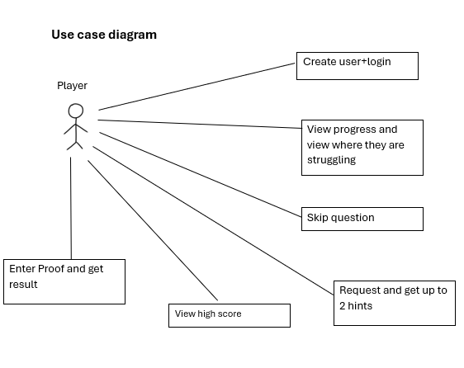
How the Components Interact(flow)
- The user will enter their proof based on the problem they are given. During this phase they have the option to request up to 2 hints. First hint being how many steps are in the proof. Second being a bigger hint telling them what rules they should use.
- This proof they have entered will then get sent to the database checker. The solution provided by the user will be checked against the solution in the database. If it is correct, it will return true, if it is incorrect, it will then be sent to our back-end Isabelle theorem checker to check if it is correct. This ensures so that if an answer is correct but doesn’t match that provided by the database, it will still be marked as correct.
- The result will then be stored in a database of the user and printed to the user also.
- The level manager will then pull a new level from the database for the user to do and mark the previous one as completed.

Component Diagram
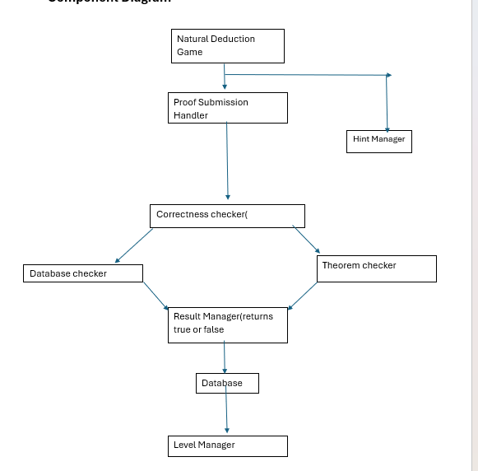
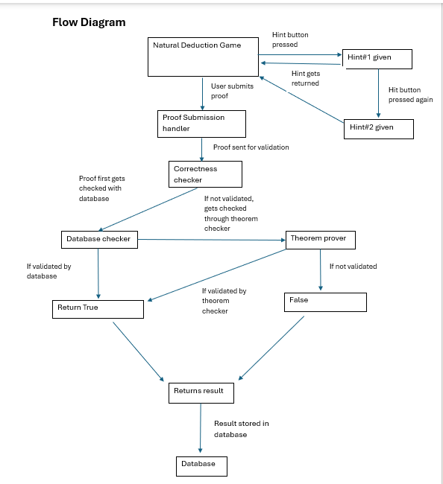

Educational Foundation
The game’s logical content and exercises are derived from:
- NaDeA (Natural Deduction Assistant), an Isabelle-verified formalisation of natural deduction.
- The Natural Deduction Pack, a structured set of proof problems increasing in difficulty.
- Insights from prior tools such as Logiko, Pandora, and QED, identifying a need for greater interactivity and visual scaffolding.

Key Features
- Each part of the proof represented as an ingredient to go on a witch’s cauldron to make a potion.
- Dynamic scope highlighting to visualise sub-proofs and assumption discharge.
- Gamified learning elements like levels, hints, and score tracking.
- Proof verification through Isabelle’s server interface.
- Extensible design, supporting future features such as adaptive difficulty.

Expected Outcomes
- Enhanced engagement and comprehension among students learning natural deduction.
- A scalable framework that can integrate deeper formal verification.
- A bridge between formal logic education and modern web-based interactivity.

Summary
This project brings together modern front-end technologies (React), formal methods foundations (Isabelle, NaDeA), and educational design principles to create an innovative learning platform.
By combining game design, formal logic, and interactive feedback, it directly addresses long-standing challenges in logic education — transforming natural deduction from an abstract symbolic exercise into an engaging, visual, and conceptually clear experience.

