Table of Contents
Demo Recording Script — Java Spring Boot + MCP + Copilot 1
Episode 1 of 4 — Build and debug your first Spring Boot app 2
Intro — Talking head (~20s) 2
Demo — Build & run 2
Demo — Debug & watch memory 3
Outro — Talking head (~20s) 5
Episode 2 of 4 — Expose your endpoints to Copilot with MCP 5
Intro — Talking head (~20s) 5
Demo 5
Outro — Talking head (~20s) 8
Episode 3 of 4 — Let Copilot test it with Playwright 9
Intro — Talking head (~20s) 9
Demo 9
Outro — Talking head (~20s) 10
Episode 4 of 4 — Hand a feature to the Copilot cloud agent 11
Intro — Talking head (~20s) 11
Demo 11
Outro — Talking head (~20s) 14
Resources (video descriptions / hand-off) 14

Demo Recording Script — Java Spring Boot + MCP + Copilot
Demo source: Prepared local copy. Add a repository URL only if it is approved for publication.
Publication check: Review every screenshot and screen recording for repository names, local paths, account names, notifications, and other identifying information. Redact or replace any exposed details before publishing.

Episode 1 of 4 — Build and debug your first Spring Boot app

Intro — Talking head (~20s)
In this video, I'll build and debug a Spring Boot Java app in VS Code. I'll install the Java and Spring extension packs, scaffold the app with Spring Initializr, and run it directly from the editor. Then I'll use breakpoints to step through the code and monitor the app's health and memory while it runs. Let's jump right in.
Do: End on “let's jump right in,” then cut to screen share.

Demo — Build & run
Where | Do | Say
VS Code — Extensions view (Ctrl+Shift+X) | Search "Extension Pack for Java" and install. Then install a JDK 25 (Ctrl+Shift+P → Java: Install New JDK, or show it already installed). | "Let's start from nothing. First I install the Extension Pack for Java — that gives me language support, debugging, Maven, and testing in one bundle — plus a JDK to compile and run."
Extensions view | Search "Spring Boot Extension Pack" (Spring Boot Tools, Dashboard, Initializr) and install. | "Next, the Spring Boot Extension Pack. This adds the Spring Initializr, the Spring Boot Dashboard, and smart editing for Spring config."
Command Palette (Ctrl+Shift+P) | Run "Spring Initializr: Create a Maven Project". Choose: Spring Boot 4.1.x → Java → group com.example → artifact springboot-mcp-demo → Java 25 → dependencies Spring Web, Thymeleaf, Actuator. | "The Initializr scaffolds a project right inside VS Code — no browser needed. I pick Web, Thymeleaf, and Actuator to get started."
Explorer + editor | Close the temporary scaffold and open the prepared Todo app. Show TodoController, TodoService, TodoRepository, Todo, and templates/index.html. | "The Initializr gives me the baseline project. To keep this short, I'll switch to a prepared Todo app built from that scaffold, with the controller, service, in-memory repository, and Thymeleaf page already filled in."
Terminal | In a dedicated terminal, run .\mvnw.cmd spring-boot:run, open http://localhost:8080, then add, toggle, and delete a todo. When finished, stop the app with Ctrl+C. | "I run it with the Maven wrapper and exercise the basic flow: add, complete, delete. Then I stop this process before launching the debugger, so only one app is using port 8080."
The running Todo web app:
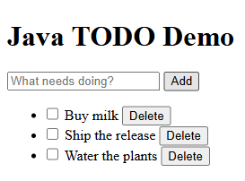
The Spring Initializr version picker — auto-captured by scripts/capture-initializr.ps1:
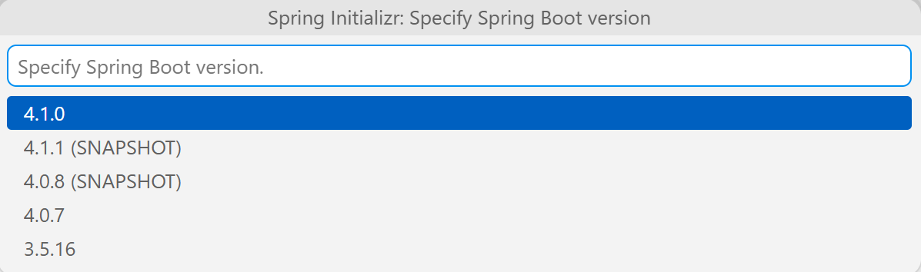

Demo — Debug & watch memory
Where | Do | Say
Editor — TodoController.java | Click the gutter to set a breakpoint on the addForm method (the service.add(title) line). | "Let's debug. I'll drop a breakpoint where a new todo gets created."
Spring Boot Dashboard / Run view | Start the app with F5 (Debug). In the browser add a todo to hit the breakpoint. | "Launch in debug mode with F5, add a todo, and execution pauses right on our line."
Debug toolbar + Variables panel | Expand Local and inspect title, then step into TodoService.add (F11). Step over the Todo todo = ... line (F10) and inspect the new todo local. Continue (F5). Before recording, close Chat and hide any terminal output that contains local paths or account details. | "The controller shows me the incoming title. I can step into the service, execute the object creation, and inspect the new Todo before it is saved."
Spring Boot Dashboard → running app → Memory view (or Actuator) | Open the Actuator / Memory view; show heap/non-heap live gauges. Also hit http://localhost:8080/actuator/health. | "Because we added Actuator, VS Code gives me a live Memory view and health endpoint — real-time JVM insight while the app runs."
Debug toolbar | Stop the debug session (Shift+F5) before ending the episode. | "I'll stop the debug session here so port 8080 is free for the next run."
Actuator health summary (all systems UP; local filesystem details removed):
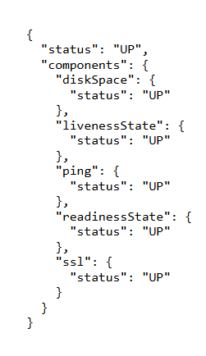
Spring Boot Dashboard Memory view — live heap gauge (auto-captured by scripts/capture-window.ps1):
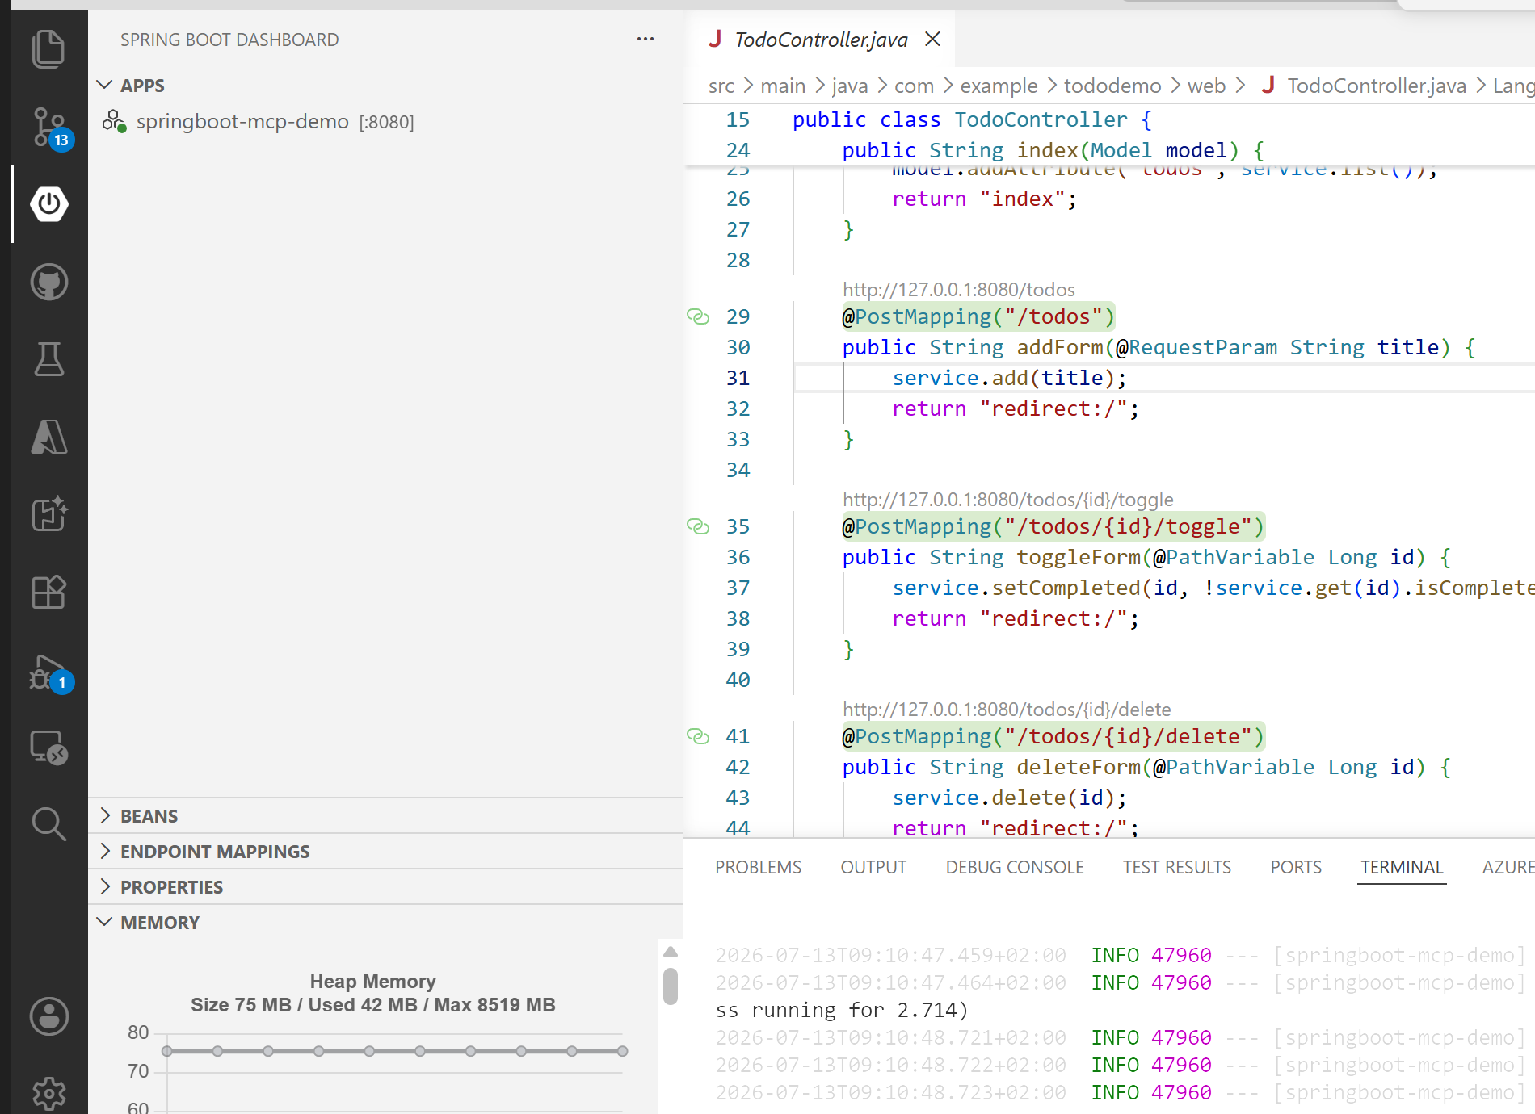

Outro — Talking head (~20s)
In this video, I built and ran a Spring Boot app in VS Code, debugged it with breakpoints, and inspected its health and memory. That gave me one workflow for setup, development, and runtime diagnostics. In the next video, I'll connect the app to GitHub Copilot through MCP.

Episode 2 of 4 — Expose your endpoints to Copilot with MCP

Intro — Talking head (~20s)
In this video, I'll show how a Spring Boot app becomes a set of tools GitHub Copilot can call directly. I'll use Spring AI to expose the existing Java operations through MCP, while keeping the web UI and Copilot connected to the same service. Let's jump right in.
Do: End on “let's jump right in,” then cut to screen share.
Prerequisites: Open the prepared app, sign in to GitHub Copilot Chat, and allow MCP tool use when VS Code prompts for trust or confirmation.

Demo
Where | Do | Say
pom.xml | Show the dependency spring-ai-starter-mcp-server-webmvc and the spring-ai-bom 2.0.0. | "The MCP layer starts with the Spring AI MCP server dependency, with its version managed by the Spring AI BOM."
mcp/TodoTools.java | Walk through the @McpTool / @McpToolParam annotations on addTodo, listTodos, etc. Point out they just delegate to TodoService. | "Each method gets an @McpTool annotation with a name and description. They reuse the exact same service the web UI uses — no duplicated logic. Five tools: list, get, add, complete, delete."
application.properties | Highlight spring.ai.mcp.server.protocol=STREAMABLE. | "One critical setting: protocol=STREAMABLE. The WebMVC starter defaults to the old SSE transport — without this, /mcp returns 404."
Terminal | In a dedicated terminal, run .\mvnw.cmd spring-boot:run and wait for Registered tools: 5. Leave this terminal running. | "The startup log confirms that all five tools are registered and the app is serving the MCP endpoint."
.vscode/mcp.json | Show the todo-mcp HTTP entry. After the app is running, click its Start code-lens and approve the connection if prompted. | "This entry points VS Code at the running /mcp endpoint. Starting it here connects Copilot to the server; it does not launch the Java app itself."
Copilot Chat (Agent mode) | Enable the todo-mcp tools. Ask: "Use the todo-mcp tools to add a todo called 'Email the stakeholders', then list all todos." Refresh http://localhost:8080 and verify that exact title appears. | "Now I ask Copilot to add a todo and list the results. The tool call reaches the same Java service as the web UI, so the exact item created in chat appears in the browser."
Terminal | Stop the Spring Boot app with Ctrl+C after capturing the result. | "I'll stop the app so the next episode starts from a clean process and an empty in-memory store."
Proof it works — a todo created through MCP appears in the web UI (last row):
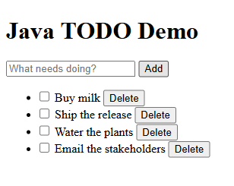
Copilot Chat calling the todo-mcp tools — the add_todo call and its JSON result:
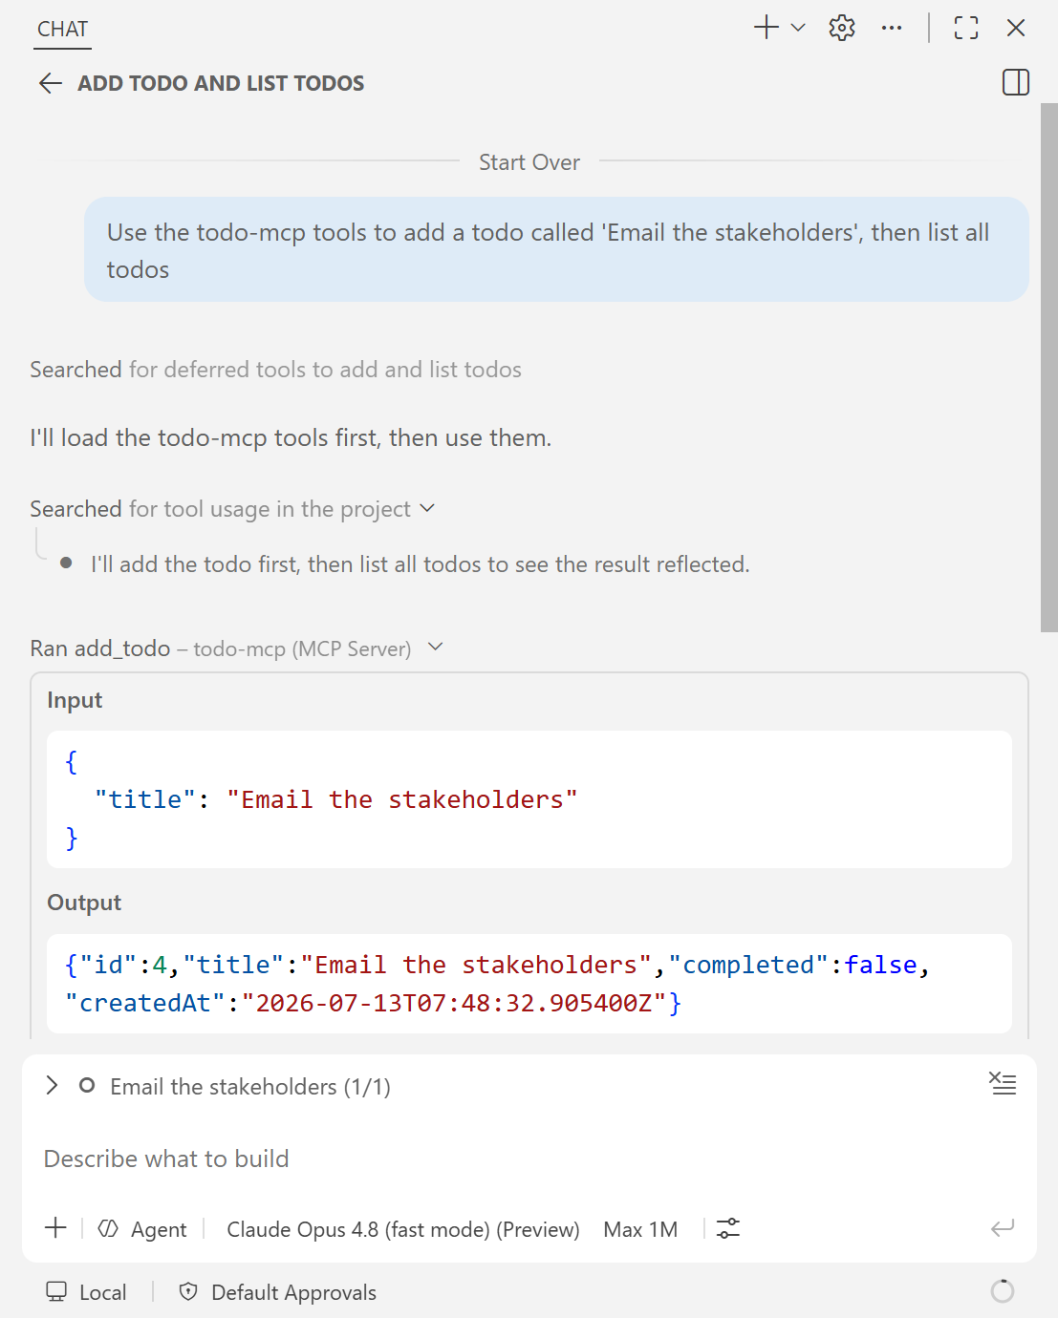

Outro — Talking head (~20s)
In this video, I exposed the Todo operations as MCP tools and connected them to GitHub Copilot. Because Copilot and the web UI shared the same Java service, changes made in chat appeared immediately in the app. In the next video, I'll test the UI in a real browser with Playwright.

Episode 3 of 4 — Let Copilot test it with Playwright

Intro — Talking head (~20s)
In this video, I'll show how to test a Spring Boot web app with Copilot and Playwright. Passing unit tests don't prove the UI works for a real user, so I'll have Copilot drive the app in a real browser and verify the experience end to end. Let's jump right in.
Do: End on “let's jump right in,” then cut to screen share.
Prerequisites: Install Node.js 18 or newer, use an installed Edge browser, sign in to GitHub Copilot Chat, and approve the Playwright MCP server and its tools when prompted.

Demo
Where | Do | Say
.vscode/mcp.json | Show the playwright server entry, which runs @playwright/mcp through npx with Microsoft Edge. Click its Start code-lens. | "The workspace includes the Playwright MCP server configuration. It uses the installed Edge browser, so I don't need a separate browser download."
Terminal 1 | Run .\mvnw.cmd spring-boot:run and leave the app running on http://localhost:8080. | "I start the app in its own terminal and leave it running while the browser and protocol checks execute."
templates/index.html | Point out the data-testid hooks: new-todo-input, add-todo, todo-item, delete-todo. | "I added stable test IDs to the UI so automation has reliable selectors."
Copilot Chat (Agent mode, Playwright MCP) | Ask: "Use the Playwright tools to open http://localhost:8080. Add a todo called 'Verify the browser flow', find that todo's row, complete it and verify it is checked, then delete it and verify it is gone." | "Using the Playwright tools, Copilot drives a real browser through one deterministic user journey and verifies the result at each stage."
Browser window (Playwright) | Watch the automated browser perform the add → complete → delete flow. | "There it goes: filling the input, clicking add, toggling, deleting — a full UI smoke test."
Terminal 2 | While the app remains running in Terminal 1, run powershell -ExecutionPolicy Bypass -File scripts\mcp-smoke-test.ps1, then .\mvnw.cmd test. | "The smoke test verifies the MCP handshake, the exact tool set, and a real add_todo result. The Maven tests separately cover the service, web flow, and Spring context."
Terminals / .vscode/mcp.json | Stop the app with Ctrl+C, then stop the Playwright MCP server. | "I stop both processes here, leaving the workspace ready for another clean run."
Representative smoke-test output (session and generated todo IDs vary):
1. initialize -> server: todo-mcp-server v1.0.0 (session dd013c8a-bee0-4393-be7e-8e2fc99aac00)
2. notifications/initialized -> sent
3. tools/list -> 5 tools: add_todo, complete_todo, delete_todo, get_todo, list_todos
4. tools/call add_todo -> {"id":1,"title":"Created through the MCP add_todo tool","completed":false,"createdAt":"2026-07-16T10:54:28.414002200Z"}
MCP smoke test PASSED.
Illustrative browser state during a Playwright run — captured by scripts/screenshots/capture.mjs; the live Copilot tool calls are shown during the demo:
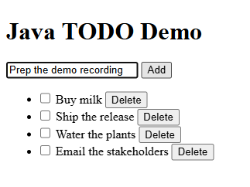

Outro — Talking head (~20s)
In this video, I used Copilot and Playwright to test my Java app in a real browser, then backed that up with automated checks across the application. That covered both the user experience and the code behind it. In the next video, I'll delegate a complete feature to the Copilot coding agent.

Episode 4 of 4 — Hand a feature to the Copilot cloud agent

Intro — Talking head (~20s)
In this video, I'll hand a complete Spring Boot feature to the GitHub Copilot coding agent and review the pull request it creates. The task spans persistence, due dates, and tests, so I can evaluate how the agent handles one clearly scoped change. Let's jump right in.
Do: End on “let's jump right in,” then cut to screen share.
Prerequisites: Use a GitHub account with Copilot coding agent enabled, write access to the demo repository, and the GitHub Pull Requests extension signed in to VS Code.
Recording plan: Assign the issue before recording and let the asynchronous agent finish. During the video, use the prepared issue and draft pull request—do not create a duplicate or wait live. Keep the PR unmerged until Episodes 1–3 are recorded so their baseline remains reproducible.

Demo
Where | Do | Say
docs/copilot-agent-issue.md | Open it; show the ready-to-assign task: add Spring Data JPA + H2 persistence and a dueDate field with filtering. | "Todos are in memory on purpose. Here's a ready-to-go issue asking for real persistence and a due-date feature."
GitHub — prepared issue | Open the issue that was assigned to @copilot before recording. | "I assigned this scoped issue ahead of time because the coding agent works asynchronously in the cloud. That removes an unpredictable live wait from the demo."
GitHub Pull Requests view (VS Code) | Open the draft pull request after the implementation commit has arrived; update it with the current baseline, then review the 13-file feature diff, including the JPA entity, repository, dueDate, MCP changes, and tests. | "The agent opened a draft pull request and then completed the implementation. I first bring in the current baseline, then review the actual feature diff rather than assuming the first draft contains finished code."
Pull-request branch + Terminals | Check out the updated PR branch. Run .\mvnw.cmd test; start the app in one terminal; in another run powershell -ExecutionPolicy Bypass -File scripts\mcp-smoke-test.ps1 -ExpectedTools add_todo,complete_todo,delete_todo,get_todo,list_todos,set_due_date. Then create a todo with a due date, restart the app, and confirm it persists. | "Before I consider merging, I run the tests, verify the expanded six-tool MCP contract, and check the two key behaviors locally: due dates work and data survives a restart."
PR review | Review the results and leave comments if needed. Keep the PR draft and unmerged during this recording; only mark it ready and merge after the review is complete and the baseline has been preserved. | "The agent produced the implementation, but the review, verification, and final merge decision still belong to me."
The prepared issue assigned to the Copilot coding agent (@copilot) — auto-captured by scripts/screenshots/capture.mjs:
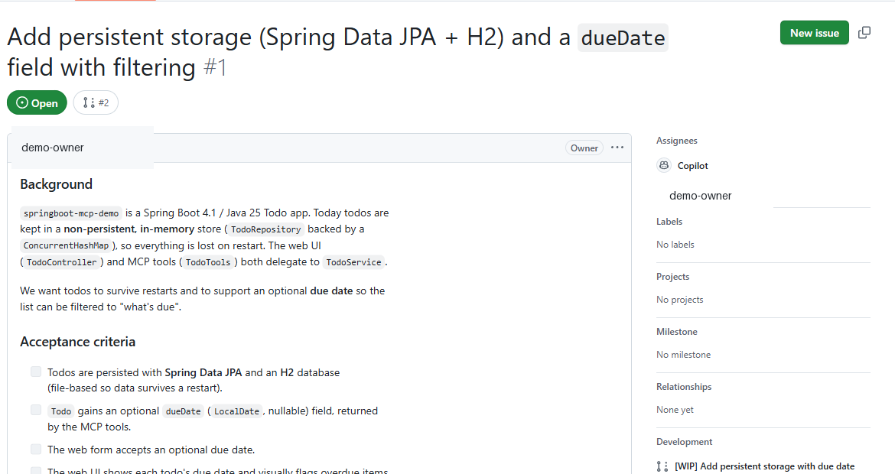
The draft pull request the Copilot agent opened — its 13-file diff includes the JPA entity, repository, dueDate, and tests — auto-captured by scripts/screenshots/capture.mjs:
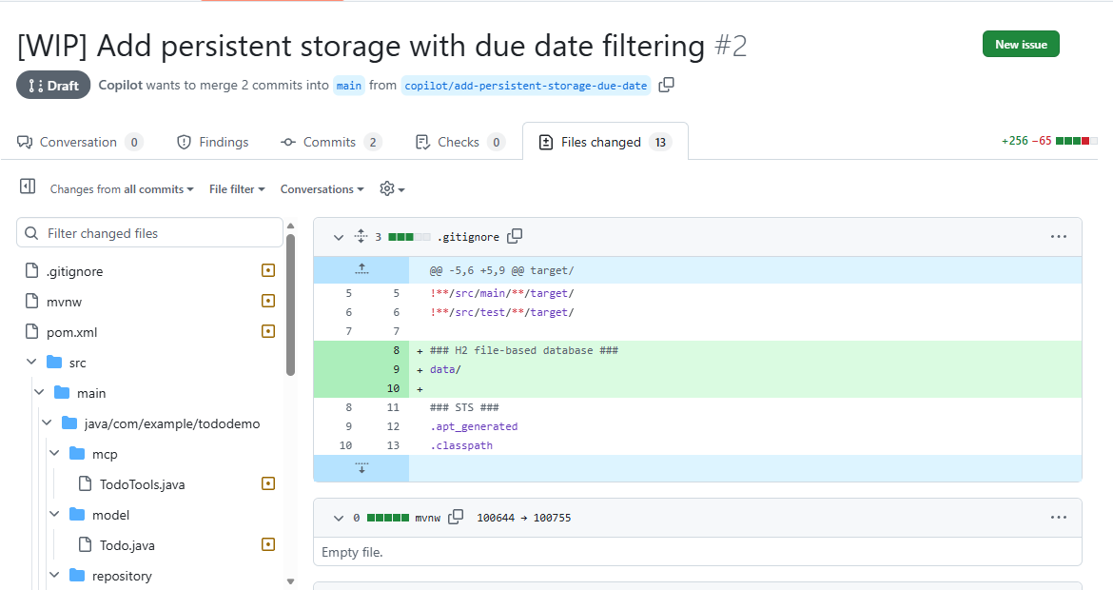

Outro — Talking head (~20s)
In this video, I gave the Copilot coding agent a scoped feature request and reviewed the pull request it produced. The change added persistence, due dates, and tests, while I kept control of the final review and merge decision. The agent handled the implementation; I remained responsible for what is approved to ship.
Do: Hold on the reviewed draft pull request, then fade out.

Resources (video descriptions / hand-off)
- Demo source: Add a repository URL only after publication approval
- Extension Pack for Java (Microsoft): https://marketplace.visualstudio.com/items?itemName=vscjava.vscode-java-pack
- Spring Boot Extension Pack: search “Spring Boot Extension Pack” in the VS Code Marketplace
- Java in VS Code: https://code.visualstudio.com/docs/languages/java
- Spring Boot Actuator: https://docs.spring.io/spring-boot/
- Spring AI (MCP server): https://docs.spring.io/spring-ai/reference/
- Model Context Protocol: https://modelcontextprotocol.io
- MCP in VS Code: https://code.visualstudio.com/docs/copilot/chat/mcp-servers
- Playwright MCP: https://github.com/microsoft/playwright-mcp
- GitHub Copilot coding agent: https://docs.github.com/en/copilot

