Table of Contents

Demo Recording Script — Java Spring Boot + MCP + Copilot
Repo: https://github.com/roryp/vscode-learn Stack: Java 25 · Spring Boot 4.1.0 · Spring AI 2.0.0 · Thymeleaf · Maven
Format: Where = what’s on screen · Do = actions to perform · Say = narration. The Where / Do / Say table is the on-screen demo. Each episode’s intro and outro are spoken straight to camera (talking head) — no screen share. Before recording: close extra tabs, set editor font ~16pt, have a clean terminal open.
About the images below: every shot lives in docs/images/ and is produced by the helper scripts in scripts/ — no manual snipping required: - App & browser (01,02,03,07) and GitHub issue/PR (08,09): scripts/screenshots/capture.mjs (Playwright + system Edge) - VS Code UI — debug breakpoint (04) and Spring Boot Dashboard Memory view (05): scripts/capture-window.ps1 (Win32 PrintWindow — captures the Electron window) - Spring Initializr picker (00): scripts/capture-initializr.ps1 - Copilot Chat todo-mcp call (06): snipped from a live Agent-mode chat All ten screenshots are captured and embedded below.
Series format: four standalone ~3–5 min episodes, modeled on VS Code’s “…in 5 Minutes” series. Each episode opens with a ~15s talking-head intro (light “catch-up” bridge → hook → what this episode covers → “let’s jump in”) and closes with a ~15–20s talking-head outro (quick recap → a resource/URL → comments CTA → tease the next episode). The bridge gives drop-in viewers context and makes the outro→intro handoff flow when binged — nobody needs to have seen the previous video. Keep it casual and first person — “So…”, “All right”, “let’s jump right in.”

Episode 1 of 4 — Build and debug your first Spring Boot app

Intro — Talking head (~15s)
First of four short videos where we take one Spring Boot app all the way — from an empty editor to something GitHub Copilot can drive and even improve. People think a Java web app means endless setup and clunky debugging — it really doesn’t anymore. In this one I’ll scaffold the app, run it, then set a breakpoint and watch its memory live, all in VS Code. So let’s jump right in.
Do: End on “let’s jump right in,” then cut to screen share.

Demo — Build & run
Where | Do | Say
VS Code — Extensions view (Ctrl+Shift+X) | Search “Extension Pack for Java” and install. Then install a JDK 25 (Ctrl+Shift+P → Java: Install New JDK, or show it already installed). | “Let’s start from nothing. First I install the Extension Pack for Java — that gives me language support, debugging, Maven, and testing in one bundle — plus a JDK to compile and run.”
Extensions view | Search “Spring Boot Extension Pack” (Spring Boot Tools, Dashboard, Initializr) and install. | “Next, the Spring Boot Extension Pack. This adds the Spring Initializr, the Spring Boot Dashboard, and smart editing for Spring config.”
Command Palette (Ctrl+Shift+P) | Run “Spring Initializr: Create a Maven Project”. Choose: Spring Boot 4.1.x → Java → group com.example → artifact springboot-mcp-demo → Java 25 → dependencies Spring Web, Thymeleaf, Actuator. | “The Initializr scaffolds a project right inside VS Code — no browser needed. I pick Web, Thymeleaf, and Actuator to get started.”
Explorer + editor | Open the finished version of this project (the one I prepared earlier) from the repo https://github.com/roryp/vscode-learn. Show TodoController, TodoService, TodoRepository, Todo, and templates/index.html. | “To save time, here’s one I built earlier with those exact choices — same structure. One TodoService holds the logic; a Thymeleaf page and controller give us a simple web UI backed by an in-memory store.”
Terminal | .\mvnw.cmd spring-boot:run — then open http://localhost:8080. Add a todo, toggle it, delete it. | “Build and run with the Maven wrapper. There’s our Todo app — add, complete, delete. Classic Spring Boot web app.”
The running Todo web app:
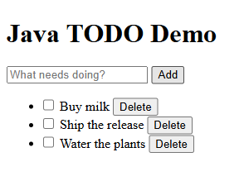
Todo web app
The Spring Initializr version picker — auto-captured by scripts/capture-initializr.ps1:
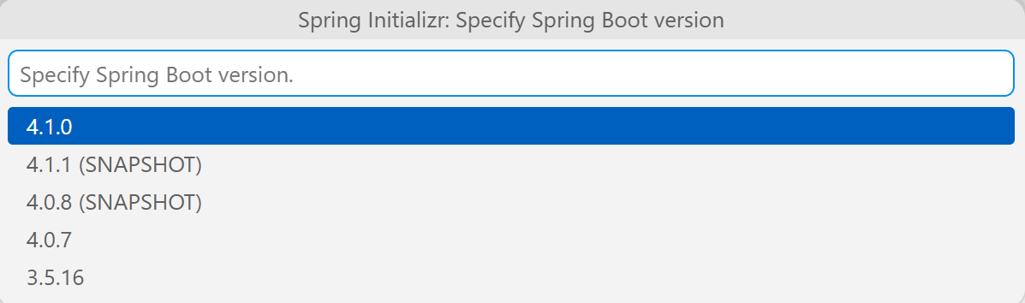
Spring Initializr version picker

Demo — Debug & watch memory
Where | Do | Say
Editor — TodoController.java | Click the gutter to set a breakpoint on the addForm method (the service.add(title) line). | “Let’s debug. I’ll drop a breakpoint where a new todo gets created.”
Spring Boot Dashboard / Run view | Start the app with F5 (Debug). In the browser add a todo to hit the breakpoint. | “Launch in debug mode with F5, add a todo, and execution pauses right on our line.”
Debug toolbar + Variables panel | Step over (F10), inspect title and the returned Todo in Variables. Continue (F5). | “I can step through, inspect the incoming title and the saved Todo — full breakpoint debugging, no extra setup.”
Spring Boot Dashboard → running app → Memory view (or Actuator) | Open the Actuator / Memory view; show heap/non-heap live gauges. Also hit http://localhost:8080/actuator/health. | “Because we added Actuator, VS Code gives me a live Memory view and health endpoint — real-time JVM insight while the app runs.”
Actuator health endpoint (all systems UP):
Actuator health
Paused at the breakpoint — Variables panel and live inline values (auto-captured by scripts/capture-window.ps1):
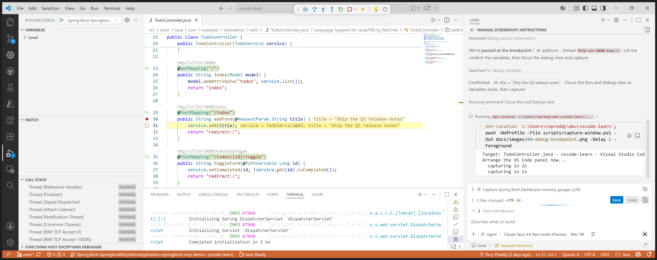
Debug breakpoint
Spring Boot Dashboard Memory view — live heap gauge (auto-captured by scripts/capture-window.ps1):
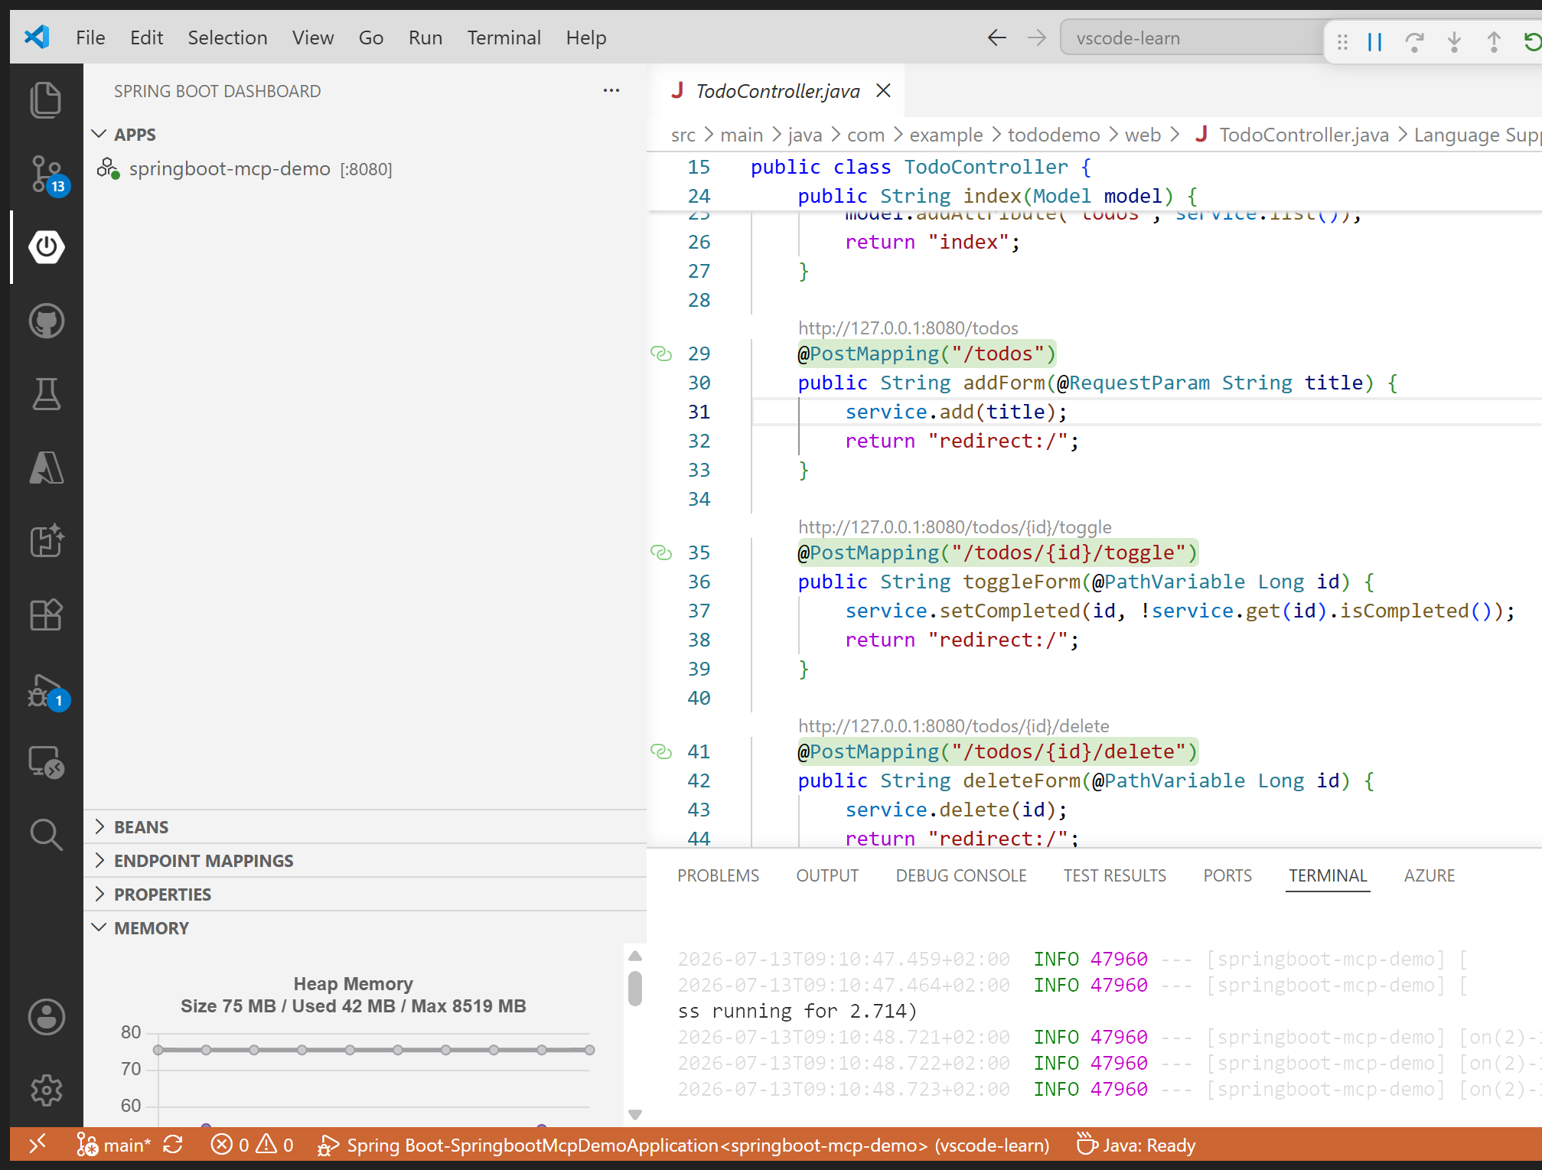
Memory view

Outro — Talking head (~15s)
So that’s a Spring Boot app built, running, and fully debuggable — breakpoints and a live memory view, no print statements, all from VS Code. The whole project’s on GitHub, linked below. Comment your favorite debugging trick. Next video’s the fun one — I’ll turn this app into tools GitHub Copilot can actually call.

Episode 2 of 4 — Expose your endpoints to Copilot with MCP

Intro — Talking head (~15s)
We’ve got our running Spring Boot app — all in the repo if you’re just joining. Everyone’s talking about giving AI agents tools, but hardly anyone exposes their own app that way. I’ll turn my endpoints into MCP tools Copilot can call directly. So let’s jump right in.
Do: End on “let’s jump right in,” then cut to screen share.

Demo
Where | Do | Say
pom.xml | Show the dependency spring-ai-starter-mcp-server-webmvc and the spring-ai-bom 2.0.0. | “To turn my app into tools an AI agent can call, I add one dependency: the Spring AI MCP server.”
mcp/TodoTools.java | Walk through the @McpTool / @McpToolParam annotations on addTodo, listTodos, etc. Point out they just delegate to TodoService. | “Each method gets an @McpTool annotation with a name and description. They reuse the exact same service the web UI uses — no duplicated logic. Five tools: list, get, add, complete, delete.”
application.properties | Highlight spring.ai.mcp.server.protocol=STREAMABLE. | “One critical setting: protocol=STREAMABLE. The WebMVC starter defaults to the old SSE transport — without this, /mcp returns 404.”
Terminal (restart app) | .\mvnw.cmd spring-boot:run and point to the log line Registered tools: 5. | “Restart, and the log confirms all five tools are registered and served at /mcp.”
.vscode/mcp.json | Show the todo-mcp HTTP server entry; click the Start code-lens. | “This file points VS Code at my server over HTTP. I start it right from the editor.”
Copilot Chat (Agent mode) | Enable the todo-mcp tools. Ask: “Use the todo-mcp tools to add a todo called ‘Email the stakeholders’, then list all todos.” Refresh http://localhost:8080. | “Now in Agent mode I ask Copilot to add a todo and list them. It calls my Java code as tools — and the new item shows up in the web UI. Same data, driven by AI.”
Proof it works — a todo created through MCP appears in the web UI (last row):
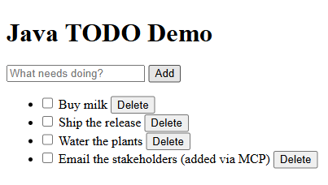
Todo added via MCP
Copilot Chat calling the todo-mcp tools — the add_todo call and its JSON result:
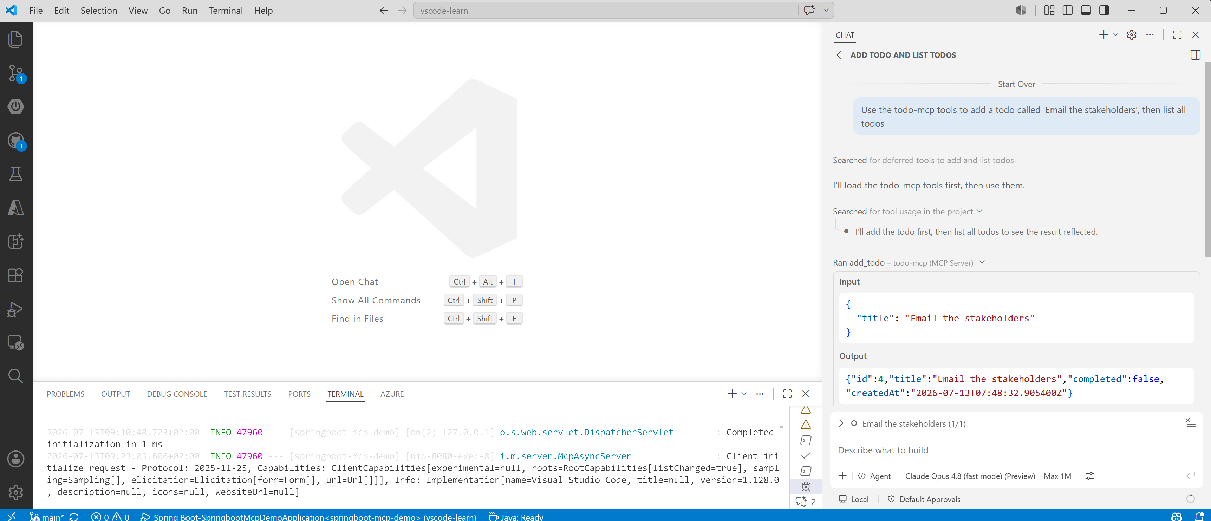
Copilot Chat todo-mcp tool call

Outro — Talking head (~15s)
And there it is — Copilot adding a todo by calling my own Java code, right in the web UI. One dependency, one setting. MCP docs linked below. Comment what you’d expose as a tool. Next up, I’ll let Copilot test this whole flow with Playwright.

Episode 3 of 4 — Let Copilot test it with Playwright

Intro — Talking head (~15s)
Last video I gave Copilot tools to drive my app through MCP — all in the repo if you missed it. UI tests are the thing everyone skips, so what if you didn’t write them at all? I’ll have Copilot drive a real browser with Playwright. Let’s get into it.
Do: End on “let’s get into it,” then cut to screen share.

Demo
Where | Do | Say
templates/index.html | Point out the data-testid hooks: new-todo-input, add-todo, todo-item, delete-todo. | “I added stable test IDs to the UI so automation has reliable selectors.”
Copilot Chat (Agent mode, Playwright MCP) | Ask Copilot to use the Playwright tools to open http://localhost:8080, add a todo, complete it, and delete it. | “Using the Playwright MCP server, I let Copilot drive a real browser — add, complete, delete — end to end, no test code written by hand.”
Browser window (Playwright) | Watch the automated browser perform the add → complete → delete flow. | “There it goes: filling the input, clicking add, toggling, deleting — a full UI smoke test.”
Terminal | Run the JSON-RPC smoke test: powershell -ExecutionPolicy Bypass -File scripts\mcp-smoke-test.ps1 (app running). Show tools/list and add_todo succeeding. Also run .\mvnw.cmd test. | “For a scripted check, this smoke test does the raw MCP handshake — initialize, list tools, call add_todo — the same protocol Copilot uses. And mvnw test covers the service, web UI, and MCP context.”
Actual smoke-test output (verified):
1. initialize -> server: todo-mcp-server v1.0.0 (session ...)
2. notifications/initialized -> sent
3. tools/list -> 5 tools: add_todo, complete_todo, delete_todo, get_todo, list_todos
4. tools/call add_todo -> {"id":4,"title":"Created through the MCP add_todo tool","completed":false,...}
MCP smoke test PASSED.
Playwright driving the UI mid-run — auto-captured by scripts/screenshots/capture.mjs:
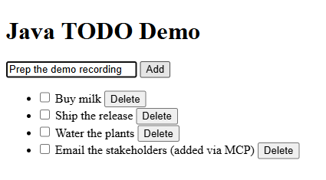
Playwright run

Outro — Talking head (~15s)
So that’s an end-to-end UI test I never wrote, plus a scripted MCP check — both green. The smoke-test script’s in the repo. Comment if you’re using Playwright with Copilot yet. Last episode, I’ll hand a whole new feature to the Copilot cloud agent and let it open the PR.

Episode 4 of 4 — Hand a feature to the Copilot cloud agent

Intro — Talking head (~15s)
Last of four videos taking one Spring Boot app from empty editor to AI-ready — all in the repo if you’re just joining. Here’s the part most people haven’t tried: handing real work to an AI agent and getting a pull request back. So let’s jump right in.
Do: End on “let’s jump right in,” then cut to screen share.

Demo
Where | Do | Say
docs/copilot-agent-issue.md | Open it; show the ready-to-assign task: add Spring Data JPA + H2 persistence and a dueDate field with filtering. | “Todos are in memory on purpose. Here’s a ready-to-go issue asking for real persistence and a due-date feature.”
GitHub — new issue | Paste the issue content, create it, and assign it to @copilot (or use Delegate to coding agent in the GitHub Pull Requests view). | “I assign this to the Copilot coding agent — it works asynchronously in the cloud, just like a teammate.”
GitHub Pull Requests view (VS Code) | Wait for the agent to open a pull request; open it and review the diff (new JPA entity, repository, dueDate, tests). | “A few minutes later the agent opens a pull request — JPA entity, Spring Data repository, the new field, and updated tests.”
PR review | Skim the changes, leave a comment or approve, then merge. | “I review, comment if needed, and merge. From a web app, to MCP tools, to an AI-built feature — all inside VS Code.”
The issue assigned to the Copilot coding agent (@copilot) — auto-captured by scripts/screenshots/capture.mjs:
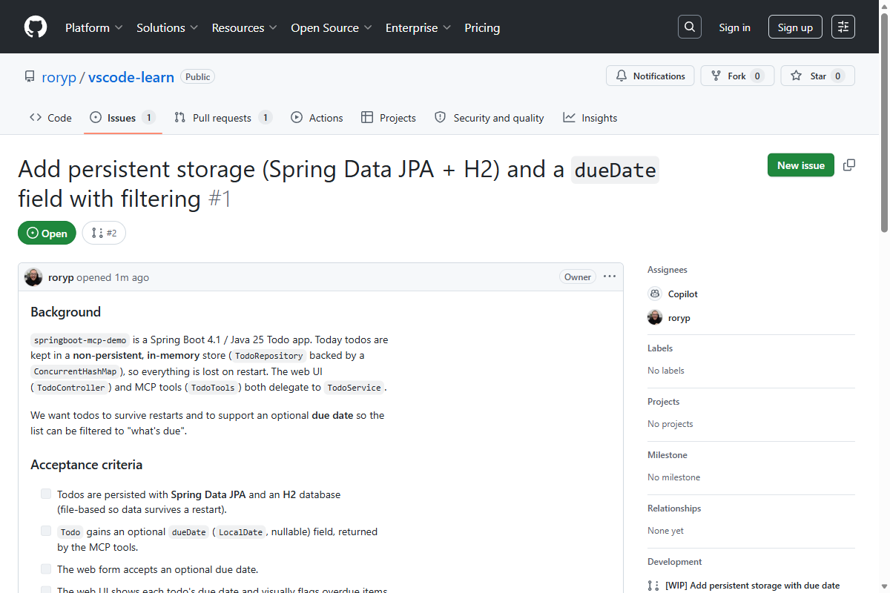
Issue assigned to Copilot
The pull request the Copilot agent opened — its diff (13 files: new JPA entity, repository, dueDate, tests) — auto-captured by scripts/screenshots/capture.mjs:
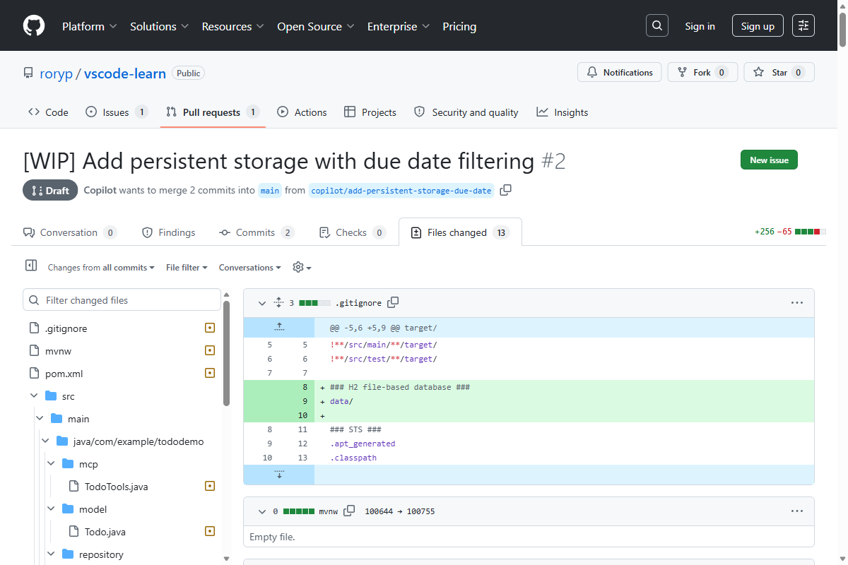
Agent pull request

Outro — Talking head (~20s)
And that’s a full feature — persistence and a due-date field — delivered as a pull request I just review and merge. Over four videos we went from an empty editor to a running app, exposed it to Copilot with MCP, tested it, and let the cloud agent extend it. Want to try it? Grab the extensions, turn on Copilot and the coding agent, and clone the repo — it’s all linked below. Thanks for watching.
Do: Hold on the repo URL (lower-third or on-screen text github.com/roryp/vscode-learn), then fade out.

Resources (video descriptions / hand-off)
- Demo repo: https://github.com/roryp/vscode-learn
- Extension Pack for Java (Microsoft): https://marketplace.visualstudio.com/items?itemName=vscjava.vscode-java-pack
- Spring Boot Extension Pack: search “Spring Boot Extension Pack” in the VS Code Marketplace
- Java in VS Code: https://code.visualstudio.com/docs/languages/java
- Spring Boot Actuator: https://docs.spring.io/spring-boot/
- Spring AI (MCP server): https://docs.spring.io/spring-ai/reference/
- Model Context Protocol: https://modelcontextprotocol.io
- MCP in VS Code: https://code.visualstudio.com/docs/copilot/chat/mcp-servers
- Playwright MCP: https://github.com/microsoft/playwright-mcp
- GitHub Copilot coding agent: https://docs.github.com/en/copilot

