**CSC 1100 – Problem Solving and Programming**

**Project 1 – rory lange**

**50 points – Due March 4, 11am**

**Late deadline is March 6, 11:59pm, but 20% off**

**a)** Save this document with your name and the project number somewhere in the file name.

**b)** Type/paste your answers into the document.

**c)** Submit the following documents to the Canvas assignment link where you downloaded this document:

✓ This document.

✓ Your .cpp files renamed to .txt.

Submit the documents separately, not as one .zip file.

You’ve been hired by *Rental Rambos* to write a C++ console application that projects the finances for a four-unit rental property.

**Projection parameters**

Use a validation loop to prompt for and get from the user a property value in the range $100-1,000. This value will be in thousands of dollars so multiply the user's entry by 1,000 after the loop. Then use a validation loop to prompt for and get from the user a property tax rate in the range 1-7%. Then use a validation loop to prompt for and get from the user the number of renters in the range 0-8. Then use a validation loop to prompt for and get from the user the number of months to project finances for in the range 1-36. For each of the four validation loops, whenever a value is outside the valid range, print an error message and prompt the user again. Use formatted output manipulators (setw, left/right) to print the following Projection Parameter rows:

● Property value ($)

● Property tax rate (%)

● Renters

● Months to project

And columns:

● A left-justified label

● A right-justified value

**Projection**

The projection is printed in a table with **months** rows and five columns. Print column headers for:

● Month

● Income ($)

● Expenses ($)

● Tax ($)

● Tax ($)

● Net ($)

The following are the same for each month so they may be calculated here:

● Income: renters * monthly rent of $1,000

● Tax: property value * (property tax rate / 100) / 12

Totals will be printed after the projection so initialize those: total income, total expenses, total tax, and total net. Use a while statement to loop **months** times and show the projection one month at a time. Within the loop, calculate the following:

● Expenses: (rand() % (max of $2,000 – min of $500 + 1)) + min of $500

● Net: income – expenses – tax

Use formatted output manipulators (setw, left/right) to print the following in one Projection row:

● Month

● Income

● Expenses

● Tax

● Net

Update the four totals.

**Projection totals**

After the loop, print the project totals. Use formatted output manipulators (setw, left/right) to print the following Projection Parameter rows:

● Property value ($)

● Property tax rate (%)

● Renters

● Months to project

And columns:

● A left-justified label

● A right-justified value

Insure that your code is commented! Provide a complete header comment and body comments. Define constants for the monthly rent ($1,000), minimum monthly expense ($500), maximum monthly expense ($2,000), and column widths. Format all real numbers to two decimal places. Use the following statement once near the top of the app to initialize the random number generator:

srand(time(NULL));

The output should look like this for invalid and valid input:

Welcome to Rental Rambos

========================

Enter the property value in thousands (100-1,000): 50

Error: the property value is not between 100 and 1,000.

Enter the property value in thousands (100-1,000): 250

Enter the property tax rate (1-7%): 9

Error: the property tax rate is not between 1 and 7.

Enter the property tax rate (1-7%): 2.35

Enter the number of renters (0-8): 11

Error: the number of renters is not between 0 and 8.

Enter the number of renters (0-8): 4

Enter the number of months to project finances for (1-36): 44

Error: the number of months is not between 1 and 36.

Enter the number of months to project finances for (1-36): 12

Projection Parameters

----------------------------------------------------------------------

Property value ($): 250000.00

Property tax rate (%): 2.35

Renters: 4

Months to project: 12

Projection

----------------------------------------------------------------------

Month Income ($) Expenses ($) Tax ($) Net ($)

1 4000.00 1492.00 489.58 2018.42

2 4000.00 952.00 489.58 2558.42

3 4000.00 1940.00 489.58 1570.42

4 4000.00 1512.00 489.58 1998.42

5 4000.00 1857.00 489.58 1653.42

6 4000.00 1074.00 489.58 2436.42

7 4000.00 980.00 489.58 2530.42

8 4000.00 961.00 489.58 2549.42

9 4000.00 952.00 489.58 2558.42

10 4000.00 1452.00 489.58 2058.42

11 4000.00 1091.00 489.58 2419.42

12 4000.00 1485.00 489.58 2025.42

Totals

----------------------------------------------------------------------

48000.00 15748.00 5875.00 26377.00

End of Rental Rambos

Do not use this sample input for the final runs pasted below.

//Project 1 created by Rory Lange on 2/26/21 for CSC1100

#include <cstdlib> // For several general-purpose functions

#include <fstream> // For file handling

#include <iomanip> // For formatted output

#include <iostream> // For cin, cout, and system

#include <string> // For string data type

using namespace std; // So "std::cout" may be abbreviated to "cout"

void projectionParameters(int value, double tax, int renters, int months, int w, int w1) {

cout << "Projection Parameters" << endl;

cout << "-----------------------------------------------------------------" << endl;

cout << left << setw(w) << "Property Value ($): " << right << setw(w1) << value << endl;

cout << left << setw(w) << "Property Tax Rate (%): " << right << setw(w1) << tax << endl;

cout << left << setw(w) << "Renters: " << right << setw(w1) << renters << endl;

cout << left << setw(w) << "Months to Project: " << right << setw(w1) << months << endl << endl;

}

void Projection(int months, int income, double totalTax, int w) {

const int max = 2000;

const int min = 500;

double net;

double expenses;

double totalIncome = 0;

double totalExpenses = 0;

double totalNet = 0;

double finalTax = 0;

cout << "Projection" << endl;

cout << "-----------------------------------------------------------------" << endl;

cout << right << setw(w) << "Month" << right << setw(w) << "Income ($)" << right << setw(w) << "Expenses ($)"

<< right << setw(w) << "Tax ($)" << right << setw(w) << "Net ($)" << endl;

for (int i = 1; i <= months; i++) {

expenses = (rand() % (max - min + 1)) + min;

net = income - expenses - totalTax;

cout << right << setw(w) << i << right << setw(w) << income << right << setw(w) << expenses

<< right << setw(w) << totalTax << right << setw(w) << net << endl;

totalIncome = totalIncome + income;

totalExpenses = totalExpenses + expenses;

totalNet = totalNet + net;

finalTax = finalTax + totalTax;

}

cout << endl;

cout << "Totals" << endl;

cout << "-----------------------------------------------------------------" << endl;

cout << right << setw(26) << totalIncome << right << setw(w) << totalExpenses << right << setw(w) << finalTax

<< right << setw(w) << totalNet << endl;

}

int main() {

//header

cout << "Rental Rambos monetary calculator" << endl;

cout << "-----------------------------------------------------------------" << endl << endl;

//declare variables

int value; //in 1000s of dollars after user inputs multiply by 1000

const int highVal = 1000;

const int lowVal = 100;

double tax; //percentage

const double highTax = 7;

const double lowTax = 1;

int renters;

const int highRenters = 8;

const int lowRenters = 0;

int months;

const int highMonths = 36;

const int lowMonths = 1;

const int w = 25;

const int w1 = 15;

cout << fixed << setprecision(2);

//prompt for value

cout << "Value of the poperty in 1000s: ";

cin >> value;

while (value < lowVal || value > highVal) {

cout << "Error: Invalid property value" << endl;

cout << "Enter a valid property value: ";

cin >> value;

}

value = value * 1000;

//prompt for tax

cout << "Property Tax Percentage: ";

cin >> tax;

while (tax < lowTax || tax > highTax) {

cout << "Error: Invalid tax percentage" << endl;

cout << "Enter a valid property tax value: ";

cin >> tax;

}

//prompt for renters

cout << "How many renters: ";

cin >> renters;

while (renters < lowRenters || renters > highRenters) {

cout << "Error: Invalid number of renters" << endl;

cout << "Enter a valid number of renters: ";

cin >> renters;

}

//prompt for months

cout << "How many months: ";

cin >> months;

while (months < lowMonths || months > highMonths) {

cout << "Error: Invalid number of months" << endl;

cout << "Enter a valid number of months: ";

cin >> months;

}

cout << endl;

int income = renters * 1000;

double totalTax = value * (tax / 100) / 12;

//projection table

projectionParameters(value, tax, renters, months, w, w1);

//projection

Projection(months, income, totalTax, 13);

//end

cout << endl << "End of Rental Rambos";

}

**If possible, format your code like this:**

**Font “Courier New”**

**Font size “9”**

**Bold**

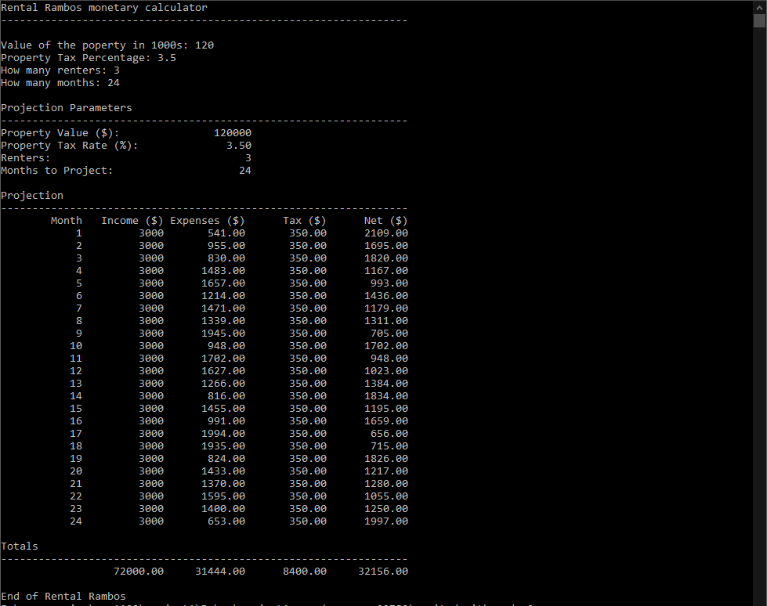

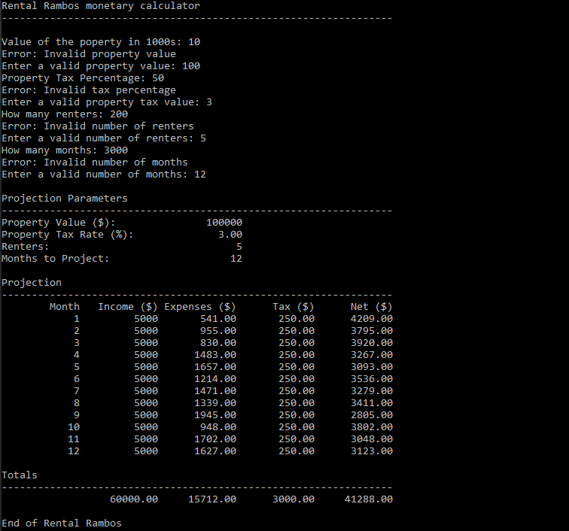

**\* Copying-and-pasting C++ code to a Word document**

**macOS**

1) From within the C++ program, press **command-A** and press **command-C**.

2) From within the Word document, press **command-V**.

**Windows**

1) From within the C++ program, press **CTRL-A** and press **CTRL-C**.

2) From within the Word document, press **CTRL-V**.

**\*\* Copying-and-pasting C++ console application output to a Word document**

**macOS**

1) From the C++ console, press **shift-command-4-space**.

2) From within the Word document, **command-V**.

**Windows**

1) From the C++ console, press **ALT-PrintScreen**.

2) From within the Word document, press **CTRL-V**.