**CSC 1101 – Problem Solving and Programming Laboratory – Winter 2021**

**Lab 1 – rory lange**

**25 points – Due January 19, end-of-class**

**a)** Save this document with your name and the lab assignment number somewhere in the file name.

**b)** Type/paste your answers into the document.

**c)** Submit the following two documents to the Canvas assignment link where you downloaded this document: this document and your .cpp file renamed to .txt. Submit the documents separately, not as one .zip file.

Create a new Visual Studio Empty Project and name the project “Lab01”. The location of this project should be in the “CSC1101” folders you created during WarmUpLab01 last week.

Add a new item to your project. This file should be a C++ File (.cpp) and named Lab01.cpp. Download and copy the file contents from Lab01.txt into your Lab01.cpp file. Fill out all header information with your information. Examine lines 43 – 45 and/or lines 92 – 96 **ONLY** in your code. Run the program, follow the command window prompt, and attempt to answer the questions (your answers will not affect your grade).

**//==========================================================**

**//This is the header information**

**//**

**// Title:      Lab 01**

**// Course:     CSC 1101**

**// Lab Number: 1**

**// Author:     Rory Lange**

**// Date:       1/19/21**

**// Description:**

**//   Tests students ability to set up a file, follow a**

**//   simple project, and communicate with the keyboard for**

**//   inputs and outputs.**

**//**

**//==========================================================**

**#include <cstdlib> // For several general-purpose functions**

**#include <fstream> // For file handling**

**#include <iomanip> // For formatted output**

**#include <iostream> // For cin, cout, and system**

**#include <string> // For string data type**

**using namespace std; // So "std::cout" may be abbreviated to "cout"**

**int Menu();**

**int main()**

**{**

**//Declare Constants**

**const int COLM1 = 30;**

**const int COLM2 = 25;**

**const int COLM3 = 50;**

**// Declare variables**

**string name, accessID; // Quicker but less recommended way of declaration using same data type**

**string slogan;         // It is recommended to declare one variable per line regardless of type**

**int answer;**

**double experience;**

**// Show application header**

**cout << "Welcome to my Application!" << endl;**

**cout << "--------------------------" << endl;**

**// Write to screen**

**cout << "\nHi There!\n";**

**cout << "I am looking forward to working with you. ";**

**cout << "Lets have a great semester!" << endl << endl;**

**// Request user information**

**cout << "Enter your name: ";**

**// Store user information for later use..**

**getline(cin, name);**

**cout << "Enter your access ID: ";**

**cin >> accessID;**

**cout << "Enter your number of years of programming experience: ";**

**cin >> experience;**

**cin.ignore(1000, '\n');**

**cout << "What's your personal slogan for 2021?: ";**

**getline(cin, slogan);**

**cout << endl;**

**//cin.ignore(1000, '\n');**

**// The variable answer stores the data obtained from the function Menu()**

**answer = Menu();**

**cout << setw(COLM1) << left << "Name: " << setw(COLM2) << left << name << endl;**

**cout << setw(COLM1) << left << "Access ID: " << setw(COLM1) << left << accessID << endl;**

**cout << setw(COLM1) << left << "Years of Experience: " << setw(COLM1) << left << experience << endl;**

**cout << setw(COLM1) << left << "Choice: " << setw(COLM1) << left << answer << endl << endl;**

**cout << setw(COLM1) << left << "Personal Slogan: " << setw(COLM3) << left << slogan << endl;**

**// Show application close**

**cout << "\nEnd of my Application" << endl;**

**return 0;**

**}**

**int Menu() {**

**// Declare a variable**

**int choice = 0;**

**do {**

**// Request user decision**

**cout << "Multiple Choice Question" << endl;**

**cout << "---------------------------------------------------------------------" << endl;**

**cout << "Which of the following is (are) true." << endl;**

**cout << "What is the effect of beginning or ending a line with the following: " << endl;**

**cout << "new line character(\\n), endl, or semi-colon(;)?\n";**

**cout << "---------------------------------------------------------------------" << endl;**

**cout << "1. '\\n' forces output to continue printing on a new line. \n";**

**cout << "2. endl forces output to continue printing on a new line." << endl;**

**cout << "3. ';' will make all the output";**

**cout << " print on the same line";**

**cout << endl;**

**cout << "4. All of the Above." << endl << endl;**

**cout << "Choice (Enter a selection from 1-4): ";**

**//Store user decision**

**cin >> choice;**

**cout << endl;**

**} while (choice < 1 || choice > 4);**

**if (choice != 4) cout << "Incorrect, but dont worry your answer will not count against you" << endl << endl;**

**else cout << "Correct!" << endl << endl;**

**return choice;**

**}**

**///////////////////////////////////////////////////////////////////////////////**

**Welcome to my Application!**

**--------------------------**

**Hi There!**

**I am looking forward to working with you. Lets have a great semester!**

**Enter your name: rory**

**Enter your access ID: hc9332**

**Enter your number of years of programming experience: 1**

**What's your personal slogan for 2021?: uhhh**

**Multiple Choice Question**

**---------------------------------------------------------------------**

**Which of the following is (are) true.**

**What is the effect of beginning or ending a line with the following:**

**new line character(\n), endl, or semi-colon(;)?**

**---------------------------------------------------------------------**

**1. '\n' forces output to continue printing on a new line.**

**2. endl forces output to continue printing on a new line.**

**3. ';' will make all the output print on the same line**

**4. All of the Above.**

**Choice (Enter a selection from 1-4): 2**

**Incorrect, but dont worry your answer will not count against you**

**Name: rory**

**Access ID: hc9332**

**Years of Experience: 1**

**Choice: 2**

**Personal Slogan: uhhh**

**End of my Application**

**PS C:\Users\rorys\OneDrive - Wayne State University\CSC1101\labs\Lab 01>**

Example of Output for Submission:

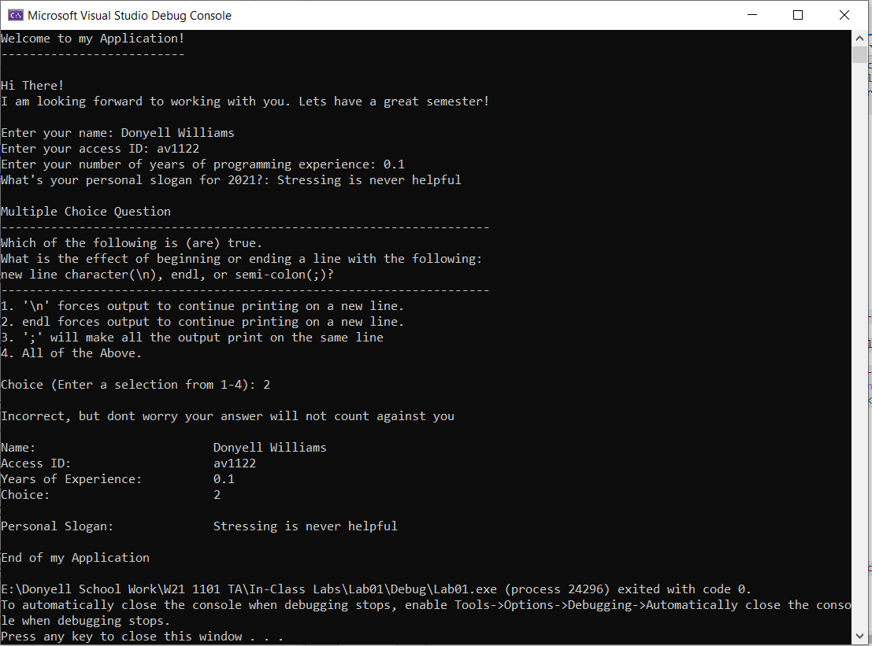

**\* Copying-and-pasting C++ code to a Word document**

**macOS**

1) From within the C++ program, press **command-A** and press **command-C**.

2) From within the Word document, press **command-V**.

**Windows**

1) From within the C++ program, press **CTRL-A** and press **CTRL-C**.

2) From within the Word document, press **CTRL-V**.

**\*\* Copying-and-pasting C++ console application output to a Word document**

**macOS**

1) From the C++ console, press **shift-command-4-space**.

2) From within the Word document, **command-V**.

**Windows**

1) From the C++ console, press **ALT-PrintScreen**.

2) From within the Word document, press **CTRL-V**.