**CSC 1101 – Problem Solving and Programming Laboratory – Winter 2021**

**Lab 3 – rory lange**

**25 points – Due January 26, end-of-class**

**a)** Save this document with your name and the lab assignment number somewhere in the file name.

**b)** Type/paste your answers into the document.

**c)** Submit the following two documents to the Canvas assignment link where you downloaded this document: this document and your .cpp file renamed to .txt. Submit the documents separately, not as one .zip file.

The purpose of this assignment is to fix my busted program that should do the following two things: encode a statement by moving each character 3 spaces to the right or decode a statement by moving each character 3 spaces to the left. I need a lot of help and I have no idea where I went wrong. Please also leave me comments to help me in the future.

1. Create a Visual Studio program named Lab03. Download and add Lab03.cpp to your Visual Studio project as an “Existing Item”.
2. Complete the header comment in Lab03.cpp
3. Declare several variables with the following information:
   1. **Three string** data types named statement, cipher, and decipher. Initialize the variable statement using a string literal that contains the phrase “Don’t eat tide pods”
   2. **Two integer** data types named numLetters and choice. Initialize choice to zero.
   3. **One boolean** data type named flag that is initialized to “false”.
4. Within your main program locate the **two** pieces of pseudo-code that needs to be commented out and create single line comments on those lines.
5. Add the following as block comments (multi-line comments) above their respective functions
   1. Add the following statement above the function encode() “The function encode() alters a statement by moving each character in the statement 3 spaces to right then returns the altered statement to the program as a string.”
   2. Add the following statement above the function decode() “The function decode() alters a statement by moving each character in the statement 3 spaces to left then returns the altered statement to the program as a string.”
6. Answer the question in the prompt correctly. Hint: my provided answer in the example output below is incorrect.
7. Don’t forget to submit both your Word document and the .txt file of your program

**//==========================================================**

**//**

**// Title:      Lab 03**

**// Course:     CSC 1101**

**// Lab Number: 03**

**// Author:     rory lange**

**// Date:       1/26/21**

**// Description:**

**//   <brief description of application including its inputs,**

**// processing, and outputs>**

**//**

**//==========================================================**

**#include <cstdlib> // For several general-purpose functions**

**#include <fstream> // For file handling**

**#include <iomanip> // For formatted output**

**#include <iostream> // For cin, cout, and system**

**#include <string> // For string data type**

**#include <cstring>**

**using namespace std; // So "std::cout" may be abbreviated to "cout"**

**string encode(string statement, int length);**

**string decode(string statement, int length);**

**int main()**

**{**

**//Show application header**

**cout << "Welcome to my Application!" << endl;**

**cout << "--------------------------" << endl << endl;**

**// Declare variables**

**string statement = "dont eat tide pods";**

**string cipher;**

**string decipher;**

**int numLetters;**

**int choice = 3;**

**bool flag = false;**

**//Length of your statement**

**numLetters = statement.length();**

**//Call the functions needed**

**cipher = encode(statement, numLetters + 1);**

**decipher = decode(cipher, numLetters + 1);**

**do {**

**cout << "Question of the day" << endl;**

**cout << "Which of the following is NOT a keyword (Your answer is gra/ded): \n";**

**cout << "1. namespace \t 2. double \t 3. length \t 4. return \t 5. false\n";**

**cout << "Your choice: ";**

**cin >> choice;**

**} while (choice < 1 || choice >5);**

**flag = (choice == 3) ? true : false;**

**//Print coded and decoded message to the screen**

**cout << "\nYour coded message was: " << cipher << endl;**

**cout << "Your decoded message was: " << decipher << endl;**

**cout << "Your answer to the multiple choice question was: " << choice << endl;**

**cout << "Flag = " << flag << endl;**

**// Show application close**

**cout << "\nEnd of my Application" << endl;**

**}**

**//Add mulit-line comment**

**/\***

**The function encode() alters a statement by moving each character in the**

**statement 3 spaces to right then returns the altered statement to the**

**program as a string**

**\*/**

**string encode(string statement, int length) {**

**//Declare variable**

**string message = "";**

**// Declaring character array for use**

**char statement_array[100];**

**// Copys string into character array for easy usage**

**strcpy_s(statement_array, statement.c_str());**

**for (int i = 0; i < length; i++) {**

**statement_array[i] = (char)(statement_array[i] + 2);**

**message = message + statement_array[i];**

**}**

**return message;**

**}**

**//Add mulit-line comment**

**/\***

**The function decode() alters a statement by moving each character in the**

**statement 3 spaces to left then returns the altered statement to the**

**program as a string**

**\*/**

**string decode(string statement, int length) {**

**//Declare variable**

**string message = "";**

**// Declaring character array for use**

**char statement_array[100];**

**// Copys string into character array for easy usage**

**strcpy_s(statement_array, statement.c_str());**

**for (int i = 0; i < length; i++) {**

**statement_array[i] = (char)(statement_array[i] - 2);**

**message = message + statement_array[i];**

**}**

**return message;**

**}**

**If possible, format your code like this:**

**Font “Courier New”**

**Font size “9”**

**Bold**

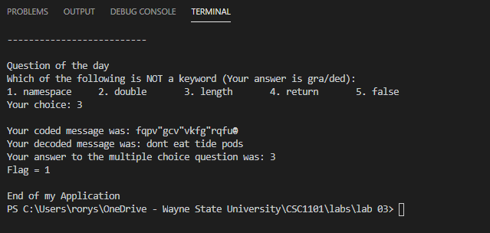

Example of Program Output:

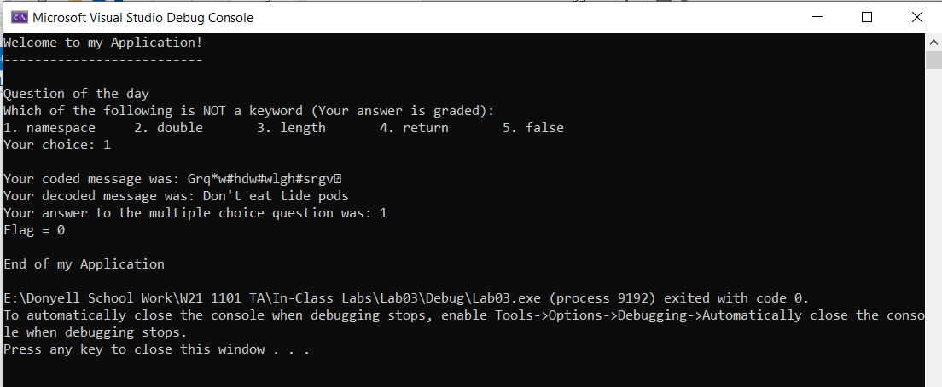

**\* Copying-and-pasting C++ code to a Word document**

**macOS**

1) From within the C++ program, press **command-A** and press **command-C**.

2) From within the Word document, press **command-V**.

**Windows**

1) From within the C++ program, press **CTRL-A** and press **CTRL-C**.

2) From within the Word document, press **CTRL-V**.

**\*\* Copying-and-pasting C++ console application output to a Word document**

**macOS**

1) From the C++ console, press **shift-command-4-space**.

2) From within the Word document, **command-V**.

**Windows**

1) From the C++ console, press **ALT-PrintScreen**.

2) From within the Word document, press **CTRL-V**.