**CSC 1101 – Problem Solving and Programming Laboratory**

**Lab 4 – rory lange**

**25 points – Due February 1, 11pm**

**a)** Save this document with your name and the lab assignment number somewhere in the file name.

**b)** Type/paste your answers into the document.

**c)** Submit the following documents to the Canvas assignment link where you downloaded this document:

✓ This document.

✓ Your .cpp files renamed to .txt.

Submit the documents separately, not as one .zip file.

You will write two programs in this lab. You may use one Visual Studio / Xcode project and switch among your C++ .cpp files, or create one Visual Studio / Xcode project for each program.

**1) [12 points]** You've been hired by *Edgy Egrets* to complete a C++ console application that displays information about the number of geese observed on a golf course. Start with file **Lab04-01. cpp** and make the following edits:

1) Complete the header comment.

2) Declare three variables: course (string), days (int), geese (int).

3) Add an application header using cout statements.

4) Enter a rough (truncated) calculation for the average geese observed per day.

5) Enter a precise (non-truncated) calculation for the average geese observed per day.

6) Add an application close using a cout statement.

Run the application with a golf course and numbers of your choice, and paste your output screenshot below. What happens if you accidentally enter a golf course name instead of a number for observation days? Paste your output screenshot below.

Gives an error message saying that a number cannot be divided by zero, probably because letters do not have a numerical value when they are in the integer format.

**//==========================================================**

**//**

**// Title: lab 04**

**// Course: CSC 1101**

**// Lab Number: 04**

**// Author: rory lange**

**// Date: 1/28/21**

**// Description:**

**// <brief description of application including its inputs,**

**// processing, and outputs>**

**//**

**//==========================================================**

**#include <cstdlib> // For several general-purpose functions**

**#include <fstream> // For file handling**

**#include <iomanip> // For formatted output**

**#include <iostream> // For cin, cout, and system**

**#include <string> // For string data type**

**using namespace std; // So "std::cout" may be abbreviated to "cout"**

**int main()**

**{**

**// Declare variables**

**// your code here ...**

**string course;**

**int days;**

**int geese;**

**// Show application header**

**// your code here ...**

**cout << "average geese calculator" << endl << endl;**

**// Prompt for and get course name**

**cout << "Enter golf course name (no spaces): ";**

**cin >> course;**

**// Prompt for and get observation days**

**cout << "Enter observation days: ";**

**cin >> days;**

**// Prompt for and get course name**

**cout << "Enter observed geese: ";**

**cin >> geese;**

**// Print inputs and outputs**

**cout << "\nGolf course:\t\t\t" << course << endl;**

**cout << "Observation days:\t\t" << days << endl;**

**cout << "Observed geese:\t\t\t" << geese << endl;**

**cout << "Rough average geese per day:\t"**

**<< geese / days << endl;**

**cout << "Precise average geese per day:\t"**

**<< (float) geese / days << endl;**

**// Show application close**

**cout << "\nEnd of geese calculation - " << "Lab 04";**

**// your code here ...**

**}**

**If possible, format your code like this:**

**Font “Courier New”**

**Font size “9”**

**Bold**

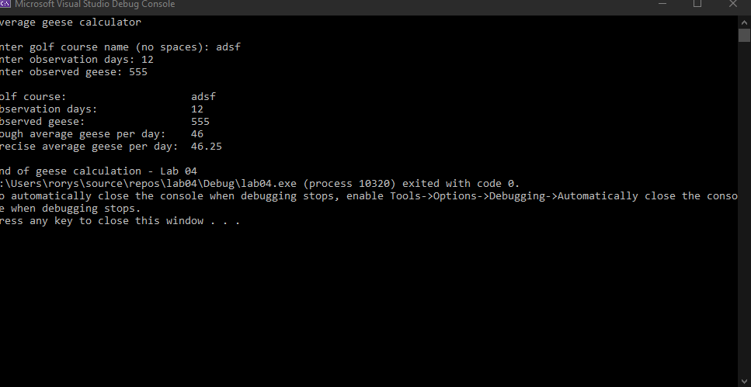

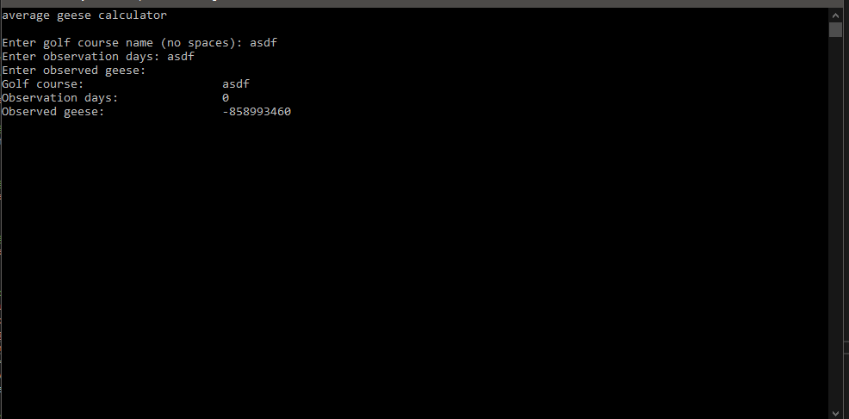

**2) [13 points]** You've been hired by *Binary Buffaloes* to write a C++ console application that converts a decimal number to a binary number. Start with file **Lab04-02. cpp** and make the following edits:

1) Complete the header comment.

2) Declare constant BASE (int) with value 2.

3) Declare three variables: numDec (int), numBin (int), and numStr (string).

4) Add an application header using cout statements.

5) Add an application close using a cout statement.

Run the program three times with different values for the decimal number. What are the results?

|  |  |  |
| --- | --- | --- |
| Run | Decimal number | Binary number |
| **1** | 1 | 1 |
| **2** | 4576 | 1000111100000 |
| **3** | 21 | 10101 |

Is there a limit to the decimal number that may be entered?

Yes the limit is 2147483647.

**//==========================================================**

**//**

**// Title: Lab 04 - 02**

**// Course: CSC 1101**

**// Lab Number: 04**

**// Author: rory lange**

**// Date: 2/1/21**

**// Description:**

**// <brief description of application including its inputs,**

**// processing, and outputs>**

**//**

**//==========================================================**

**#include <cstdlib> // For several general-purpose functions**

**#include <fstream> // For file handling**

**#include <iomanip> // For formatted output**

**#include <iostream> // For cin, cout, and system**

**#include <string> // For string data type**

**using namespace std; // So "std::cout" may be abbreviated to "cout"**

**int main()**

**{**

**// Declare constants**

**// your code here ...**

**const int BASE = 2;**

**// Declare variables**

**// your code here ...**

**int numDec;**

**int numBin;**

**string numStr;**

**// Show application header**

**// your code here ...**

**cout << "Binary Buffalos decimal to binary number converter" << endl << endl;**

**// Prompt for and get decimal number**

**cout << "Enter a decimal number: ";**

**cin >> numDec;**

**// Loop to convert decimal to binary**

**cout << "Decimal " << numDec << " is binary ";**

**numStr = "";**

**while (numDec > 0)**

**{**

**numBin = numDec % BASE;**

**if (numBin == 0)**

**numStr = "0" + numStr;**

**else**

**numStr = "1" + numStr;**

**numDec = numDec / BASE;**

**}**

**cout << numStr << endl << endl;**

**// Show application close**

**// your code here ...**

**cout << "end of decimal to binary conversions";**

**}**

**If possible, format your code like this:**

**Font “Courier New”**

**Font size “9”**

**Bold**

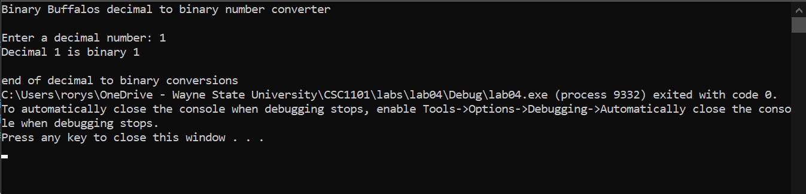

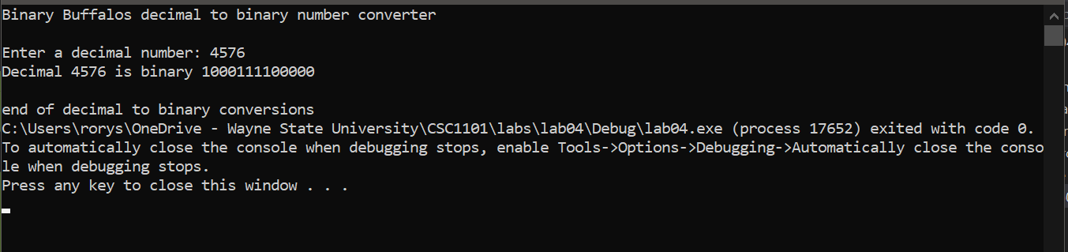

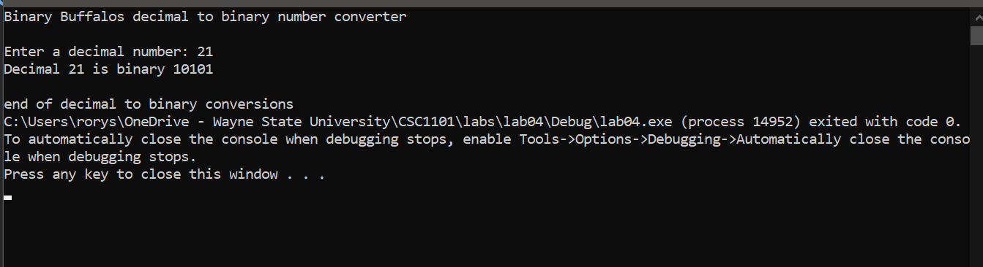

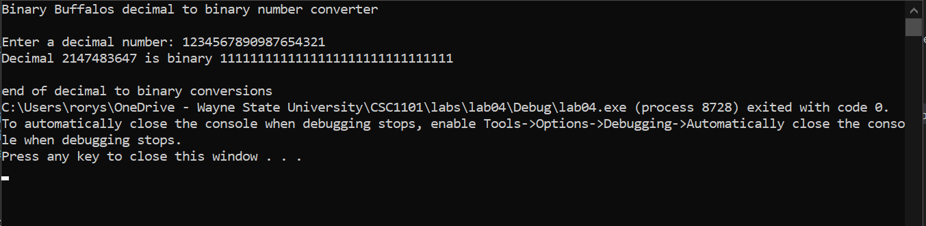

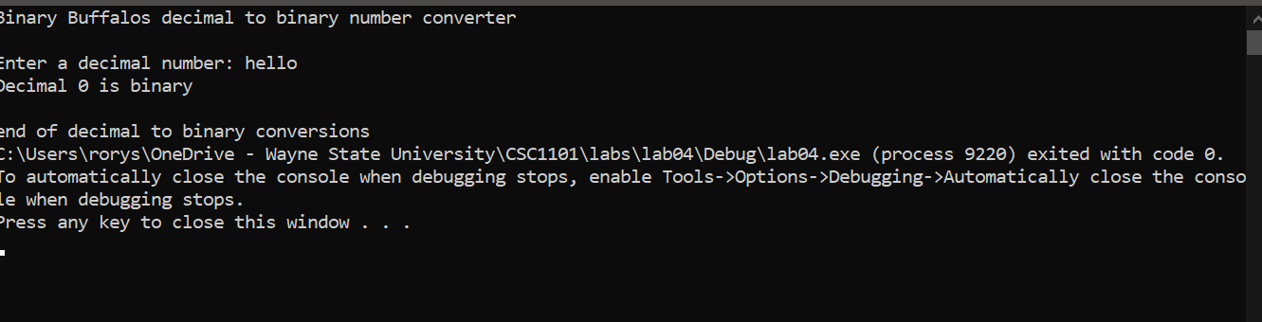

**\* Copying-and-pasting C++ code to a Word document**

**macOS**

1) From within the C++ program, press **command-A** and press **command-C**.

2) From within the Word document, press **command-V**.

**Windows**

1) From within the C++ program, press **CTRL-A** and press **CTRL-C**.

2) From within the Word document, press **CTRL-V**.

**\*\* Copying-and-pasting C++ console application output to a Word document**

**macOS**

1) From the C++ console, press **shift-command-4-space**.

2) From within the Word document, **command-V**.

**Windows**

1) From the C++ console, press **ALT-PrintScreen**.

2) From within the Word document, press **CTRL-V**.