**CSC 1101 – Problem Solving and Programming Laboratory – Winter 2021**

**Lab [05] – rory lange**

**25 points – Due 2/2/21, end-of-class**

**a)** Save this document with your name and the lab assignment number somewhere in the file name.

**b)** Type/paste your answers into the document.

**c)** Submit the following two documents to the Canvas assignment link where you downloaded this document: this document and your .cpp file renamed to .txt. Submit the documents separately, not as one .zip file.

You've been hired by BMI Buddy to complete a C++ console application that calculates the BMI of a person. Start with file **Lab05.cpp** and make the following edits:

1) Complete the header comment.

2) Declare two constants for your formatted output: COLFMT1, COLFMT2.

3) Declare four variables: name, height, BMI, and weight.

4) Format all real numbers to print with one decimal point.

5) Add an application header.

6) Enter a calculation for the BMI using formula:

BMI = (703 * weight) / (height * height)

7) Add formatted output for height **in cm**, weight **in kg**, and BMI.

Some useful formulas:

1 inch = 2.54cm

1lb = .45kg

8) Add an application close.

Your output should look like the following:

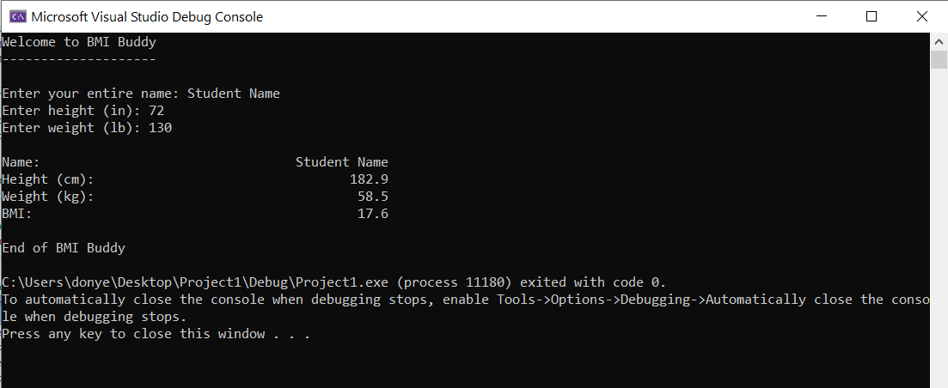

**//==========================================================**

**//**

**// Title: lab 05**

**// Course: CSC 1101**

**// Lab Number: 05**

**// Author: rory lange**

**// Date: 2/2/21**

**// Description:**

**// <brief description of application including its inputs,**

**// processing, and outputs>**

**//**

**//==========================================================**

**#include <cstdlib> // For several general-purpose functions**

**#include <fstream> // For file handling**

**#include <iomanip> // For formatted output**

**#include <iostream> // For cin, cout, and system**

**#include <string> // For string data type**

**using namespace std; // So "std::cout" may be abbreviated to "cout"**

**int main()**

**{**

**// Declare constants**

**// your code here ...**

**const int COLFMT1 = 15;**

**const int COLFMT2 = 10;**

**// Declare variables**

**// your code here ...**

**string name;**

**double height;**

**double BMI;**

**double weight;**

**// Set real-number precision**

**// your code here ...**

**cout << fixed << setprecision(1);**

**// Show application header**

**// your code here ...**

**cout << "BMI CALCULATOR FROM BMI BUDDY" << endl << endl;**

**// Prompt for and get inputs**

**cout << "Enter your entire name: ";**

**getline(cin, name);**

**cout << "Enter height (in): ";**

**cin >> height;**

**cout << "Enter weight (lb): ";**

**cin >> weight;**

**// Calculate BMI and metric conversions**

**// your code here ...**

**BMI = (703 * weight) / (height * height);**

**// Print inputs and outputs**

**cout << endl;**

**cout << setw(COLFMT1) << left << "Name: " << setw(COLFMT2) << right << name << endl;**

**// your code here ...**

**cout << setw(COLFMT1) << left << "height (cm): " << setw(COLFMT2) << right << (float) height * 2.54 << endl;**

**cout << setw(COLFMT1) << left << "weight (kg): " << setw(COLFMT2) << right << (float) weight * .45 << endl;**

**cout << setw(COLFMT1) << left << "BMI: " << setw(COLFMT2) << right << BMI << endl << endl;**

**// Show application close**

**// your code here ...**

**cout << "END OF CALCULATIONS FOR BMI BUDDY";**

**}**

**If possible, format your code like this:**

**Font “Courier New”**

**Font size “9”**

**Bold**

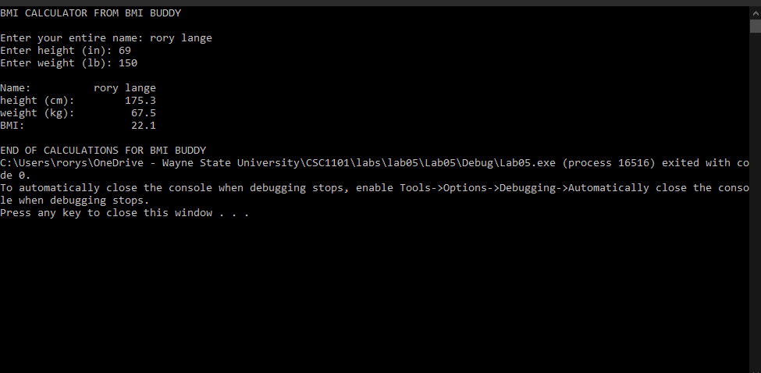

**\* Copying-and-pasting C++ code to a Word document**

**macOS**

1) From within the C++ program, press **command-A** and press **command-C**.

2) From within the Word document, press **command-V**.

**Windows**

1) From within the C++ program, press **CTRL-A** and press **CTRL-C**.

2) From within the Word document, press **CTRL-V**.

**\*\* Copying-and-pasting C++ console application output to a Word document**

**macOS**

1) From the C++ console, press **shift-command-4-space**.

2) From within the Word document, **command-V**.

**Windows**

1) From the C++ console, press **ALT-PrintScreen**.

2) From within the Word document, press **CTRL-V**.