**CSC 1101 – Problem Solving and Programming Laboratory – Winter 2021**

**Lab 7 – rory lange**

**25 points – Due 2/9, end-of-class**

**a)** Save this document with your name and the lab assignment number somewhere in the file name.

**b)** Type/paste your answers into the document.

**c)** Submit the following two documents to the Canvas assignment link where you downloaded this document: this document and your .cpp file renamed to .txt. Submit the documents separately, not as one .zip file.

Your advisor saw that you have been doing amazing in class and suggested to WSU that you make a program that allows students to check-in with their advisors. The college has requested that you also create a formatted table that shows the student’s check-in information. After receiving the student information you will display the student’s full name, first name, last name, and the percentage of the degree that the student has completed. Start with the C++ template or other sample application on Canvas.

1. Complete the header comment
2. Declare constants:
   1. **Two** column widths **(int)**.
   2. the number of credits needed to graduate which is 120 **(int)**.
3. Declare variables.
4. Set your precision to **two** decimal points (all numbers will be rounded to the 100ths place)
5. Request the following information from the student:
   1. First name
   2. Last name
   3. Number of credits they have completed toward their degree.
6. Calculate the percentage of the student’s degree that has been completed

1 - (Credits_to_graduate – student_credits)/100

1. Display all information in a table like the one shown below.
   1. Concatenate the first and last name variables to form and print a full name
   2. Use formatted output (setw, left/right) to print headings and data for first name (left), last name (left), and degree completed (right)
2. Submit both your word document with you code and screenshots, and your txt file with your code.

Sample Output:

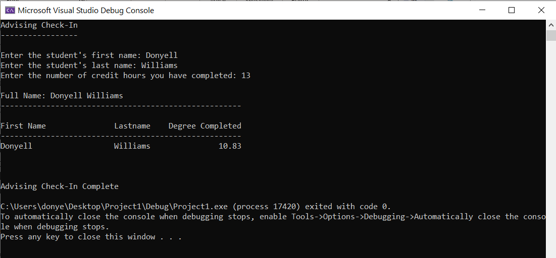

//==========================================================//

// Title: advising check in

// Course: CSC 1101

// Lab Number: 07

// Author: rory lange

// Date: 2/9/21

// Description:

//

// <brief description of application including its inputs

// processing, and outputs>

//

//==========================================================

#include <cstdlib> // For several general-purpose functions

#include <fstream> // For file handling

#include <iomanip> // For formatted output

#include <iostream> // For cin, cout, and system

#include <string> // For string data type

using namespace std; // So "std::cout" may be abbreviated to "cout"

int main(){

// Declare variables

const int w = 20;

const int w1 = 15;

const int graduate = 120;

int credits;

double degree;

string firstName;

string lastName;

string fullName;

// Show application header

cout << "ADVISING CHECK IN" << endl;

cout << "--------------------------" << endl << endl;

//get user input

cout << "Enter the user's first name: ";

cin >> firstName;

cout << endl;

cout << "Enter the user's last name: ";

cin >> lastName;

cout << endl;

cout << "Enter the number of credit hours the user has completed: ";

cin >> credits;

cout << endl << endl;

//make full name

fullName = firstName + " " + lastName;

cout << "Full Name: " << fullName << endl;

cout << "----------------------------------------------------" << endl << endl;

//calculate degree %

degree = (1 - ((double)(graduate - credits) / graduate)) * 100;

//degree = (double)(credits / graduate) * 100;

//set precision

cout << fixed << setprecision(2);

cout << setw(w) << left << "First Name" << setw(w1) << left << "Last Name" << setw(w1) << right << "Degree Completed" << endl;

cout << "----------------------------------------------------" << endl;

cout << setw(w) << left << firstName << setw(w1) << left << lastName << setw(w1) << right << degree;

// Show application close

cout << "\nEnd of my Application" << endl;

}

**If possible, format your code like this:**

**Font “Courier New”**

**Font size “9”**

**Bold**

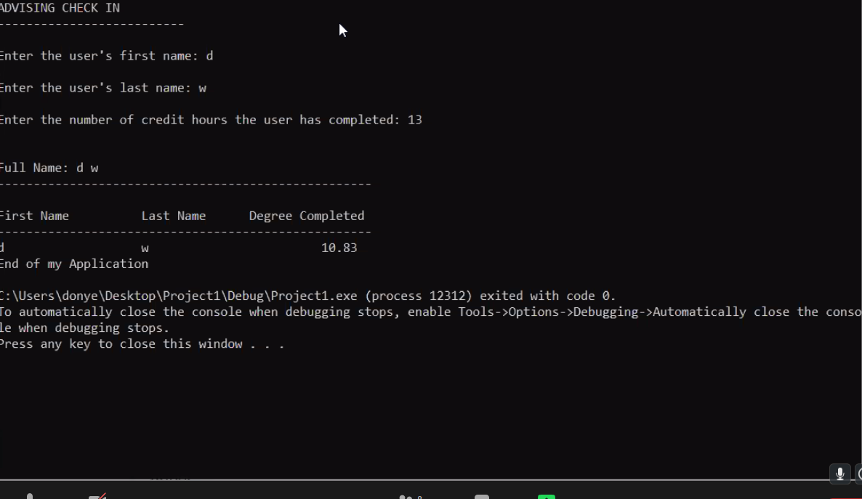

**\* Copying-and-pasting C++ code to a Word document**

**macOS**

1) From within the C++ program, press **command-A** and press **command-C**.

2) From within the Word document, press **command-V**.

**Windows**

1) From within the C++ program, press **CTRL-A** and press **CTRL-C**.

2) From within the Word document, press **CTRL-V**.

**\*\* Copying-and-pasting C++ console application output to a Word document**

**macOS**

1) From the C++ console, press **shift-command-4-space**.

2) From within the Word document, **command-V**.

**Windows**

1) From the C++ console, press **ALT-PrintScreen**.

2) From within the Word document, press **CTRL-V**.