**CSC 1101 – Problem Solving and Programming Laboratory**

**Lab 8 – [your name]**

**25 points – Due February 15, 11pm**

**a)** Save this document with your name and the lab assignment number somewhere in the file name.

**b)** Type/paste your answers into the document.

**c)** Submit the following documents to the Canvas assignment link where you downloaded this document:

✓ This document.

✓ Your .cpp files renamed to .txt.

Submit the documents separately, not as one .zip file.

**1) [10 points]** You've been hired by *Moisture Madcaps* to write a C++ console application that analyzes a ground-level humidity level. Prompt for and get from the user a humidity level as a percentage. Use one **if statement\*** to analyze the level per the following table:

|  |  |
| --- | --- |
| Level | Message to print |
| **< 0** | Error: the level must be greater than or equal to 0. |
| **<= 20** | You must be in the desert! |
| **<= 60** | That's a comfortable level. |
| **<= 100** | Soon it's gonna rain! |
| **> 100** | Error: the level must be less than or equal to 100. |

Define constants for the desert level boundary (20) and rain level boundary (60). The output should look like this for invalid and valid input:

Welcome to Moisture Madcaps

---------------------------

Enter the current ground-level humidity (0%-100%): -4

Error: the level must be greater than or equal to 0.

End of Moisture Madcaps

Welcome to Moisture Madcaps

---------------------------

Enter the current ground-level humidity (0%-100%): 62

Soon it's gonna rain!.

End of Moisture Madcaps

Do not use this sample input for the final runs pasted below.

//==========================================================

//

// Title: lab08

// Course: CSC 1101

// Lab Number: 08

// Author: rory lange

// Date: 2/11/21

// Description:

// <brief description of application including its inputs,

// processing, and outputs>

//

//==========================================================

#include <cstdlib> // For several general-purpose functions

#include <fstream> // For file handling

#include <iomanip> // For formatted output

#include <iostream> // For cin, cout, and system

#include <string> // For string data type

using namespace std; // So "std::cout" may be abbreviated to "cout"

int main()

{

// Declare variables

const int desert = 20;

const int rain = 100;

const int comfort = 60;

int humidity;

// Show application header

cout << "HUMIDITY CALCULATOR" << endl;

cout << "--------------------------" << endl << endl;

//get user input

cout << "Enter the current ground-level humidity (%): ";

cin >> humidity;

cout << endl;

if (humidity < 0)

cout << "Error: THE HUMIDITY LEVEL MUST BE >= 0." << endl;

else if (humidity >= 0 && humidity <= desert)

cout << "You must be in the desert!" << endl;

else if (humidity > desert && humidity <= comfort)

cout << "Thats a comfortable level." << endl;

else if (humidity > comfort && humidity <= rain)

cout << "Soon its gonna rain!" << endl;

else

cout << "Error: THE LEVEL MUST BE LESS THAN OR EQUAL TO 100" << endl;

// Show application close

cout << "\NEND OF MOISTURE MADCAPS CALCULATIONS..." << endl;

}

**If possible, format your code like this:**

**Font “Courier New”**

**Font size “9”**

**Bold**

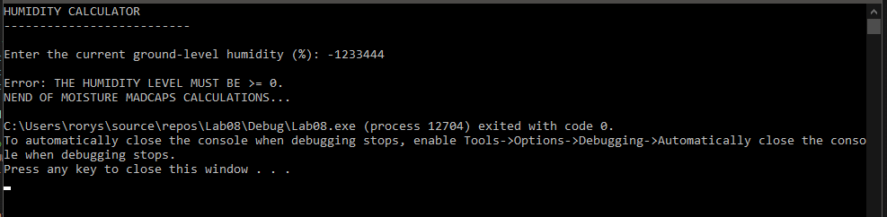

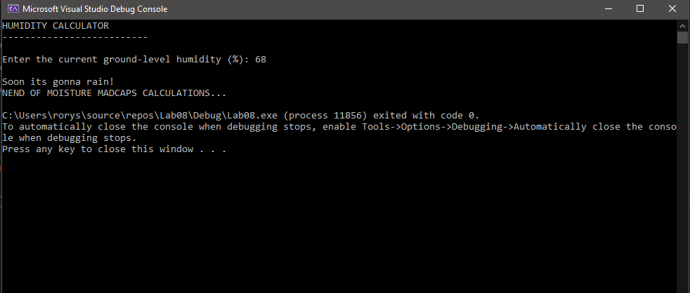

**2) [15 points]** You've been hired by *Satin Stylers* to write a C++ console application that estimates the cost and time to paint the walls of a square room (width of each wall is same; height of each wall is same - I hope!). Prompt for and get from the user the following inputs:

● Number of painters in the range 1-4.

● Wall width in feet in the range 10-40.

● Wall height in feet in the range 7-11.

Then use one **if statement\*** to test if any of the three inputs are invalid:

● If the number of painters is outside the range 1-4, then print an error message.

● Otherwise if the wall width is not in the range 10-40, then print an error message.

● Otherwise, if the wall height is not in the range 7-11, then print an error message.

Only if all the inputs are valid, calculate the area, estimated cost, and estimated time using the following formulas:

area = width * height * walls

cost estimate = area * wall rate

time estimate = area / paint rate / painters

Use formatted output manipulators (setw, left/right) to print the following rows:

● Painters

● Wall width (feet)

● Wall height (feet)

● Four-wall area (square feet)

● Cost estimate ($)

● Time estimate (hours)

And columns:

● A left-justified label

● A right-justified value

Define constants for the number of walls (4), wall painter rate ($1.75 per square foot), wall painting rate (20 square feet per hour per painter), and column widths. Format all real numbers to two decimal places. The output should look like this for invalid and valid input:

Welcome to Satin Stylers

------------------------

Enter the number of painters (1-4): 6

Enter the wall width in feet (10-40): 13

Enter the wall height in feet (7-11): 9

Error: invalid number of painters (6).

End of Satin Stylers

Welcome to Satin Stylers

------------------------

Enter the number of painters (1-4): 2

Enter the wall width in feet (10-40): 10

Enter the wall height in feet (7-11): 7

Painters: 2

Wall width (feet): 10

Wall height (feet): 7

Four-wall area (square feet): 280

Cost estimate ($): 490.00

Time estimate (hours): 7.00

End of Satin Stylers

Do not use this sample input for the final runs pasted below.

//==========================================================

//

// Title: lab0802

// Course: CSC 1101

// Lab Number: 08

// Author: rory lange

// Date: 2/11/21

// Description:

// <brief description of application including its inputs,

// processing, and outputs>

//

//==========================================================

#include <cstdlib> // For several general-purpose functions

#include <fstream> // For file handling

#include <iomanip> // For formatted output

#include <iostream> // For cin, cout, and system

#include <string> // For string data type

using namespace std; // So "std::cout" may be abbreviated to "cout"

int main()

{

//header

cout << "SATIN STYLERS PAINT COST CALCULATOR" << endl;

cout << "---------------------------------------" << endl << endl;

//declare variables

int painters;

int width;

int height;

int area;

double cost;

double time;

const int wallRate = 1.75;

const int w = 30;

const int w1 = 15;

const int paintRate = 20;

// get user input

cout << "How many painters (1-4): ";

cin >> painters;

cout << endl;

cout << "Width of wall in feet (10 - 40): ";

cin >> width;

cout << endl;

cout << "Height of wall in feet (7-11): ";

cin >> height;

cout << endl;

//check if any variables are bad

if (painters < 1 || painters > 4)

cout << "Invalid number of painters (" << painters << ")." << endl;

else if (width > 40 || width < 10)

cout << "Invalid width (" << width << ")." << endl;

else if (height > 11 || height < 7)

cout << "Invalid height (" << height << ")." << endl;

else {

cout << endl;

cout << fixed << setprecision(2);

//do some math

area = width * height * 4;

cost = (double)area * wallRate;

time = (double)area / paintRate / painters;

cout << setw(w) << left << "Painters: " << setw(w1) << right << painters << endl;

cout << setw(w) << left << "Wall width (ft): " << setw(w1) << right << width << endl;

cout << setw(w) << left << "Wall height (ft): " << setw(w1) << right << height << endl;

cout << setw(w) << left << "Four-wall area (square feet): " << setw(w1) << right << area << endl;

cout << setw(w) << left << "Cost estimate ($): " << setw(w1) << right << cost << endl;

cout << setw(w) << left << "Time estimate (hours): " << setw(w1) << right << time << endl;

}

//footer

cout << "END OF PAINT CALCULATOR CALCULATIONS..." << endl;

}

**If possible, format your code like this:**

**Font “Courier New”**

**Font size “9”**

**Bold**

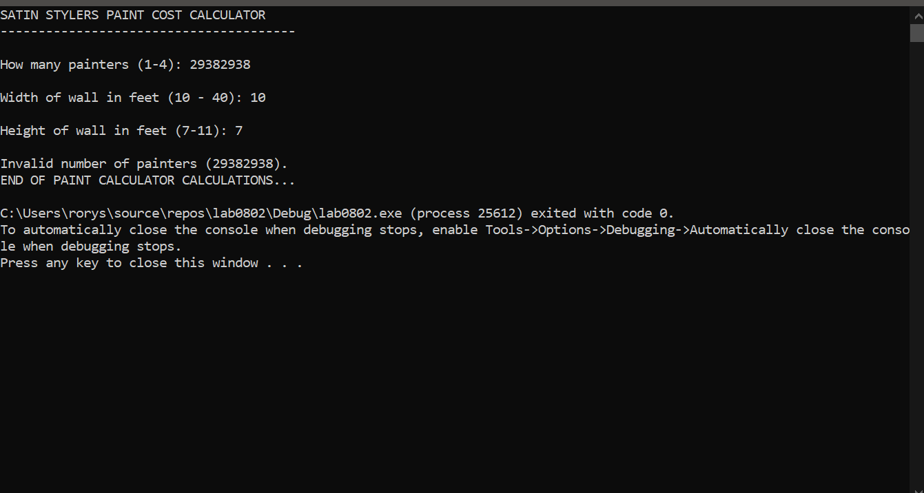

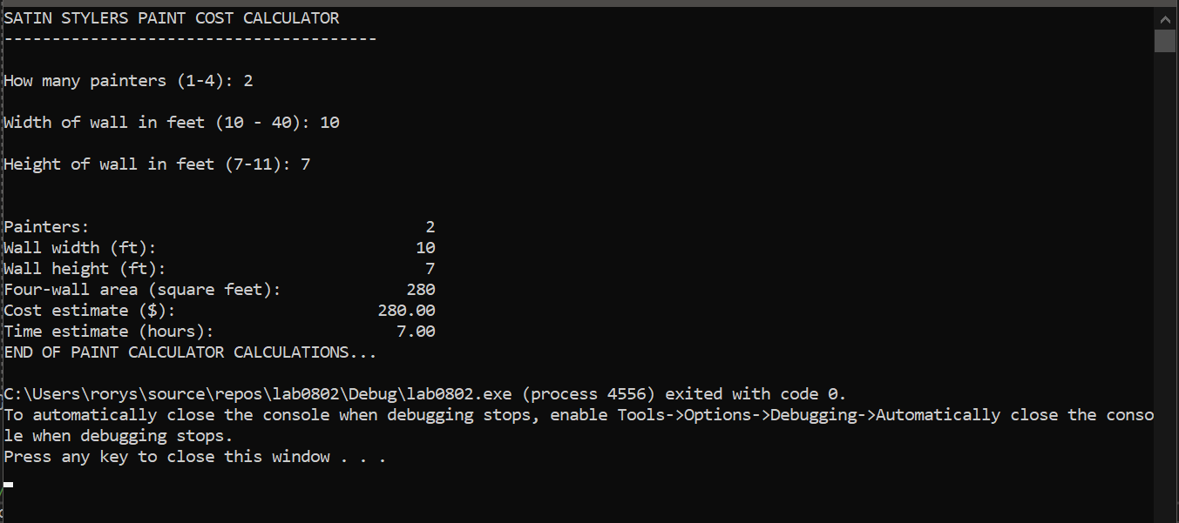

**\* Copying-and-pasting C++ code to a Word document**

**macOS**

1) From within the C++ program, press **command-A** and press **command-C**.

2) From within the Word document, press **command-V**.

**Windows**

1) From within the C++ program, press **CTRL-A** and press **CTRL-C**.

2) From within the Word document, press **CTRL-V**.

**\*\* Copying-and-pasting C++ console application output to a Word document**

**macOS**

1) From the C++ console, press **shift-command-4-space**.

2) From within the Word document, **command-V**.

**Windows**

1) From the C++ console, press **ALT-PrintScreen**.

2) From within the Word document, press **CTRL-V**.