**CSC 1101 – Problem Solving and Programming Laboratory – Winter 2021**

**Lab [09] – rory lange**

**25 points – Due 02/16, end-of-class**

**a)** Save this document with your name and the lab assignment number somewhere in the file name.

**b)** Type/paste your answers into the document.

**c)** Submit the following two documents to the Canvas assignment link where you downloaded this document: this document and your .cpp file renamed to .txt. Submit the documents separately, not as one .zip file.

Today’s in class lab has you working with a switch statement. Prompt the user for a single character (j, f, or m, anything else is invalid), and display the avg high temperature, avg low temperature, and precipitation for that month.

**Be sure to include a default case in your switch statement in case the input is invalid.**

Your output should look like the following:

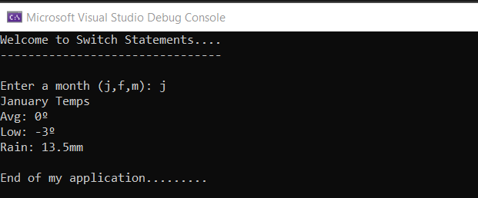

Some useful data:

**If possible, format your code like this:**

**Font “Courier New”**

**Font size “9”**

**Bold**

//==========================================================

//

// Title: lab09

// Course: CSC 1101

// Lab Number: 09

// Author: rory lange

// Date: 2/16/21

// Description:

// <brief description of application including its inputs,

// processing, and outputs>

//

//==========================================================

#include <cstdlib> // For several general-purpose functions

#include <fstream> // For file handling

#include <iomanip> // For formatted output

#include <iostream> // For cin, cout, and system

#include <string> // For string data type

using namespace std; // So "std::cout" may be abbreviated to "cout"

int main() {

//header

cout << "Welcome to Switch Statements" << endl;

cout << "---------------------------------------" << endl << endl;

//declare variables

const char degree = 167;

char userInput;

//get user input

cout << "Enter a month (j,f,m): ";

cin >> userInput;

cout << endl;

//switch

switch (userInput) {

case 'j':

cout << "January Temps" << endl;

cout << "High: " << "0" << degree << endl;

cout << "Low: " << "-6" << degree << endl;

cout << "rain: " << "13.6mm" << endl;

break;

case 'f':

cout << "February Temps" << endl;

cout << "High: " << "1" << degree << endl;

cout << "Low: " << "-6" << degree << endl;

cout << "rain: " << "12.9mm" << endl;

break;

case 'm':

cout << "March Temps" << endl;

cout << "High: " << "7" << degree << endl;

cout << "Low: " << "-2" << degree << endl;

cout << "rain: " << "13.0mm" << endl;

break;

default:

cout << "Invalid input" << endl;

break;

}

//close

cout << "End of my application" << endl;

}

*[your program output here]\*\**

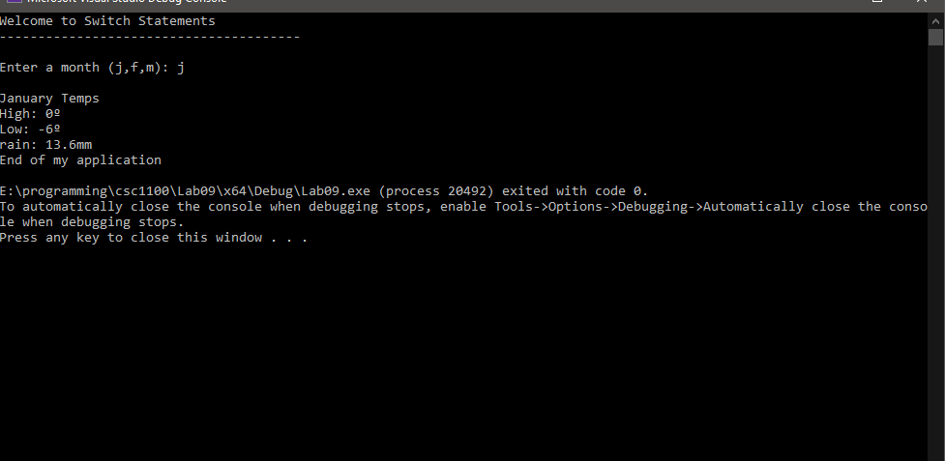

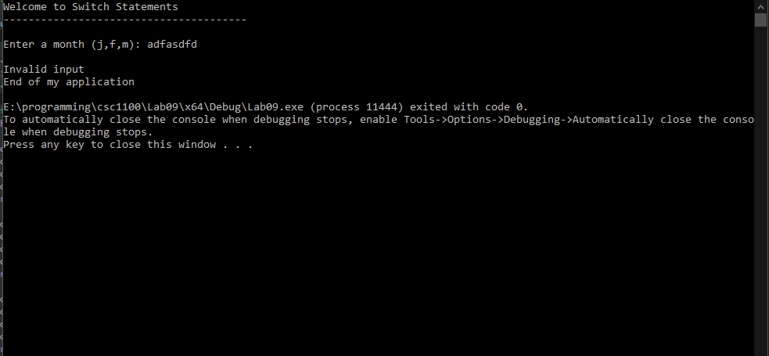

**\* Copying-and-pasting C++ code to a Word document**

**macOS**

1) From within the C++ program, press **command-A** and press **command-C**.

2) From within the Word document, press **command-V**.

**Windows**

1) From within the C++ program, press **CTRL-A** and press **CTRL-C**.

2) From within the Word document, press **CTRL-V**.

**\*\* Copying-and-pasting C++ console application output to a Word document**

**macOS**

1) From the C++ console, press **shift-command-4-space**.

2) From within the Word document, **command-V**.

**Windows**

1) From the C++ console, press **ALT-PrintScreen**.

2) From within the Word document, press **CTRL-V**.