**CSC 1101 – Problem Solving and Programming Laboratory – Winter 2021**

**Lab 11 – rory lange**

**25 points – Due 2/23, end-of-class**

**a)** Save this document with your name and the lab assignment number somewhere in the file name.

**b)** Type/paste your answers into the document.

**c)** Submit the following documents to the Canvas assignment link where you downloaded this document:

✓ This document.

✓ Your .cpp files renamed to .txt.

Submit the documents separately, not as one .zip file.

*Satin Stylers* has requested that you improve the C++ console application you created to estimate the cost and time to paint the walls of a square room. They are requesting that you add two features:

1. To report an error to the user and ask the user again for input if they request accommodations outside of the proper range of what *Satin Stylers* is offering.
2. To ask the user at the end of the application if they would like to run it again. If the user enters ‘y’ the application will start over and run again. If the user enters ‘n’ the application will end.

Use **while statements** to create **validation loops** to read and check the values entered by the user. The user should be prompted continuously until a valid value is entered. Write validation loops to check and correct any of the three inputs:

● If the number of painters is outside the range 1-4, request the user enter a number in the proper range and record their new input.

● If the wall width is not in the range 10-40, request the user enter a number in the proper range and record their new input.

● If the wall height is not in the range 7-11, request the user enter a number in the proper range and record their new input.

Use a **sentinel loop** to continually run the application until the user enters ‘n’. After the user enters ‘n’ the application close should be shown and the program should end.

This application will still calculate the area, estimated cost, and estimated time then print the related information (see example output below).

Example Output for Screenshot:

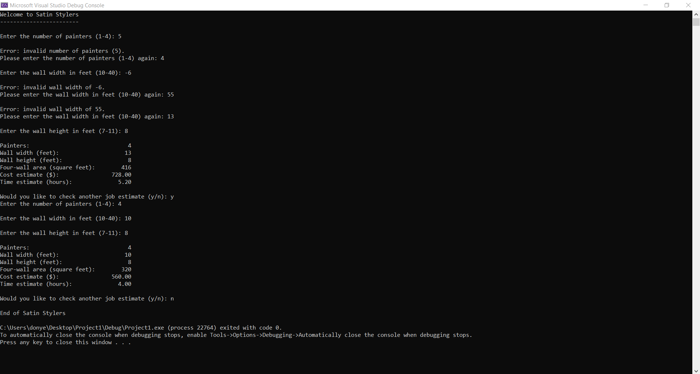

//==========================================================

//

// Title: Satin Stylers

// Course: CSC 1101

// Lab Number: 11

// Author: rory lange

// Date: 2/23/21

// Description:

// This C++ console application estimates the cost and

// time to paint the walls of a square room (width of each

// wall is same; height of each wall is same - I hope!).

// It prompts for and gets from the user the following

// inputs:

// -Number of painters in the range 1 - 4

// -Wall width in feet in the range 10 - 40

// -Wall height in feet in the range 7 - 11

// If any of the inputs are out of range, it requests the user

// enter proper values. Once all of the inputs are in range, the

// application calculates and prints the area, estimated

// cost, and estimated time. Lastly, the user has the option

// to run the program as long as they enter 'y' when prompted.

//

//==========================================================

#include <cstdlib> // For several general-purpose functions

#include <fstream> // For file handling

#include <iomanip> // For formatted output

#include <iostream> // For cin, cout, and system

#include <string> // For string data type

using namespace std; // So "std::cout" may be abbreviated to "cout"

int main()

{

// Declare constants

const int WALLS = 4;

const double WALL_RATE = 1.75; // $ per square foot

const double PAINT_RATE = 20; // Square feet per hour per painter

const int COLFMT1 = 30;

const int COLFMT2 = 10;

// Declare variables

int painters;

int width;

int height;

int area;

double costEstimate;

double timeEstimate;

char choice = ' ';

// Format real numbers

cout << fixed << setprecision(2);

// Show application header

cout << "Welcome to Satin Stylers" << endl;

cout << "------------------------" << endl << endl;

//[code here]

//s loop

while (choice != 'n') {

// Prompt for and get job type

cout << "Enter the number of painters (1-4): ";

cin >> painters;

// Test painters

while (painters < 1 || painters > 4) {

cout << "Number of painters is invalid" << endl;

cout << "Enter a valid number of painters: ";

cin >> painters;

}

// Prompt for and get width

cout << "\nEnter the wall width in feet (10-40): ";

cin >> width;

// Test width

while (width < 10 || width > 40) {

cout << "width is an invalid number" << endl;

cout << "enter a valid width: ";

cin >> width;

}

// Prompt for and get height

cout << "\nEnter the wall height in feet (7-11): ";

cin >> height;

// Test height

while (height < 7 || height > 11) {

cout << "Height is an invalid number" << endl;

cout << "Enter a valid height: ";

cin >> height;

}

// Calculate cost and time estimates

area = width * height * WALLS;

costEstimate = area * WALL_RATE;

timeEstimate = (area / PAINT_RATE) / painters;

// Show job estimate

cout << endl;

cout << setw(COLFMT1) << left << "Painters:"

<< setw(COLFMT2) << right << painters << endl;

cout << setw(COLFMT1) << left << "Wall width (feet):"

<< setw(COLFMT2) << right << width << endl;

cout << setw(COLFMT1) << left << "Wall height (feet):"

<< setw(COLFMT2) << right << height << endl;

cout << setw(COLFMT1) << left << "Four-wall area (square feet):"

<< setw(COLFMT2) << right << area << endl;

cout << setw(COLFMT1) << left << "Cost estimate ($):"

<< setw(COLFMT2) << right << costEstimate << endl;

cout << setw(COLFMT1) << left << "Time estimate (hours):"

<< setw(COLFMT2) << right << timeEstimate << endl << endl;

cout << "Would you like to run the program again (y/n)";

cin >> choice;

cout << endl;

}

// Show application close

cout << "\nEnd of Satin Stylers" << endl;

}

**If possible, format your code like this:**

**Font “Courier New”**

**Font size “9”**

**Bold**

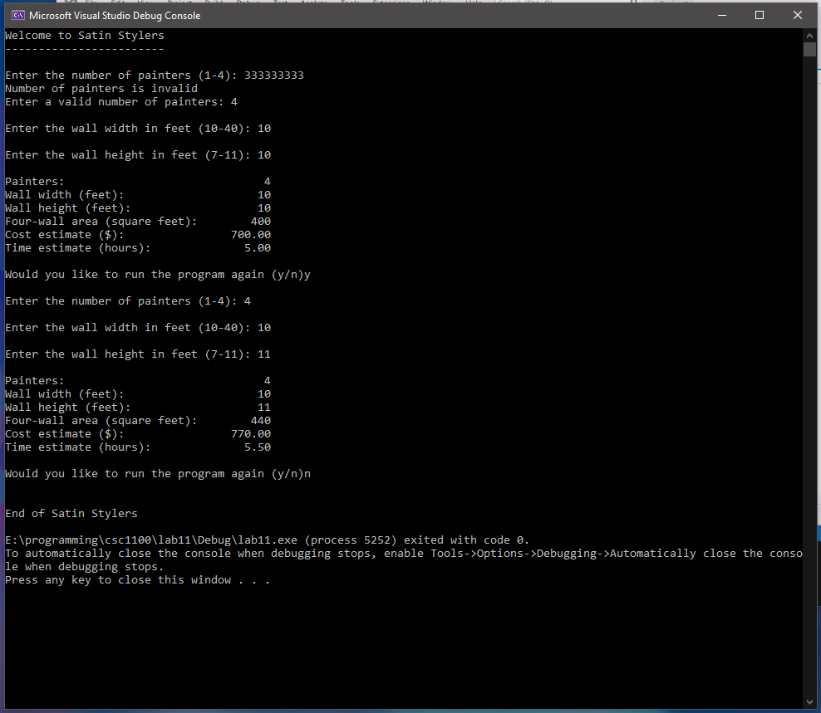

**\* Copying-and-pasting C++ code to a Word document**

**macOS**

1) From within the C++ program, press **command-A** and press **command-C**.

2) From within the Word document, press **command-V**.

**Windows**

1) From within the C++ program, press **CTRL-A** and press **CTRL-C**.

2) From within the Word document, press **CTRL-V**.

**\*\* Copying-and-pasting C++ console application output to a Word document**

**macOS**

1) From the C++ console, press **shift-command-4-space**.

2) From within the Word document, **command-V**.

**Windows**

1) From the C++ console, press **ALT-PrintScreen**.

2) From within the Word document, press **CTRL-V**.