**CSC 1101 – Problem Solving and Programming Laboratory – Winter 2021**

**Lab 13 – rory lange**

**25 points – Due 3/9, end-of-class**

**a)** Save this document with your name and the lab assignment number somewhere in the file name.

**b)** Type/paste your answers into the document.

**c)** Submit the following two documents to the Canvas assignment link where you downloaded this document: this document and your .cpp file renamed to .txt. Submit the documents separately, not as one .zip file.

This lab has two parts:

● Part 1 creates and writes a text file.

● Part 2 opens and reads the text file created in Part 1.

**Part 1 – file writing**

Attempt to create (open) a text file. Test whether the file was created. If not, print an error message. If so, use a while loop to write five lines to the file in the form:

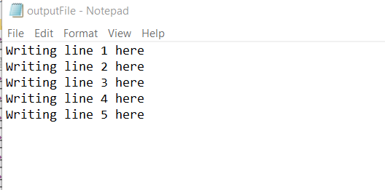

Close the file. See sample app **Text file output** on Canvas.

**Part 2 – file reading**

Attempt to open the file created in Part 1. Test whether the file was opened. If not, print an error message. If so, use a while loop to read one line at a time and write it to the screen. Close the file. See sample app **Text file input – one line per read** on Canvas.

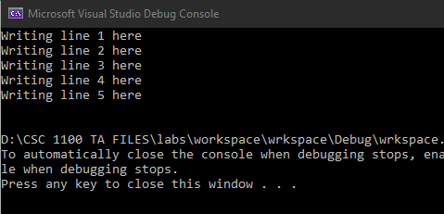

Paste a screenshot of your program output and text file below.

//==========================================================

//

// Title: lab 13

// Course: CSC 1101

// Lab Number: 12

// Author: rory lange

// Date: 3/9/21

// Description: reading and writing to file in the same lab

//

//==========================================================

#include <cstdlib> // For several general-purpose functions

#include <fstream> // For file handling

#include <iomanip> // For formatted output

#include <iostream> // For cin, cout, and system

#include <string> // For string data type

using namespace std; // So "std::cout" may be abbreviated to "cout"

int main()

{

//declare variables

const string fileName = "text.txt";

string input;

ofstream outputFile; //variable for outputfile

//create new output file

outputFile.open(fileName);

if (!outputFile.is_open())

cout << "Error opening file" << endl;

while (outputFile.good())

{

for (int i = 1; i <= 5; i++) {

outputFile << "Writing line " << i << " here" << endl;

}

outputFile.close();

}

ifstream inputFile;

inputFile.open(fileName);

//open input file

string line;

while (inputFile.good())

{

getline(inputFile, line);

cout << line << endl;

}

//remember to close file when done!

inputFile.close();

//close

cout << "end of calculations for lab13" << endl;

}

**If possible, format your code like this:**

**Font “Courier New”**

**Font size “9”**

**Bold**

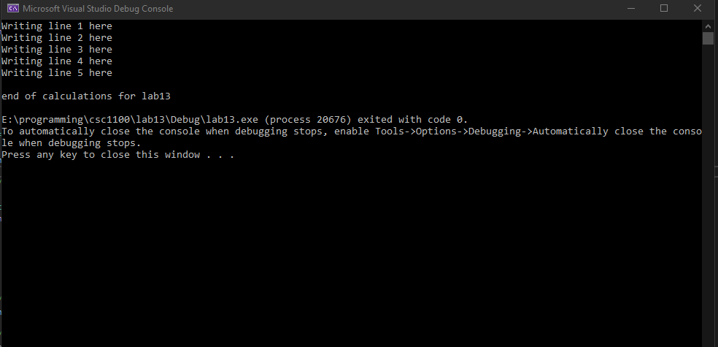

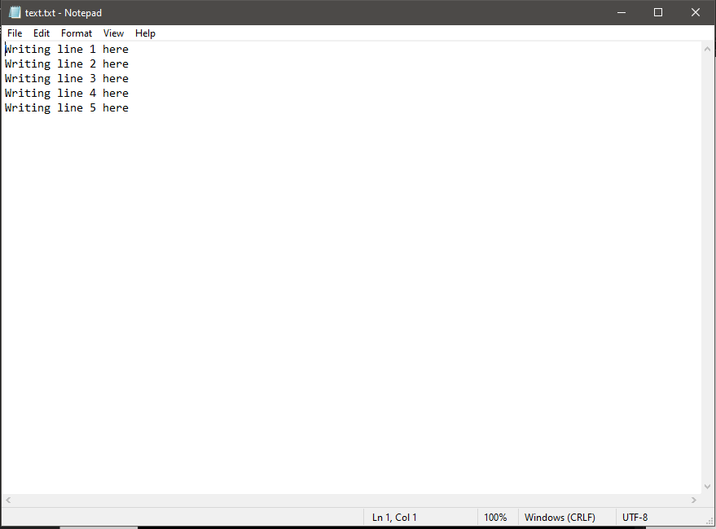

**\* Copying-and-pasting C++ code to a Word document**

**macOS**

1) From within the C++ program, press **command-A** and press **command-C**.

2) From within the Word document, press **command-V**.

**Windows**

1) From within the C++ program, press **CTRL-A** and press **CTRL-C**.

2) From within the Word document, press **CTRL-V**.

**\*\* Copying-and-pasting C++ console application output to a Word document**

**macOS**

1) From the C++ console, press **shift-command-4-space**.

2) From within the Word document, **command-V**.

**Windows**

1) From the C++ console, press **ALT-PrintScreen**.

2) From within the Word document, press **CTRL-V**.