**CSC 1101 – Problem Solving and Programming Laboratory – Winter 2021**

**Lab 15 – [your name]**

**25 points – Due March 23, end-of-class**

**a)** Save this document with your name and the lab assignment number somewhere in the file name.

**b)** Type/paste your answers into the document.

**c)** Submit the following documents to the Canvas assignment link where you downloaded this document:

✓ This document.

✓ Your .cpp files renamed to .txt.

Submit the documents separately, not as one .zip file.

You found checking for different characters tedious while working on your application for *Hidden Halos* so you decided to make a function called “stringChecker” that compares two strings and returns an integer.

Your function has four parameters:

* **Two** strings (these should be obtained from the user)
* **Two** integers (these should be the lengths of the strings obtained from string function **length()**)

Your function returns an integer that tells the position of the first character that was different in the strings **OR** -1 if the strings are the same.

Inside your main function you should prompt the user for two strings, call your function with the correct arguments, store the returned value from your function “stringChecker”, then print either the position the strings differed or that the strings are equivalent.

Inside your “stringChecker” function you need to compare the corresponding characters from each string (first character of string 1 with first character of string 2, etc.). There are three possibilities and for each one you may use a for loop or a while loop to compare the corresponding characters (for example, string1[i] == string2[i]):

1. The length of string1 > The length of string2
   1. Return position of different character **OR** return next position after end of string2.
2. The length of string1 < The length of string2
   1. Return position of different character **OR** return next position after end of string1.
3. The lengths are equal
   1. Return position of different character **OR** return -1 if the strings are exactly the same

Example Outputs for Screenshots:

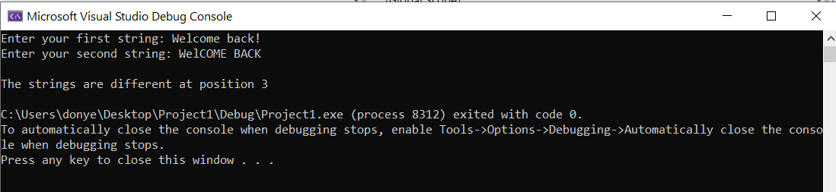

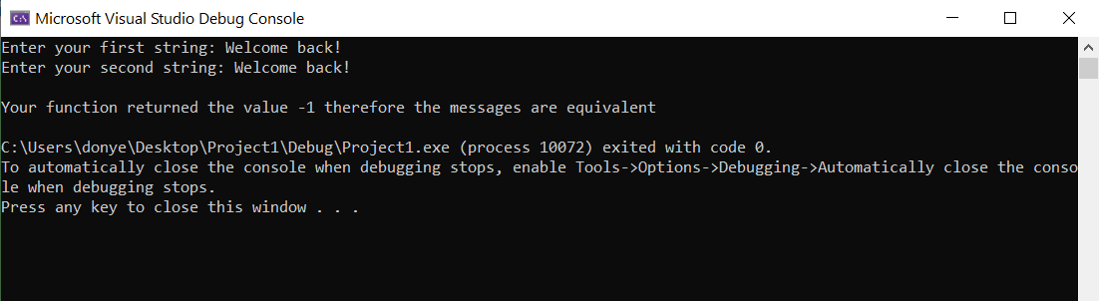

//==========================================================

// Title: Lab15

// Course: CSC 1101

// Lab Number: 15

// Author: rory lange

// Date: 3/23/21

// Description:

// This console application creates a function to compare

//strings.

//INPUT: Two strings and the lengths of the two strings

//OUTPUT: An integer. If the numbers is greater than or equal

// to zero its the position that differs in the strings.

// If the number is -1 the strings are equivalent

//==========================================================

#include <cstdlib> // For several general-purpose functions

#include <fstream> // For file handling

#include <iomanip> // For formatted output

#include <iostream> // For cin, cout, and system

#include <string> // For string data type

using namespace std; // So "std::cout" may be abbreviated to "cout"

//Use this function declaration

int stringChecker(string string1, int length1, string string2, int length2) {

if (length1 > length2) {

for (int i = 0; i < length2; i++) {

if (string1[i] != string2[i])

return i;

}

}

else if (length2 > length1) {

for (int i = 0; i < length2; i++) {

if (string1[i] != string2[i])

return i;

}

}

else {

for (int i = 0; i < length2; i++) {

if (string1[i] != string2[i])

return i;

}

return -1;

}

}

int main() {

string str1, str2;

int charNum;

cout << "Enter your first string: ";

getline(cin, str1);

cout << "Enter your second string: ";

getline(cin, str2);

cout << endl;

//Call the function

charNum = stringChecker(str1, str1.length(), str2, str2.length());

//Compare the return value from the function

if (charNum == -1)

cout << "Your function returned the value -1, therefore the messages are equivalent" << endl;

else

cout << "The strings are different at position " << charNum << endl;

}

**If possible, format your code like this:**

**Font “Courier New”**

**Font size “9”**

**Bold**

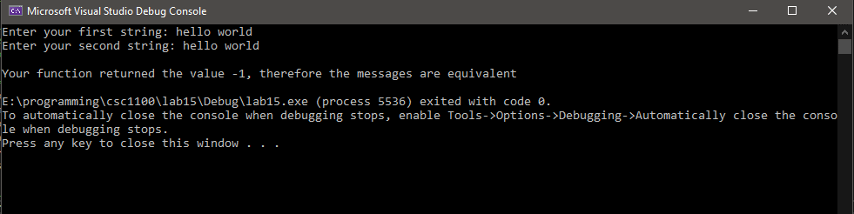

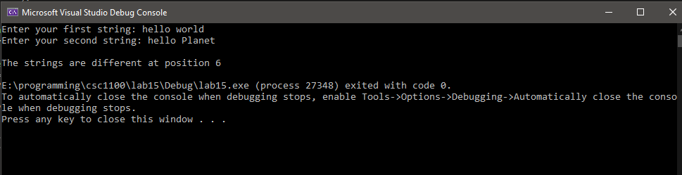

**\* Copying-and-pasting C++ code to a Word document**

**macOS**

1) From within the C++ program, press **command-A** and press **command-C**.

2) From within the Word document, press **command-V**.

**Windows**

1) From within the C++ program, press **CTRL-A** and press **CTRL-C**.

2) From within the Word document, press **CTRL-V**.

**\*\* Copying-and-pasting C++ console application output to a Word document**

**macOS**

1) From the C++ console, press **shift-command-4-space**.

2) From within the Word document, **command-V**.

**Windows**

1) From the C++ console, press **ALT-PrintScreen**.

2) From within the Word document, press **CTRL-V**.