**CSC 1101 – Problem Solving and Programming Laboratory – Winter 2021**

**Lab 17 – rory lange**

**25 points – Due March 30, end-of-class**

**a)** Save this document with your name and the lab assignment number somewhere in the file name.

**b)** Type/paste your answers into the document.

**c)** Submit the following documents to the Canvas assignment link where you downloaded this document:

✓ This document.

✓ Your .cpp files renamed to .txt.

Submit the documents separately, not as one .zip file.

*Wacky Winners* is holding raffle at WSU where students were allowed to enter their full name and GPA for a chance to win a mystery award, but the catch was the student with the lowest GPA must attend summer school. Only the first 5 participants can enter this raffle.

Create two arrays of size **5**.

1. One array will hold the names of the 5 students entering the raffle.
2. The second array will hold the GPAs of the 5 students.

Use for loops to accomplish the following:

1. Record all the student names and GPAs into the arrays. Keep track of the names and GPAs of the students with the highest and lowest GPAs. Declare four variables: nameHigh, gpaHigh, nameLow, and gpaLow. One approach is to store a small (negative) value in gpaHigh and a large value in gpaLow before the loop. After each GPA is entered, test whether gpaHigh **and** gpaLow need to be updated.
2. Print out a formatted table displaying all of the students names and GPAs. All numbers should display one decimal place.

Print the following:

1. Print out the name and GPA of the student who won the raffle with the highest GPA
2. Print out the name and GPA of the student who will be forced to attend summer school.

Define constants for the column widths in your table and for the number of students allowed to enter the raffle(5).

Example Outputs for Screenshots:

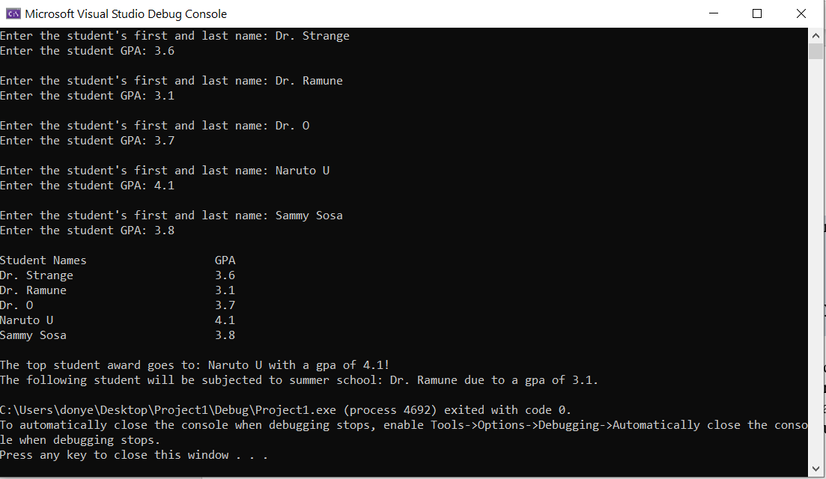

//==========================================================

//This is the header information

//

// Title:      Wacky Winners

// Course:     CSC 1101

// Lab Number: 19

// Author:     rory lange

// Date:       4/6/21

// Description: Use arrays to record the names of the students

//  along with their GPAs. Print out all the names of the students

//  with their related GPAs. Also print the name and gpa of the

//  best and worst student

//==========================================================

#include <cstdlib> // For several general-purpose functions

#include <fstream> // For file handling

#include <iomanip> // For formatted output

#include <iostream> // For cin, cout, and system

#include <string> // For string data type

#include<cmath> //For math equations

using namespace std; // So "std::cout" may be abbreviated to "cout"

string getNames() {

    string name;

    cout << "Enter a students first and last name: ";

    getline(cin, name);

    return name;

}

float getGPAs() {

    float gpa;

    cout << "Enter the student's gpa: ";

    cin >> gpa;

    cin.ignore(200, '\n');

    return gpa;

}

int main() {

    cout << "Welcome to Wacky Winners" << endl;

    const int NUM_STUDENTS = 5;

    const int COLM1 = 30;

    const int COLM2 = 10;

    //Declare Arrays

    string students[NUM_STUDENTS];

    float gpa[NUM_STUDENTS];

    //Declare variables

    //initialize best and worst student positions in arrays for comparisons

    float gpaHigh = 0;

    float gpaLow = 5;

    int highIndex;

    int lowIndex;

    //Prompt users for names and grades

    for (int i = 0; i < NUM_STUDENTS; i++) {

        students[i] = getNames();

        gpa[i] = getGPAs();

        cout << endl;

        //compare the GPAs of the students and record the best and worst GPA

        if (gpa[i] > gpaHigh) {

            gpaHigh = gpa[i];

            highIndex = i;

        }

        if (gpa[i] < gpaLow) {

            gpaLow = gpa[i];

            lowIndex = i;

        }

    }

    cout << left << setw(COLM1) << "Student Names" << right << setw(COLM2) << "GPA" << endl;

    for (int i = 0; i < NUM_STUDENTS; i++) {

        //Print out all the student names and GPAs

        cout << left << setw(COLM1) << students[i] << right << setw(COLM2) << gpa[i] << endl;

    }

    //Print out the name and GPA of the winning and lossing student

    cout << endl << "the top student award goes to: " << students[highIndex] << " with a gpa of " << gpa[highIndex] << endl;

    cout << "the following student will be subjected to summer school: " << students[lowIndex] << " with a gpa of " << gpa[lowIndex] << endl;

    cout << "Thank you for participating with Wacky Winners!!" << endl << endl;

}

**If possible, format your code like this:**

**Font “Courier New”**

**Font size “9”**

**Bold**

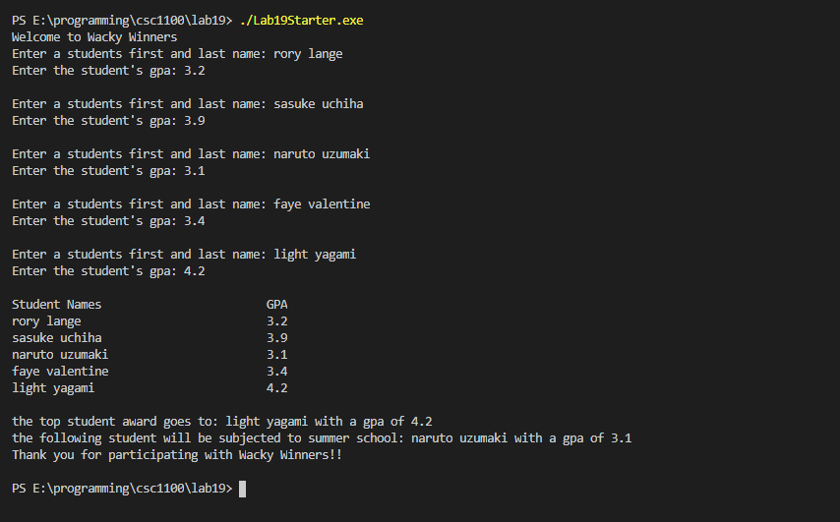

**\* Copying-and-pasting C++ code to a Word document**

**macOS**

1) From within the C++ program, press **command-A** and press **command-C**.

2) From within the Word document, press **command-V**.

**Windows**

1) From within the C++ program, press **CTRL-A** and press **CTRL-C**.

2) From within the Word document, press **CTRL-V**.

**\*\* Copying-and-pasting C++ console application output to a Word document**

**macOS**

1) From the C++ console, press **shift-command-4-space**.

2) From within the Word document, **command-V**.

**Windows**

1) From the C++ console, press **ALT-PrintScreen**.

2) From within the Word document, press **CTRL-V**.