**CSC 1101 – Problem Solving and Programming Laboratory – Winter 2021**

**Lab 21 – rory lange**

**25 points – Due 4/13, 3:45pm**

**a)** Save this document with your name and the lab assignment number somewhere in the file name.

**b)** Type/paste your answers into the document.

**c)** Submit the following two documents to the Canvas assignment link where you downloaded this document: this document and your .cpp file renamed to .txt. Submit the documents separately, not as one .zip file.

Define a struct “**Student**” with three members:

* **Name (string)**
* **3-digit ID (int)**
* **GPA (double)**

Create the following struct constructors:

* A zero-parameter constructor with signature: **Student()**. This constructor sets the three fields to default values.
* A three-parameter constructor with signature: **Student(string name, int id, double gpa)**. This constructor sets the three fields based on data passed into the constructor.

Also create function **printInfo** to print information about the student.

In function **main**, create two **Student** objects, one with data prompted for and read from the user, and one with data set using the default constructor. Print the info for each object. Your output should look like this….

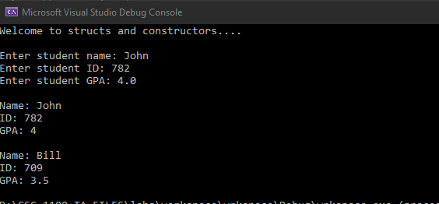

Starter code is provided.

**If possible, format your code like this:**

**Font “Courier New”**

**Font size “9”**

**Bold**

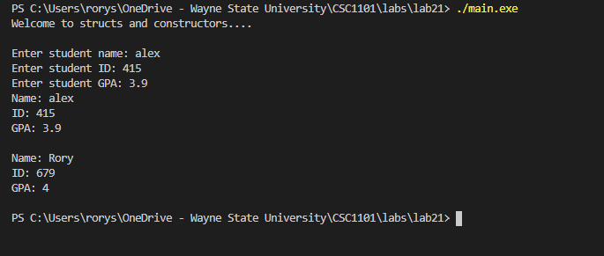

//==========================================================

//This is the header information

//

// Course:     CSC 1101

// Lab Number: 21

// Author:     rory lange

// Date:       4/13/21

//==========================================================

#include <cstdlib> // For several general-purpose functions

#include <fstream> // For file handling

#include <iomanip> // For formatted output

#include <iostream> // For cin, cout, and system

#include <string> // For string data type

#include<cmath> //For math equations

using namespace std; // So "std::cout" may be abbreviated to "cout"

struct Student {

    //member declarations here...

    string name;

    int id;

    double gpa;

    //default constructor

    Student() {

        name = "Rory";

        id = 679;

        gpa = 4.0;

    }

    //constructor with parameters here...

    Student(string name, int id, double gpa) {

        this->name = name;

        this->id = id;

        this->gpa = gpa;

    }

};

void printInfo(Student stu)

{

    //your code here

    cout << "Name: " << stu.name << endl;

    cout << "ID: " << stu.id << endl;

    cout << "GPA: " << stu.gpa << endl << endl;

}

int main()

{

    Student myStudent;

    string name;

    int id;

    double gpa;

    cout << "Welcome to structs and constructors...." << endl << endl;

    //get input from user

    cout << "Enter student name: ";

    cin >> name;

    cout << "Enter student ID: ";

    cin >> id;

    cout << "Enter student GPA: ";

    cin >> gpa;

    Student parameterStudent(name, id, gpa);

    //call printinfo

    printInfo(parameterStudent);

    printInfo(myStudent);

}

**\* Copying-and-pasting C++ code to a Word document**

**macOS**

1) From within the C++ program, press **command-A** and press **command-C**.

2) From within the Word document, press **command-V**.

**Windows**

1) From within the C++ program, press **CTRL-A** and press **CTRL-C**.

2) From within the Word document, press **CTRL-V**.

**\*\* Copying-and-pasting C++ console application output to a Word document**

**macOS**

1) From the C++ console, press **shift-command-4-space**.

2) From within the Word document, **command-V**.

**Windows**

1) From the C++ console, press **ALT-PrintScreen**.

2) From within the Word document, press **CTRL-V**.