**CSC 1101 – Problem Solving and Programming Laboratory**

**Warmup Lab 2b – Rory Lange**

**Not graded**

**a)** Save this document with your name and the lab assignment number somewhere in the file name.

**b)** Type/paste your answers into the document.

**c)** Submit this document to the Canvas item where you downloaded this document.

**//==========================================================**

**//**

**// Title:      <application>**

**// Course:     CSC 1101**

**// Lab Number: <number>**

**// Author:     <name>**

**// Date:       <date>**

**// Description:**

**//   <brief description of application including its inputs,**

**// processing, and outputs>**

**//**

**//==========================================================**

**#include <cstdlib> // For several general-purpose functions**

**#include <fstream> // For file handling**

**#include <iomanip> // For formatted output**

**#include <iostream> // For cin, cout, and system**

**#include <string> // For string data type**

**using namespace std; // So "std::cout" may be abbreviated to "cout".**

**int main()**

**{**

**// Declare variables**

**int i;**

**double r;**

**string s;**

**char c;**

**// Show application header**

**cout << "Welcome to my Application!" << endl;**

**cout << "--------------------------" << endl << endl;**

**// Read from console**

**cout << "Enter a number: ";**

**cin >> i;**

**// Write to screen**

**cout << "Hello World!" << endl;**

**// Show application close**

**cout << "\nEnd of my Application" << endl << endl;**

**}**

**If possible, format your code like this:**

**Font “Courier New”**

**Font size “9”**

**Bold**

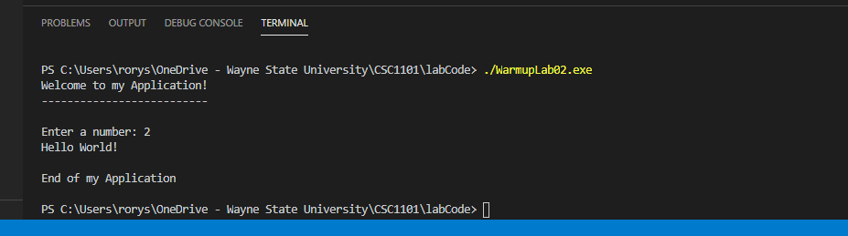

**\* Copying-and-pasting C++ code to a Word document**

**macOS**

1) From within the C++ program, press **command-A** and press **command-C**.

2) From within the Word document, press **command-V**.

**Windows**

1) From within the C++ program, press **CTRL-A** and press **CTRL-C**.

2) From within the Word document, press **CTRL-V**.

**\*\* Copying-and-pasting C++ console application output to a Word document**

**macOS**

1) From the C++ console, press **shift-command-4-space**.

2) From within the Word document, **command-V**.

**Windows**

1) From the C++ console, press **ALT-PrintScreen**.

2) From within the Word document, press **CTRL-V**.