If you have done this at home, feel free to skip. Thank you!
Repository setup | Laptop workflow
Step 1: Clone repository (ONLINE method)  git clone --recursive https://github.com/ros-realtime/roscon-2023-realtime-workshop.git code  Step 1: Clone repository (OFFLINE method)  - Borrow a Raspberry Pi and connect directly via Ethernet  - Download http://192.168.10.1/data/repository.tar.gz  - Extra the tarball: tar xzf repository.tar.gz  Step 2: Import and start Docker container  You need this for both laptop- and Raspberry-Pi-based workflows!  - Borrow a Raspberry Pi and connect directly via Ethernet  - cd into the downloaded repository  - Run docker/fetch  - Run docker/start  - Run docker/shell  Step 3: Test compiling and running exercise 1  Run all commands inside the Docker shell started above  - cd /code/exercise1  - colcon build  - ./run.sh  - This should create a file called exercise1.perfetto  - Go to http://localhost:3100  - Click Open trace file on top left  - Open the exercise1.perfetto file  - Consult with Perfetto trace viewer guide  - Expected result:  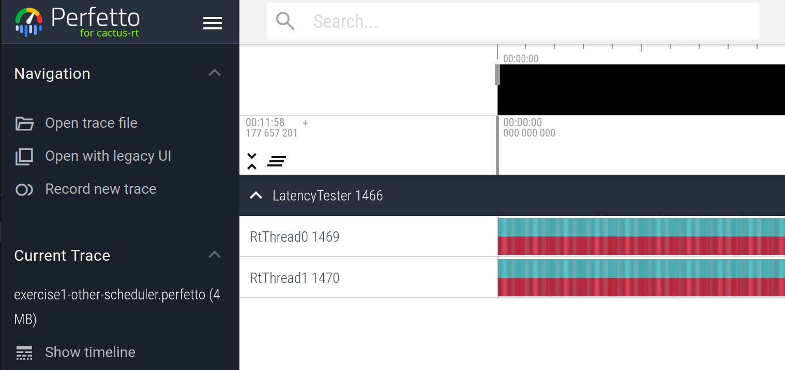  If compilation fails with missing dependencies, check that you cloned with the --recursive flag, or simply clone the repository using the offline method. | - Edit the code in the repo with your preferred editor  - cd to the repo in a terminal  - Login to the Docker container via docker/shell  - Inside the shell, cd to the correct exercise directory. Example: /code/exercise1  - Compile and run the exercise according to instructions on slides and/or exercise README. This will generate a file named exercise<X>.perfetto in the same directory. Example: exercise1.perfetto  - Go to http://localhost:3100 and Open trace file with the file above.  - Go back to step 1.
 | Raspberry Pi workflow
- Connect Raspberry Pi directly to your laptop via Ethernet.
- Edit the code in the repo with your preferred editor
- Login to the Docker container via docker/shell
- Run the command upload-to-pi
- Login to the Raspberry Pi with:
  - ssh ubuntu@192.168.10.1
  - Password is ubuntu
- After login, cd to the correct exercise directory. Example: /code/exercise1
- Compile and run the exercise according to instructions on slides and/or exercise README. This will generate a file named exercise<X>.perfetto in the same directory.
- Download the trace file by browsing to http://192.168.10.1/repo/ and clicking on the right perfetto trace file
- Go to http://localhost:3100 and Open trace file with the downloaded trace file above
- Go back to step 2.

Loading data in Perfetto  Step 1: A locally-hosted version of Perfetto is available with the Docker container, at http://localhost:3100. Go there and you will find the following interface:  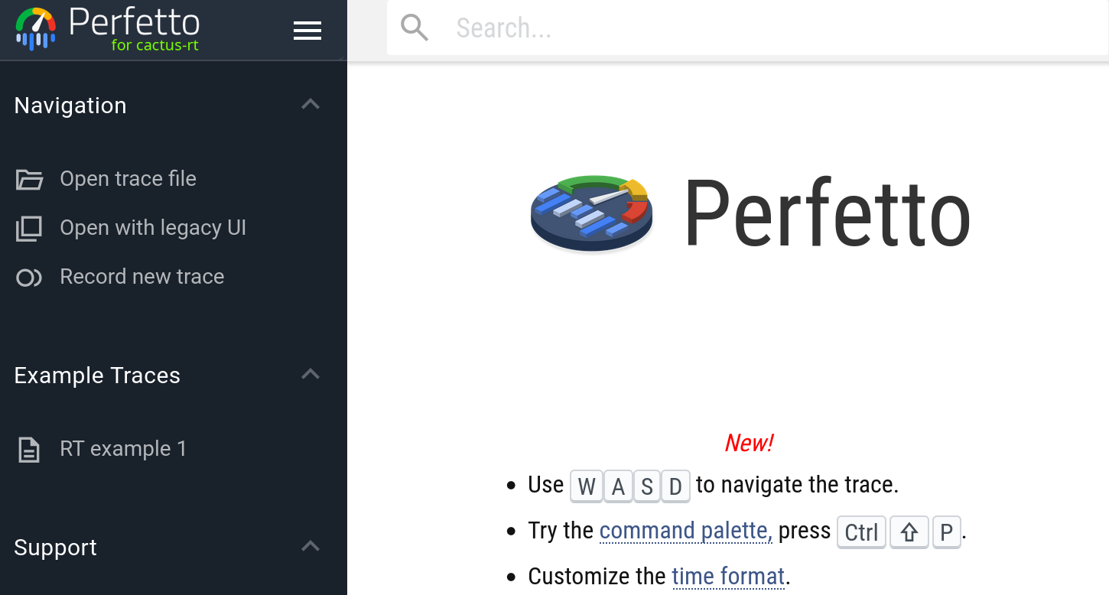  Step 2: To open a trace file, click Open trace file and select a file:  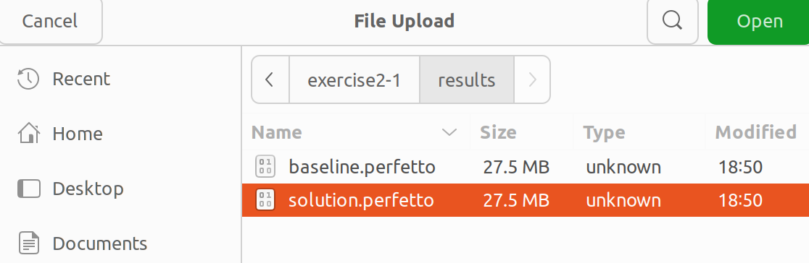  Step 3: Use WASD to navigate. W: zoom in; S: zoom out; A: pan left; D: pan right. Zoom and pan until you see the following:  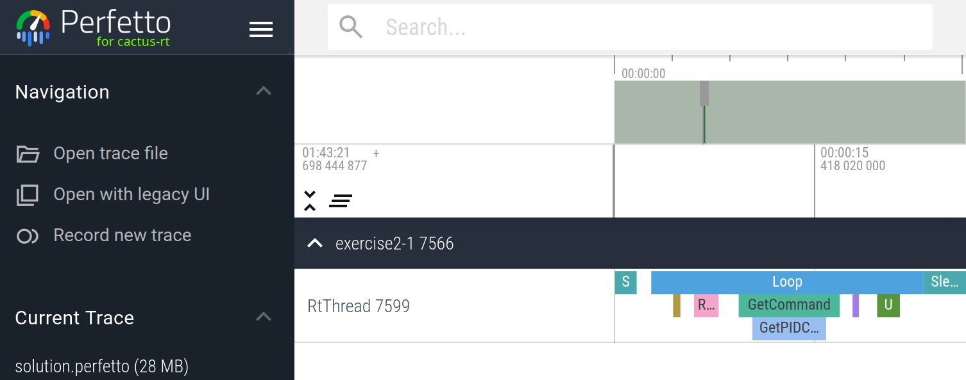 | Find the longest slice  Click on a slice such as Loop:  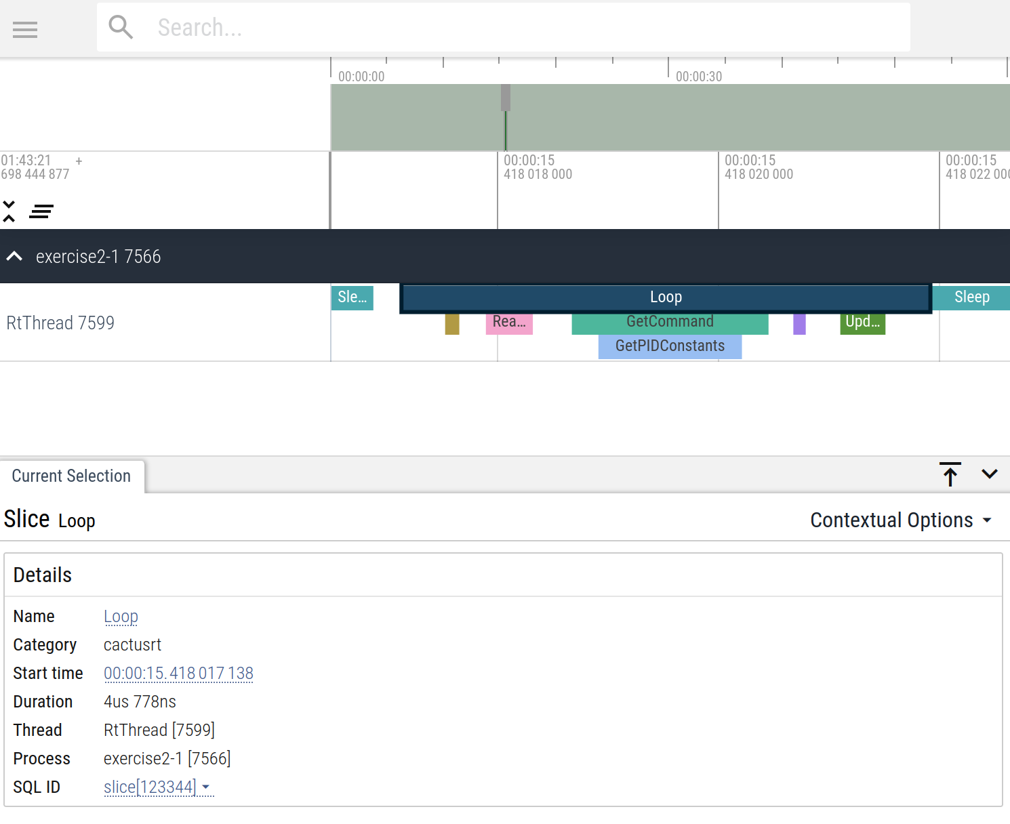  Click on the Loop link at the bottom then click Slices with same name in the popup menu  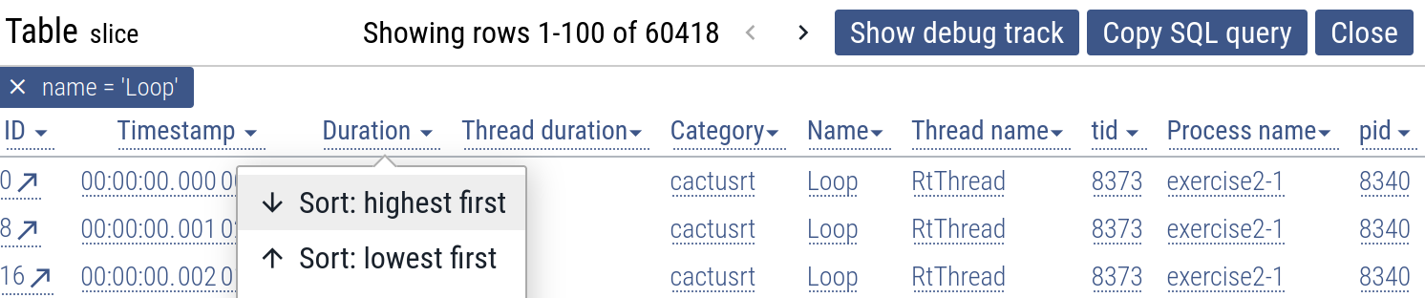  Clock on Duration in the table header then Sort: highest first:  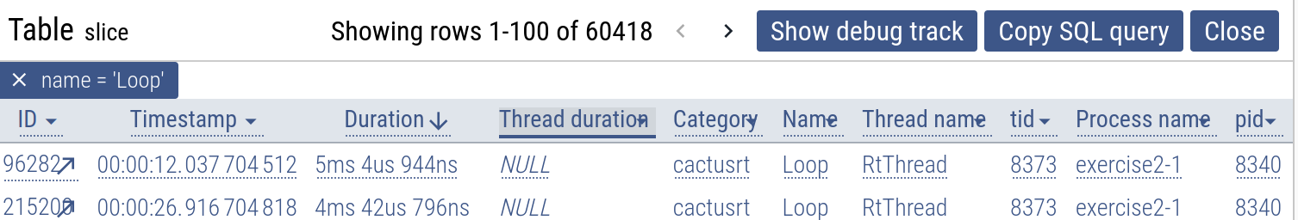  Click on the the ID shown on the left most column (96282 in the above example) to bring the timeline view to the longest Loop instance:  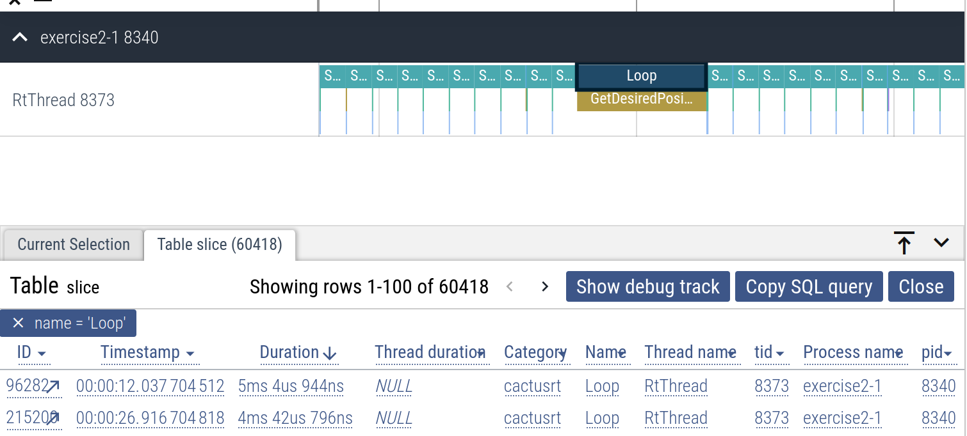

Using histogram visualization
After loading data, on the left side bar, click on Latency:
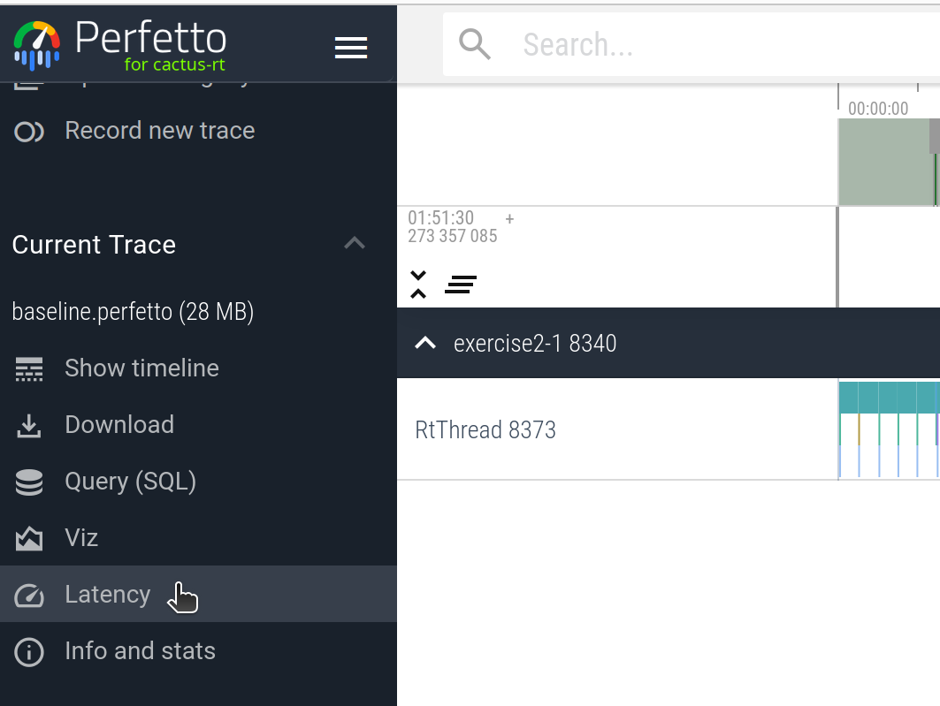
Select a thread and a slice on the drop down:
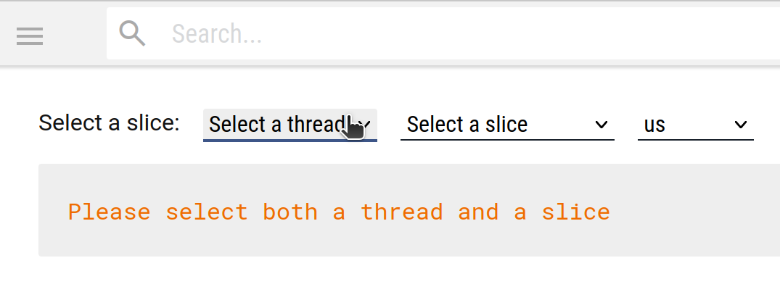
Visualize the latency histogram. Click on us to change the time scale if necessary. Min, average, max duration is also shown below. Red vertical line shows maximum latency:
