|  |  |
| --- | --- |
| **Name** | Ian Towey |
| **Student Number** | 04128591 |
| **Subject** | STAT40850 – Bayesian Analysis |
| **Assignment** | Lab 3 |
| **Date** | 6th May 2016 |

A number of Poisson and Binomial likelihood regession models were fitted to the dataset

1. yi ~ Poisson(λi) , log(λi) <- α + β1*xi + β2*zi DIC = 189.901
2. yi ~ Poisson(λi) , log(λi) <- α + β1*(xi - μx) + β2*(zi – μz) DIC = 191.570
3. yi ~ Poisson(λi) , log(λi) <- α + β1*xi + β2*log(zi)DIC = 210.878
4. yi ~ Bin(n, pi), logit(pi) <- α + β1*xi + β2*zi DIC = 157.011 (**)
5. yi ~ Bin(n, pi), logit(pi) <- α + β1*(xi - μx) + β2*(zi – μz)DIC = 157.439

Using these with vector **x =** Distance column, **z =** No. Tries Columnand **y** = No. Successes, yielded DIC values indicated above.

Model 4 above has the lowest DIC value, this indicates it fits the data the best.

The estimates for regression parameters for model 4 are;

|  |  |  |
| --- | --- | --- |
| **Parameter** | **Estimate** | **Standard Deviation** |
| α | 0.7336 | 0.1183 |
| β1 | -0.1612 | 0.009171 |
| β2 | 0.00163 | 1.222E-4 |

The estimate's of the proportion of successes from 5, 10, and 30 feet are given below

|  |  |
| --- | --- |
| **Distance** | **Estimate proportion of successes** |
| 5 | 0.6231 |
| 10 | 0.3653 |
| 30 | 0.01943 |

Below is a lot of the data along with the fitted regression slope , from this and the estimate above the odds of landing a put from 30 feet are 1 in 50.

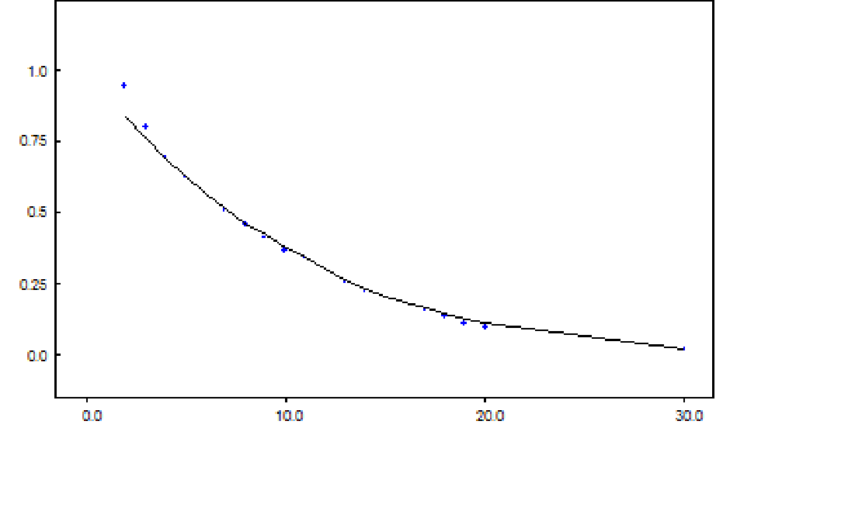

Appendix

|  |
| --- |
| Golf putting model  model{  for (i in 1:N){  Tries[i] ~ dflat()  Success[i] ~ dbin(p[i],Tries[i])  logit(p[i]) <- alpha + beta1*Dist[i]+ beta2*Tries[i]  }  alpha ~ dflat()  beta1 ~ dflat()  beta2 ~ dflat()  }  # The data  list(N=20)  Dist[] Tries[] Success[]  2 1443 1346  3 694 577  4 455 337  5 353 208  6 272 149  7 256 136  8 240 111  9 217 69  10 200 67  11 237 75  12 202 52  13 192 46  14 174 54  15 167 28  16 201 27  17 195 31  18 191 33  19 147 20  20 152 24  30 100 0  END  # Initial values  list(alpha=0,beta1=0,beta2=0) |