Project 1 Build Log
Pilbara Ridge Fleet Reliability and Maintenance Performance
Project purpose
Build an end-to-end Power BI analytics solution for Pilbara Ridge Mining Operations to identify fleet reliability risks, repeat failures, downtime drivers, supply-chain delays, weather impacts and maintenance priorities.
Business problem
Operations leaders need a clear view of which assets are driving downtime and production loss, whether recurring failures are being resolved, whether delayed parts are extending repair duration, and which assets should be prioritized for maintenance intervention or replacement planning.

Milestone tracker
Date | Milestone | Status | Evidence saved
06/07/2026 | Project folders and GitHub repository created | Completed | 01_github_repository_published, 02_project_folder_structure, 03_readme_created_in_vscode, 04_readme_content_added_in_vscode, 05_gitignore_created, 06_project_build_log_updated, 07_github_repository_synced_after_setup_commit
06/07/2026 | Raw files reviewed and data-quality issues identified | Completed | 09_raw_data_files_received
07/07/2026 | Excel raw-data audit completed | Completed | 10_asset_register_loaded_in_excel, 11_asset_register_audit_completed, 12_breakdown_events_loaded_in_excel, 13_breakdown_events_audit_completed, 14_crew_roster_audit_completed, 15_fuel_usage_loaded_in_excel, 16_maintenance_work_orders_audit_completed, 17_shift_operations_log_audit_completed, 18_excel_audit_commit_ready
08/07/2026  To  16/07/2026 | Power Query cleaning completed | Completed | 19_asset_register_opened_in_power_query, 20_three_staging_tables_loaded, 21_fuel_usage_quality_flags_created, 22_stg_breakdown_events_loaded, 23_breakdown_events_timestamp_artifact_identified, 25_maintenance_failure_category_standardised, 26_maintenance_work_orders_quality_flags_created, 27_shift_operations_date_errors_replaced, 28_shift_operations_quality_flag_created, 29_shift_operations_include_flag_created, 30_shift_operations_final_flags_and_asset_match
16/07/2026 | Data model completed | Completed | 31_power_bi_model_initial_relationship_view, 32_manage_relationships_initial_relationships, 33_asset_relationships_added, 34_date_relationships_added, 35_power_bi_model_relationship_layout
17/07/2026 | SQL database and tables created | Completed | 48_sql_asset_register_loaded 49_sql_breakdown_events_loaded 50_sql_crew_roster_loaded 51_sql_fuel_usage_loaded 52_sql_parts_inventory_loaded 53_sql_maintenance_work_orders_loaded 54_sql_shift_operations_log_loaded 55_sql_all_tables_row_count_validation
17/07/2026 | SQL validation and analysis queries created | Completed | 13_sql_data_quality_checks.sql 14_sql_asset_reliability_analysis.sql 15_sql_maintenance_performance_analysis.sql 56_sql_data_quality_checks_work_orders 57_sql_data_quality_checks_shift_fuel 58_sql_data_quality_checks_exclusions 59_sql_asset_reliability_breakdowns 60_sql_asset_reliability_downtime 61_sql_asset_reliability_risk_ranking 62_sql_maintenance_performance_summary 63_sql_maintenance_performance_work_order_details_part_1 64_sql_maintenance_performance_work_order_details_part_2
24/07/2026 | Power BI DAX measures completed | Completed | 65_power_bi_measures_table_created 66_power_bi_maintenance_measures_created 67_power_bi_breakdown_reliability_measures_created 68_power_bi_data_quality_measures_created 69_power_bi_fuel_operations_measures_created 70_power_bi_executive_kpi_measures_created Power BI .pbix file saved in 04_power_bi DAX_Measure_Dictionary.docx updated
28/07/2026 | Dashboard development | In progress | 71_power_bi_executive_kpi_measures_validated  72_power_bi_executive_overview_header_and_kpis  73_power_bi_top_10_assets_by_downtime  74_power_bi_work_order_inclusion_issue_identified  75_power_bi_corrective_work_orders_by_failure_category  76_power_bi_asset_reliability_header_kpis_and_slicers  77_power_bi_asset_reliability_breakdowns_vs_downtime  78_power_bi_top_10_assets_by_breakdown_events  79_power_bi_maintenance_failure_analysis_page_created
 | Dashboard pages completed | Not started
 | Findings and recommendations completed | Not started
 | GitHub README and portfolio case study completed | Not started
 | Medium Updated | Not Started

Build journal
Date:
Tool used:
What I did:
Why it matters:
Problem or decision:
What I learned:
Evidence saved: Screenshot / video / file name
Date: 06/07/2026
Tool used:
GitHub Desktop
What I did:
Created and published the Pilbara Ridge Fleet Reliability repository.
Why it matters:
The repository will store version-controlled evidence of my analytics process project documentation, SQL, Python, screenshots and final portfolio materials.
Problem or decision:
No issue encountered at this stage.
What I learned:
GitHub is not just for software developers. It provides a documented history of how a data project was built.
Evidence saved:
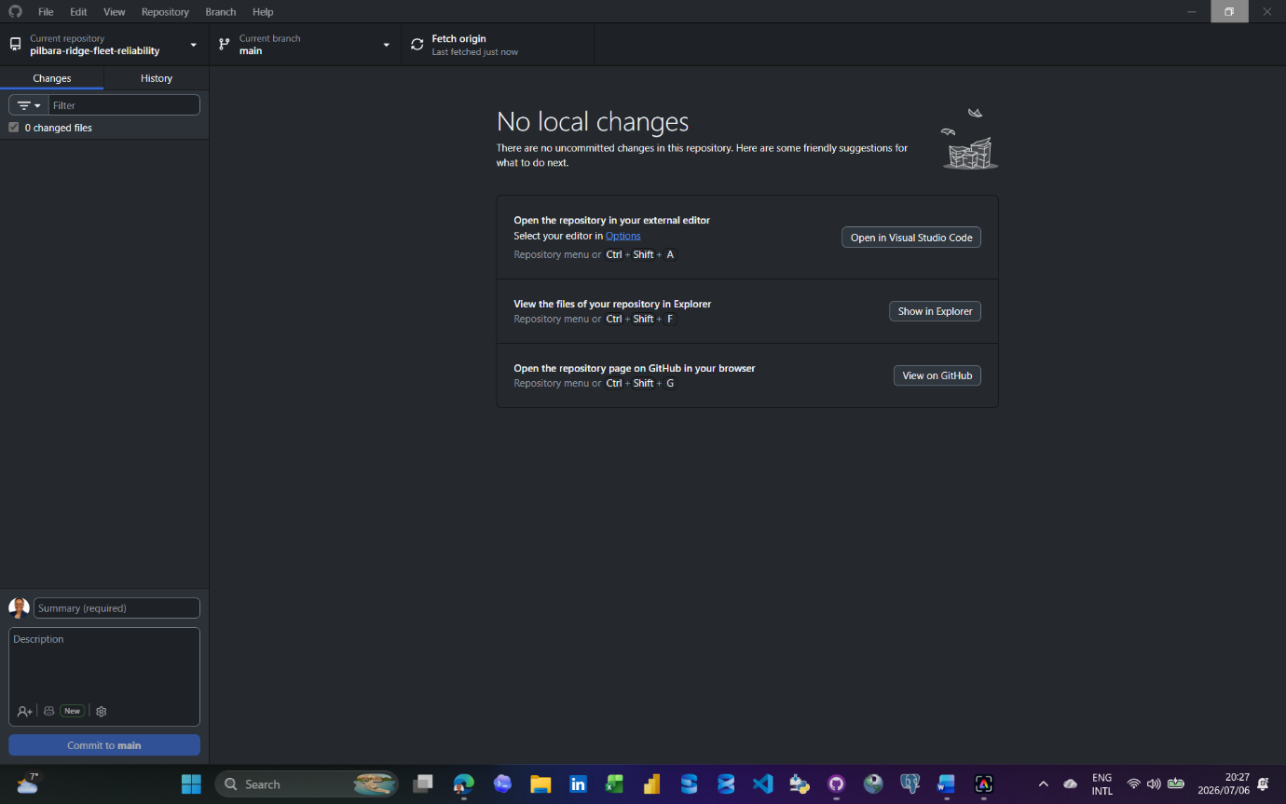

Date: 06/07/2026
Tool used:
Visual Studio Code
What I did:
Created the README.md file for the GitHub repository.
Why it matters:
The README.md is the public front page of the project and explains the business problem, tools, project scope, and build status.
Problem or decision:
No issue encountered at this stage.
What I learned:
Markdown is plain text formatting used by GitHub to display project documentation clearly.
Evidence saved:
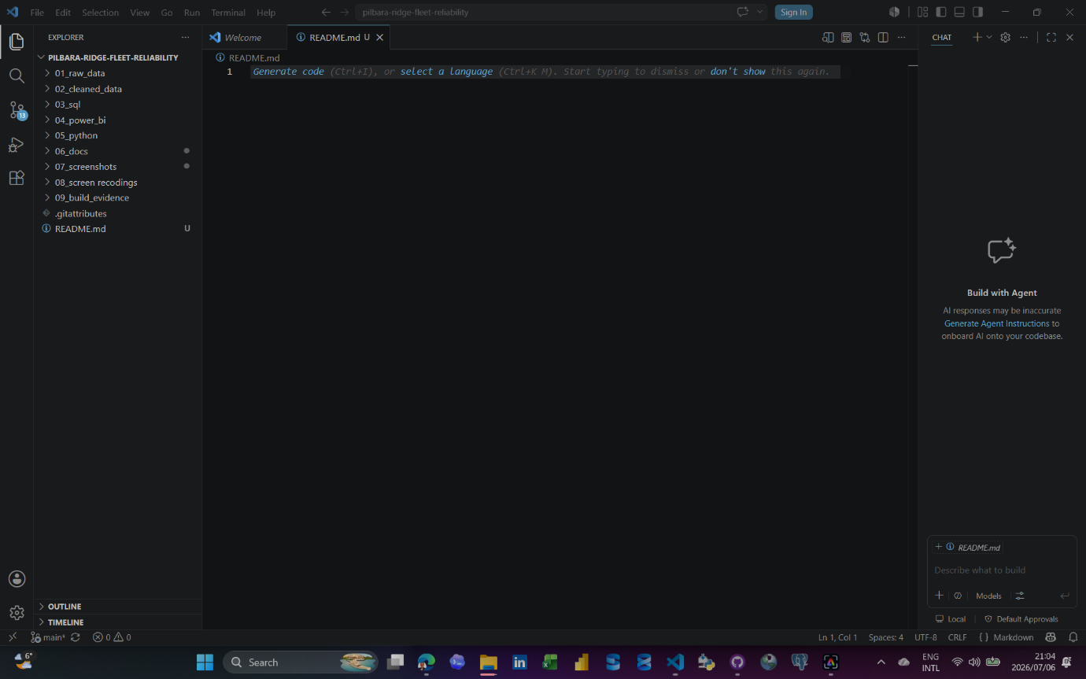
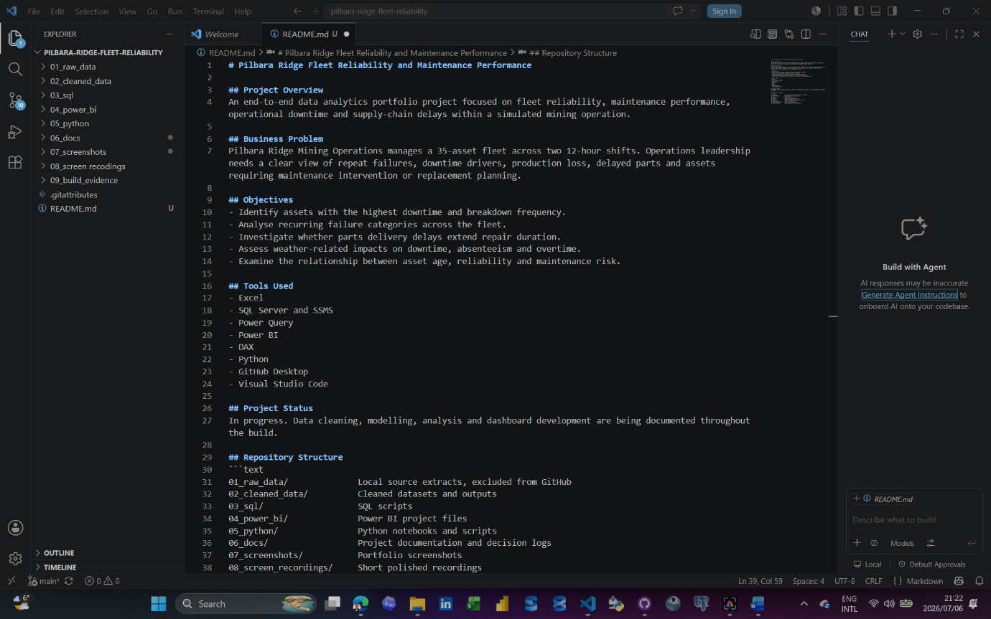
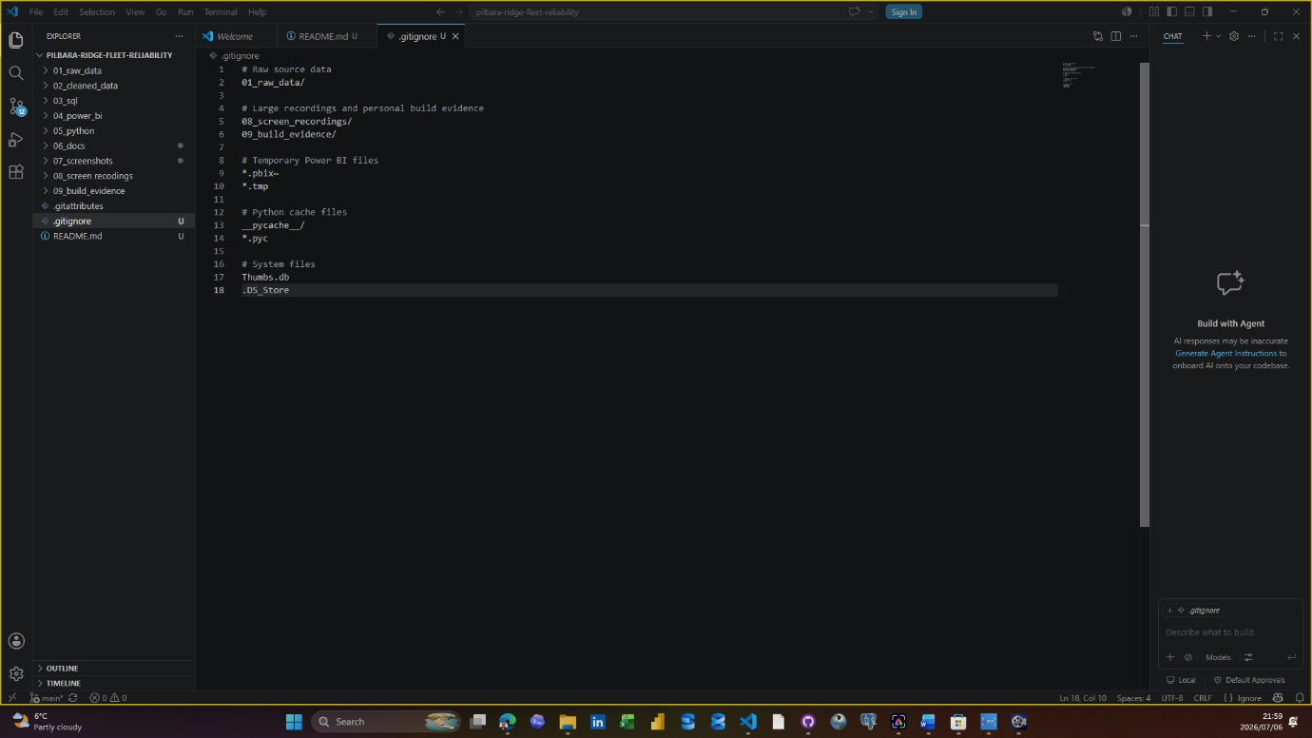
Date: 06/07/2026
Tool used: GitHub Desktop
What I did: Committed and pushed the initial project structure, README, documentation templates, screenshots and .gitignore rule to GitHub.
Why it matters: The repository now has a visible, version-controlled starting point before the technical analysis begins.
Problem or decision: Raw data, long recordings and build evidence files are intentionally retained locally and excluded from the public repository
What I learned: A commit records a snapshot locally; Push origin publishes that snapshot to GitHub.
Evidence saved:
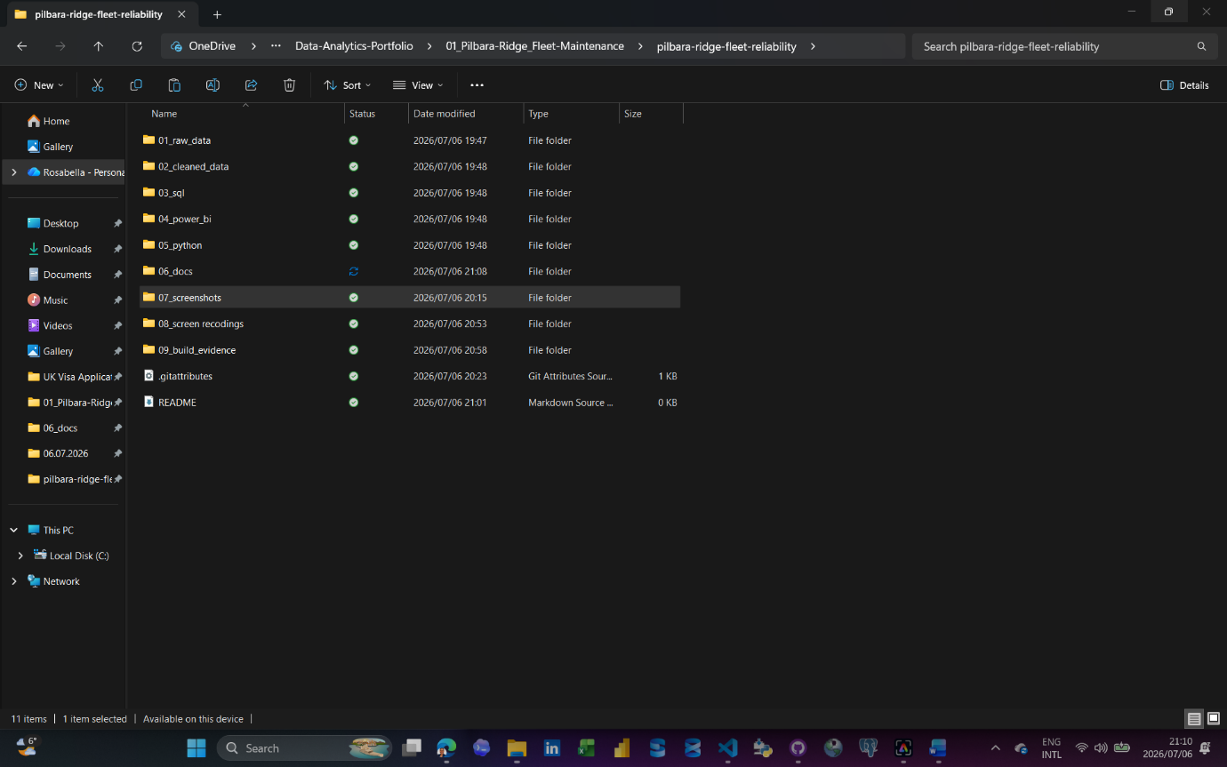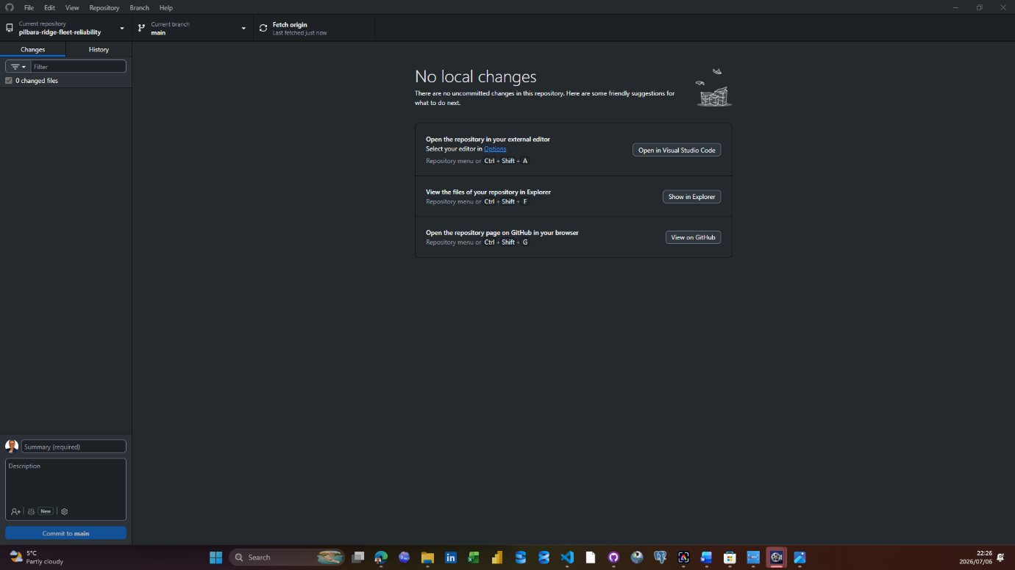

Date: 07/07/2026
Tool used:
Excel, Microsoft Word, GitHub Desktop and Power BI Desktop
What I did:
Completed the Excel raw-data audit for all seven Project 1 source files, documented the findings in the Data Cleaning Log, committed the Excel audit workbook to GitHub, created the Power BI file and imported the first staging table, stg_asset_register, through Power Query.
Why it matters:
This created a documented quality baseline before cleaning. The Excel audit identified which tables are structurally clean and which tables require repeatable Power Query cleaning. It also created evidence of my process before moving into modelling and dashboard development.
Problem or decision:
The first reference tables were mostly clean, so no unnecessary transformations were forced. The main cleaning focus will be fuel_usage, maintenance_work_orders and shift_operations_log because the Excel audit found missing values, duplicate IDs, invalid dates, unmatched asset IDs and data-type issues in those tables.
What I learned:
A data project does not only involve finding errors. It also involves proving which tables are reliable, documenting quality decisions and using the right tool at the right stage. Excel helped with initial auditing, while Power Query will be used for repeatable cleaning.
Evidence saved:
Pilbara_Ridge_Excel_Raw_Data_Audit.xlsx
Data_Cleaning_Log.docx
Power BI file: Pilbara_Ridge_Fleet_Reliability.pbix
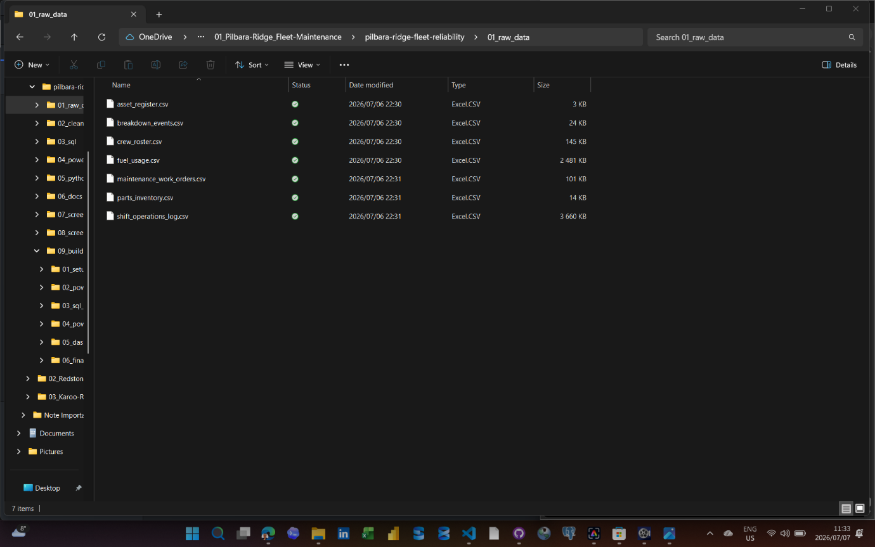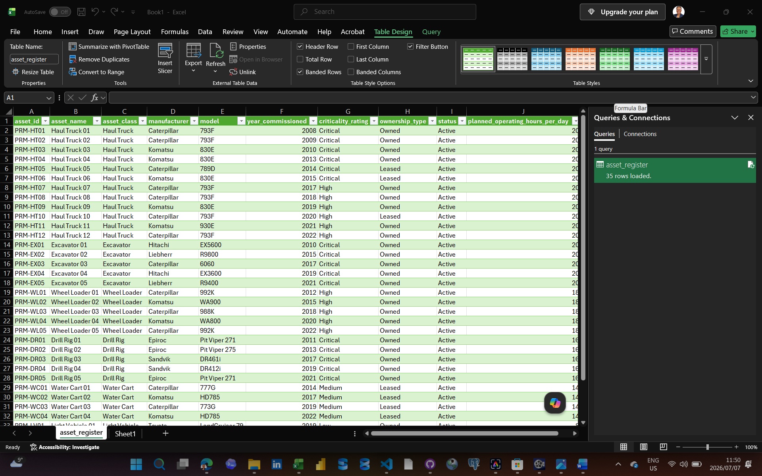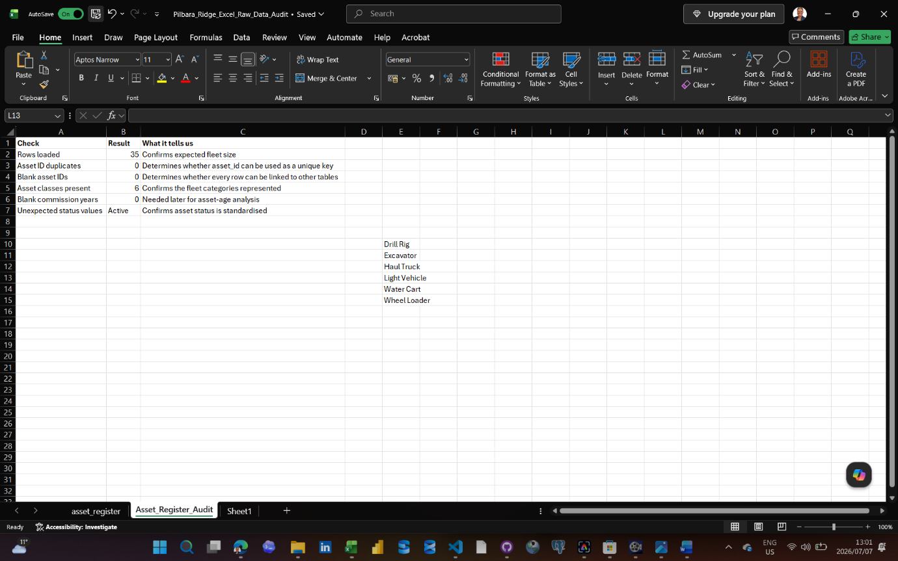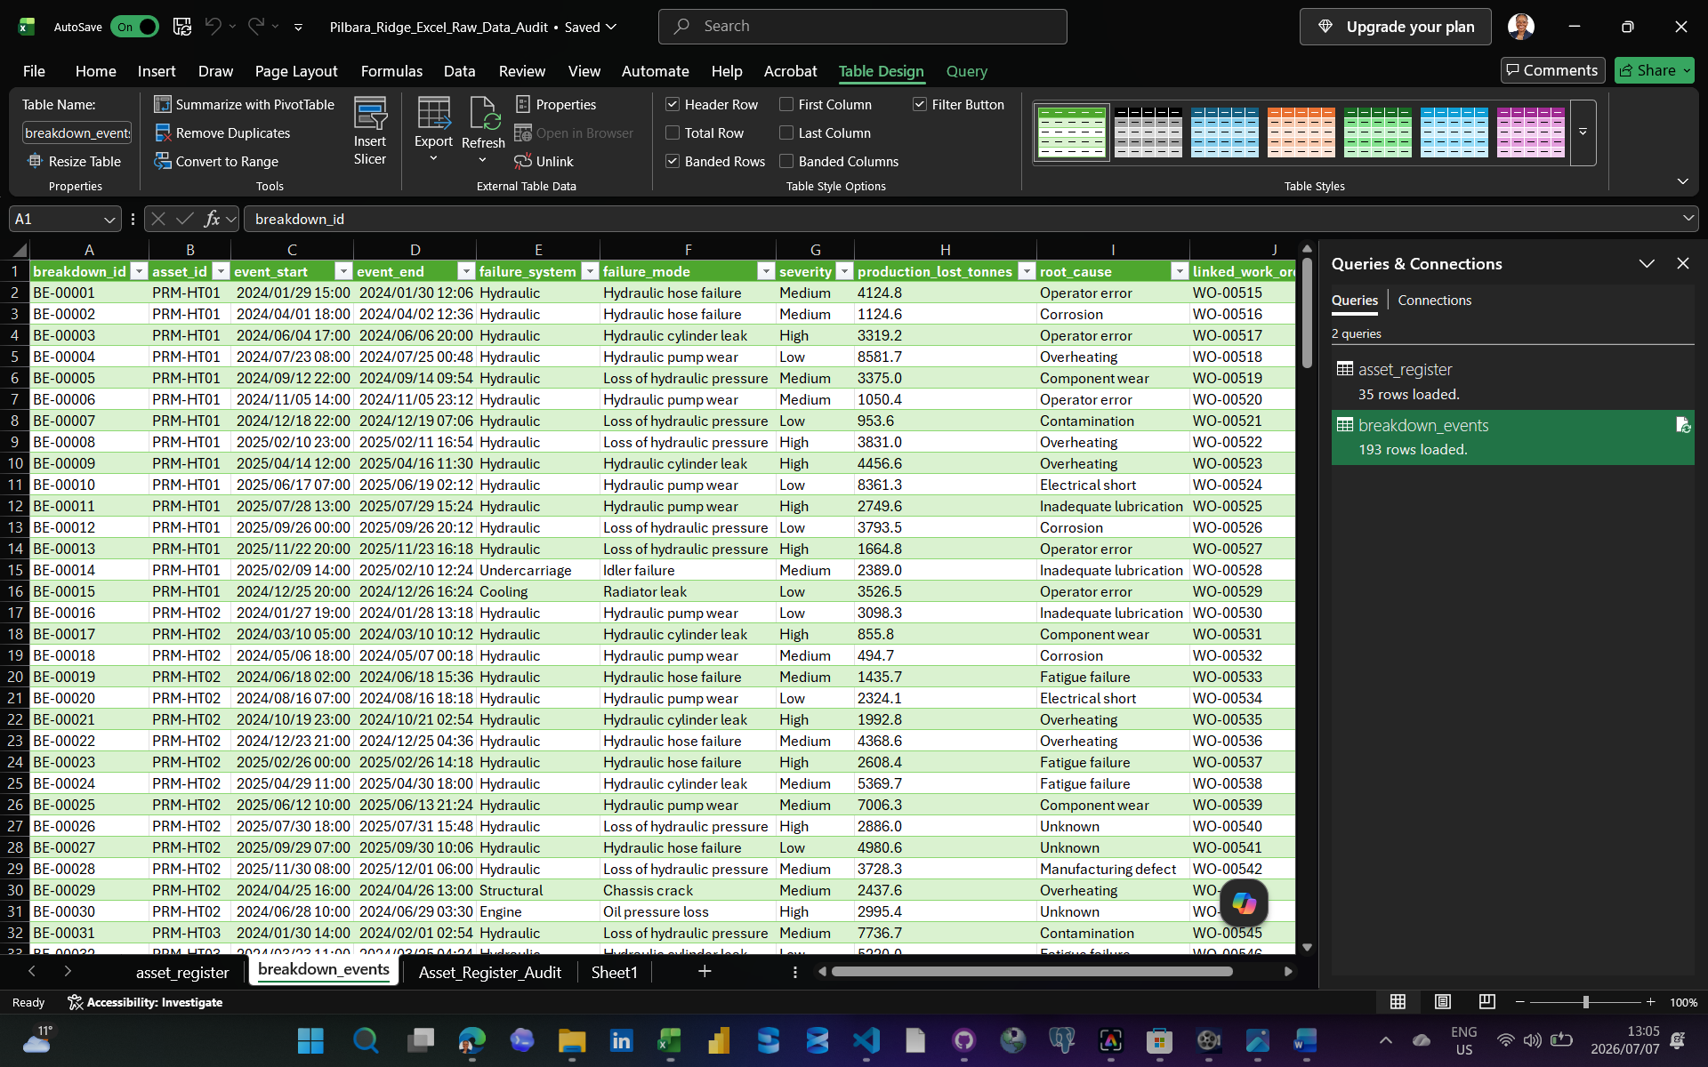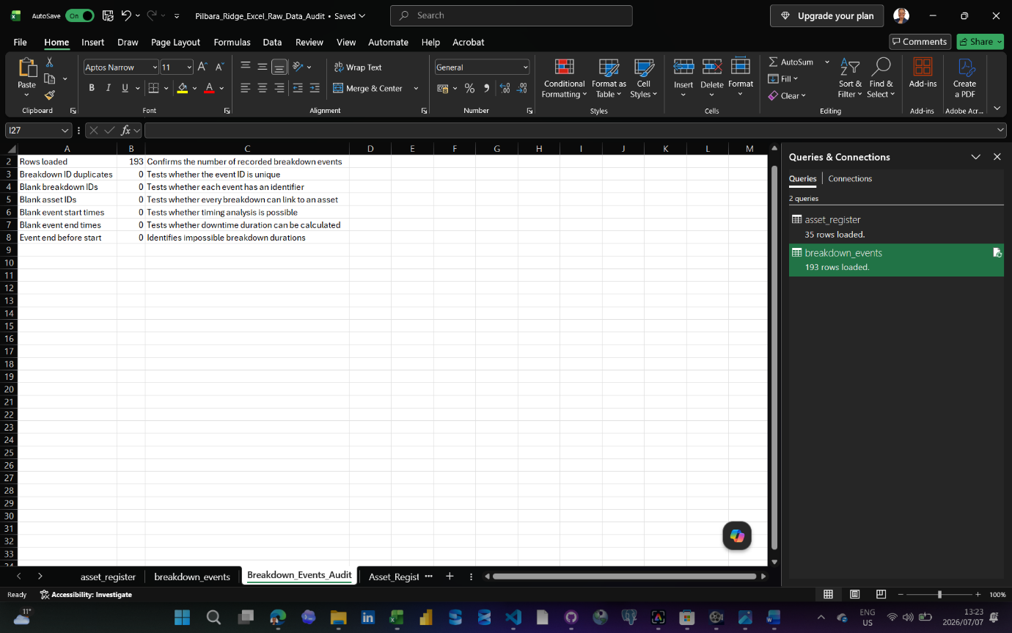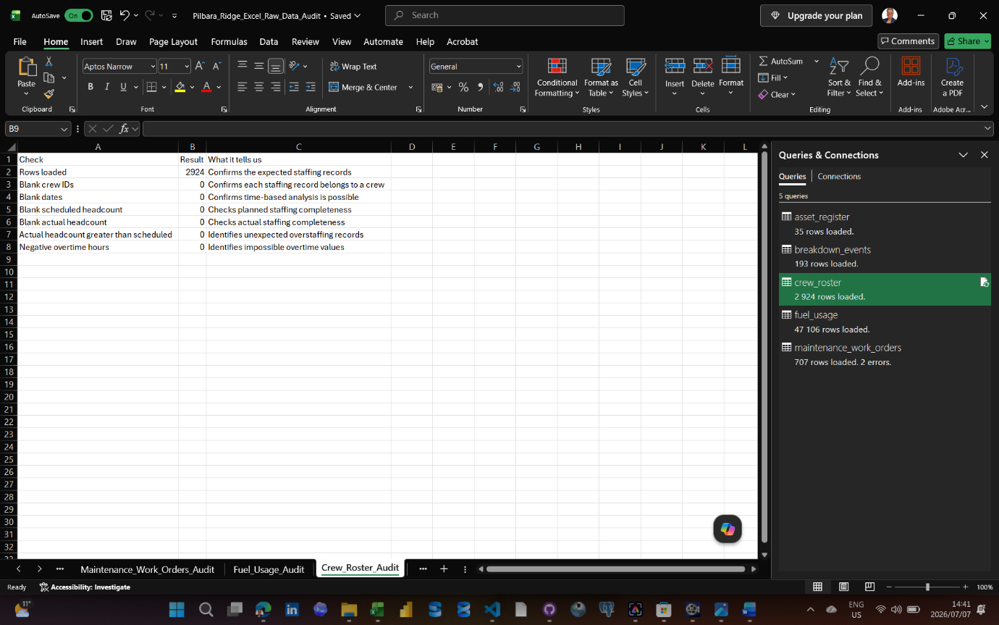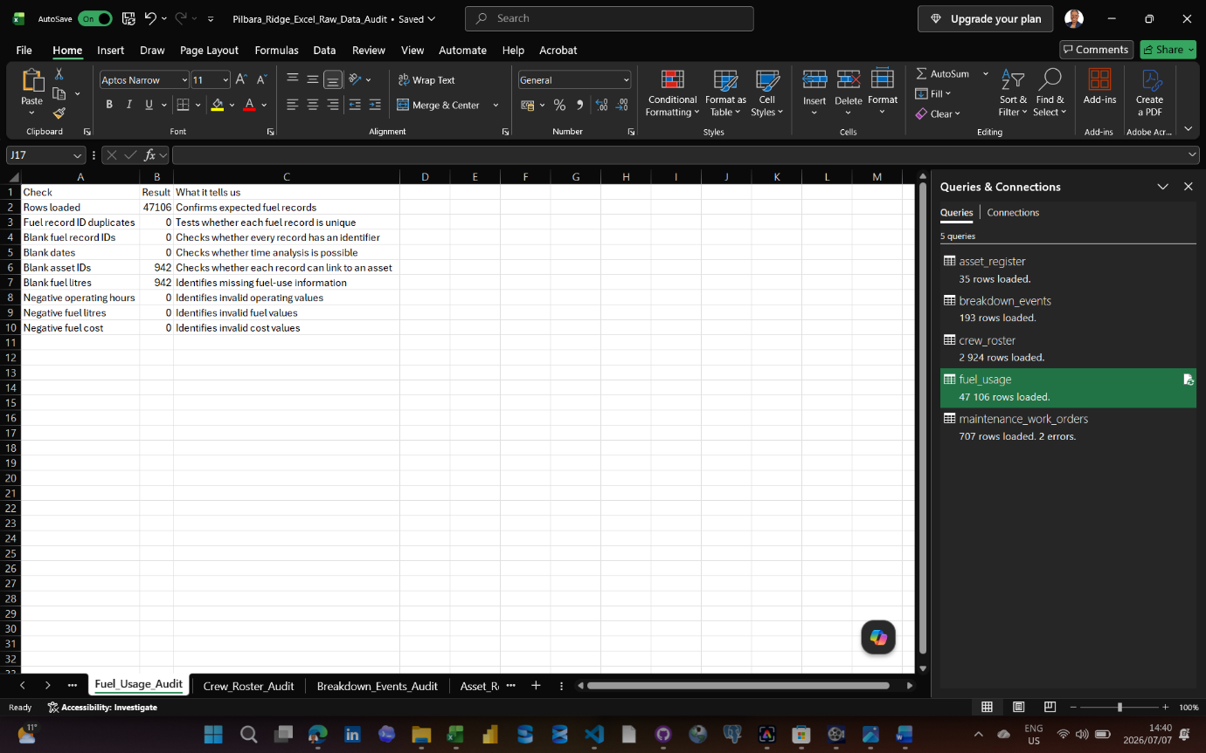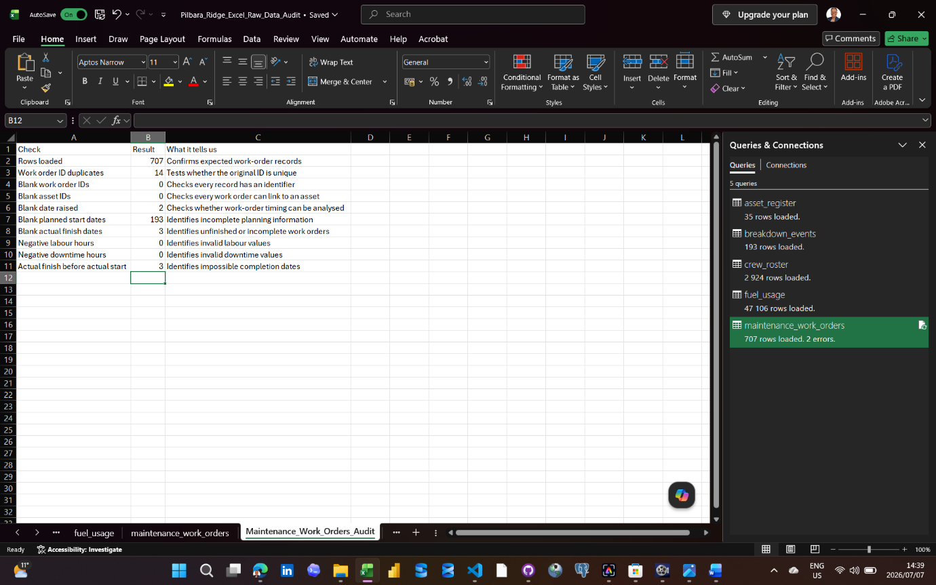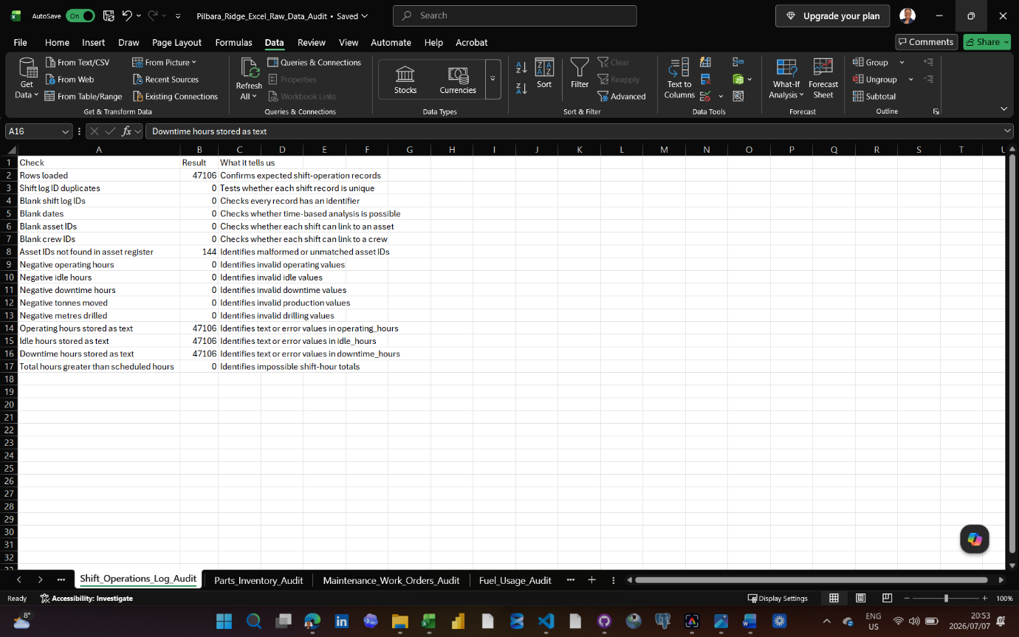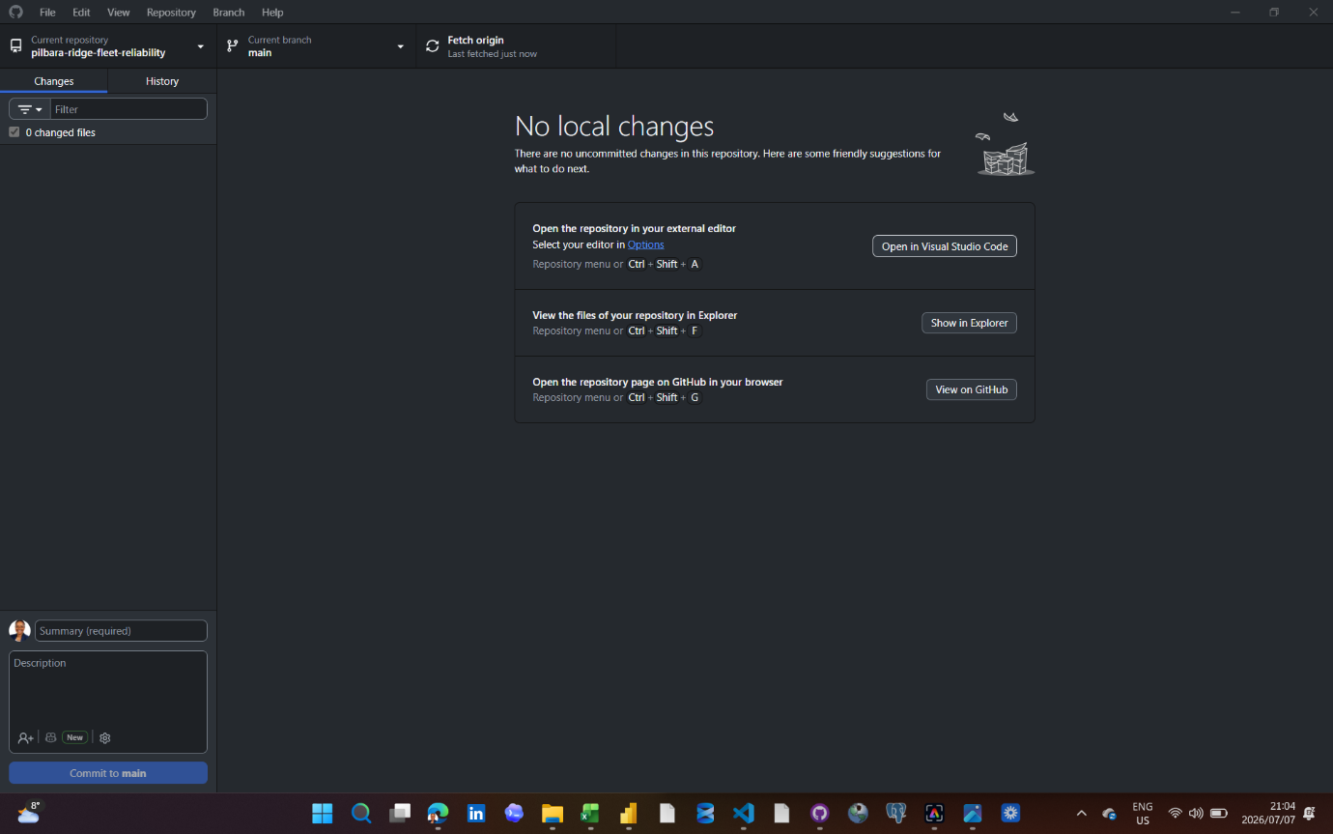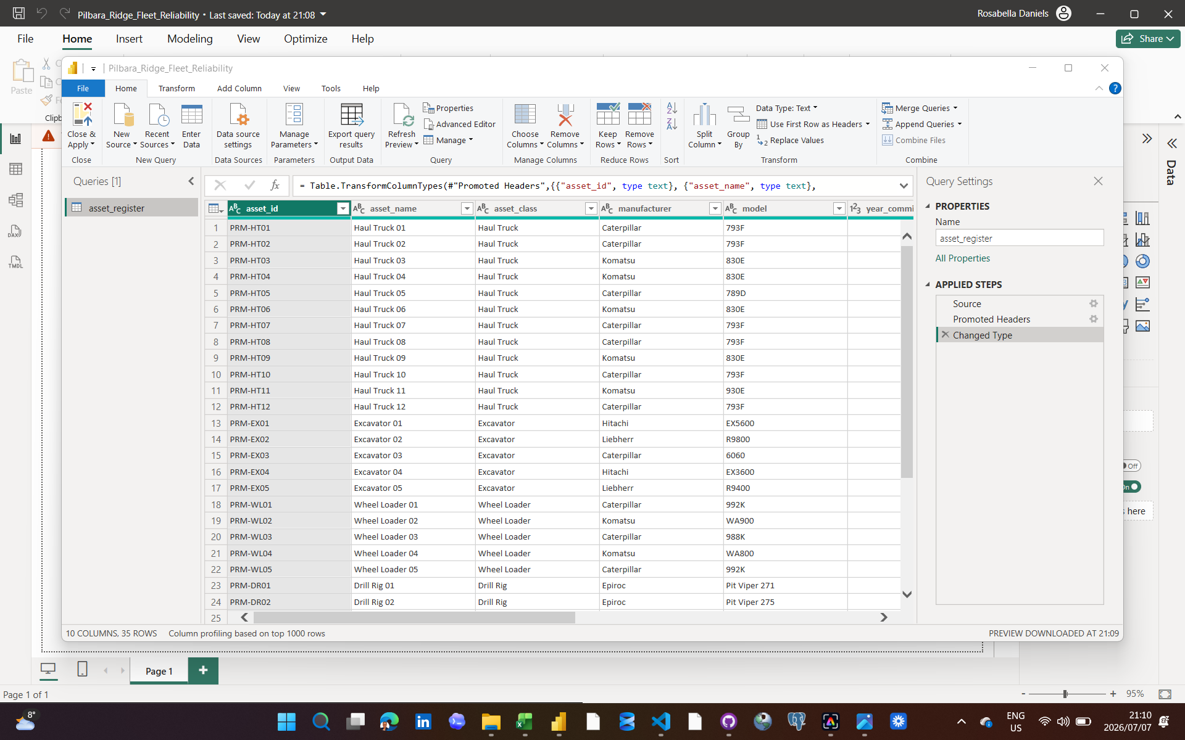
Date: 08/07/2026
Tool used:
Continued the Power Query build by importing asset_register.csv into Power BI, renaming the query to stg_asset_register and making minor heading changes for consistency.
What I did:
Continued the Power Query build by importing asset_register.csv into Power BI, renaming the query to stg_asset_register and making minor heading changes for consistency.
Why it matters:
This created the first staging table in the Power BI file and established the naming approach for the remaining imported tables.
Problem or decision:
The asset register did not require data cleaning, but column headings were adjusted to keep the model readable and consistent.
What I learned:
Power Query can be used not only to fix bad data, but also to standardise structure before modelling.
Evidence saved:
Power BI file: Pilbara_Ridge_Fleet_Reliability.pbix
Date: 10/07/2026
Tool used:
Imported breakdown_events.csv into Power Query and renamed the query to stg_breakdown_events.
What I did:
Checked that the expected columns were present and reviewed the data types. Set breakdown_id, asset_id, failure_system, failure_mode, severity, root_cause and linked_work_order_id as Text. Set event_start and event_end as Date/Time. Set production_lost_tonnes as Decimal Number.

I also fixed a timestamp issue where some event_start and event_end values contained floating-point timestamp artifacts such as 11:47:59.999999999. I rounded event_start and event_end to the nearest second and reapplied the Date/Time type after the transformation.
Why it matters:
This created a clean staging version of the breakdown events table for later analysis. The timestamp correction matters because breakdown duration, downtime patterns and links to maintenance work orders depend on reliable start and end times.
Problem or decision:
The date/time fields needed extra attention because the timestamp rounding transformation reset the columns to a generic type. I decided to correct the timestamp artifact and then reapply the Date/Time type rather than leaving messy timestamp values in the model.
What I learned:
Power Query can change column types after a transformation, even when the original type was already correct. I learned to check data types again after applying cleaning steps, especially for date/time fields. I also learned that not every strange value is a data-entry error. Some issues are source-system or serialization artifacts that need controlled correction.
Evidence saved:
Power BI file: Pilbara_Ridge_Fleet_Reliability.pbix
Data cleaning documentation: Data_Cleaning_Log.docx
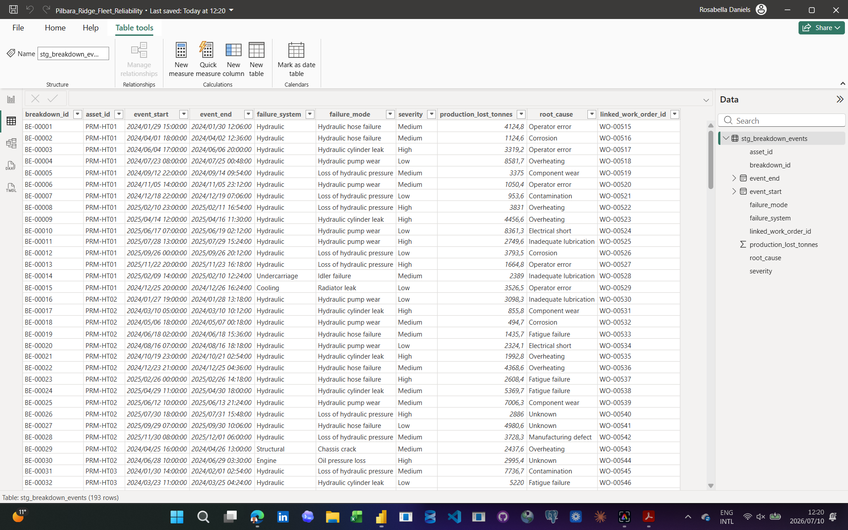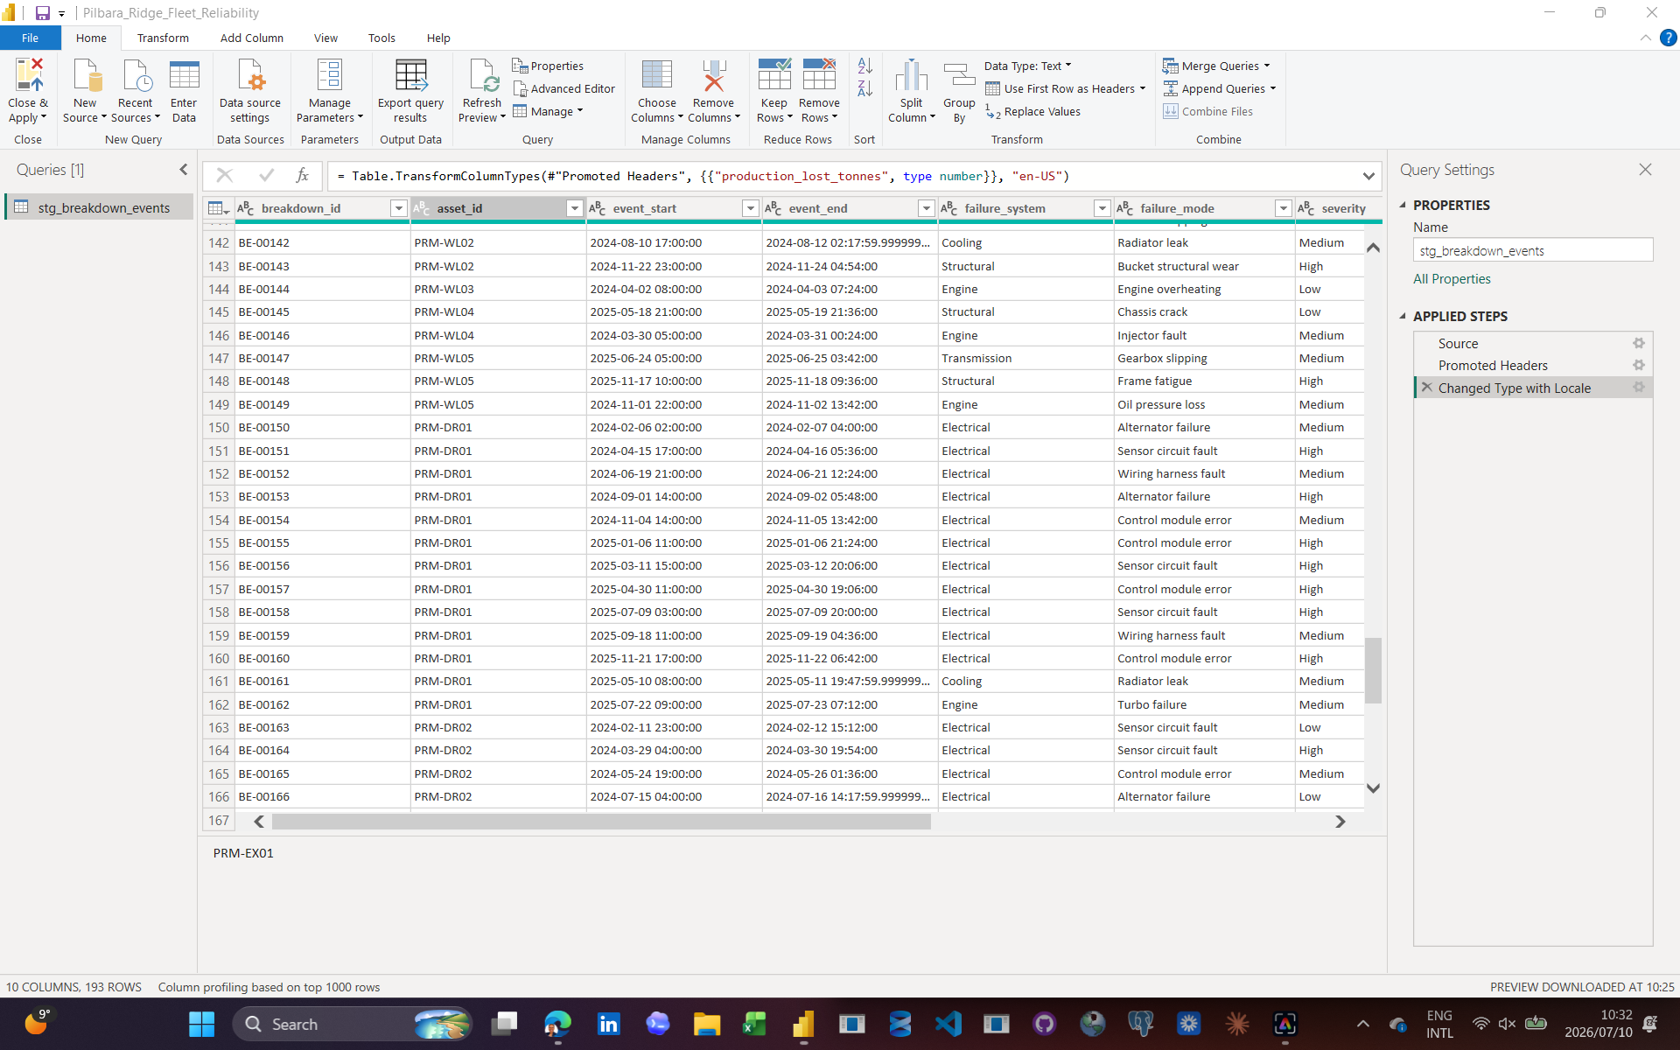
Date: 12/07/2026
Tool used:
Power BI Desktop, Power Query, Microsoft Word.
What I did:
Continued the Power Query cleaning phase for Project 1. Confirmed that stg_asset_register, stg_breakdown_events, stg_crew_roster and stg_parts_inventory were loaded into the Power BI model.

Re-imported stg_asset_register after noticing it was missing from the Data pane and confirmed it appeared correctly with the other staging tables. Imported fuel_usage.csv into Power Query and renamed the query to stg_fuel_usage.

Checked the expected headings: fuel_record_id, date, asset_id, operating_hours, fuel_litres, fuel_cost_aud and shift_type. Updated the numeric fields so operating_hours, fuel_litres and fuel_cost_aud were stored as Decimal Number.

Created Fuel_Record_Quality_Flag to identify incomplete fuel records.
Created Include_In_Fuel_Analysis to separate records that can be used safely in fuel-consumption KPIs from records that should remain in the dataset for data-quality reporting. Created Asset_ID_Standardised to clean inconsistent asset ID formatting, including lowercase IDs and IDs missing hyphens.
Why it matters:
This moved the project from simple importing into actual repeatable Power Query cleaning. The fuel_usage table is one of the first tables with real data-quality issues, so documenting and controlling those issues is important before building relationships, DAX measures and dashboard visuals.
Problem or decision:
The Excel audit suggested blank asset_id values, but Power Query validation did not confirm true null or blank asset IDs. Further inspection showed the real issue was inconsistent asset ID formatting, such as lowercase IDs and IDs without hyphens. I decided to keep the original asset_id field for transparency and create a separate Asset_ID_Standardised column for clean relationships.

I also decided not to replace null fuel_litres values with zero. These records are retained, flagged as Missing fuel litres, and excluded from fuel KPI calculations using Include_In_Fuel_Analysis.
What I learned:
I learned that an Excel audit finding should be validated again in Power Query before cleaning decisions are finalised. A value can look like a blank or matching issue in one tool but reveal itself as a formatting problem in another. I also learned the difference between cleaning data for relationships and preserving original source values for auditability.
Evidence saved:
Power BI file: Pilbara_Ridge_Fleet_Reliability.pbix
Data cleaning documentation: Data_Cleaning_Log.docx
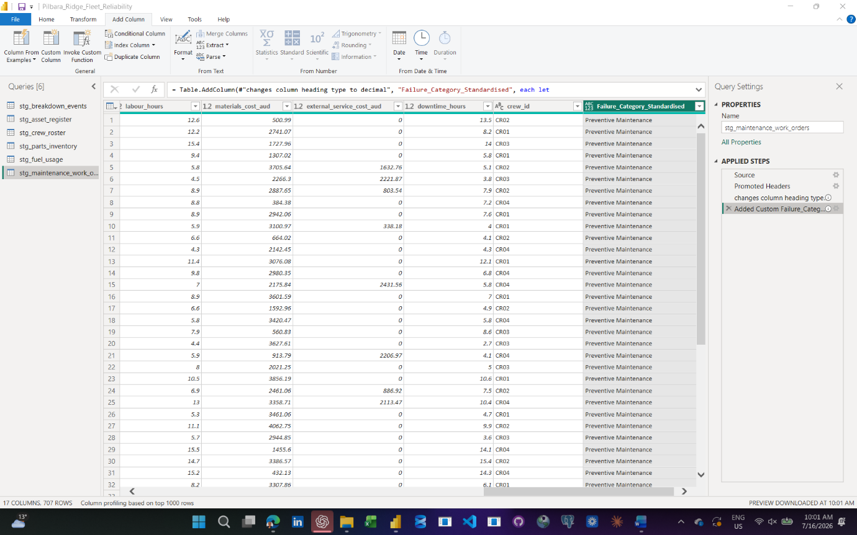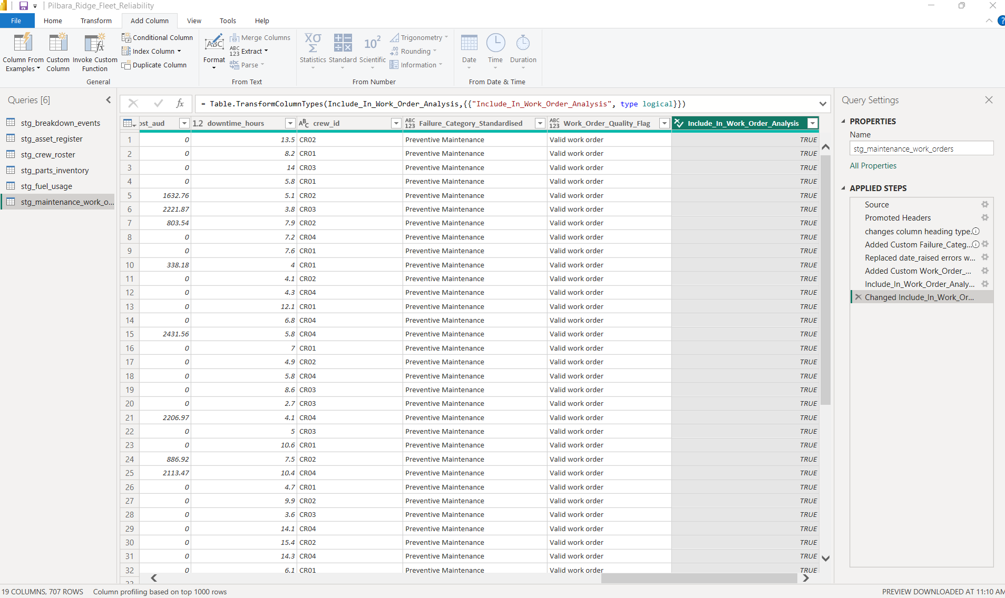
Date: 16/07/2026
Tool used:
Power BI Desktop, Power Query
What I did:
Continued the Power Query cleaning phase for Project 1 by working on maintenance_work_orders.csv. Imported the file into Power Query and renamed it to stg_maintenance_work_orders. Confirmed 707 rows loaded and checked that all expected columns were present. I corrected the main numeric fields by setting labour_hours, materials_cost_aud, external_service_cost_aud and downtime_hours to Decimal Number. I reviewed the failure_code and failure_description fields and identified inconsistent failure code labels, including abbreviations and mixed formats such as ELEC, Elec, Electrical, HYD, HYDRAULICS, TYR and TYRES. I created Failure_Category_Standardised to convert failure codes into full readable categories such as Electrical, Hydraulics, Transmission, Cooling, Engine, Structural, Tyres, Undercarriage and Preventive Maintenance.

I kept the original failure_code column unchanged for auditability. I also identified errors in date_raised on rows 469 and 563. These values could not be parsed as valid dates, so I replaced the errors with null. I then created Work_Order_Quality_Flag to classify work order records by quality issue and created Include_In_Work_Order_Analysis as a True/False flag for KPI filtering.
Why it matters:
maintenance_work_orders is one of the central tables in the fleet reliability project. It connects assets, maintenance activity, costs, downtime, crews and failure categories. Cleaning this table properly is important because it will support work order KPIs, downtime analysis, cost analysis and failure pattern reporting.
Problem or decision:
The original failure_code field contained inconsistent abbreviations and labels, so I decided not to overwrite it. Instead, I created a separate Failure_Category_Standardised column using full readable names to support accessibility and dashboard clarity. The Excel audit suggested several quality issues. Power Query confirmed invalid date_raised values and missing planned or actual finish dates. I decided to convert invalid date_raised errors to null and flag them rather than manually guessing the correct dates. I also validated the “finish before start date” issue separately and found that Power Query did not confirm it after type handling, so I did not force that issue into the final quality flag.
What I learned:
I learned that Power Query cleaning is not only about fixing errors. It is also about making deliberate modelling decisions. I learned to keep raw source columns for transparency while creating standardised analysis columns for reporting. I also learned that accessibility starts during data preparation because readable categories make later dashboard design simpler and clearer.
Evidence saved:
26_maintenance_work_orders_quality_flags_created.png Power BI file: Pilbara_Ridge_Fleet_Reliability.pbix Data cleaning documentation: Data_Cleaning_Log.docx
Date: 16/07/2026
Tool used:
Power BI Desktop, Power Query,
What I did:
Completed the Power Query cleaning stage for shift_operations_log.csv. Imported the file into Power Query and renamed it to stg_shift_operations_log. Confirmed the table contained the expected operational columns including shift_log_id, date, shift_type, asset_id, crew_id, scheduled_hours, operating_hours, idle_hours, downtime_hours, tonnes_moved, metres_drilled, weather_condition and operator_id.

I checked and corrected the main data types, including setting scheduled_hours and the other operational hour and production fields as Decimal Number. I identified date errors in the date column and replaced those errors with null so they could be handled consistently. I created Shift_Log_Quality_Flag to classify records as valid or as having issues such as missing or invalid date, negative operating hours or negative downtime hours.

I also created Asset_ID_Standardised to make asset IDs consistent with the asset register. I merged stg_shift_operations_log with stg_asset_register using the standardised asset ID and expanded asset_name and asset_class into the shift operations table. The merge matched 47,095 of 47,106 shift operation rows, showing that 11 rows had asset IDs that did not match the official asset register.

Finally, I created Asset_Match_Flag and updated Include_In_Shift_Analysis so that a shift record is included in KPI analysis only when the shift log is valid and the asset exists in the asset register.
Why it matters:
shift_operations_log is one of the main operational fact tables in the project. It will support analysis of operating hours, downtime, idle time, production movement, drilling activity and weather-related conditions. Cleaning this table properly is important because operational KPIs can be misleading if invalid dates, negative hours or unmatched assets are included.
Problem or decision:
I decided not to delete rows with data issues. Instead, I flagged them and created an inclusion field for KPI filtering. I also decided not to treat null tonnes_moved or null metres_drilled as automatic errors because those fields depend on asset class. This means the dataset remains transparent while still allowing clean KPI calculations.
What I learned:
I learned how to use Power Query not only to clean a table, but also to validate it against another table. The merge with the asset register showed why data quality checks need to include relationship checks, not just column formatting. I also learned that dashboard accessibility starts in the data model because readable fields, standardised IDs and clear flags make reporting easier later.
Evidence saved:
Power BI file: Pilbara_Ridge_Fleet_Reliability.pbix
Data cleaning documentation: Data_Cleaning_Log.docx

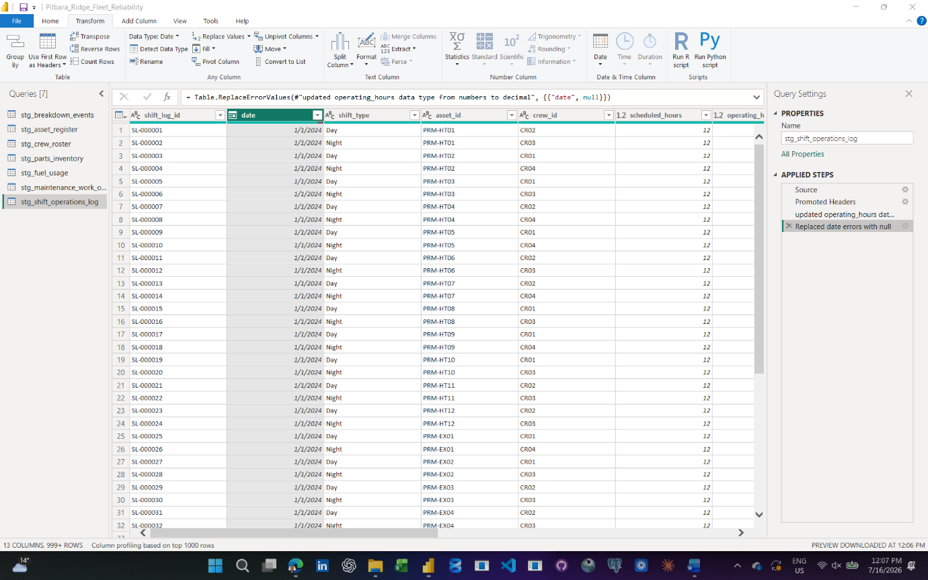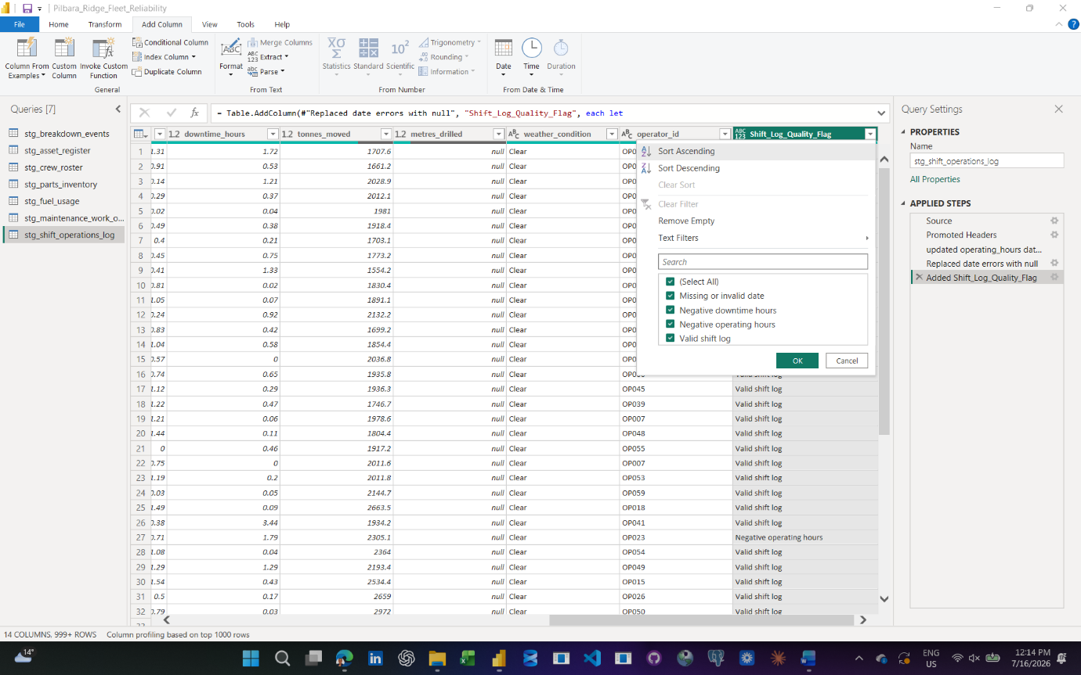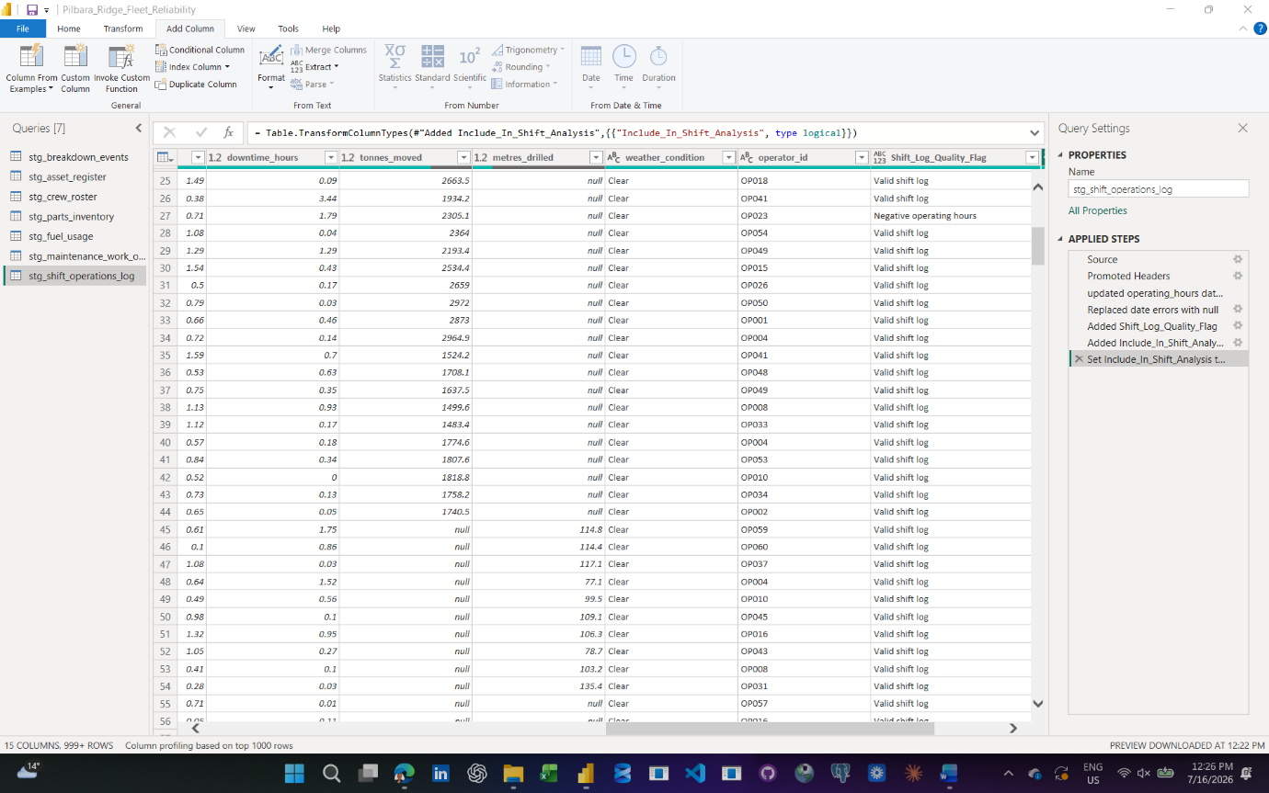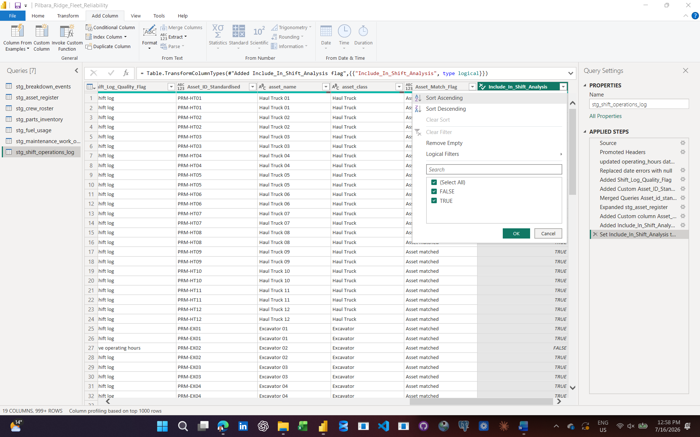
Date: 16/07/2026
Tool used: Power BI Desktop, Power Query, DAX
What I did:
Set up the initial Power BI data model for the Pilbara Ridge Fleet Reliability project. Confirmed that all seven staging tables were loaded into the model, then reviewed the automatic relationships Power BI created. I added missing relationships between the asset register and the main asset-based fact tables. The asset register now connects to breakdown events, fuel usage, maintenance work orders and shift operations. I created a DimDate table using DAX to provide a clean calendar from 01/01/2024 to 31/12/2025. The table includes Year, Month Number, Month Name, Year Month, Quarter, Weekday Number and Weekday Name. I marked DimDate as the official date table. I then created active date relationships from DimDate to the main reporting date fields in breakdown events, crew roster, fuel usage, maintenance work orders and shift operation.
Why it matters:
The Power BI model now supports reliable time-based and asset-based reporting. This means future measures and visuals can slice downtime, maintenance activity, fuel usage, crew data and operational performance by month, asset, asset class, criticality and ownership type.
Problem or decision:
I left stg_parts_inventory unconnected at this stage because it has multiple useful dates: order_date, expected_delivery_date and actual_delivery_date. Each date answers a different supply-chain question, so forcing one active relationship too early could create misleading analysis.
What I learned:
I learned that a clean data model is not just about connecting every table. It is about choosing the correct dimension tables, using single-direction relationships, and avoiding unnecessary relationships that could confuse the analysis. I also learned why a dedicated date table is important for trend reporting and DAX calculations.
Evidence saved:
Data_Model_Notes.docx
Pilbara_Ridge_Fleet_Reliability.pbix
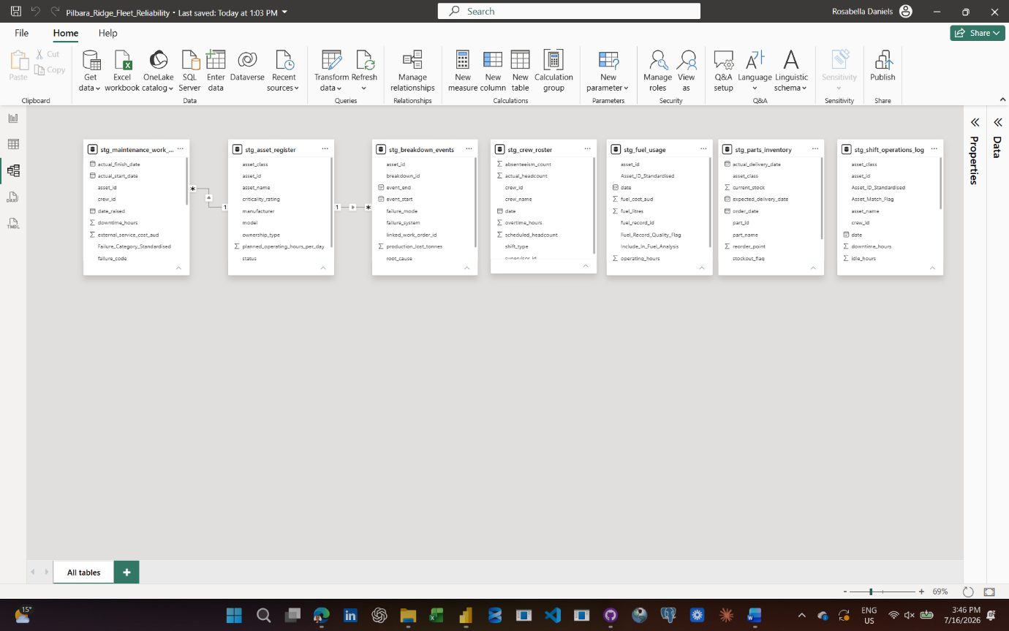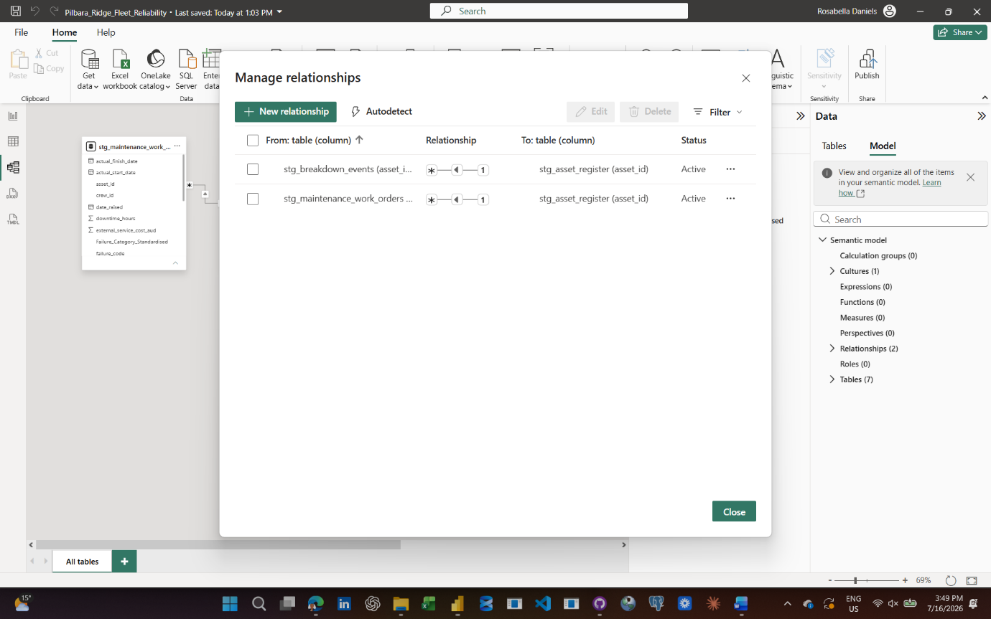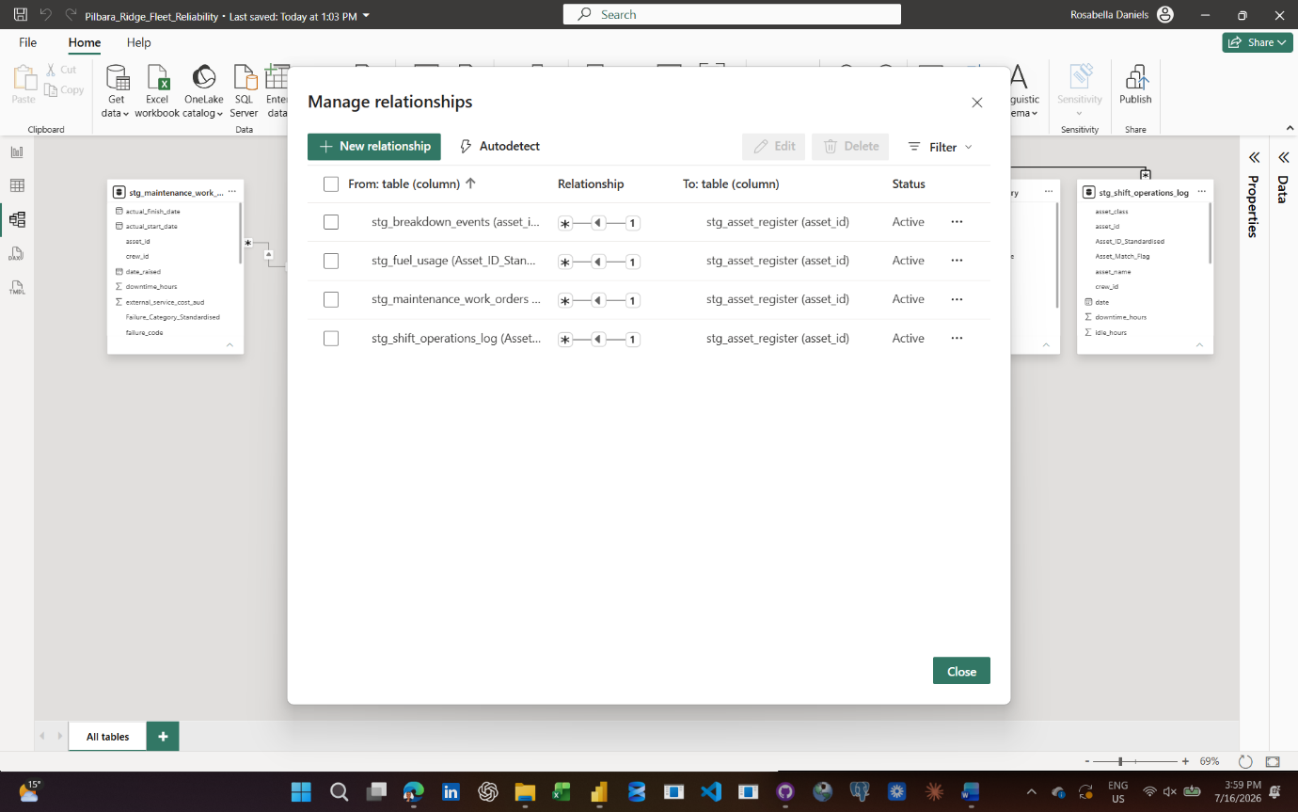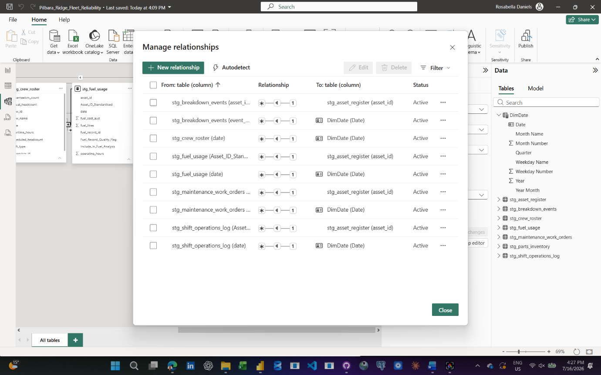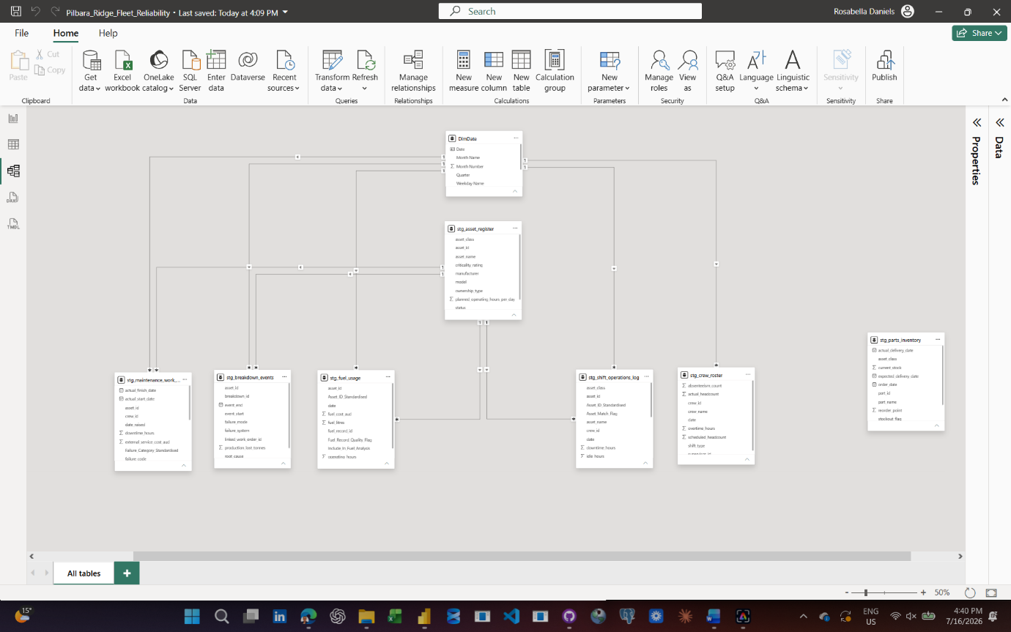
Date: 16/07/2026
Tool used:
SQL Server Management Studio
What I did:
Created the SQL Server database for the Pilbara Ridge Fleet Reliability project. Connected to the local SQL Server Express instance using Windows Authentication, created the PilbaraRidgeFleetReliability database, confirmed the database context, and created seven project tables: asset_register, breakdown_events, crew_roster, fuel_usage, parts_inventory, maintenance_work_orders and shift_operations_log.

I also saved SQL scripts in the 03_sql folder so the database setup can be reviewed, reused and version-controlled.
Why it matters:
This creates a structured SQL foundation for the project. The dataset can now be represented as relational tables with primary keys and foreign keys, which supports better data governance, repeatable analysis and future SQL querying.
Problem or decision:
The first table creation script was accidentally executed twice, which produced an “object already exists” message. I confirmed that this was not a failure of the database setup. It showed that the first two tables had already been created successfully. I saved an improved reusable table script with checks so the process can be managed more safely later.
What I learned:
I learned how to connect to SQL Server, create a database, create tables, confirm table creation through Object Explorer and inspect database metadata using INFORMATION_SCHEMA.TABLES. I also learned that SQL scripts should be saved as project assets so the database build is documented and repeatable.
Evidence saved:
01_create_database.sql
02_create_tables.sql
03_create_remaining_tables.sql
04_check_tables_created.sql
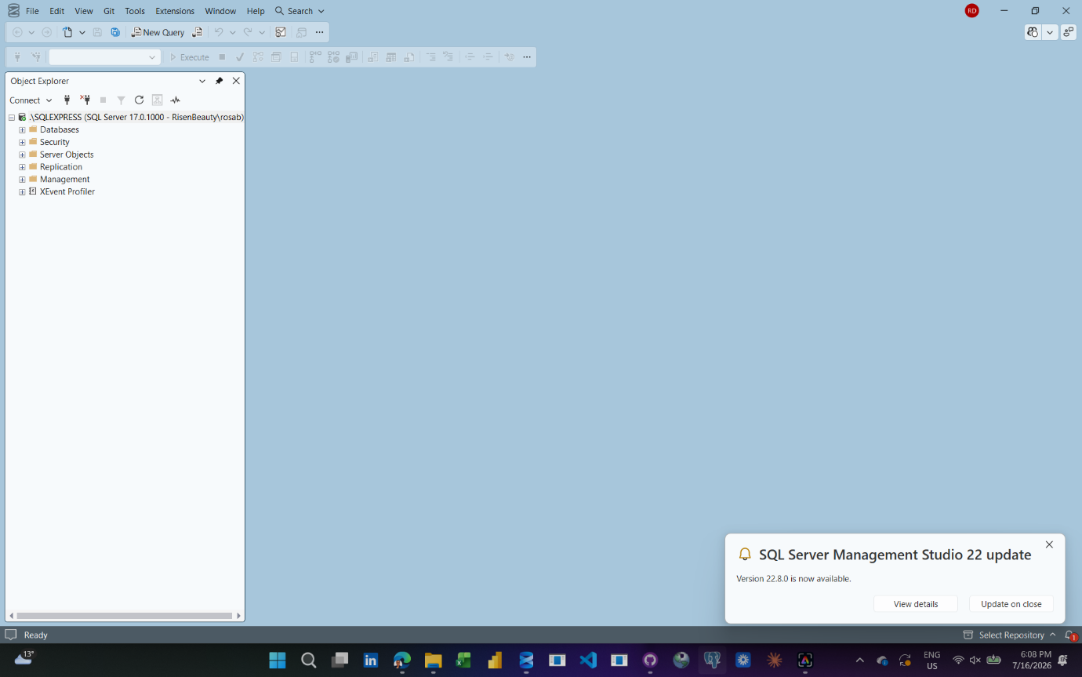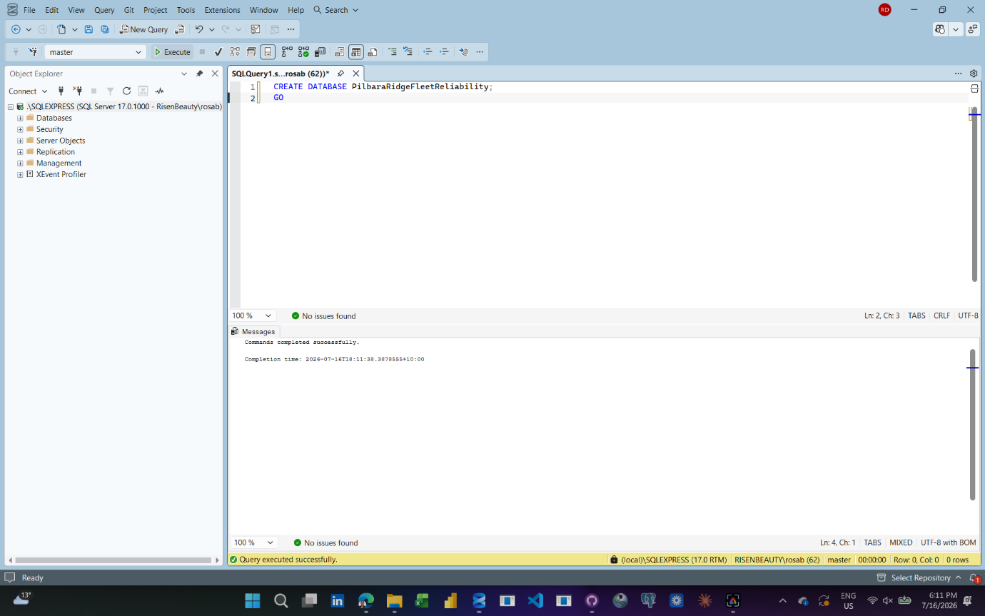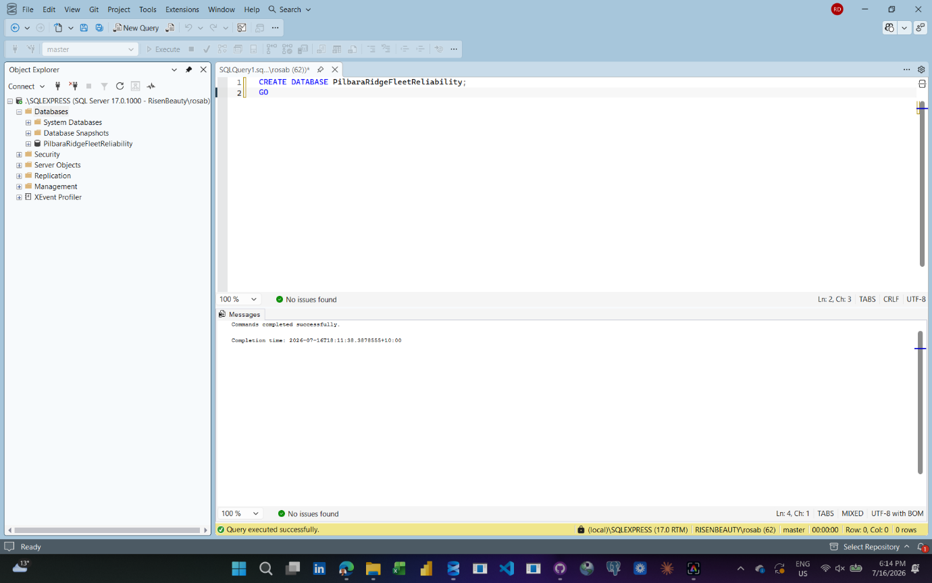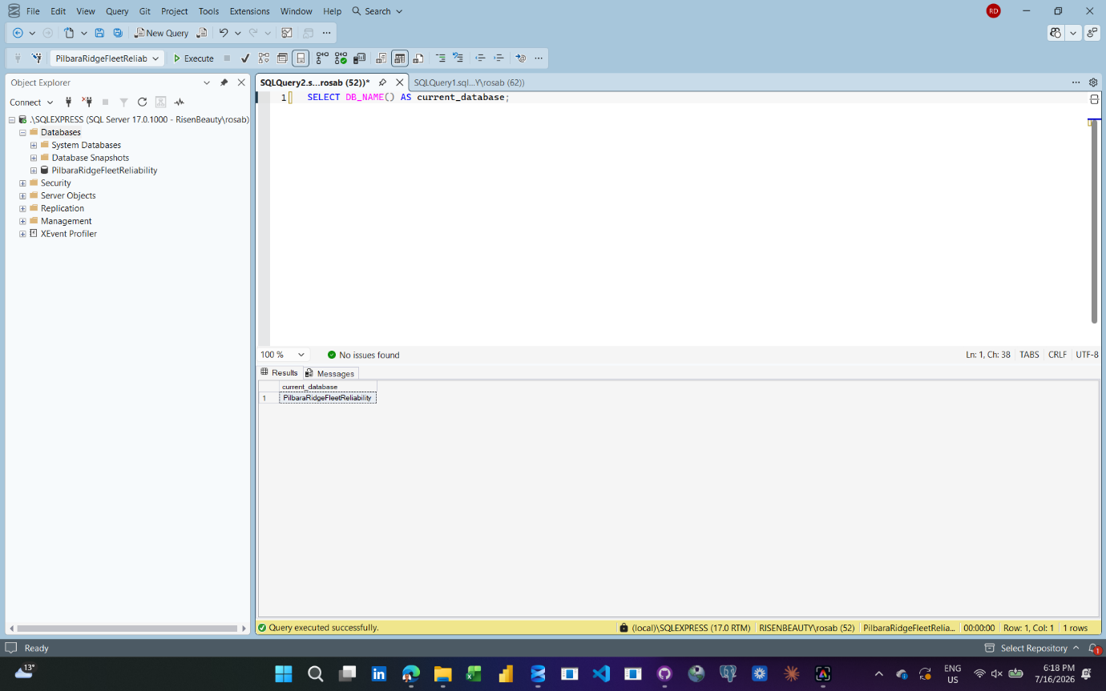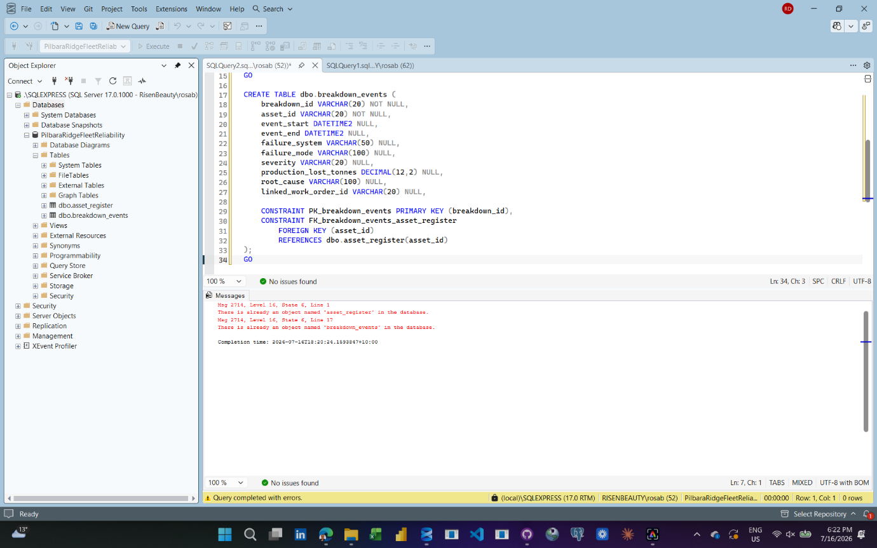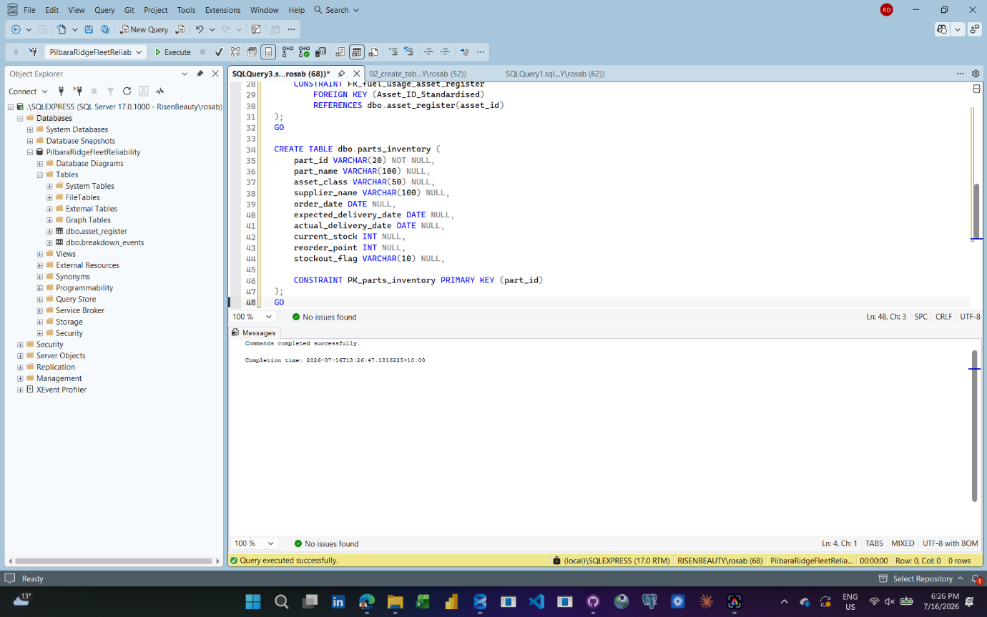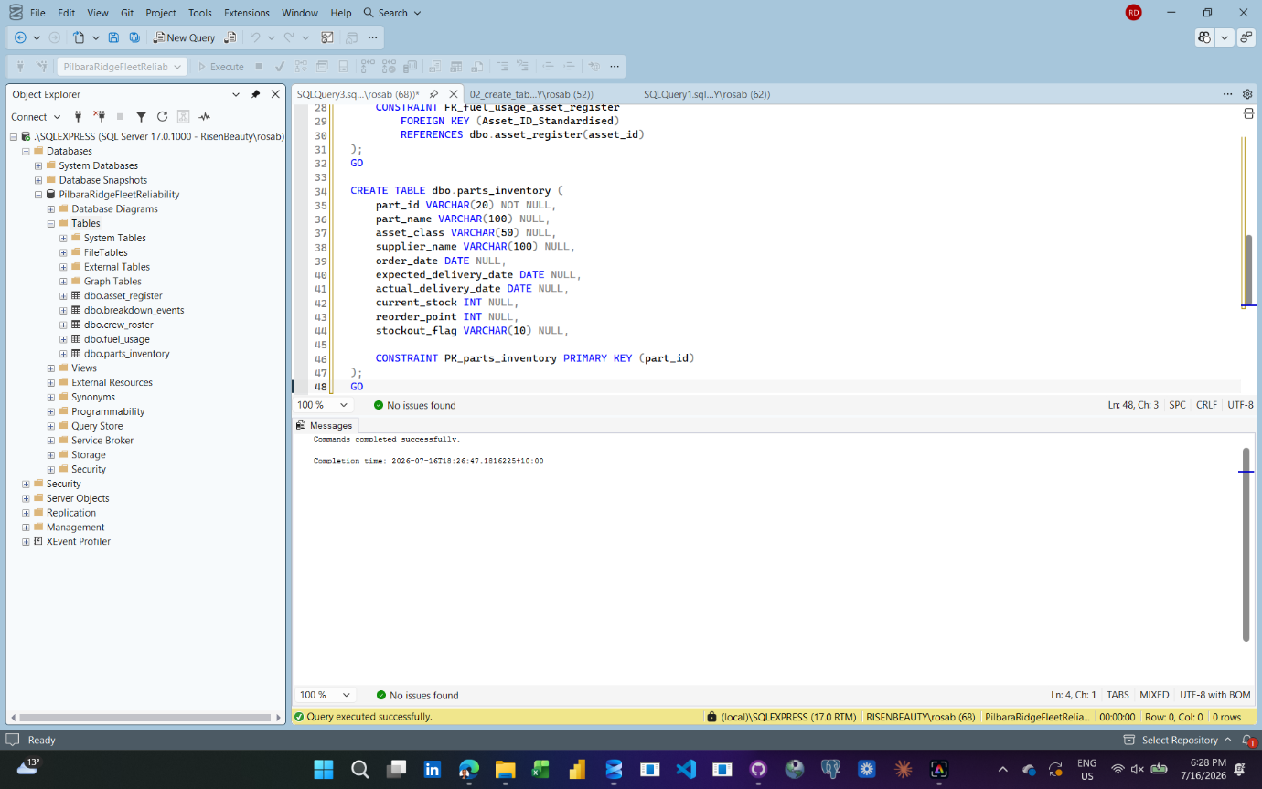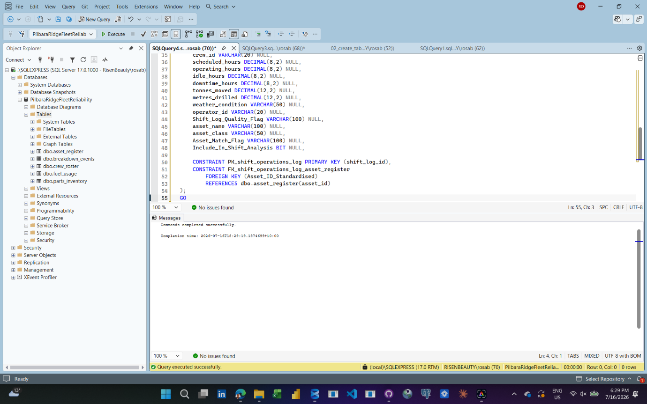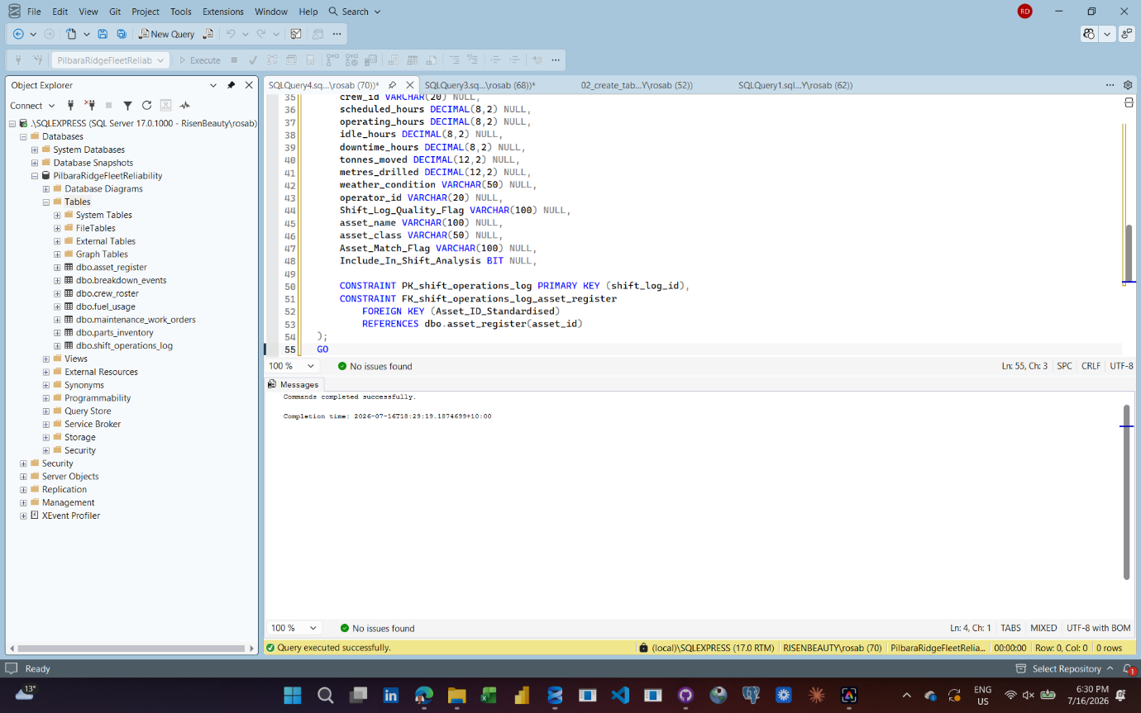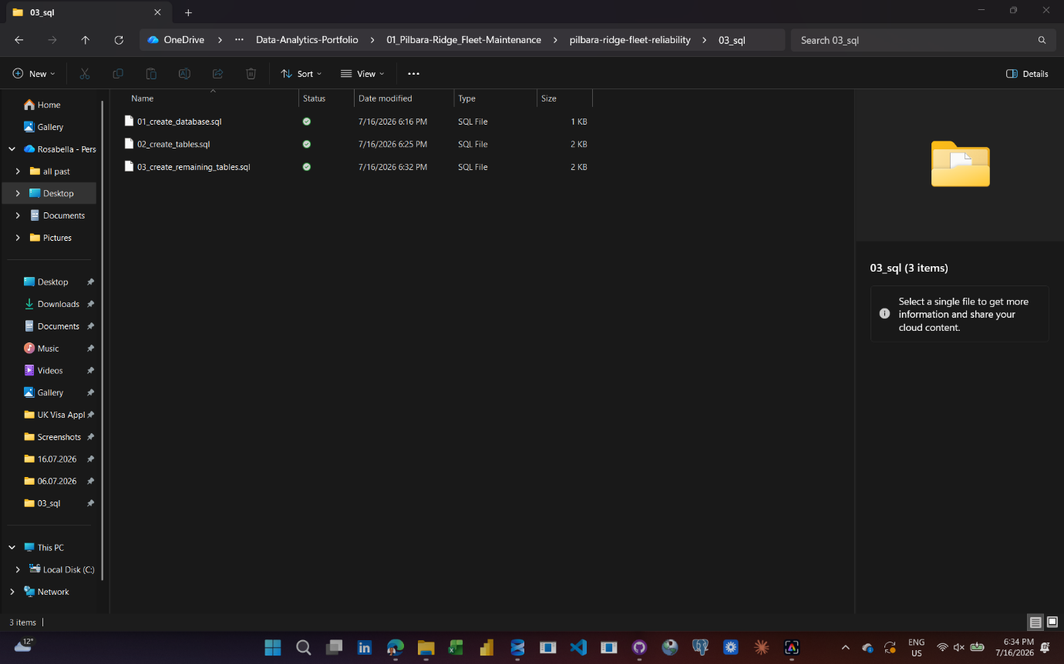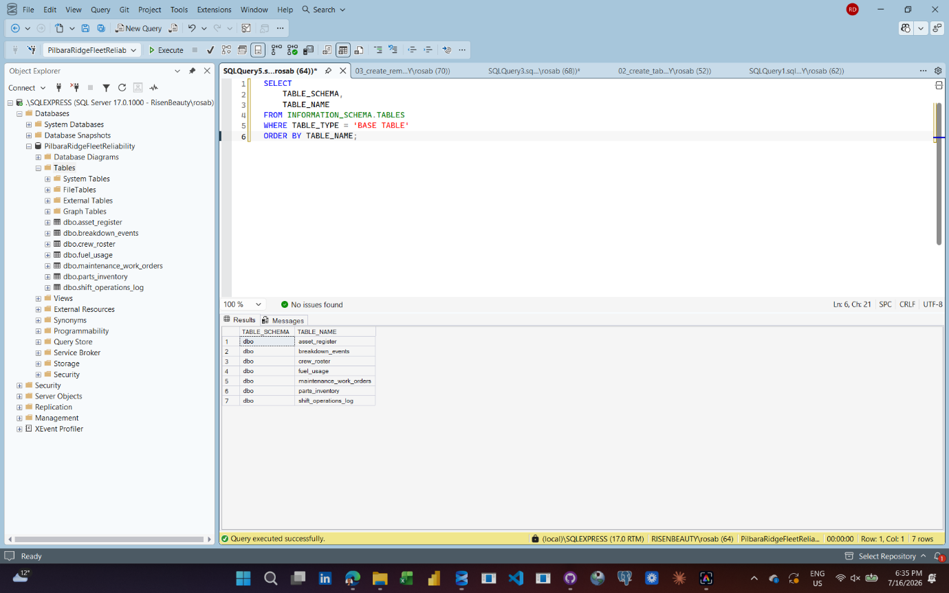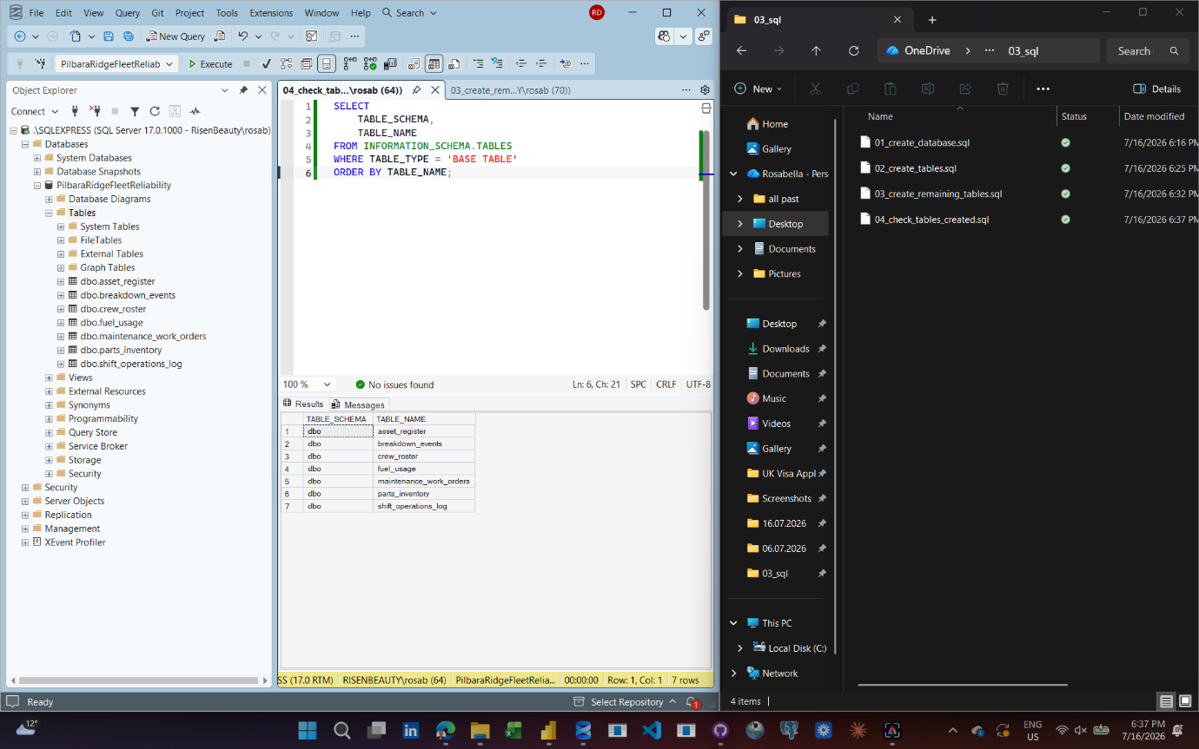
Date:
Tool used:
What I did:
Why it matters:
Problem or decision:
What I learned:
Evidence saved: Screenshot / video / file name

Date: 17/07/2026
Tool used:
SQL Server Management Studio
What I did:
Created and ran SQL scripts to load all seven project datasets into the PilbaraRidgeFleetReliability SQL Server database. Loaded asset_register, breakdown_events, crew_roster, fuel_usage, parts_inventory, maintenance_work_orders and shift_operations_log. Used staging tables where needed to handle column order differences, date conversion issues, duplicate identifiers, missing values and asset ID matching.
Why it matters:
This moved the project from file-based analysis into a relational SQL database. It also made the data loading process repeatable, auditable and suitable for portfolio evidence.
Problem or decision:
Several CSV files did not load cleanly using a direct bulk insert. I used staging tables to load raw text first, then converted dates, numbers and flags into the final SQL tables. For maintenance work orders, I changed the design so work_order_id is treated as a business identifier rather than the SQL primary key because duplicate work order IDs exist in the source data. A surrogate sql_row_id was added as the SQL primary key so all records could be loaded and audited.
What I learned:
I learned that successful row counts are not enough. The loaded columns must also be checked to make sure the data has landed in the correct fields. I also learned how staging tables, primary keys, foreign keys, row-count checks and quality flags help protect the reliability of a SQL database.
Evidence saved:
05_load_asset_register.sql
06_load_breakdown_events.sql
07_load_crew_roster.sql
08_load_fuel_usage.sql
09_load_parts_inventory.sql
10_load_maintenance_work_orders.sql
11_load_shift_operations_log.sql
12_validate_sql_table_row_counts.sql
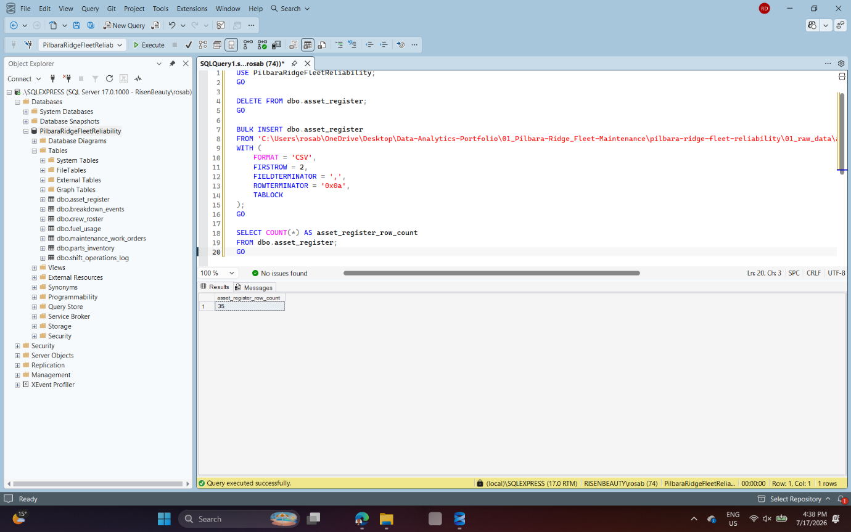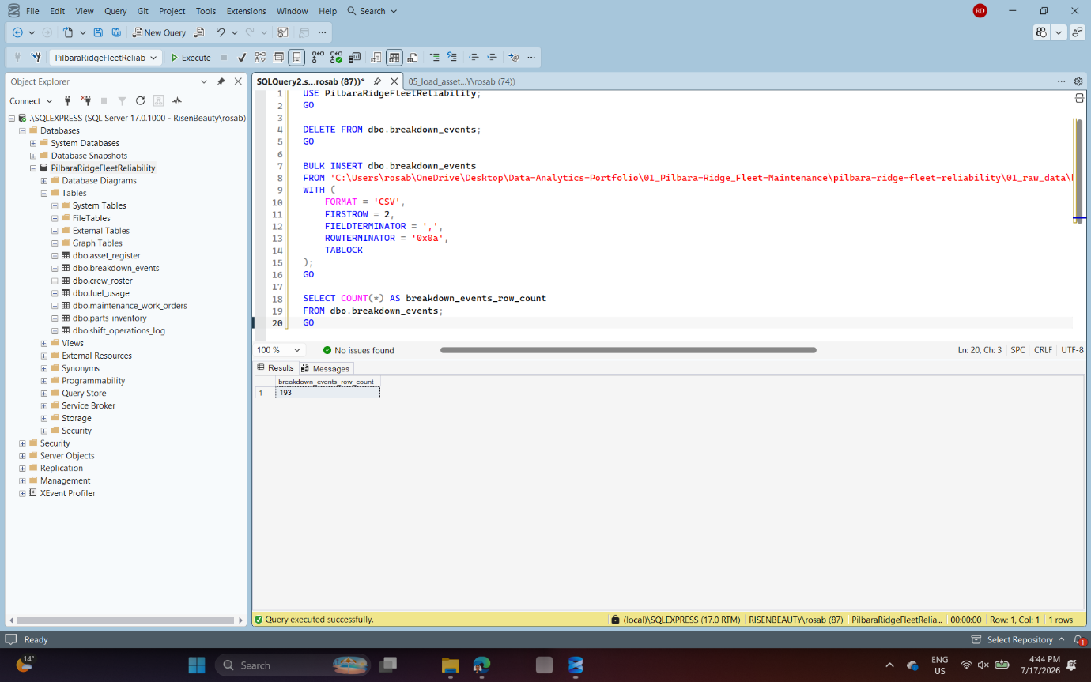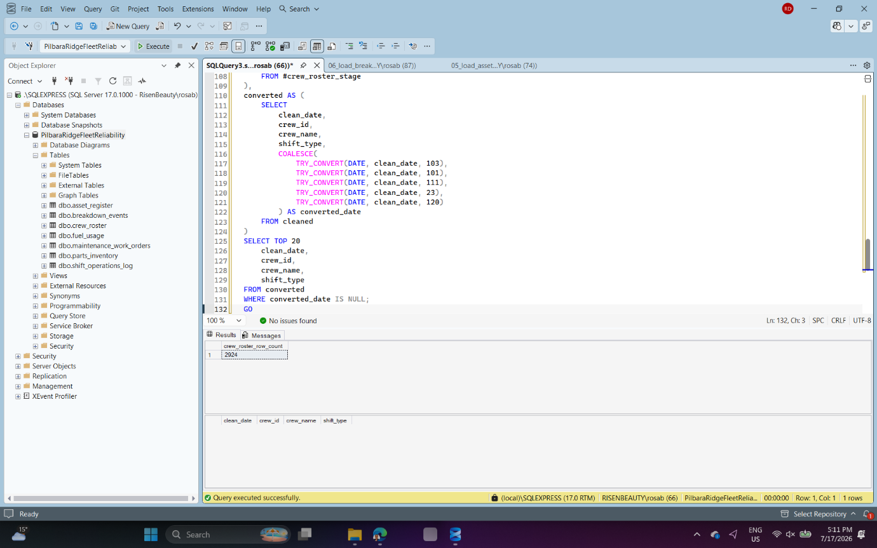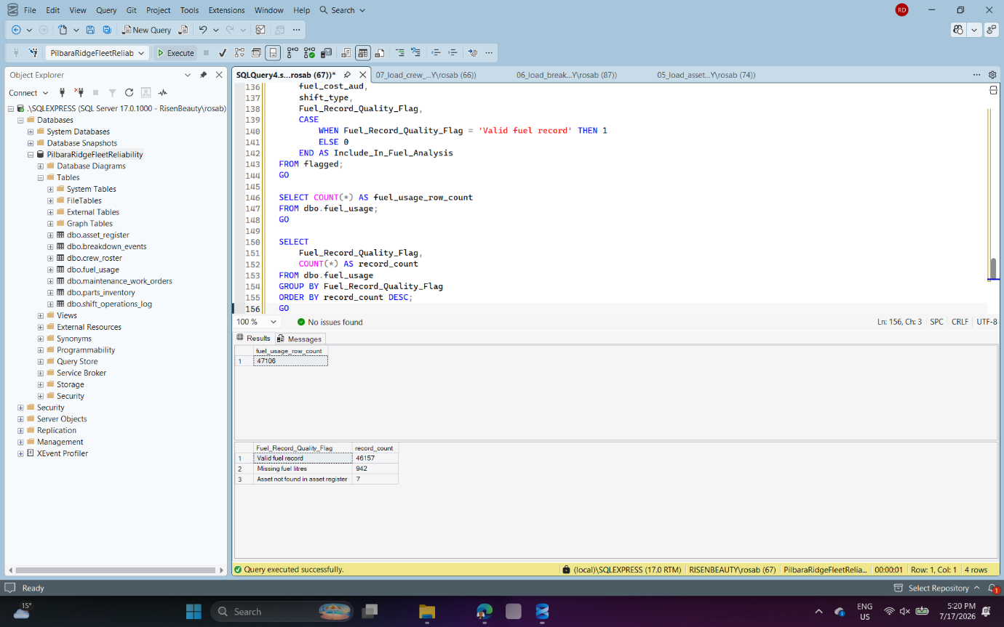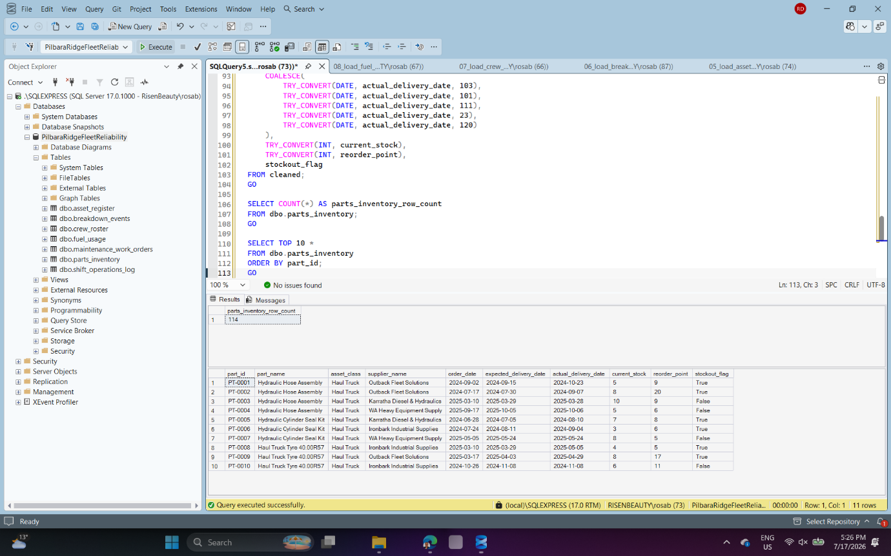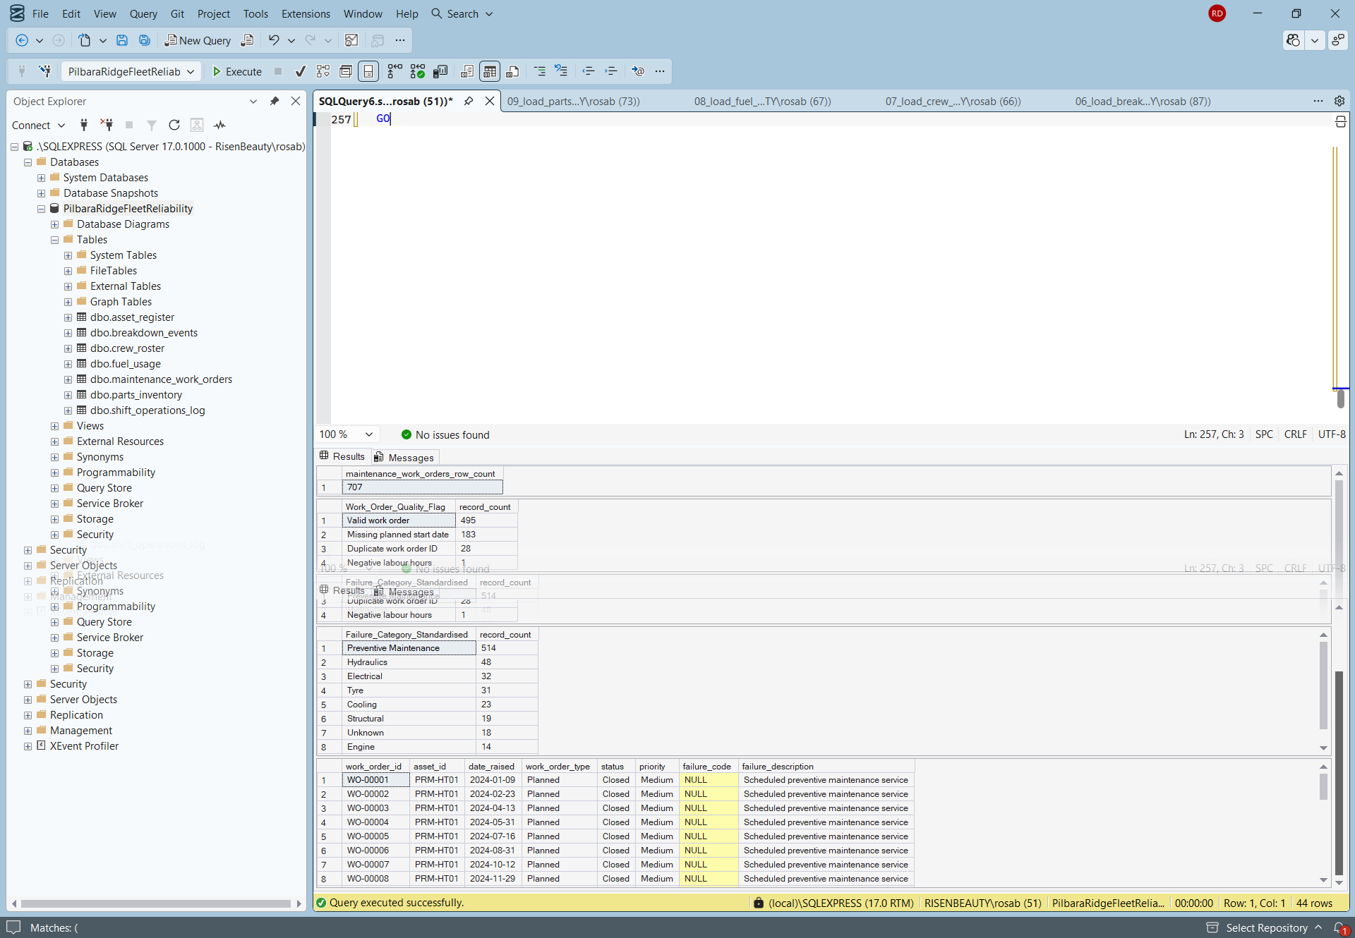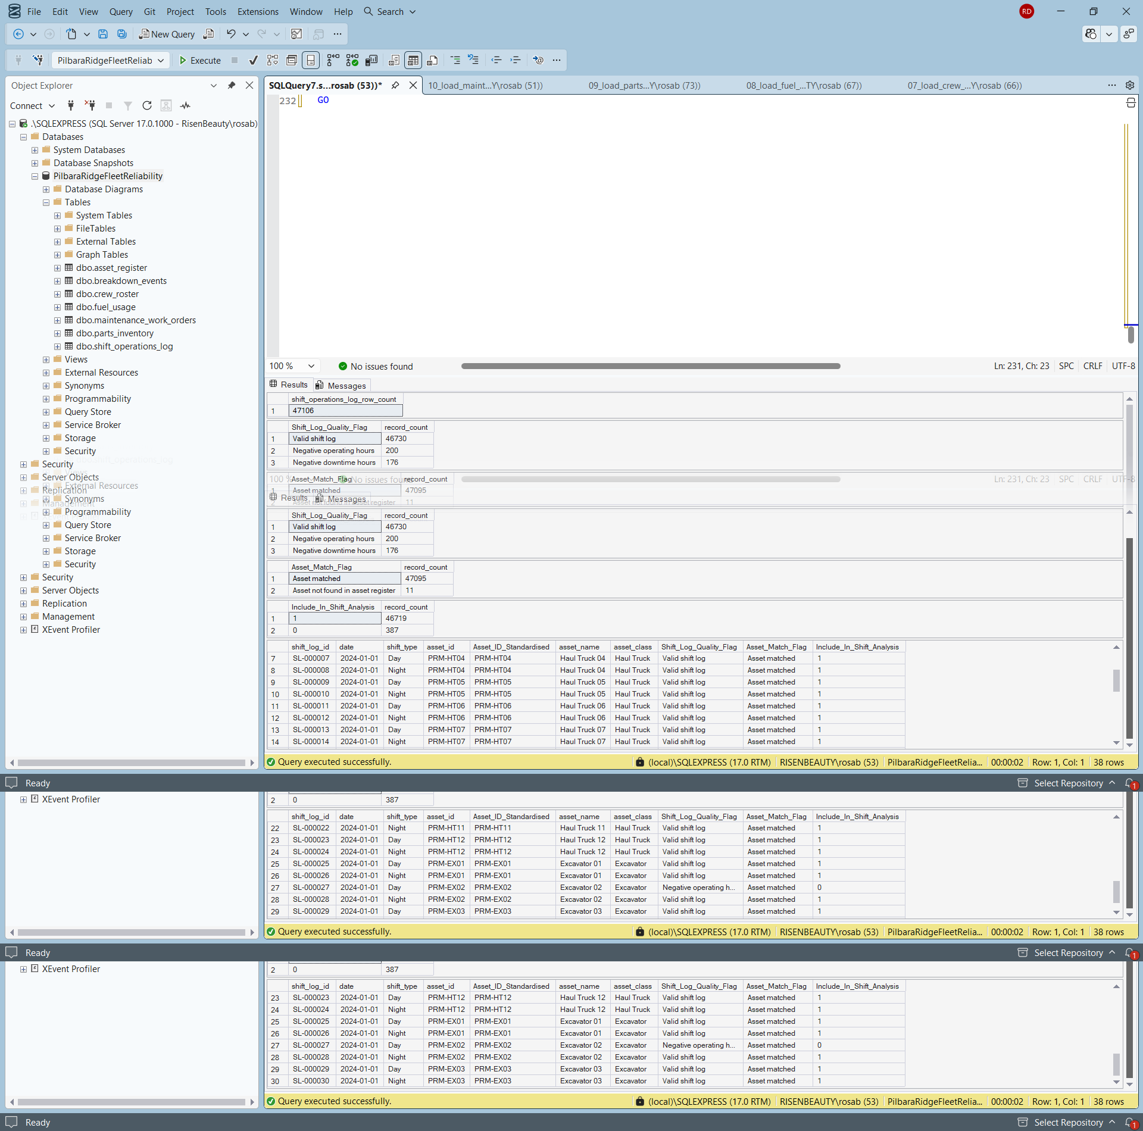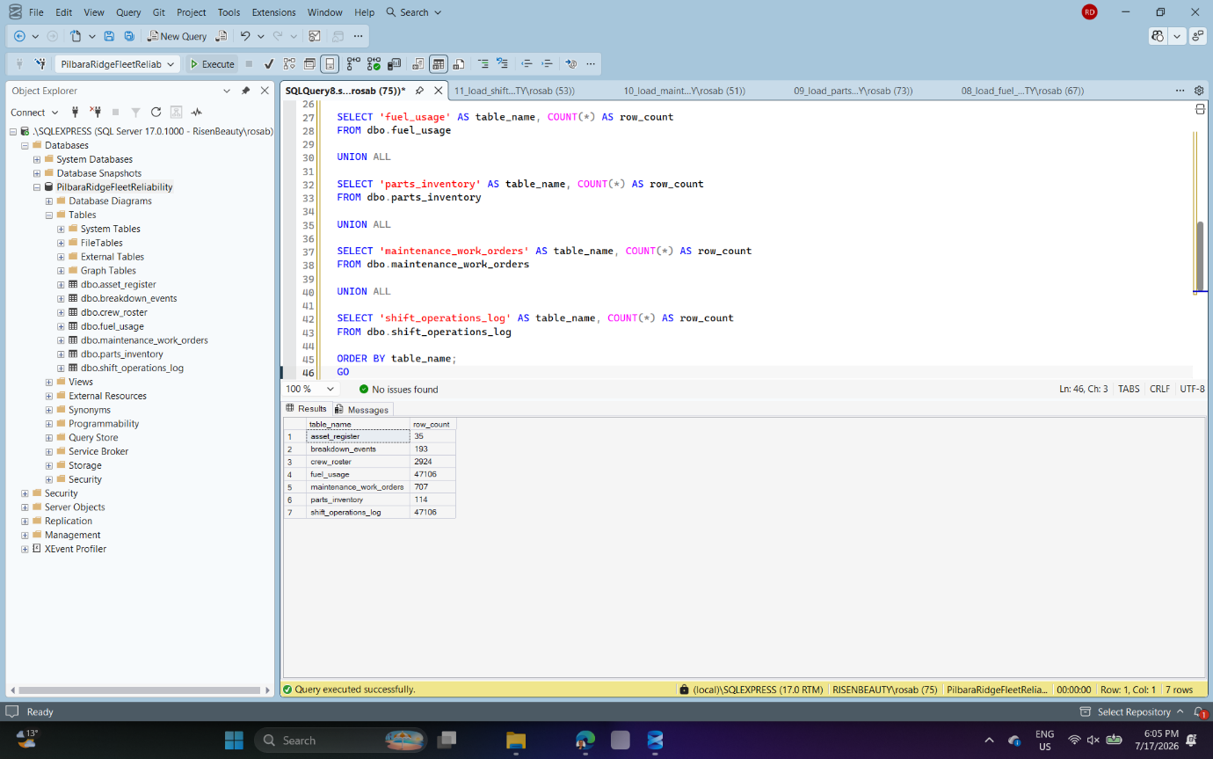
Date: 17/07/2026
Tool used:
SQL Server Management Studio
What I did:
Created SQL analysis queries to validate data quality and analyse asset reliability and maintenance performance. The scripts checked row counts, duplicate work order IDs, excluded records, unmatched asset IDs, missing values, negative values, breakdown patterns, downtime by asset, maintenance cost, repeated failure categories and ranked reliability risk. Why it matters: This stage confirms that the analysis is not only based on Power BI visuals. SQL was used to independently validate the dataset and produce evidence-based reliability and maintenance insights before dashboard design.
Why it matters:
This stage confirms that the analysis is not only based on Power BI visuals. SQL was used to independently validate the dataset and produce evidence-based reliability and maintenance insights before dashboard design.
Problem or decision:
The first asset reliability query used field names that did not exist in the breakdown_events table. I corrected the logic by using breakdown_events for event counts, maintenance_work_orders for standardised failure-category and cost analysis, and shift_operations_log for operational downtime. I also adjusted the reliability risk logic after the first version classified all 35 assets as high risk. The final version uses ranked scoring to separate assets into high, medium and lower reliability risk groups.
What I learned:
I learned that a SQL query can run successfully but still produce a weak analytical result. I also learned to check whether a risk flag is useful, not just whether the code works. Ranking assets gave a clearer and more defensible reliability-risk output.
Evidence saved:
13_sql_data_quality_checks.sql
14_sql_asset_reliability_analysis.sql
15_sql_maintenance_performance_analysis.sql
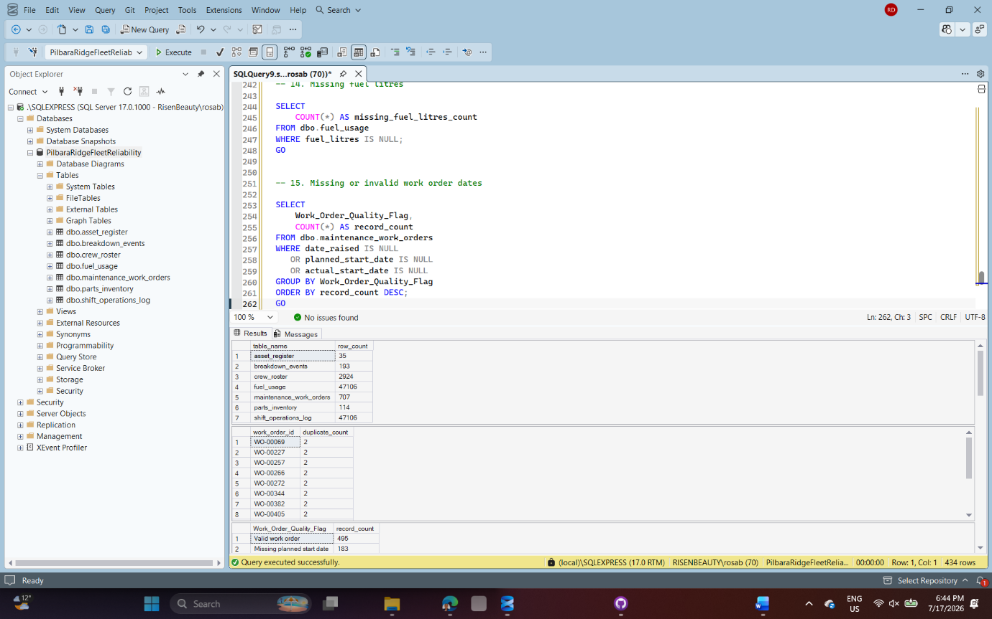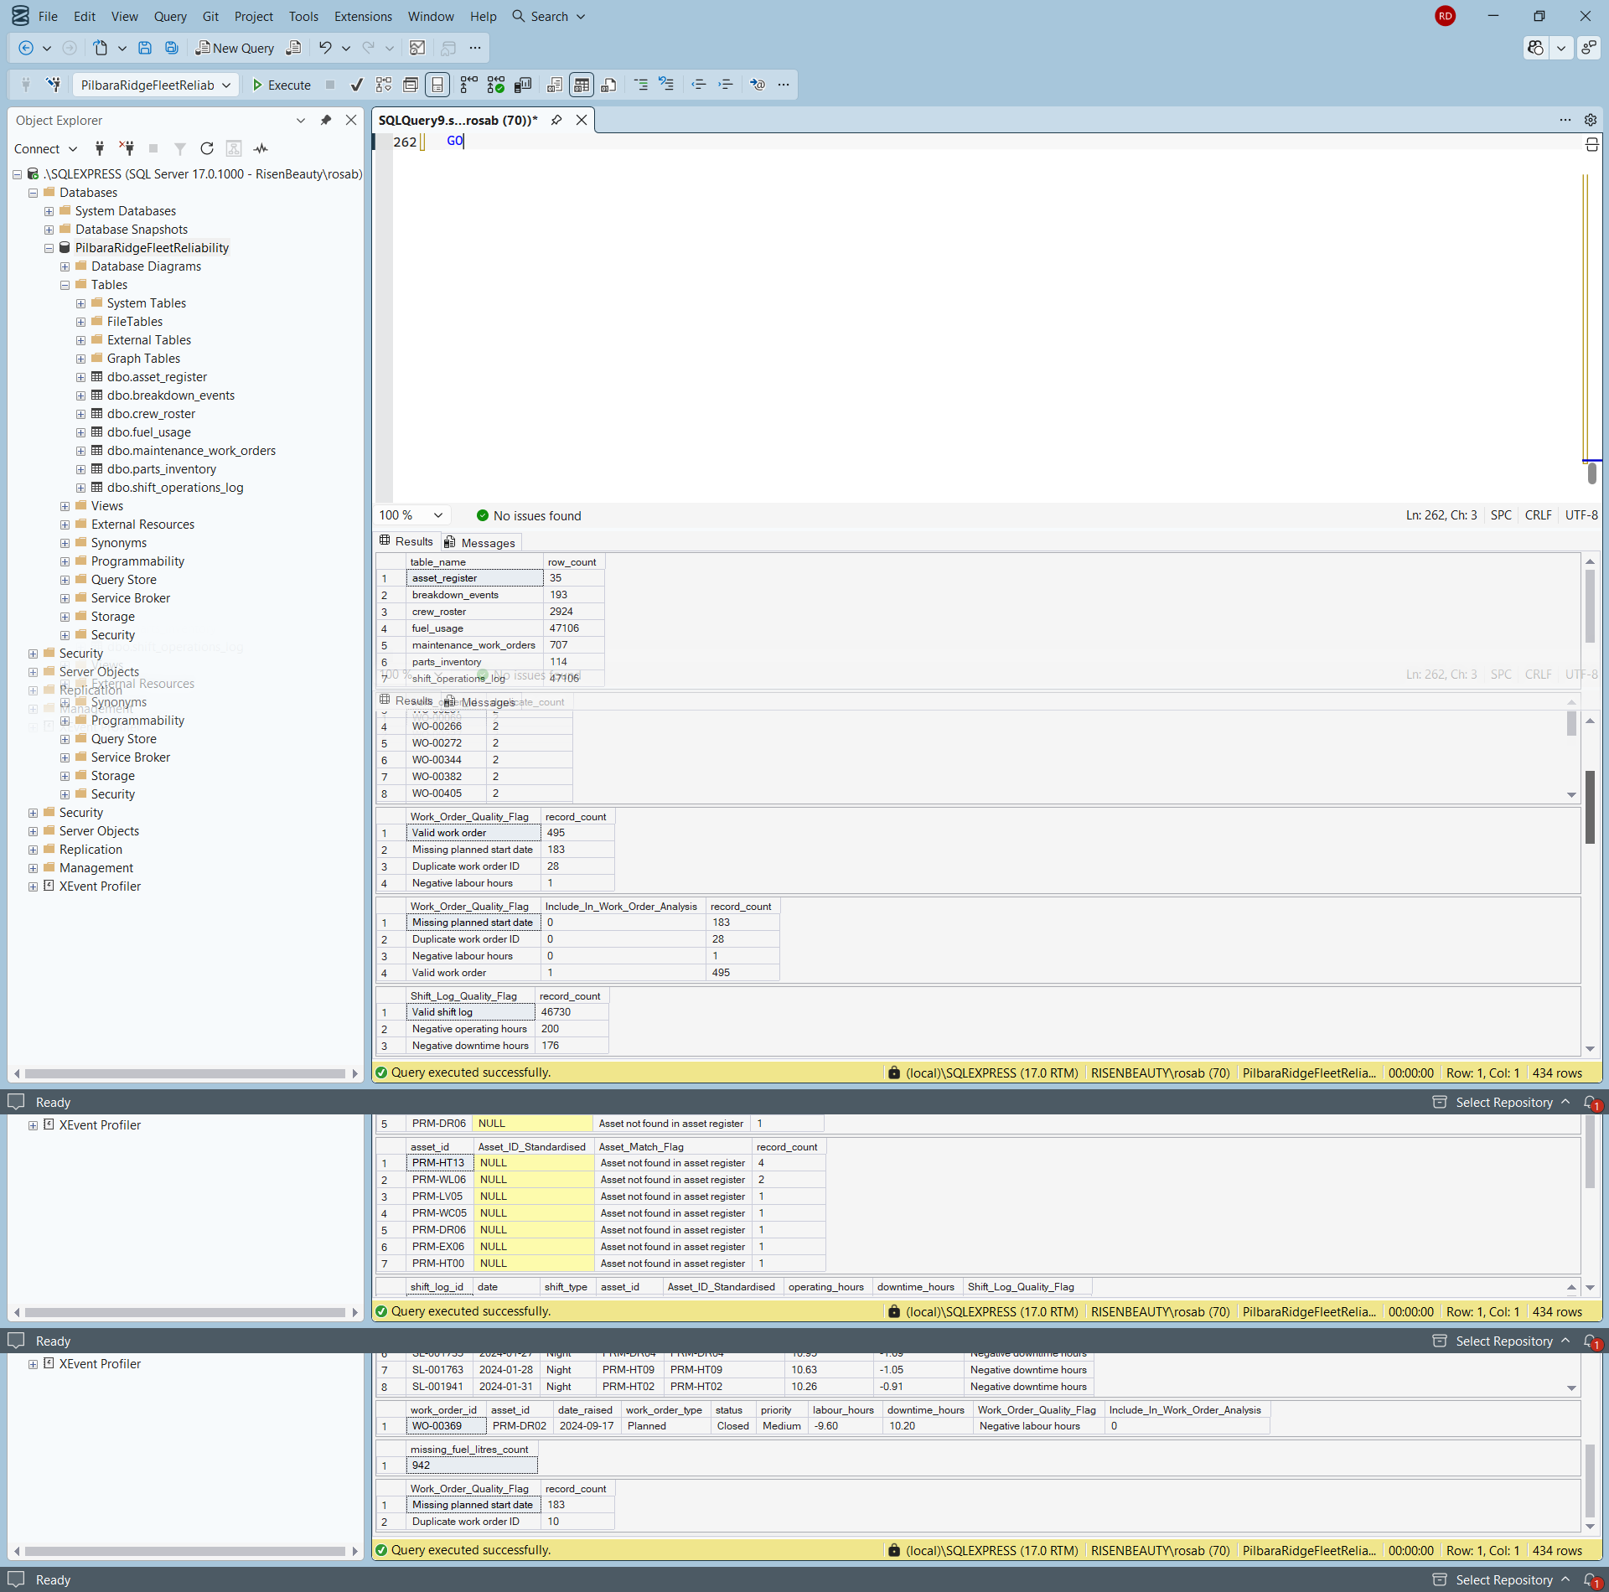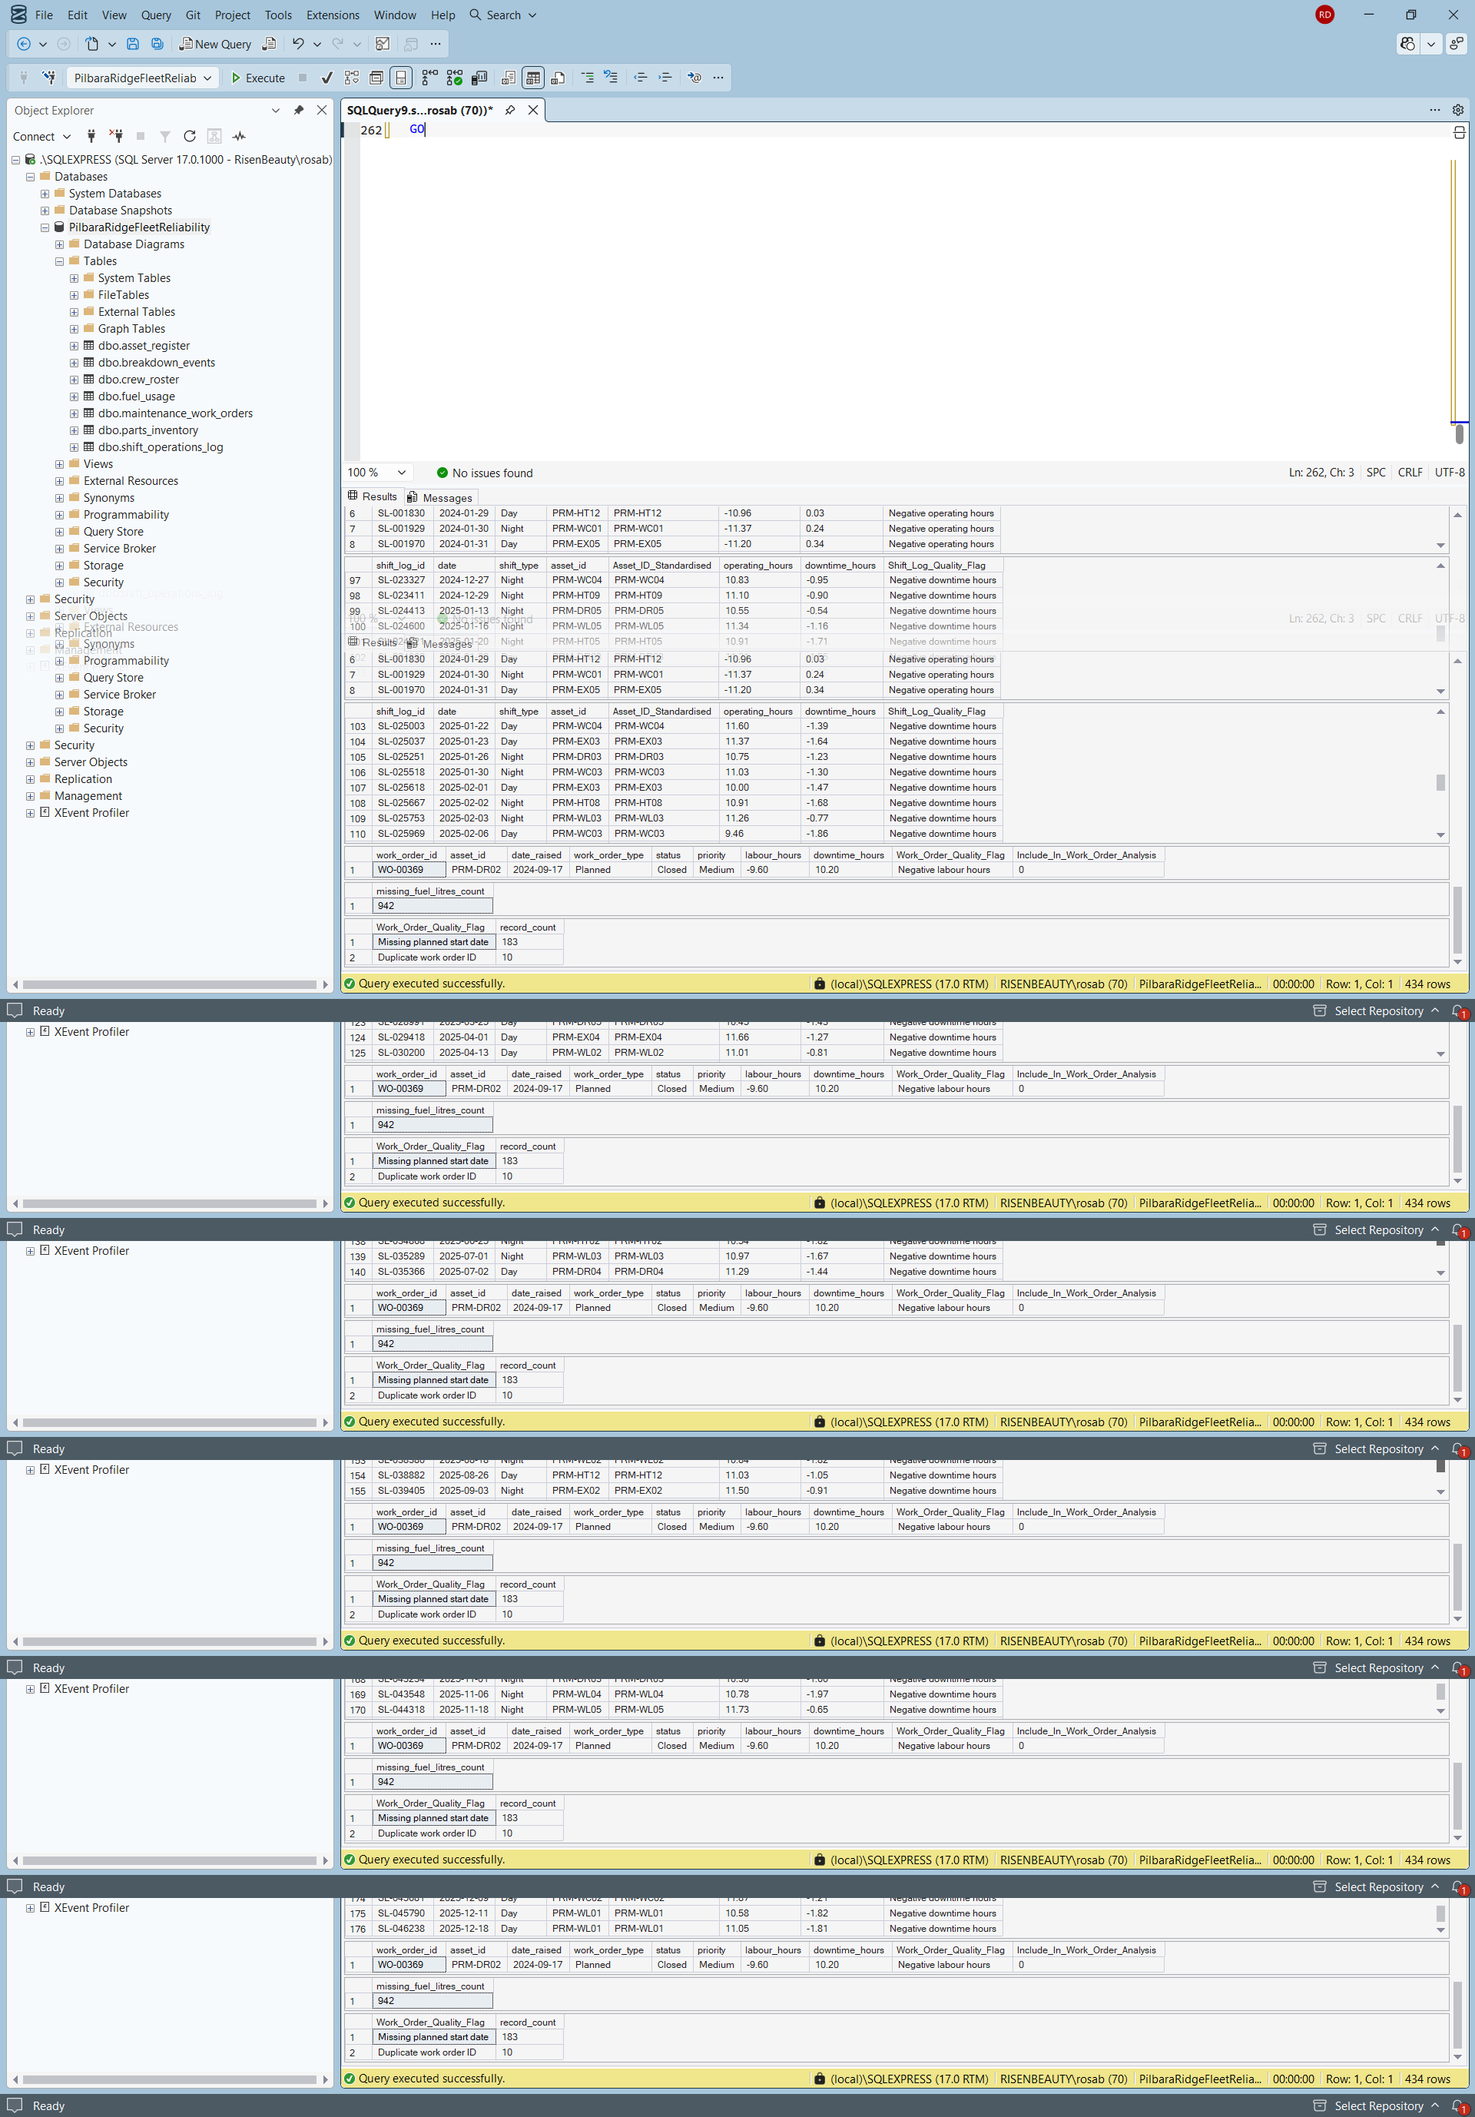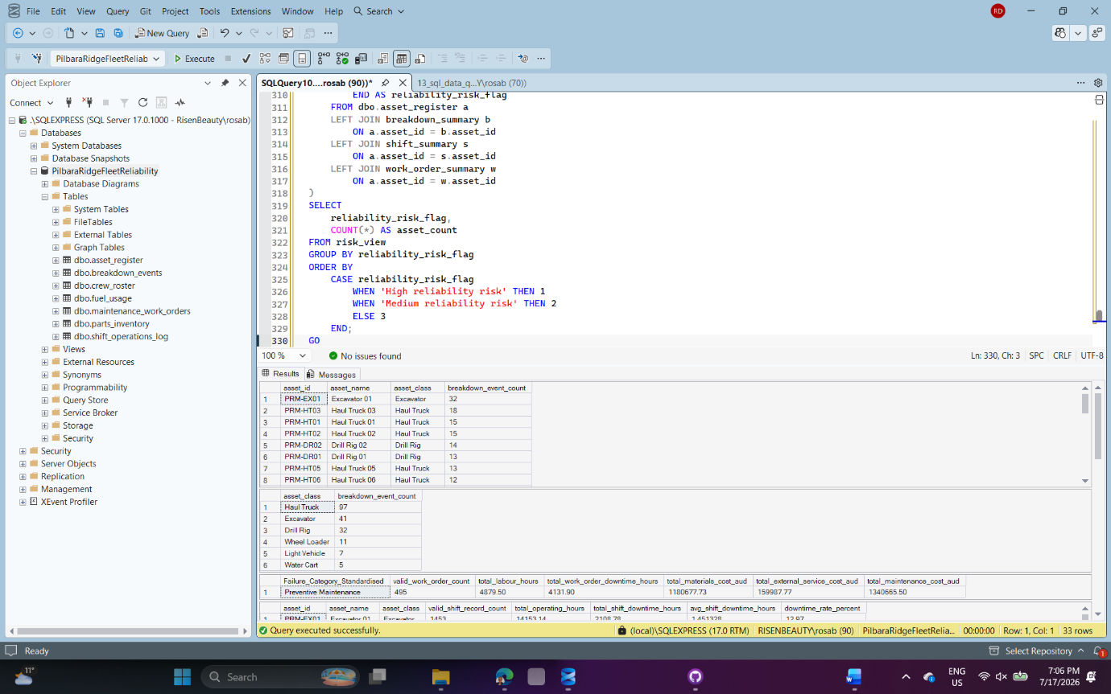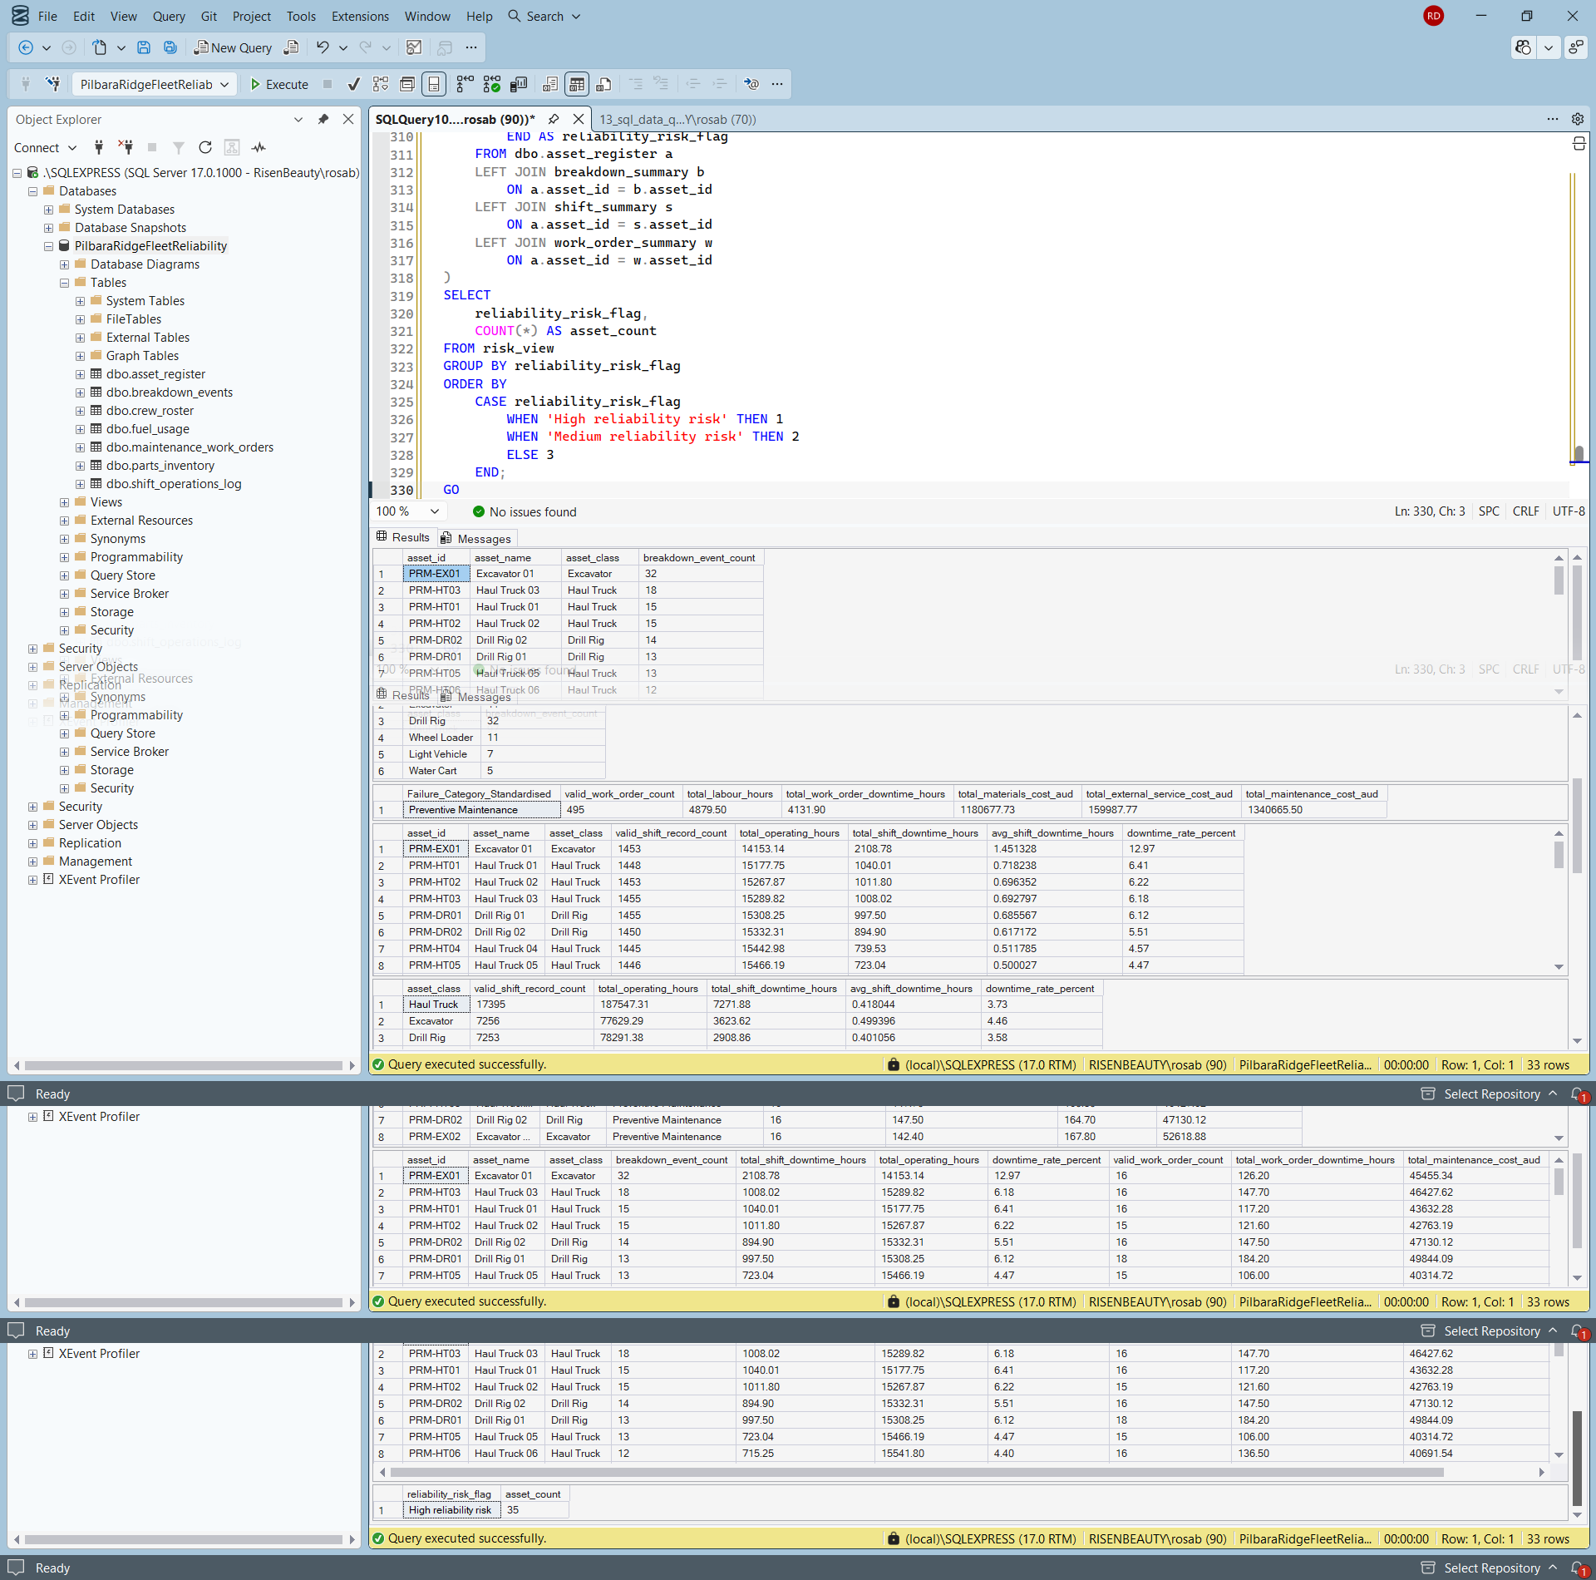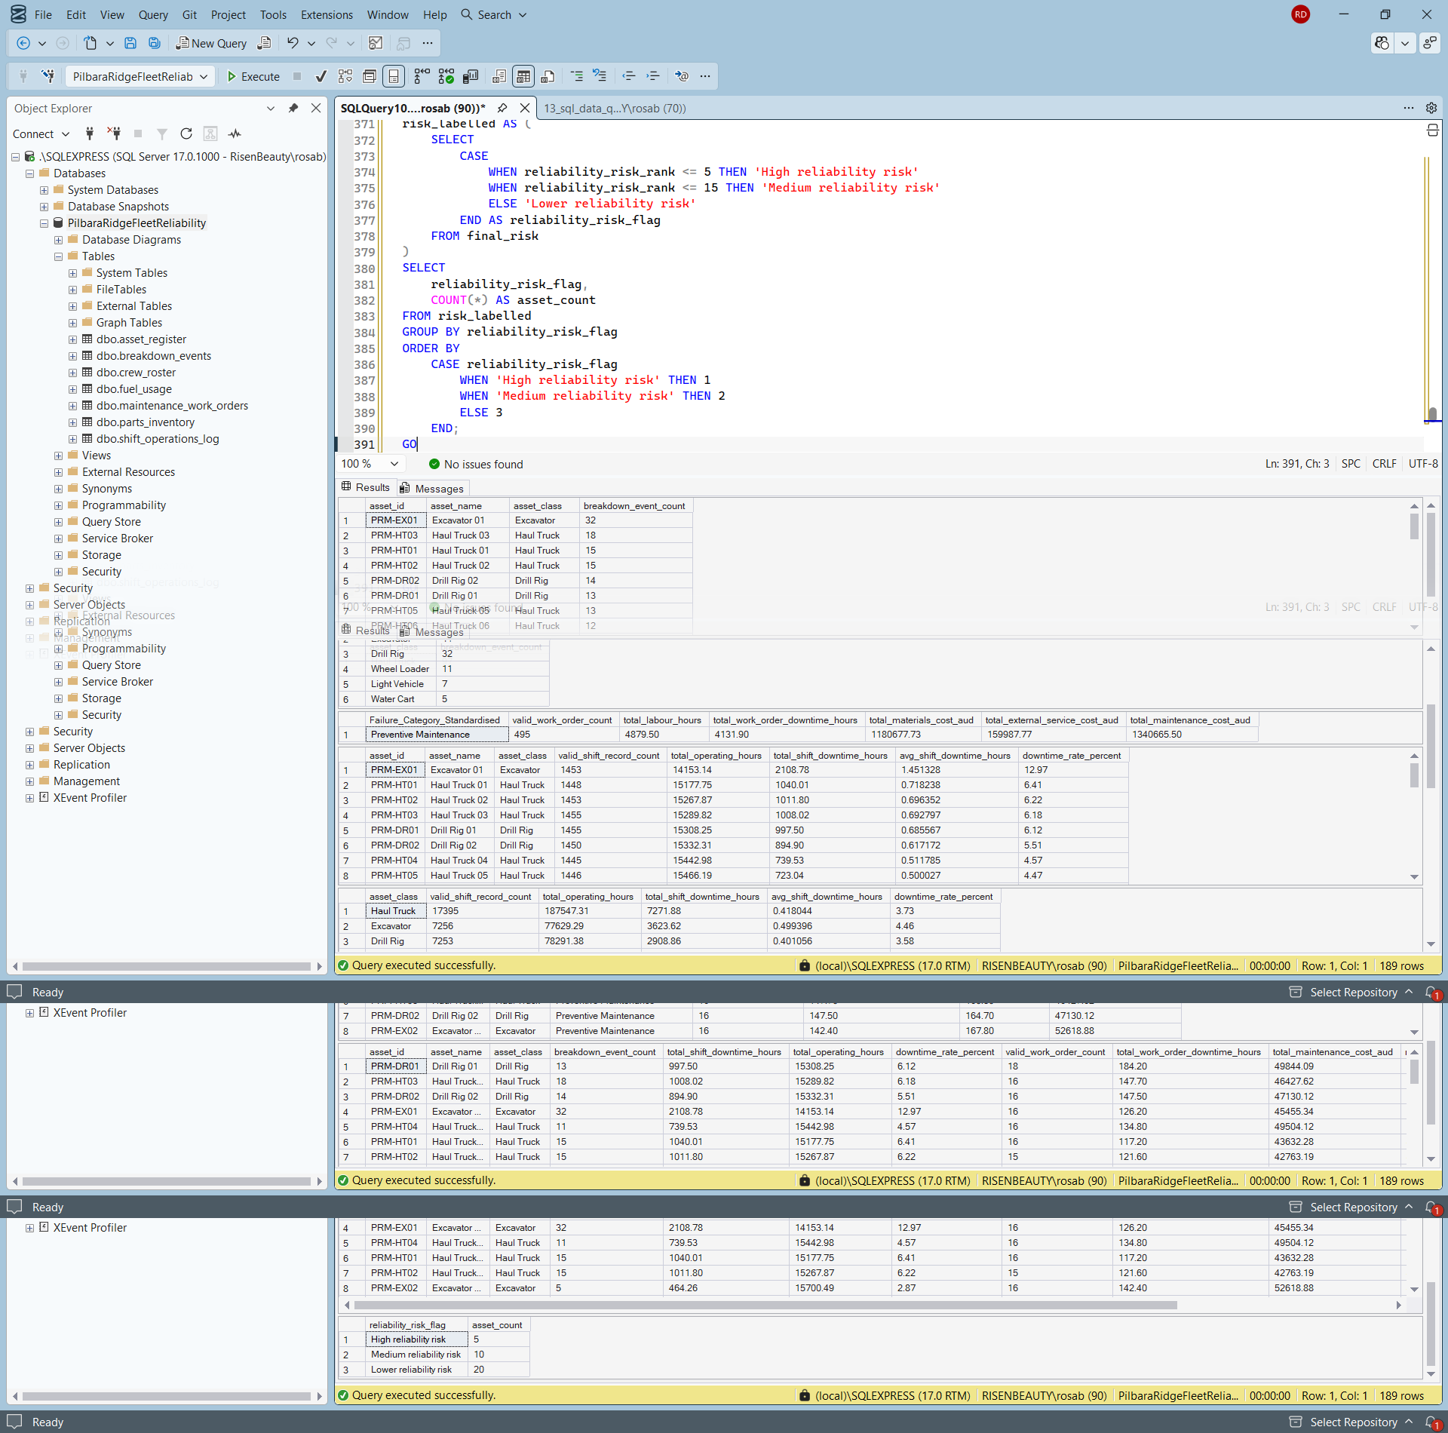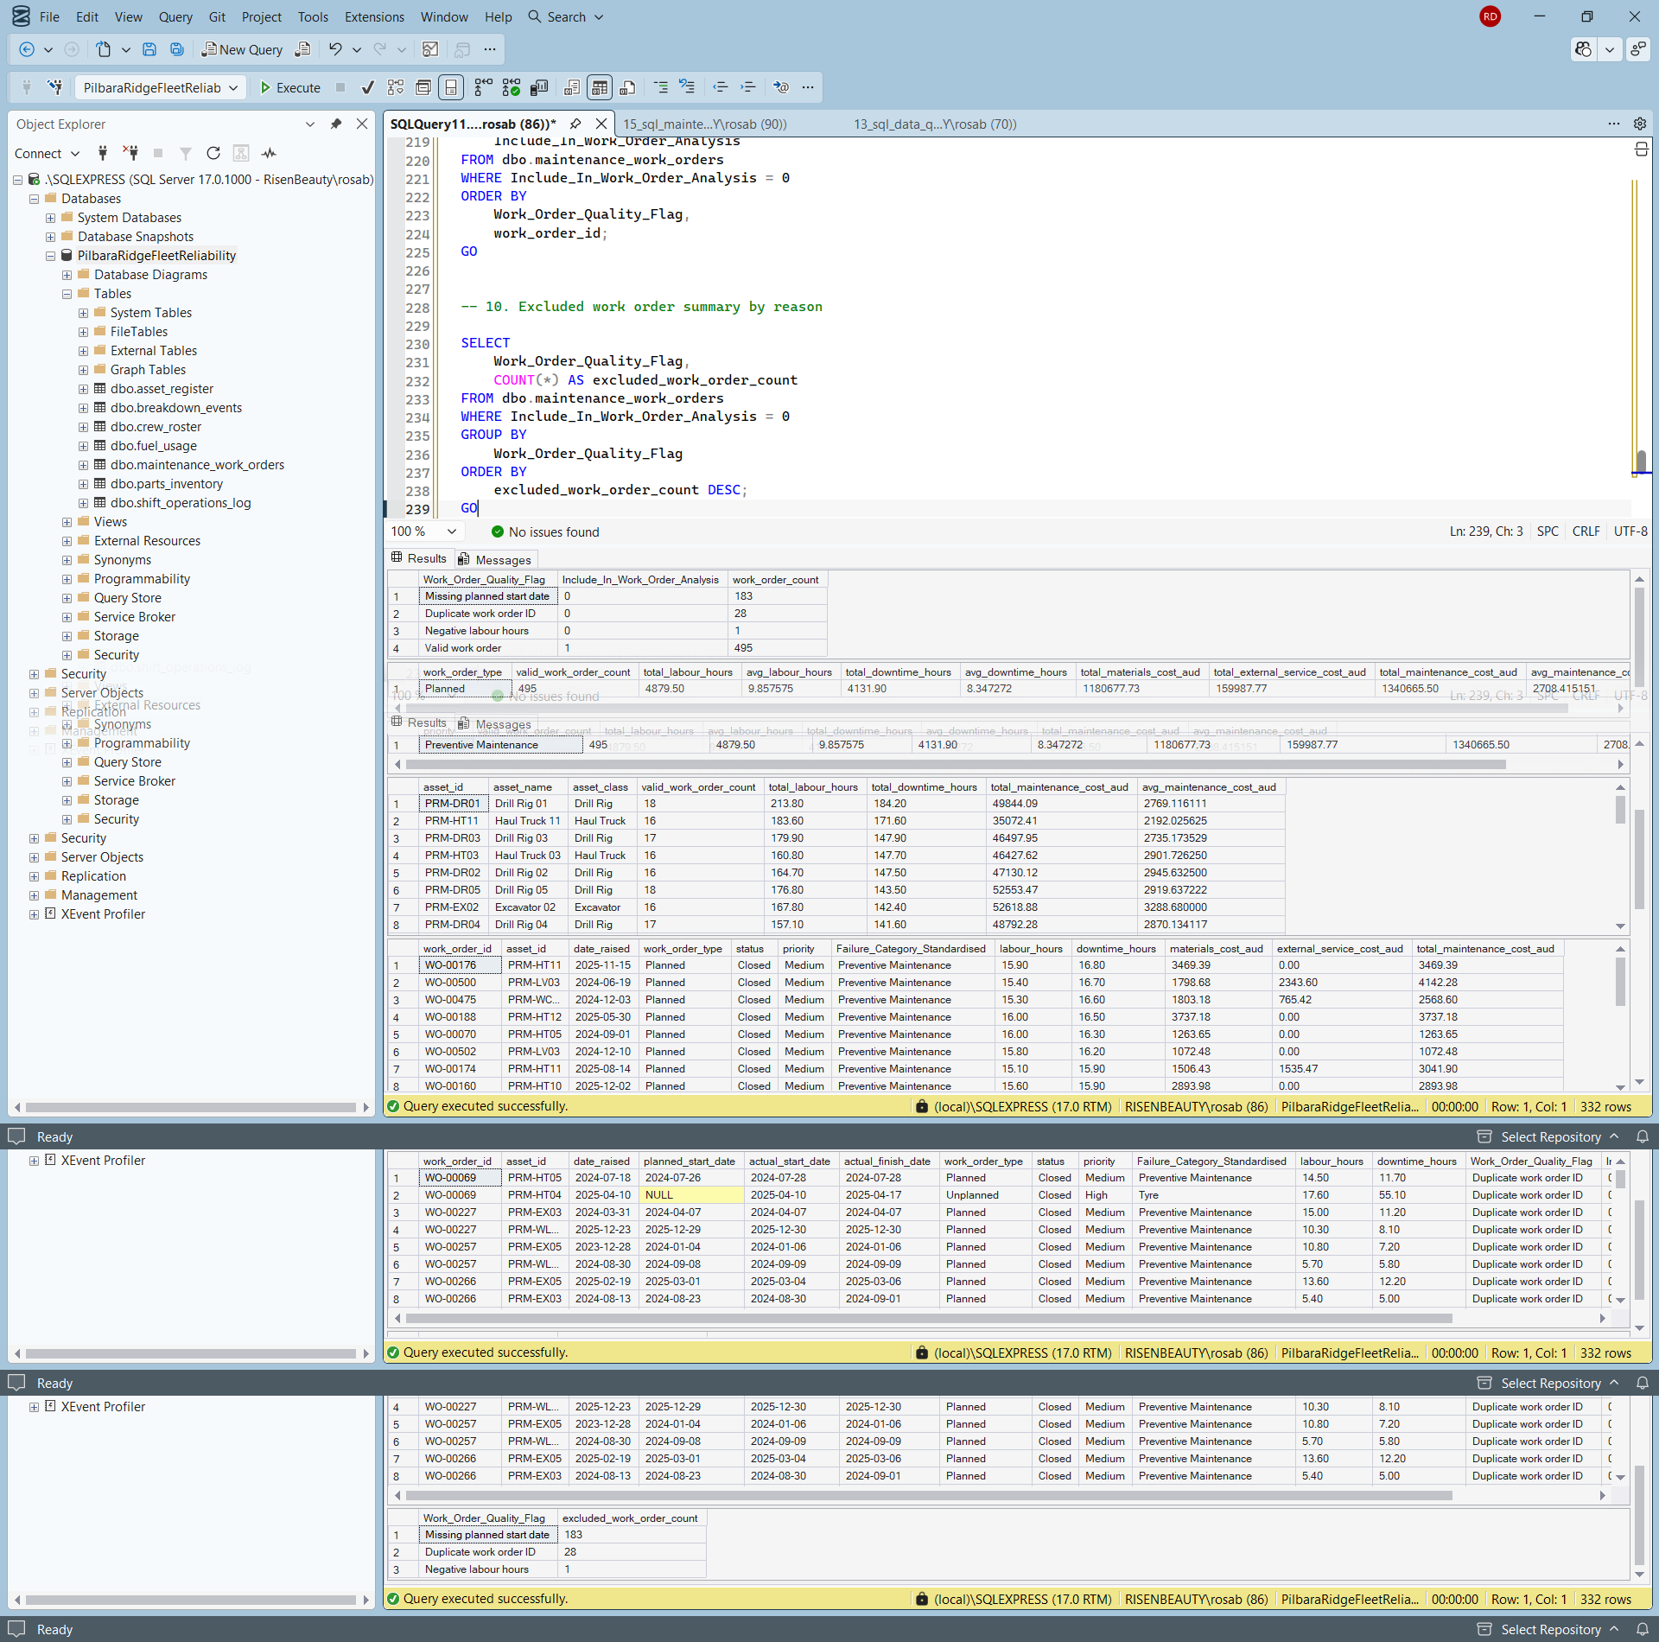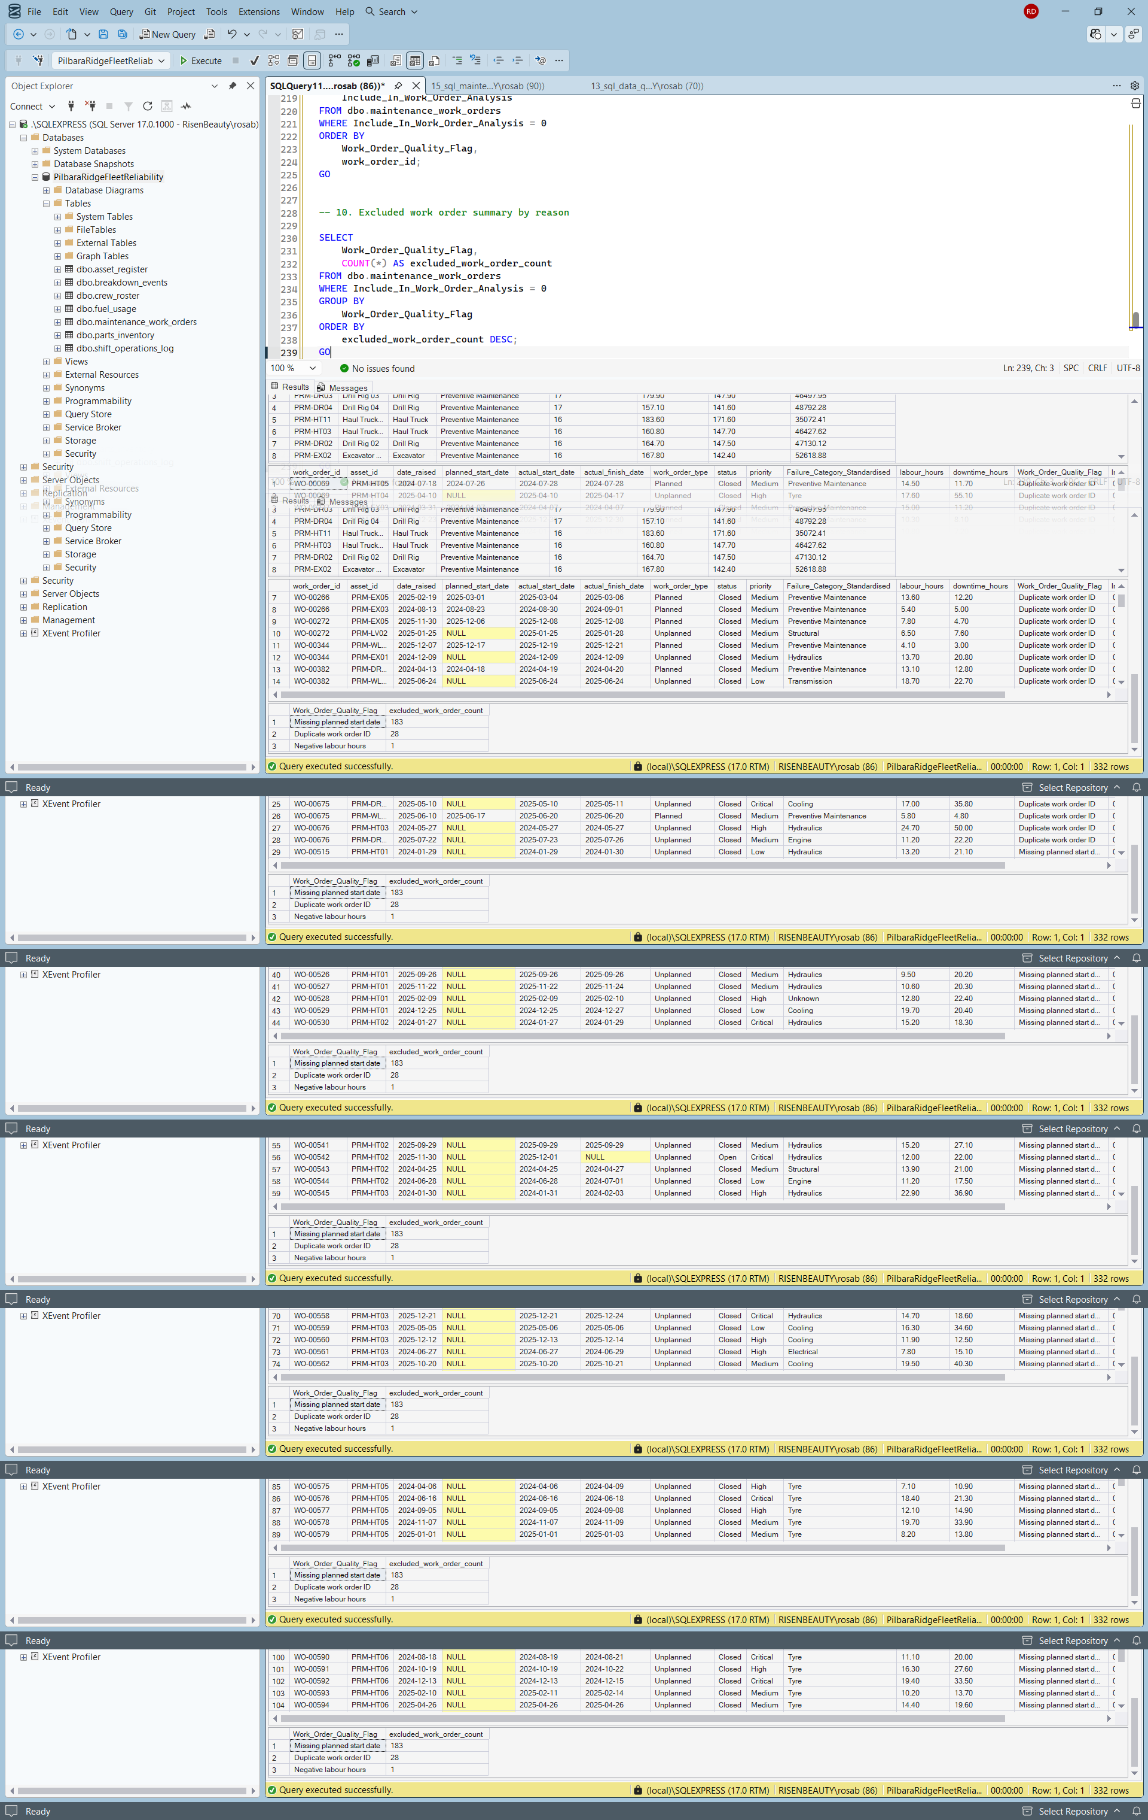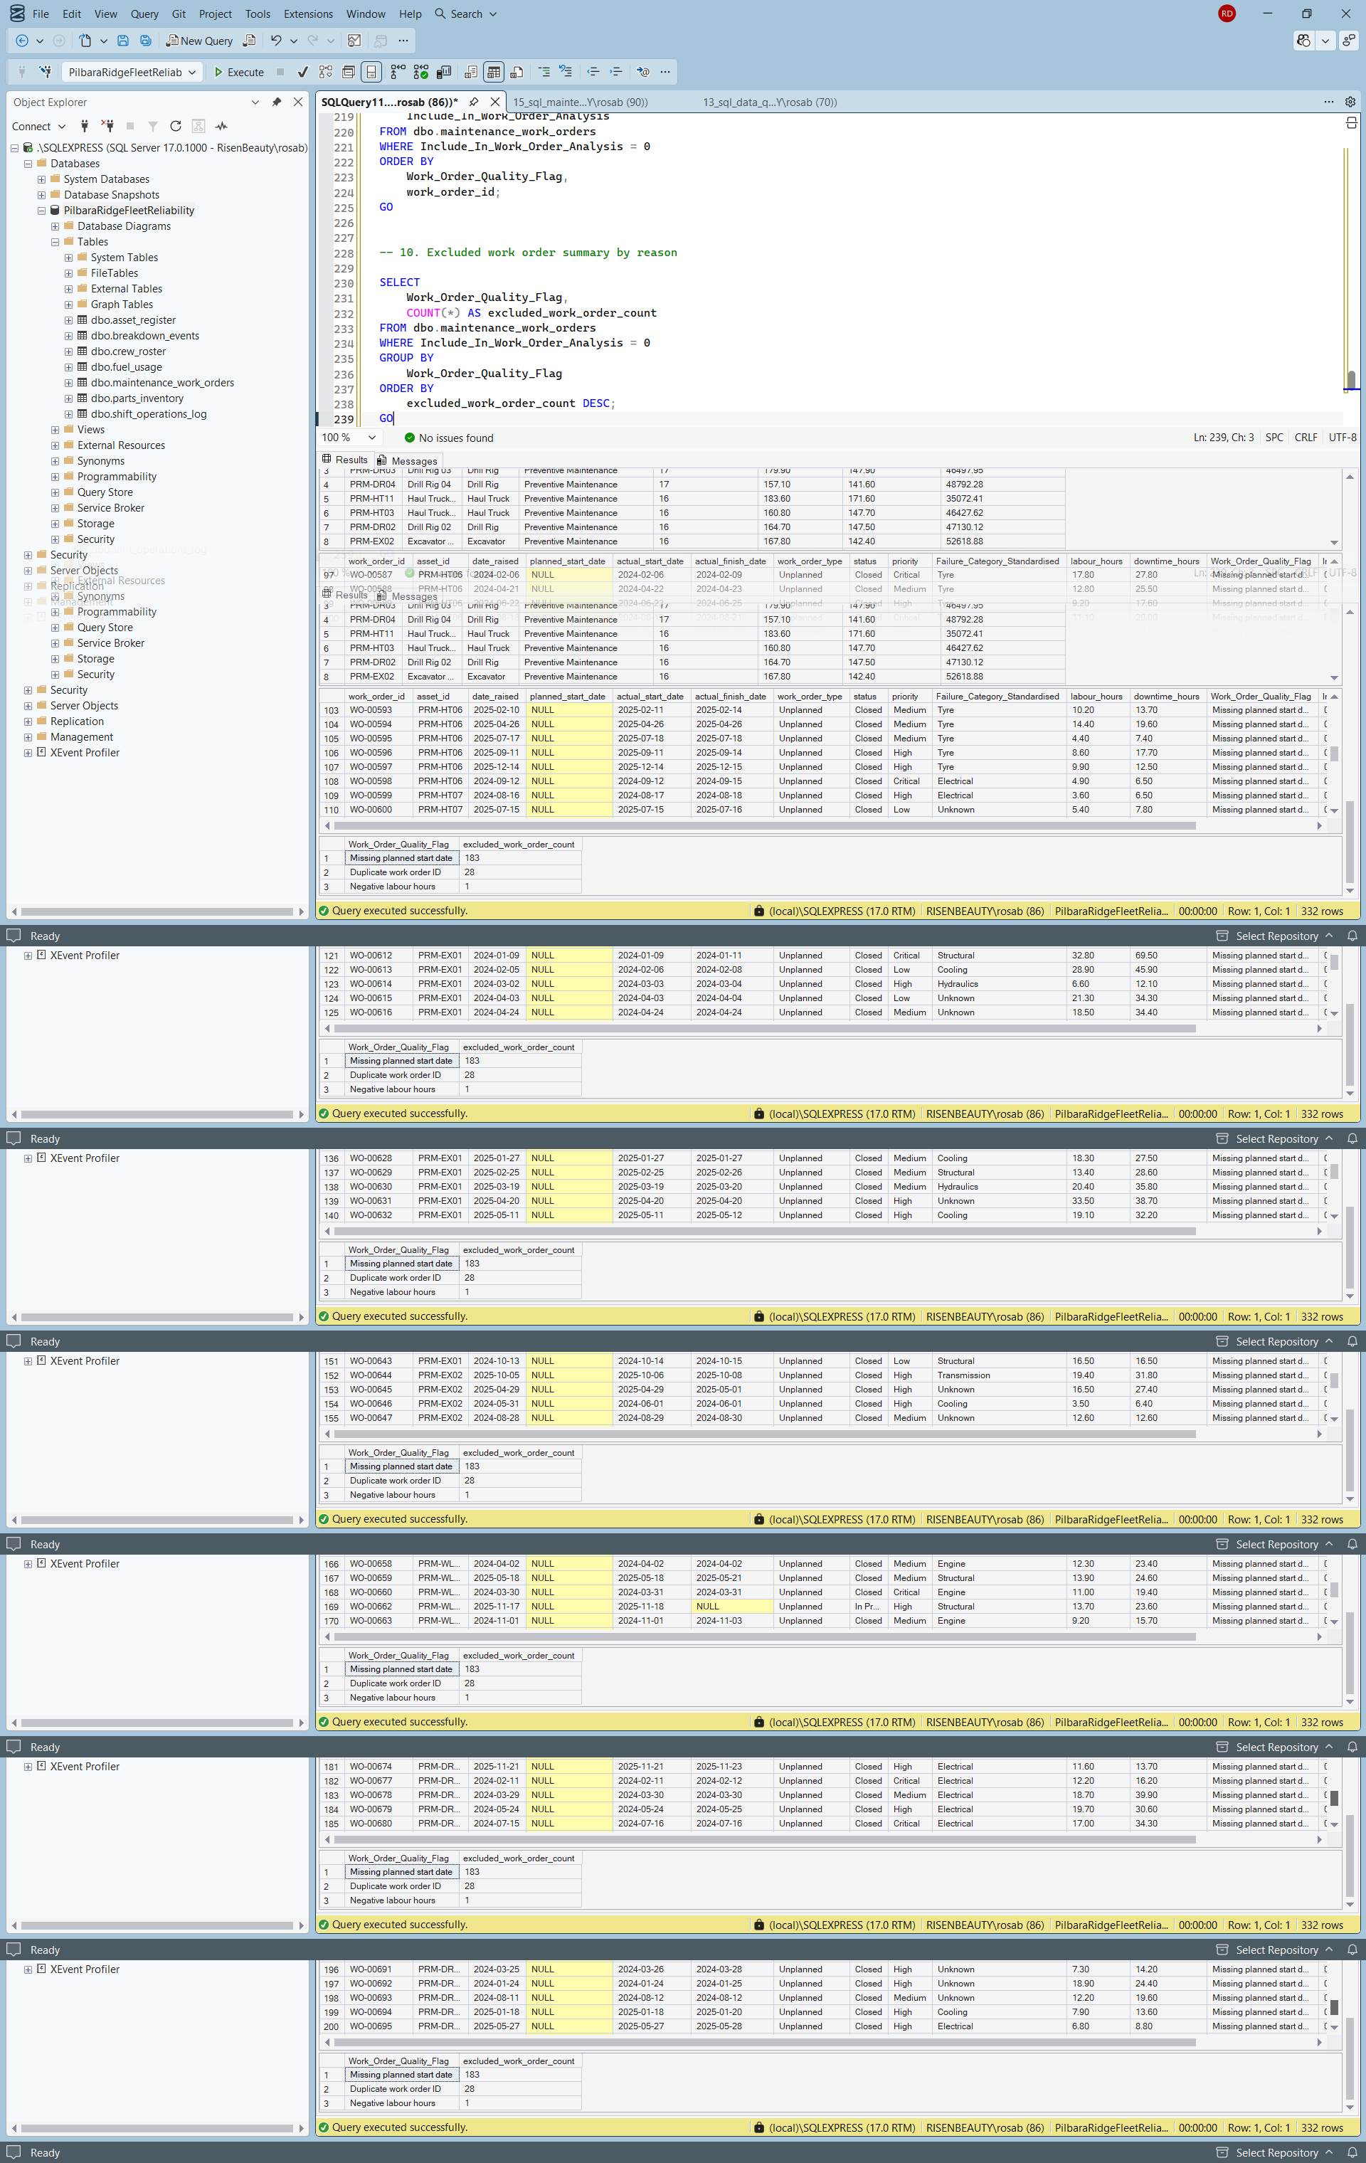

Date: 24/07/2026
Tool used:
Power BI Desktop, DAX
What I did:
Created a dedicated _Measures table and built DAX measures for operations, downtime, maintenance performance, breakdowns, fuel usage, data quality and executive KPI reporting.
Why it matters:
This created the metric layer required for dashboard development. The Power BI report can now use consistent measures for cards, charts, KPIs and future analysis pages.
Problem or decision:
I separated operational downtime from work order downtime because they come from different business processes. Operational downtime comes from shift records, while work order downtime comes from maintenance records. I also checked and corrected measure formats before continuing.
What I learned:
I learned that measure naming and formatting matter because they affect how clearly dashboard users interpret the numbers. I also learned that DAX measures should reflect business meaning, not just calculations.
Evidence saved:
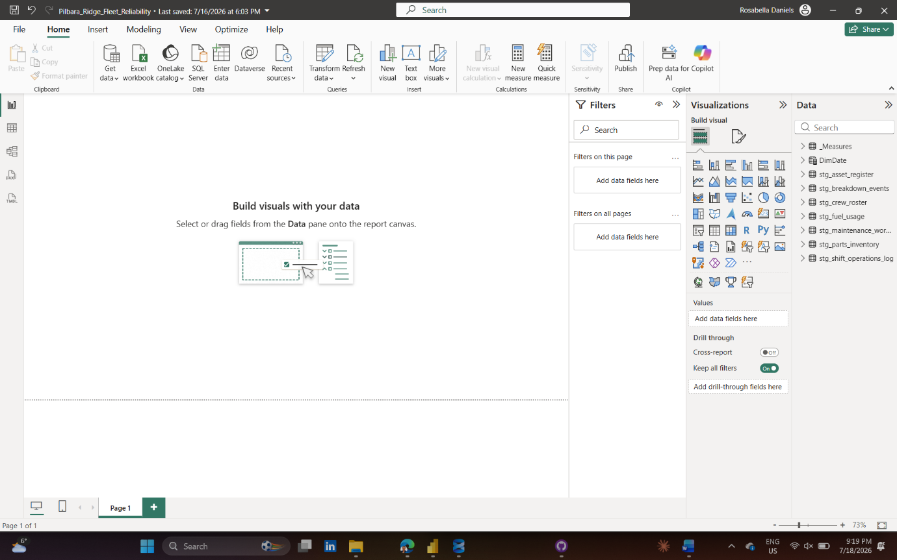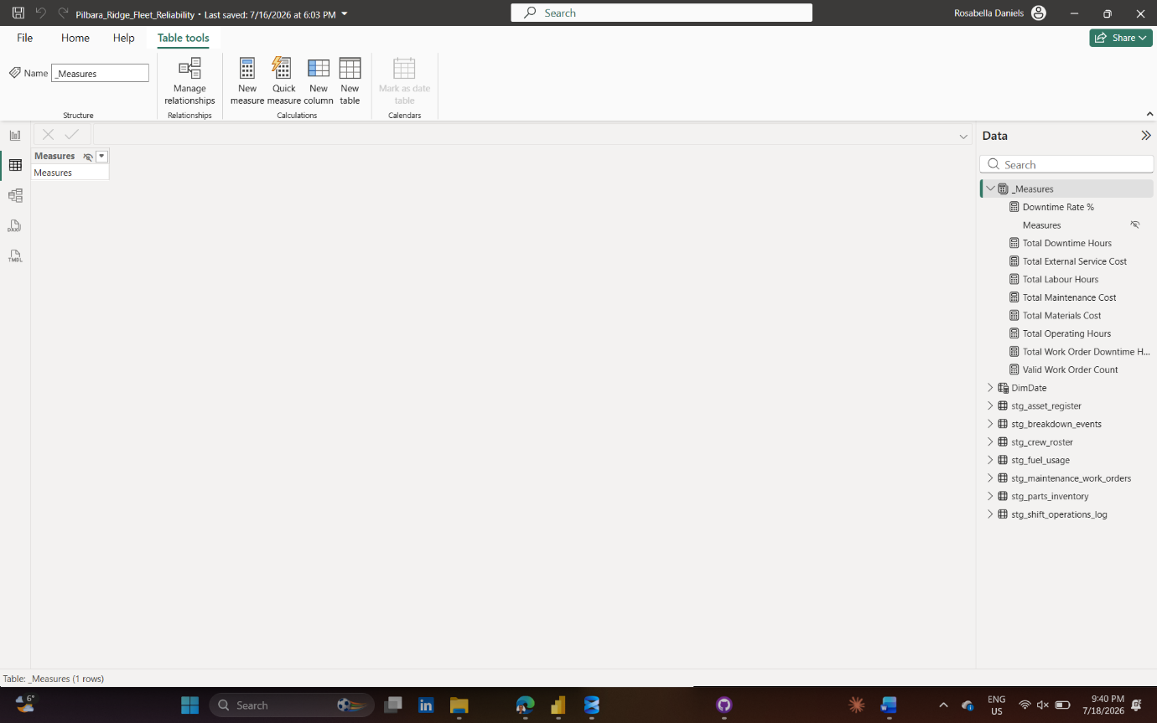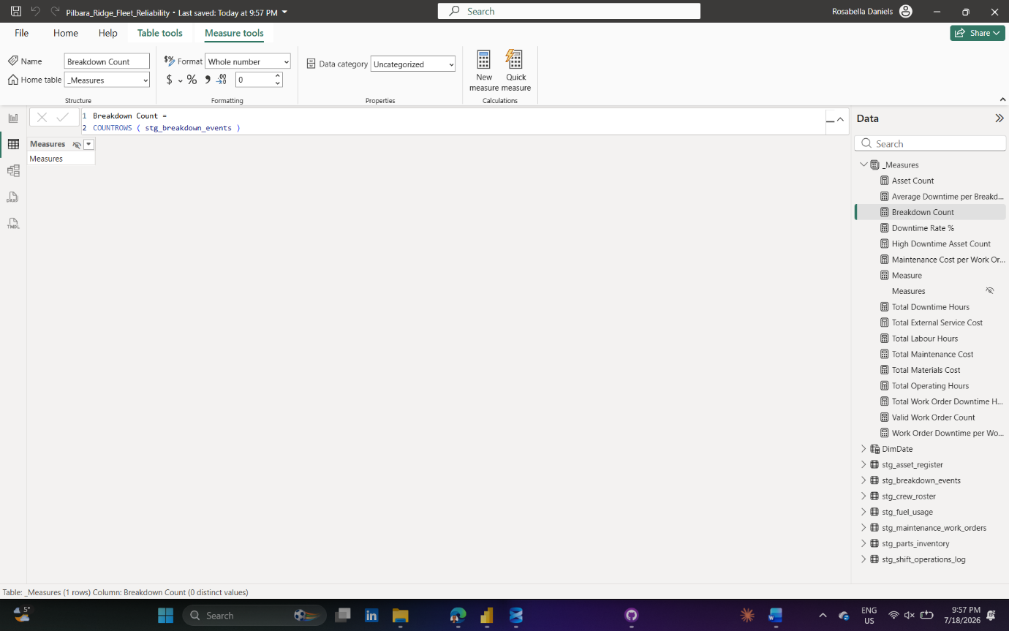
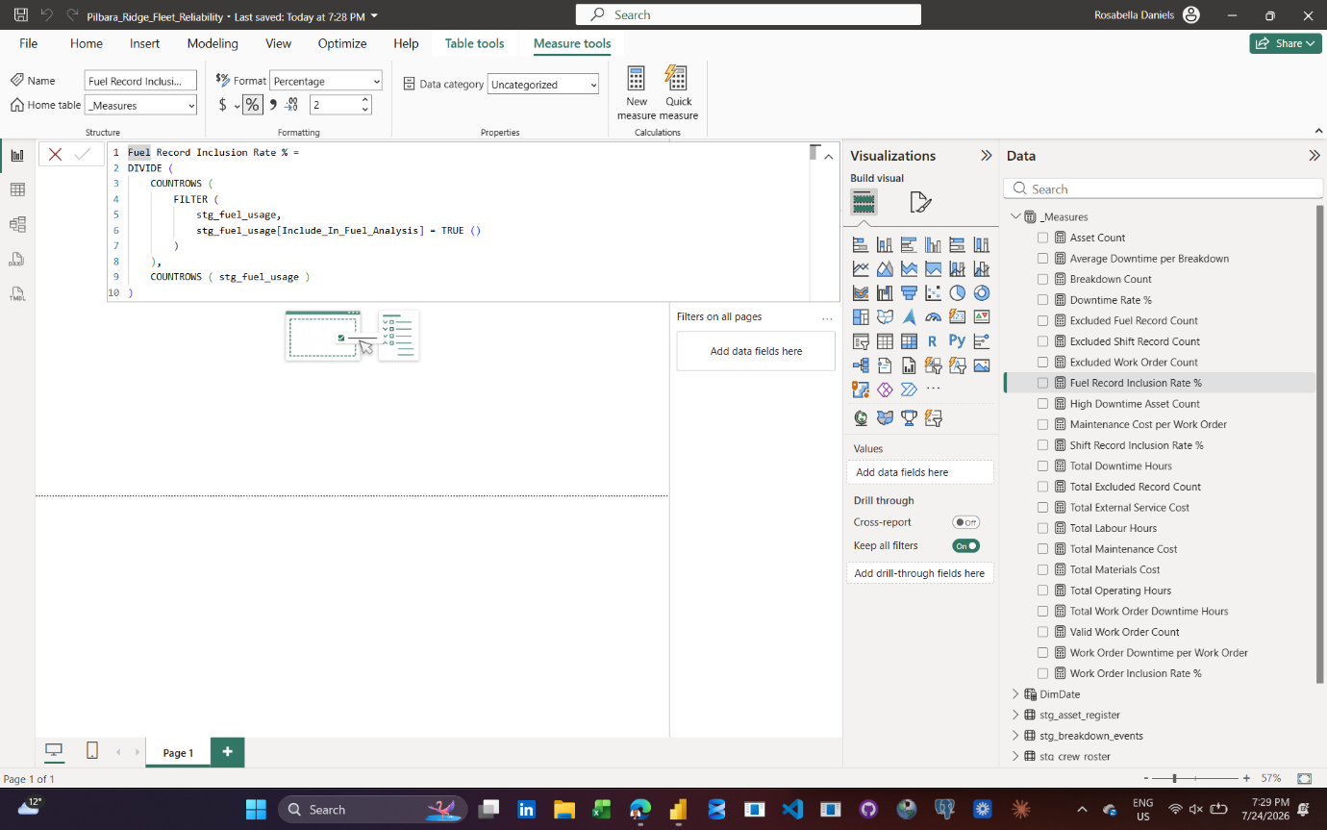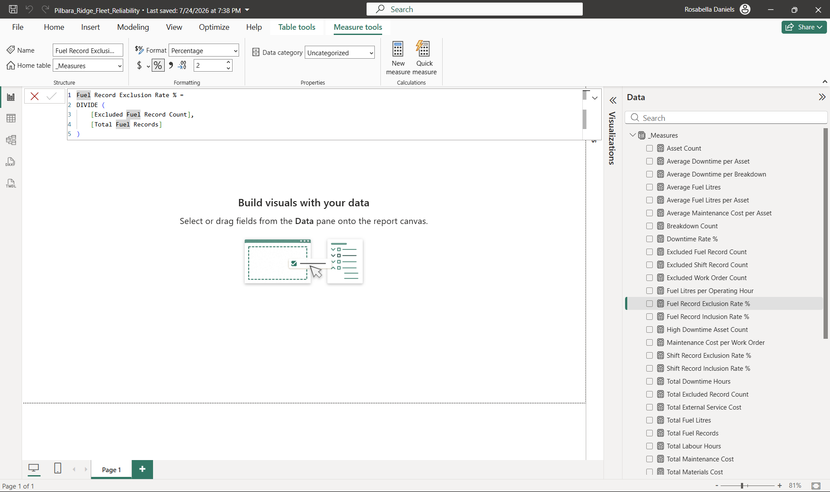
Date: 28/07/2026
Tool used:
Power BI Desktop, Microsoft Word and external-drive backup
What I did:
Resumed Project 1 dashboard development using Pilbara_Ridge_Fleet_Reliability_Dashboard_v01.pbix. Validated the executive KPI measures and built the working structure of the Executive Overview page using five KPI cards, a Top 10 Assets by Downtime Hours chart and a Corrective Work Orders by Failure Category chart.
During visual validation, I identified that Valid Work Order Count excluded most corrective maintenance records because the general work-order inclusion flag treated missing planned start dates as invalid. I created a purpose-specific DAX measure, Work Order Record Count, to count all work-order records when analysing failure-category frequency. Preventive Maintenance was then excluded from the corrective-failure visual because it is a maintenance type rather than a failure category.
I also built the Asset Reliability page with Breakdown Events, Average Downtime per Asset (Hours) and High Downtime Assets KPIs; Asset Class and Criticality Rating slicers; an asset-level scatter chart comparing Breakdown Events with Total Downtime Hours; and a Top 10 Assets by Breakdown Events table.
Created the Maintenance and Failure Analysis page and added its title and subtitle ready for the next dashboard session.
Why it matters:
The dashboard now begins answering which assets create the greatest reliability risk, whether risk is driven by frequent breakdowns, high downtime or both, and which corrective failure categories require maintenance attention. The work-order validation also prevented an technically functioning but misleading visual from being included in the report.
Problem or decision:
The initial failure-category visual showed only Preventive Maintenance because Valid Work Order Count used an inclusion flag that was too restrictive for failure-frequency analysis. Missing planned start dates can make records unsuitable for schedule-compliance analysis without making them unsuitable for counting corrective failure categories.
A separate Work Order Record Count measure was created instead of changing the original inclusion flag. This preserves the existing quality-control logic while allowing each analytical question to use an appropriate record population.
The scatter chart also temporarily aggregated assets by Criticality Rating when asset_name was mistakenly renamed and removed from the Values field. The field was restored so that each point represents one individual asset.
What I learned:
A single inclusion flag should not automatically control every analytical question. Record validity depends on the intended use of the data. I also learned that fields placed in the Values or Details section of a scatter chart determine its analytical grain. Removing asset_name changed the visual from asset-level analysis to category-level aggregation. I reinforced the importance of validating chart totals, labels, filter behaviour and analytical grain before treating a visual as complete.
Evidence saved:
Power BI file: Pilbara_Ridge_Fleet_Reliability_Dashboard_v01.pbix
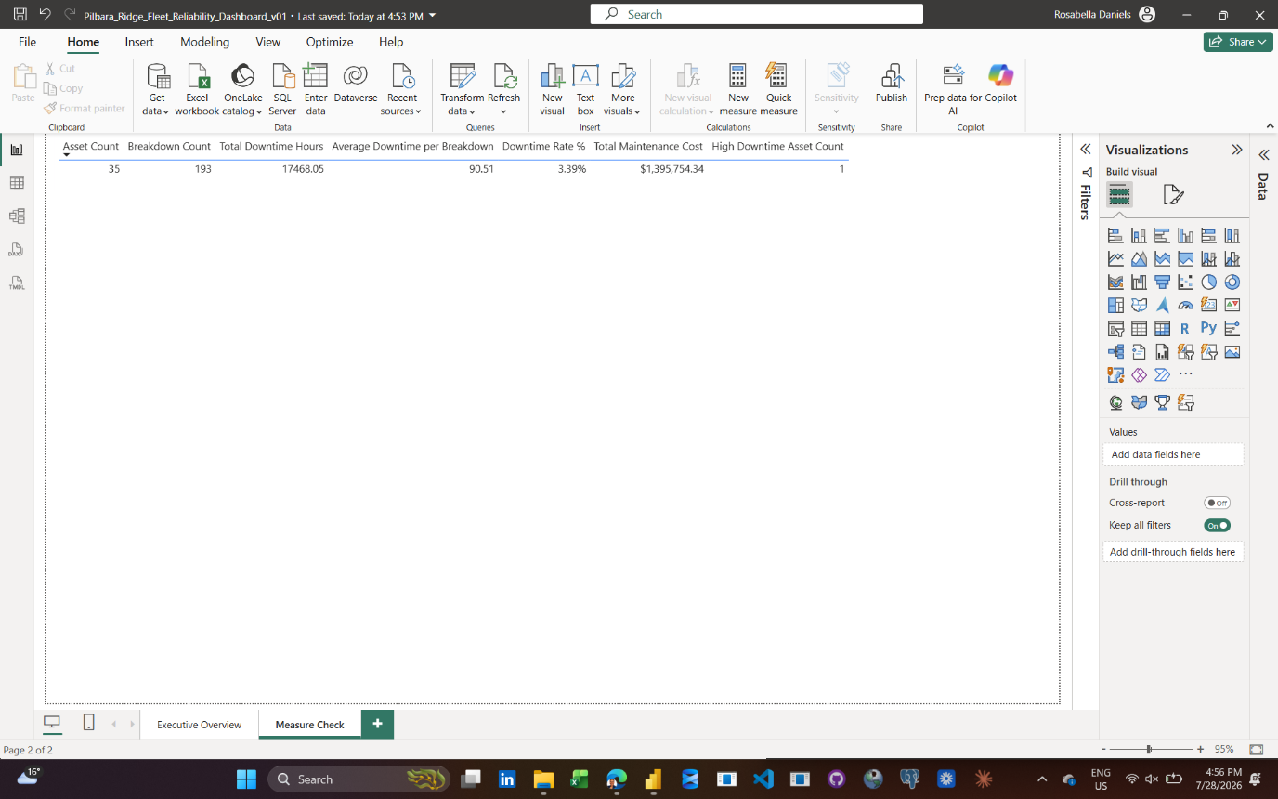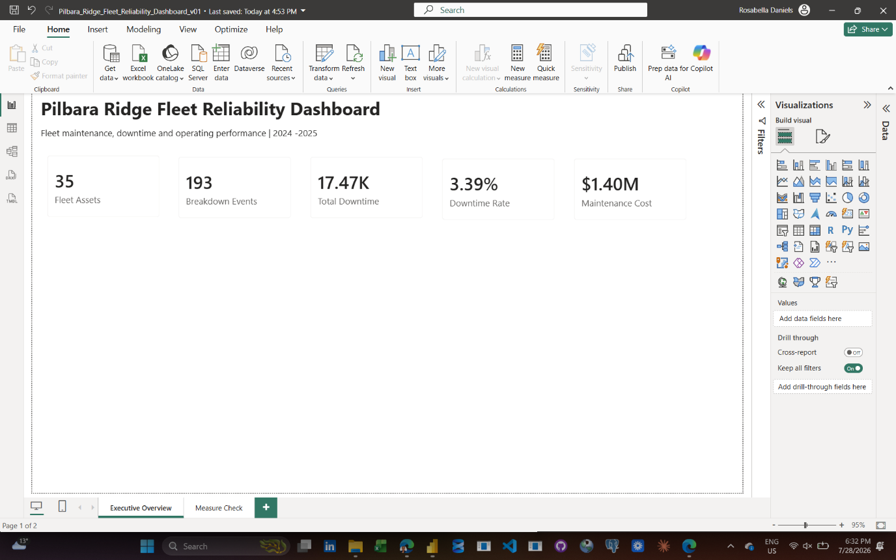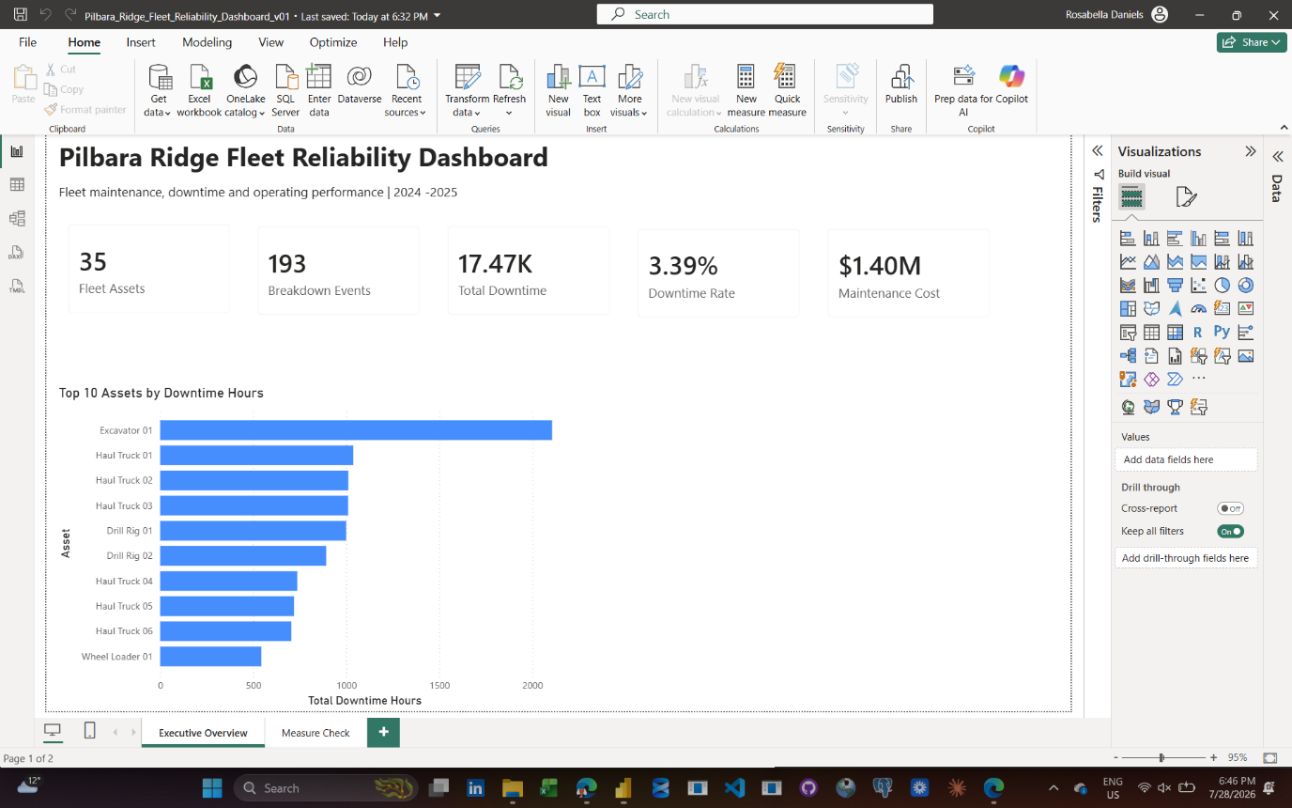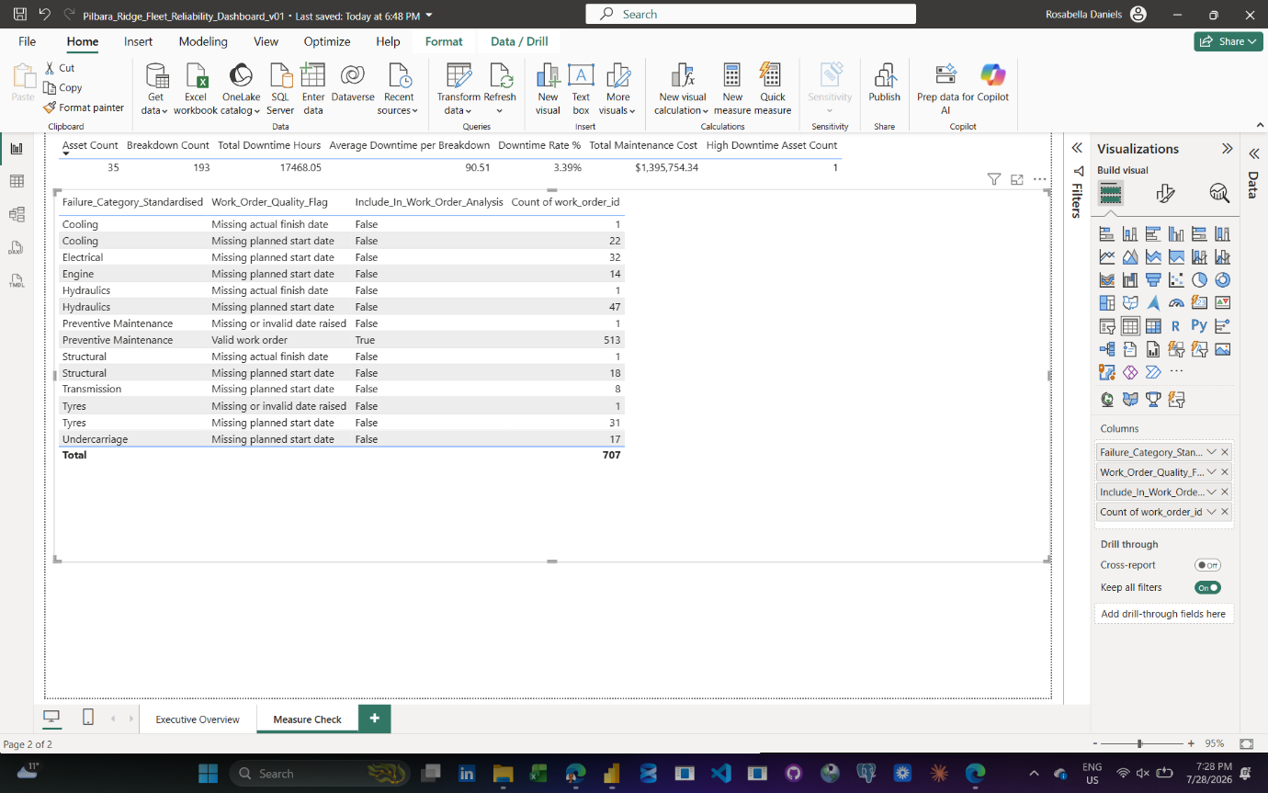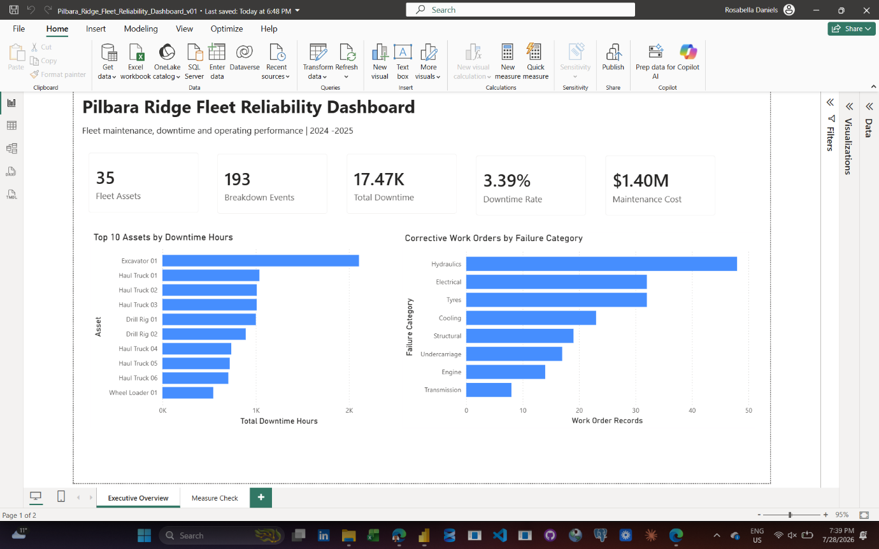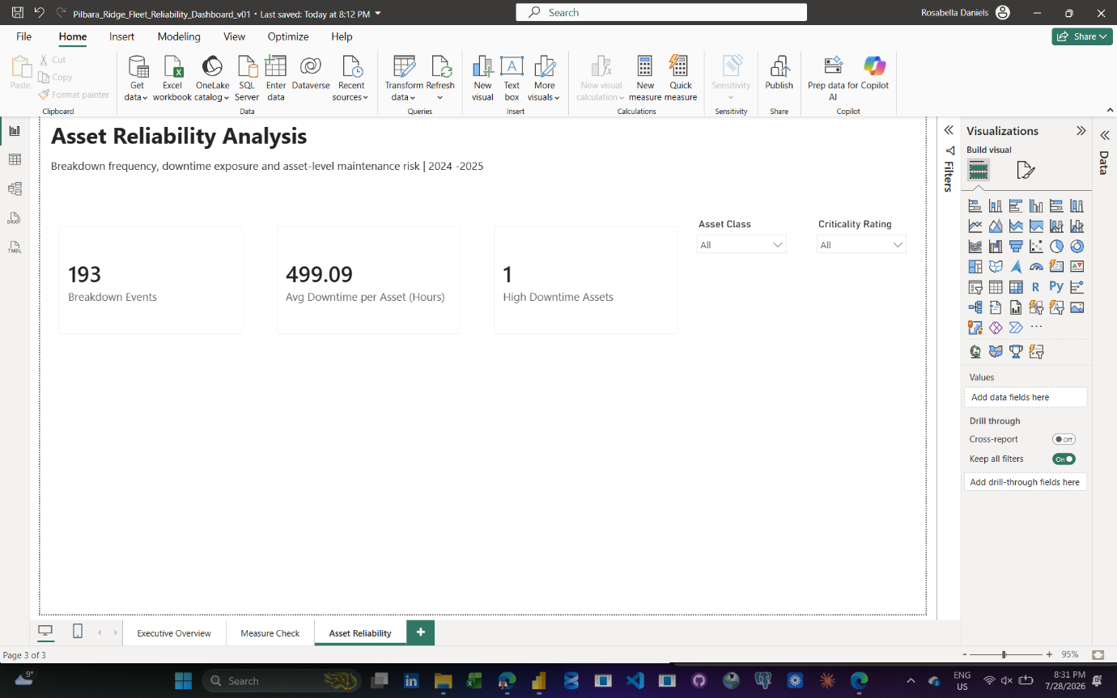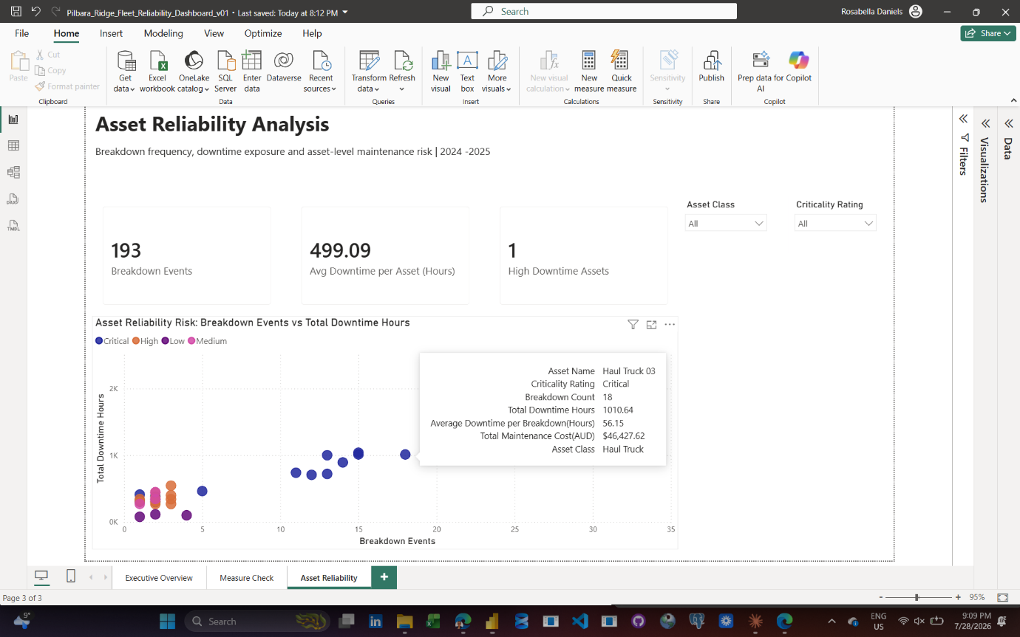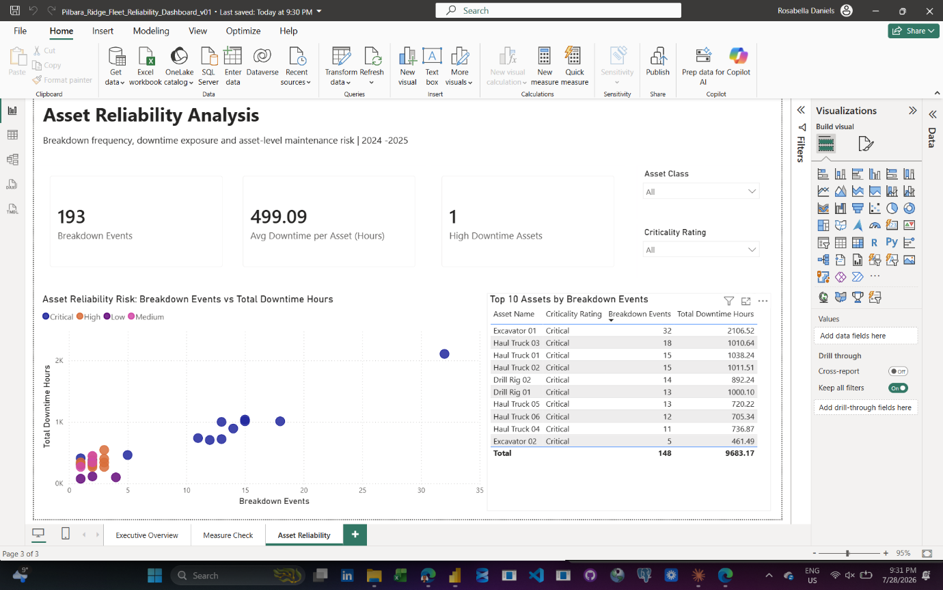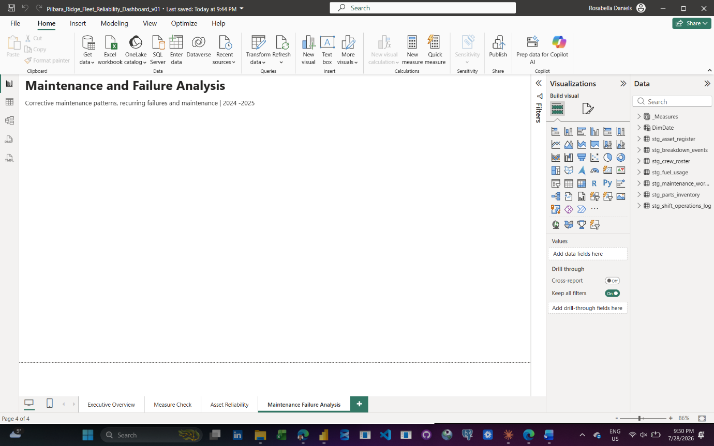

Date:
Tool used:
What I did:
Why it matters:
Problem or decision:
What I learned:
Evidence saved: Screenshot / video / file name

Date:
Tool used:
What I did:
Why it matters:
Problem or decision:
What I learned:
Evidence saved: Screenshot / video / file name

Date:
Tool used:
What I did:
Why it matters:
Problem or decision:
What I learned:
Evidence saved: Screenshot / video / file name
Date:
Tool used:
What I did:
Why it matters:
Problem or decision:
What I learned:
Evidence saved: Screenshot / video / file name

Data-quality decision log
Issue | Source table | Decision | Reason | Impact on analysis
Duplicate work-order IDs | maintenance_work_orders | Create a surrogate work-order key and retain original ID | Original ID is not reliably unique | Prevents incorrect relationships and duplicate counting
Inconsistent failure labels | maintenance_work_orders | Standardise to a failure-category mapping | Allows reliable system-level analysis | Improves repeat-failure reporting
Blank fuel litres | fuel_usage | Retain as null and create a quality flag | Blank does not mean zero fuel | Avoids understating fuel consumption
Invalid asset IDs | shift_operations_log, fuel_usage | Correct through a documented asset-ID mapping table | Corrections must be transparent and traceable | Enables relationship to asset register
Negative hours | shift_operations_log, maintenance_work_orders | Replace invalid values with null and add exception flag | Negative operating or downtime hours are not operationally valid | Prevents distorted KPIs
Mixed date formats | work orders and shift logs | Parse using locale-aware date transformation | Ensures dates are interpreted correctly | Supports accurate trend analysis

Screenshots to capture
- Folder structure and initial raw-data files.
- Power Query source queries, with raw queries set to “Enable load” off.
- Asset ID correction map.
- Failure-code standardisation steps.
- Data-quality exception flags.
- Final Power BI data model.
- Key DAX measures in the measure table.
- Each completed dashboard page.
- Final dashboard with filters applied to a reliability story.
- GitHub repository structure and finished README.

Screen recordings to capture
- Importing CSV files and setting up raw versus staging queries.
- Cleaning one complex table in Power Query, especially maintenance work orders.
- Creating the star-schema relationships in Power BI.
- Building a key DAX measure and validating the result.
- Walking through the completed dashboard and explaining three recommendations.

Key questions to answer
- Which assets have the highest downtime, breakdown count and production loss?
- Which failure categories recur most often, and on which assets?
- Are hydraulic and tyre/rim delivery delays associated with longer repair durations?
- How do extreme heat, dust storms and cyclone-watch periods affect downtime, absenteeism and overtime?
- Does asset age correlate with downtime and breakdown frequency?
- Which assets should be prioritised for maintenance intervention, root-cause analysis or replacement planning?

Final recommendations
To be completed after analysis.

