Project 1 Build Log
Pilbara Ridge Fleet Reliability and Maintenance Performance
Project purpose
Build an end-to-end Power BI analytics solution for Pilbara Ridge Mining Operations to identify fleet reliability risks, repeat failures, downtime drivers, supply-chain delays, weather impacts and maintenance priorities.
Business problem
Operations leaders need a clear view of which assets are driving downtime and production loss, whether recurring failures are being resolved, whether delayed parts are extending repair duration, and which assets should be prioritized for maintenance intervention or replacement planning.

Milestone tracker
Date | Milestone | Status | Evidence saved
06/07/2026 | Project folders and GitHub repository created | started | 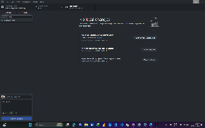
 | Raw files reviewed and data-quality issues identified | Not started
 | Power Query cleaning completed | Not started
 | SQL database and tables created | Not started
 | Data model completed | Not started
 | DAX measures completed | Not started
 | Dashboard pages completed | Not started
 | Findings and recommendations completed | Not started
 | GitHub README and portfolio case study completed | Not started

Build journal
Date:
Tool used:
What I did:
Why it matters:
Problem or decision:
What I learned:
Evidence saved: Screenshot / video / file name
Date: 06/07/2026
Tool used: GitHub Desktop
What I did: Created and published the Pilbara Ridge Fleet Reliability repository.
Why it matters: The repository will store version-controlled evidence of my analytics process project documentation, SQL, Python, screenshots and final portfolio materials.
Problem or decision: No issue encountered at this stage.
What I learned: GitHub is not just for software developers. It provides a documented history of how a data project was built.
Evidence saved:
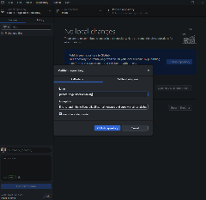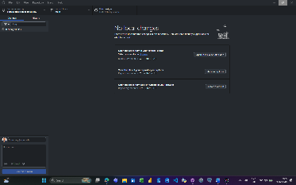

Date: 06/07/2026
Tool used: Visual Studio Code
What I did: Created the README.md file for the GitHub repository.
Why it matters: The README.md is the public front page of the project and explains the business problem, tools, project scope, and build status.
Problem or decision: No issue encountered at this stage.
What I learned: Markdown is plain text formatting used by GitHub to display project documentation clearly.
Evidence saved:
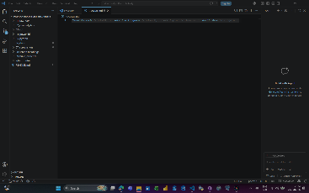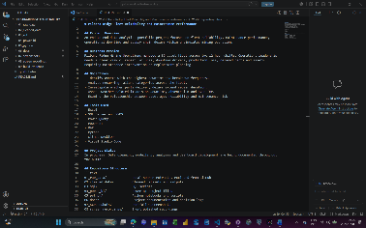

Date:
Tool used:
What I did:
Why it matters:
Problem or decision:
What I learned:
Evidence saved: Screenshot / video / file name

Date:
Tool used:
What I did:
Why it matters:
Problem or decision:
What I learned:
Evidence saved: Screenshot / video / file name

Data-quality decision log
Issue | Source table | Decision | Reason | Impact on analysis
Duplicate work-order IDs | maintenance_work_orders | Create a surrogate work-order key and retain original ID | Original ID is not reliably unique | Prevents incorrect relationships and duplicate counting
Inconsistent failure labels | maintenance_work_orders | Standardise to a failure-category mapping | Allows reliable system-level analysis | Improves repeat-failure reporting
Blank fuel litres | fuel_usage | Retain as null and create a quality flag | Blank does not mean zero fuel | Avoids understating fuel consumption
Invalid asset IDs | shift_operations_log, fuel_usage | Correct through a documented asset-ID mapping table | Corrections must be transparent and traceable | Enables relationship to asset register
Negative hours | shift_operations_log, maintenance_work_orders | Replace invalid values with null and add exception flag | Negative operating or downtime hours are not operationally valid | Prevents distorted KPIs
Mixed date formats | work orders and shift logs | Parse using locale-aware date transformation | Ensures dates are interpreted correctly | Supports accurate trend analysis

Screenshots to capture
- Folder structure and initial raw-data files.
- Power Query source queries, with raw queries set to “Enable load” off.
- Asset ID correction map.
- Failure-code standardisation steps.
- Data-quality exception flags.
- Final Power BI data model.
- Key DAX measures in the measure table.
- Each completed dashboard page.
- Final dashboard with filters applied to a reliability story.
- GitHub repository structure and finished README.

Screen recordings to capture
- Importing CSV files and setting up raw versus staging queries.
- Cleaning one complex table in Power Query, especially maintenance work orders.
- Creating the star-schema relationships in Power BI.
- Building a key DAX measure and validating the result.
- Walking through the completed dashboard and explaining three recommendations.

Key questions to answer
- Which assets have the highest downtime, breakdown count and production loss?
- Which failure categories recur most often, and on which assets?
- Are hydraulic and tyre/rim delivery delays associated with longer repair durations?
- How do extreme heat, dust storms and cyclone-watch periods affect downtime, absenteeism and overtime?
- Does asset age correlate with downtime and breakdown frequency?
- Which assets should be prioritised for maintenance intervention, root-cause analysis or replacement planning?

Final recommendations
To be completed after analysis.

