Activity 1. Measuring execution times

1. The method will overflow at *new Date(Long.MAX_VALUE)*, which is 292278994. Thus, we can use it for than 292 million years more.
2. It means that the elapsed time is less than zero, and java rounds it to 0 when showing the measurement.
3. More or less from n = 110000000.

Activity 2. Grow of the problem size

1. The time is still the same, because the complexity has not changed.
2. Yes, they are.

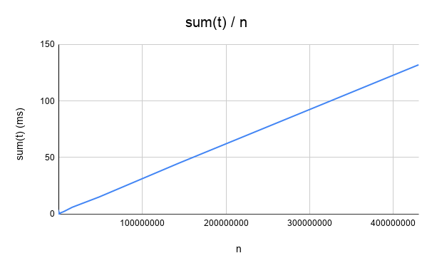

Activity 3. Taking small execution times

|  |  |  |  |
| --- | --- | --- | --- |
| ***n*** | ***fillIn(t)*** | ***sum(t)*** | ***maximum(t)*** |
| 10 | 1 | 0 | 0 |
| 30 | 0 | 0 | 0 |
| 90 | 0 | 0 | 0 |
| 270 | 0 | 0 | 0 |
| 810 | 0 | 0 | 0 |
| 2430 | 0 | 0 | 0 |
| 7290 | 1 | 1 | 0 |
| 21870 | 1 | 0 | 0 |
| 65610 | 2 | 0 | 1 |
| 196830 | 3 | 1 | 1 |
| 590490 | 4 | 0 | 1 |
| 1771470 | 12 | 1 | 1 |
| 5314410 | 36 | 2 | 2 |
| 15943230 | 108 | 6 | 6 |
| 47829690 | 318 | 15 | 15 |
| 143489070 | 928 | 45 | 49 |
| 430467210 | 2802 | 132 | 244 |

The time is in milliseconds.

* What are the main components of the computer in which you did the work (process, memory)?

The computer’s memory and CPU.

* Do the values obtained meet the expectations?

Yes, they do. The time complexity of the functions is O(n).

***fillIn(t)*:** t1 = 4 ms, n1 = 590490, n2 = 1771470, then, t2 = n2/n1 * t1 = 12 ms (the same as in the table).

t1 = 12 ms, n1 = 1771470, n2 = 5314410, then, t2 = n2/n1 * t1 = 36 ms (the same as in the table).

***sum(t)*:** t1 = 6 ms, n1 = 15943230, n2 = 47829690, then, t2 = n2/n1 * t1 = 18 ms

t1 = 15 ms, n1 = 47829690, n2 = 143489070, then, t2 = n2/n1 * t1 = 45 ms (the same as in the table).

***maximum(t)*:** t1 = 2 ms, n1 = 5314410, n2 = 15943230, then, t2 = n2/n1 * t1 = 6 ms (the same as in the table).

t1 = 6 ms, n1 = 15943230, n2 = 47829690, then, t2 = n2/n1 * t1 = 18 ms

Activity 4. Operations on matrices

|  |  |  |
| --- | --- | --- |
| ***n*** | ***sumDiagonal1(t)*** | ***sumDiagonal2(t)*** |
| 10 | 56 | 2 |
| 30 | 51 | 2 |
| 90 | 26 | 2 |
| 270 | 52 | 2 |
| 810 | 51 | 2 |
| 2430 | 50 | 2 |
| 7290 | 51 | 1 |
| 21870 | 51 | 1 |
| 65610 | 50 | 0 |
| 196830 | 51 | 1 |
| 590490 | 39 | 1 |
| 1771470 | 39 | 2 |
| 5314410 | 39 | 0 |
| 15943230 | 39 | 1 |
| 47829690 | 39 | 1 |
| 143489070 | 39 | 1 |
| 430467210 | 39 | 1 |

The time is in milliseconds.

* What are the main components of the computer in which you did the work (process, memory)?

The computer’s memory and CPU.

* Do the values obtained meet the expectations?

No, they do not.

***sumDiagonal1(t) $(O(n^{2}))$* :** t1 = 52 ms, n1 = 270, n2 = 810, then,

t2 = n2^2/n1^2 * t1 = 468 ms

t1 = 51 ms, n1 = 810, n2 = 2430, then, t2 = n2^2/n1^2 * t1 = 459 ms

***sumDiagonal2(t) $(O(n))$* :** t1 = 2 ms, n1 = 270, n2 = 810, then,

t2 = n2/n1 * t1 = 6 ms

t1 = 2 ms, n1 = 810, n2 = 2430, then, t2 = n2/n1 * t1 = 6 ms

Activity 5. Benchmarking

1. Because in Python it must first inspect the objects and find out their type, which is not known at compile time; in Java the type is declared beforehand so the compiler knows it.
2. Yes, in Java, the linear times at the beginning are greater with a smaller n than 3 iterations after; then the time increases normally.