Activity 1. Two algorithms with the same complexity

|  |  |  |  |
| --- | --- | --- | --- |
| ***N*** | ***loop2(t)*** | ***loop3(t)*** | ***loop2(t)/loop3(t)*** |
| 8 | 0 | 0 | 0 |
| 16 | 0 | 0 | 0 |
| 32 | 0 | 0 | 0 |
| 64 | 0 | 0 | 0 |
| 128 | 0 | 0 | 0 |
| 256 | 2 | 2 | 1 |
| 512 | 4 | 3 | 1,333333333 |
| 1024 | 9 | 6 | 1,5 |
| 2048 | 29 | 25 | 1,16 |
| 4096 | 117 | 112 | 1,044642857 |
| 8192 | 443 | 449 | 0,986636971 |
| 16384 | 1733 | 1718 | 1,008731083 |
| 32768 | 6977 | 6849 | 1,01868886 |
| 65536 | 28337 | 27553 | 1,028454252 |
| 131072 | 113073 | 110227 | 1,025819445 |

The time is in milliseconds. RAM: 8 GB, CPU: AMD Ryzen 7 2700X.

Having in mind that both algorithms have the same time complexity $(O\left(n^{2}\right))$, except for a couple of cases, the division is ≈ 1. Thus, the results make sense.

Nevertheless, the implementation constant tends to be > 1 when *n* is small, which indicates that loop3 might be a bit better in those cases.

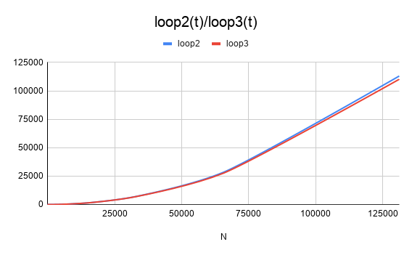

Activity 2. Two algorithms with different complexity

|  |  |  |  |
| --- | --- | --- | --- |
| ***N*** | ***loop1(t)*** | ***loop2(t)*** | ***loop1(t)/loop2(t)*** |
| 8 | 0 | 0 | 0 |
| 16 | 1 | 1 | 1 |
| 32 | 0 | 1 | 0 |
| 64 | 0 | 4 | 0 |
| 128 | 1 | 12 | 0,08333333333 |
| 256 | 3 | 43 | 0,06976744186 |
| 512 | 4 | 174 | 0,02298850575 |
| 1024 | 8 | 672 | 0,0119047619 |
| 2048 | 16 | 2648 | 0,006042296073 |
| 4096 | 34 | 10584 | 0,00321239607 |
| 8192 | 74 | 42441 | 0,001743596993 |
| 16384 | 158 | 168973 | 0,000935060631 |

The time is in milliseconds. RAM: 8 GB, CPU: AMD Ryzen 7 2700X.

Time complexities:

* **loop1**: $O\left(nlog(n)\right)$
* **loop2**: $O\left(n^{2}\right)$

Having in mind that the time complexity if the loop1 is better, the result of the division is always less than 1. Thus, the results make sense.

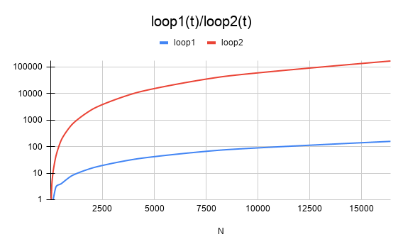

Activity 3. Complexity of other algorithms

|  |  |  |  |
| --- | --- | --- | --- |
| ***N*** | ***loop4(t)*** | ***loop5(t)*** | ***loop4(t)/loop5(t)*** |
| 8 | 1 | 1 | 1 |
| 16 | 2 | 2 | 1 |
| 32 | 7 | 3 | 2,333333333 |
| 64 | 55 | 17 | 3,235294118 |
| 128 | 1695 | 158 | 10,7278481 |
| 256 | 55375 | 1395 | 39,6953405 |

The time is in milliseconds. RAM: 8 GB, CPU: AMD Ryzen 7 2700X.

The measurements and results obtained make sense, because the time complexity of the algorithm in loop5 is better than the one in loop4. Therefore, the constant is always greater than or equal to (in small sizes) 1.

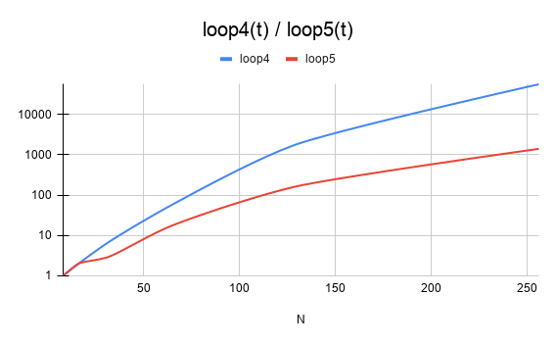

Activity 4. Study of Unknown.java

|  |  |
| --- | --- |
| ***N*** | ***unkown(t)*** |
| 8 | 0 |
| 16 | 0 |
| 32 | 1 |
| 64 | 1 |
| 128 | 4 |
| 256 | 1 |
| 512 | 12 |
| 1024 | 65 |
| 2048 | 375 |
| 4096 | 2142 |
| 8192 | 13614 |
| 16384 | 92576 |

The time is in milliseconds. RAM: 8 GB, CPU: AMD Ryzen 7 2700X.

The results obtained do not make sense, because the time complexity is $O\left(n^{3}\right)$ and the time measurements do not match the theoretical results when applying the formula.

Calculations:

* t1 = 12 ms, n1 = 512, n2 = 1024, then, t2 = n2^3/n1^3 * t1 = 96 ms
* t1 = 375 ms, n1 = 2048, n2 = 4096, then, t2 = n2^3/n1^3 * t1 = 3000 ms

