Activity 1. Counting inversions

|  |  |  |  |  |
| --- | --- | --- | --- | --- |
| ***file*** | ***t O(n2)*** | ***t O(nlogn)*** | ***t O(n2)/t O(nlogn)*** | ***n inversions*** |
| Ranking1.txt |  |  |  | 14.074.466 |
| Ranking2.txt | 750 | 3 | 250 | 56.256.142 |
| Ranking3.txt | 2410 | 6 | 401.6666667 | 225.312.650 |
| Ranking4.txt | 12079 | 15 | 805.2666667 | 903.869.574 |
| Ranking5.txt | 49160 | 25 | 1966.4 | 3.613.758.061 |
| Ranking6.txt | 289478 | 66 | 4386.030303 | 14.444.260.441 |
| Ranking7.txt | 1168172 | 154 | 7585.532468 | 57.561.381.803 |

The results are the expected. As we can see on the fourth column; ***t O(n2)/t O(nlogn)***, the result of the division is always greater than 1 and it keeps increasing with the time, that means that the algorithm of the ‘Inversions’ class is always better than the one from the ‘InversionsQuadratic’ class, as expected because of the complexities.

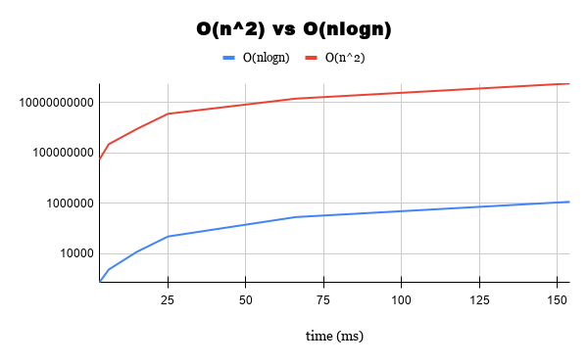

Also, on this graph comparing both complexities, we can see that the tendencies and values are the expected.