Activity 1. Validation results

The output of the *BestList* class with inputs ‘List01’ and ‘20’ is:

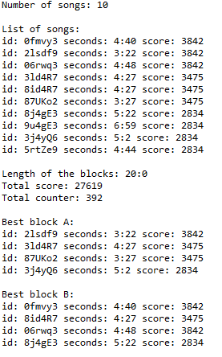

The time complexity in the worst case would be $O(n!)$, because each time we select a song to be part of the solution the number of possible songs we can select after decreases by 1;

(n = n - 1), as we do not repeat a song on the blocks of the solution.