# Cleaning documentation

🡪 originally every experiment should have 1600 trials (8*200)

🡪 break between trials: 0.7

🡪 duration of stimulus: 0.8

🡪 event slice intervals are [-0.1, 0.6]

**Subject ID 15**

* Rejected electrodes: Fp2 (broken), Fpz (noisy)
* Almost rejected: FC4, FC6
* Rejected almost the whole vibrotactile wrist block right before the third finger tapping task
* After slicing into events: removed 33 trials and 137 unreferenced events (what are unreferenced events?)

Question: Which zoom factor value should I use for rejecting the noisy parts of the data? The lower the value the noisier the data appears... Here I used 45.

Disturbed signal: from 900-907

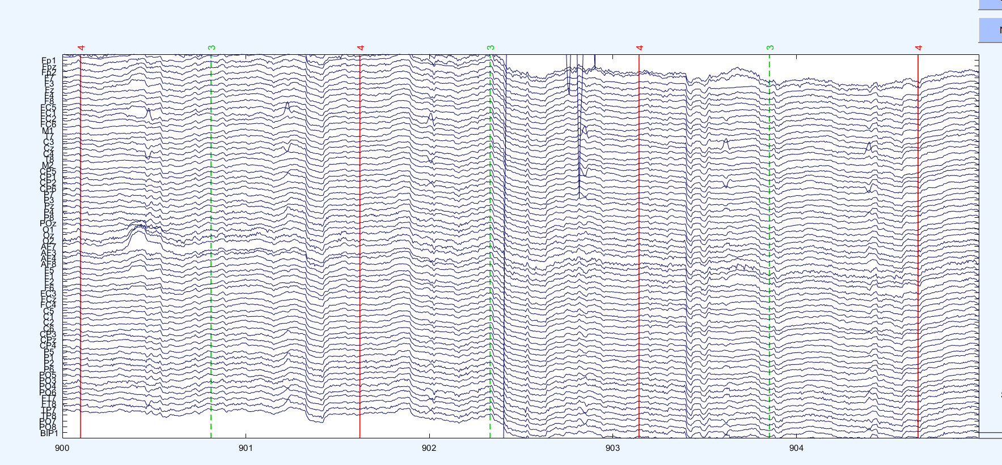

Electrode Fp1 is suddenly very noisy for a longer time: 2393-3400 (the end)

* Update: I thought it was FP1 but when I deleted the channel the noise was still there. Thus I deleted Fpz and then it was gone.

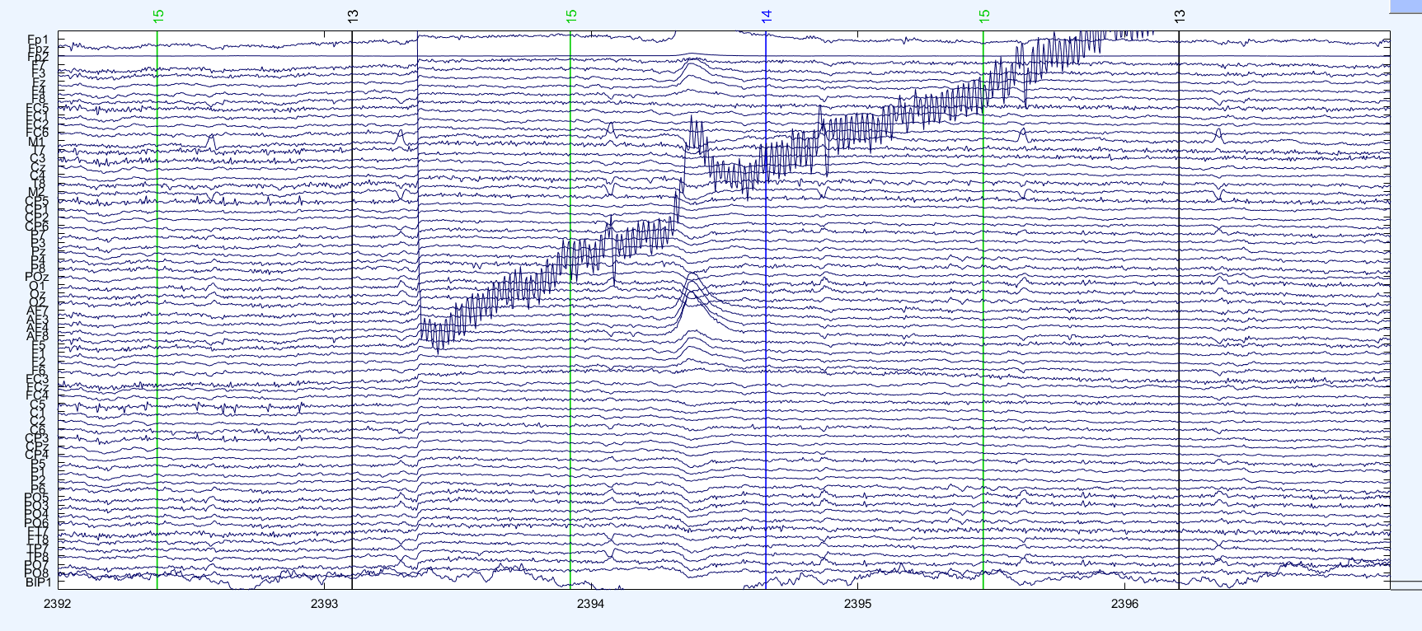

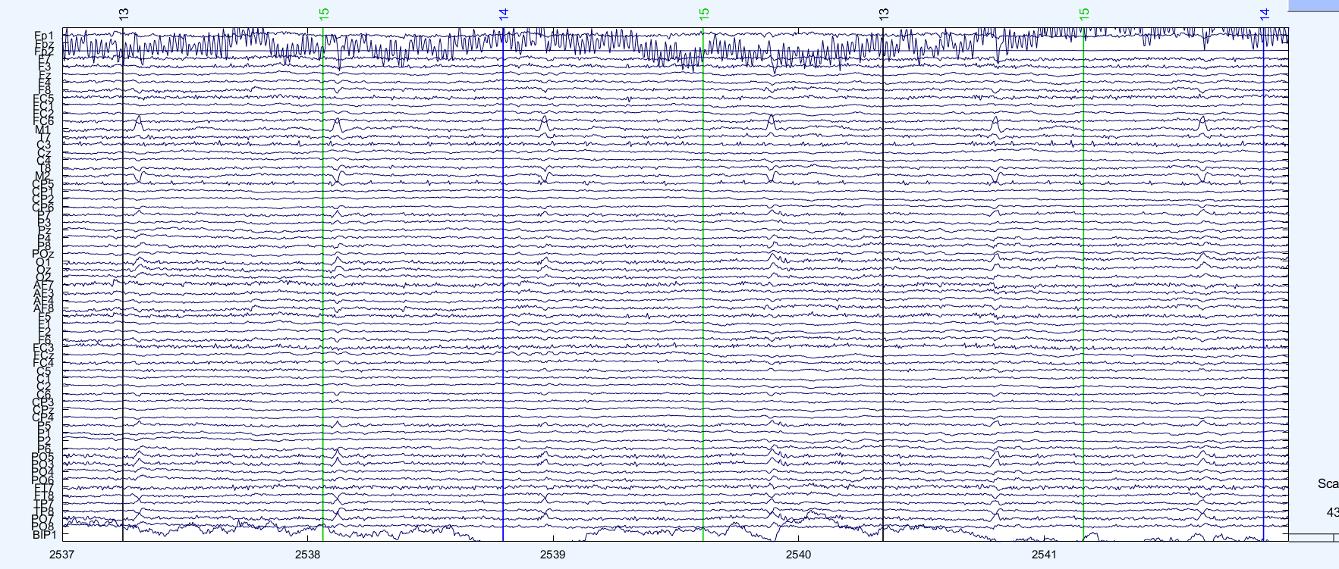

Question: Do I have to remove this section? I did not exclude the noisy channels because they were just noisy for a small amount of time.

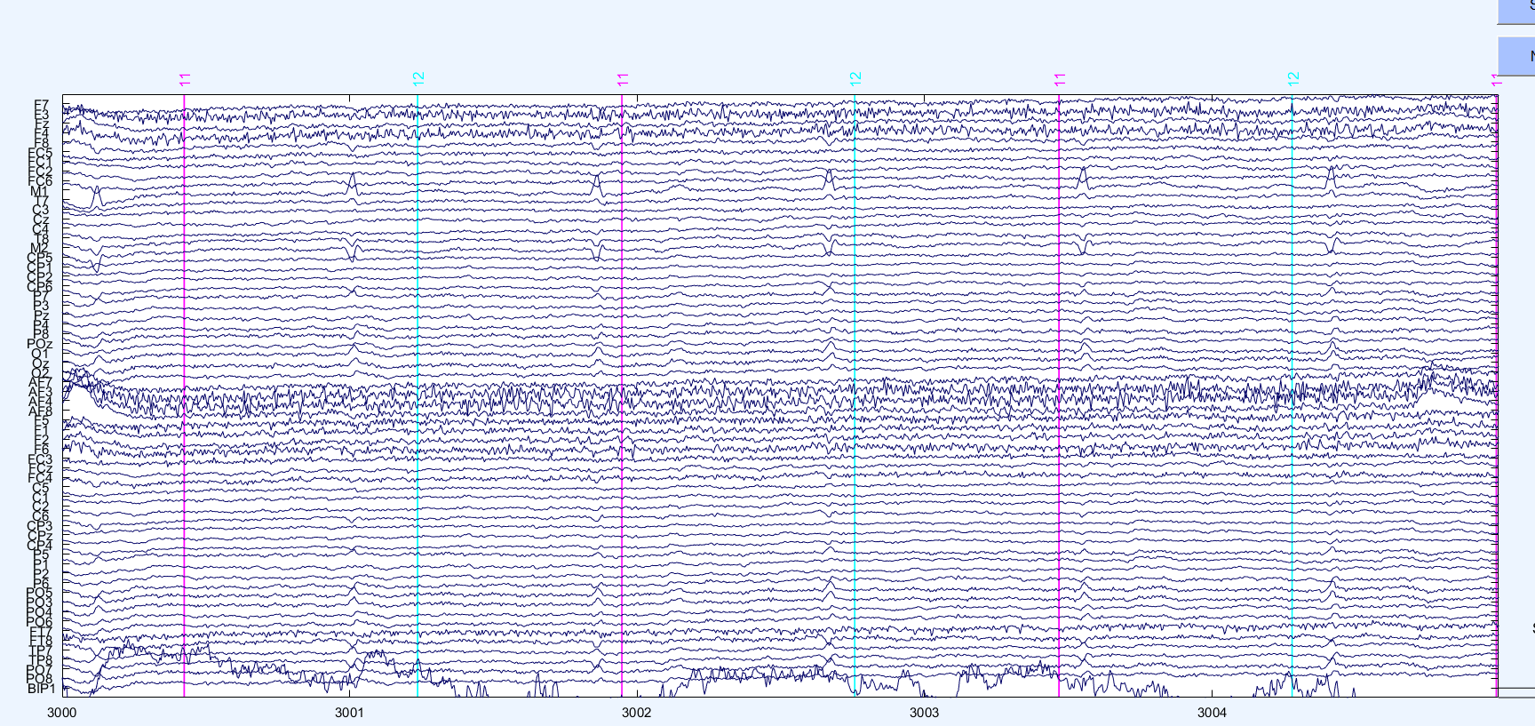

Is this a muscle artefact that has to be removed?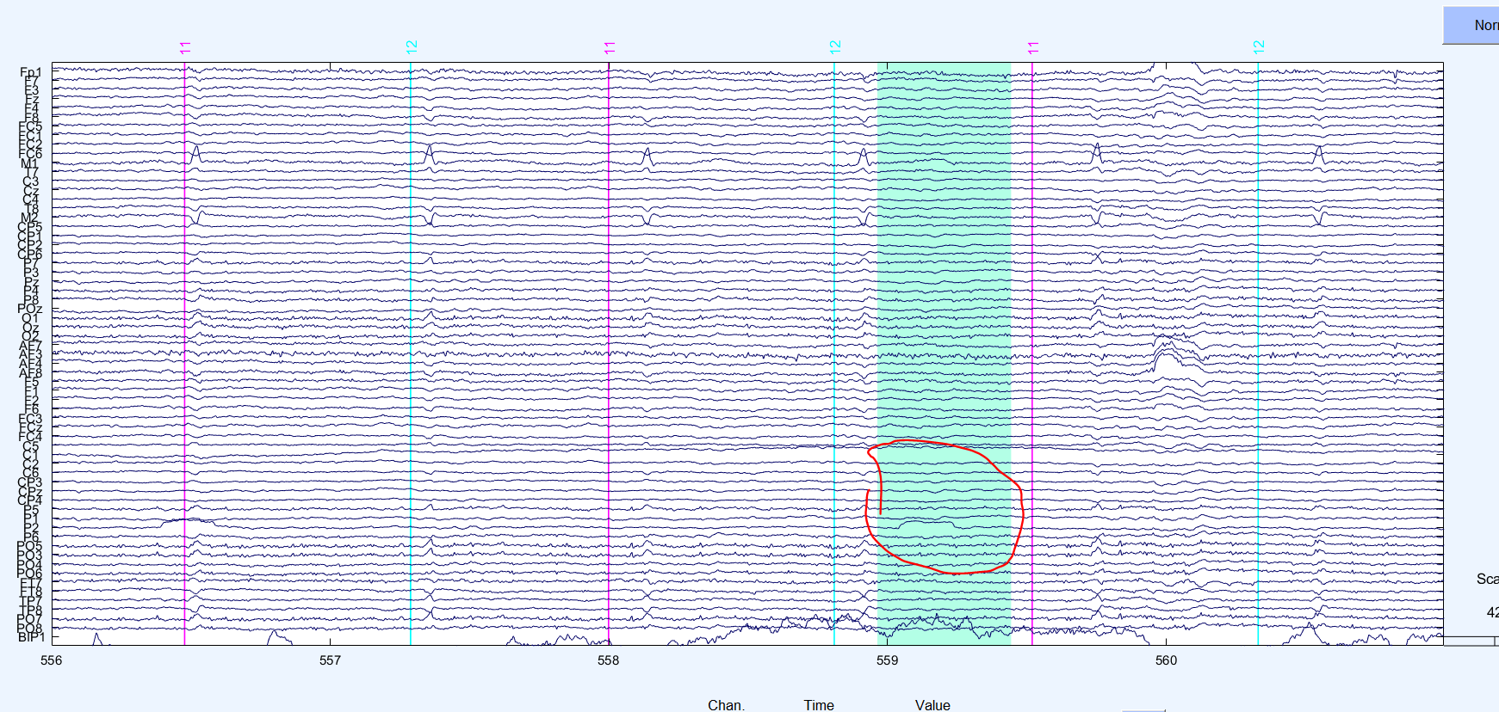

Fp1 was noisy for one block only. Do I have to reject the block or remove the electrode?

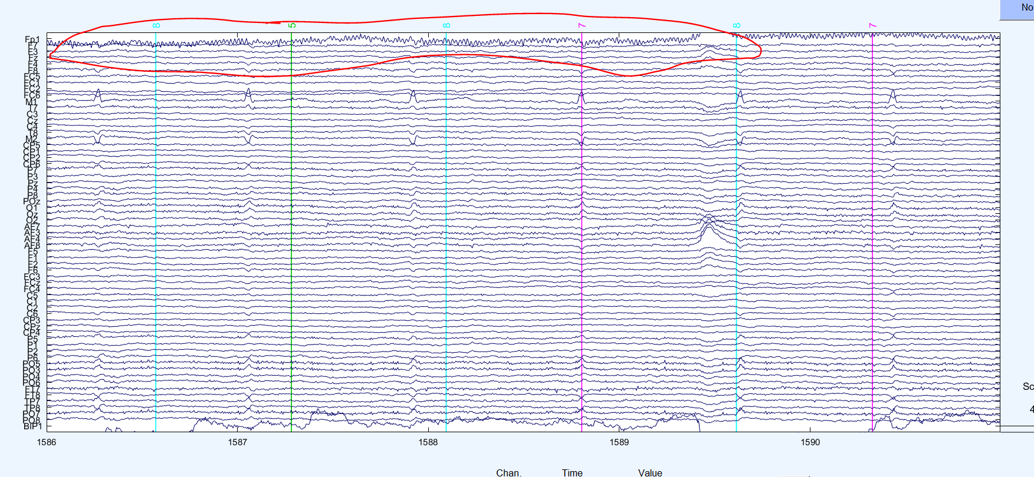

## ICA component rejection

🡪 Might the data still be too noisy to apply an independent component analysis appropriately?

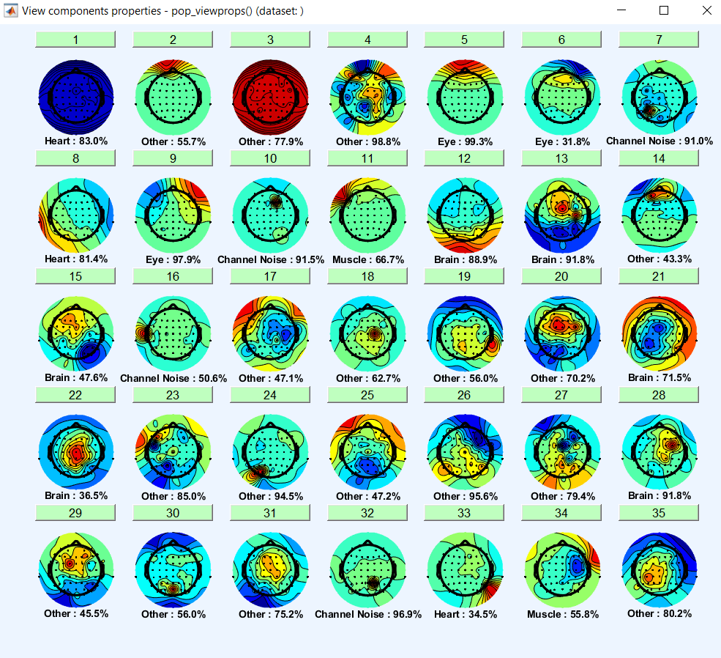

Component 1 and 3 look a little odd to me… Why are they completely coloured in red/blue? Where is the dipole?

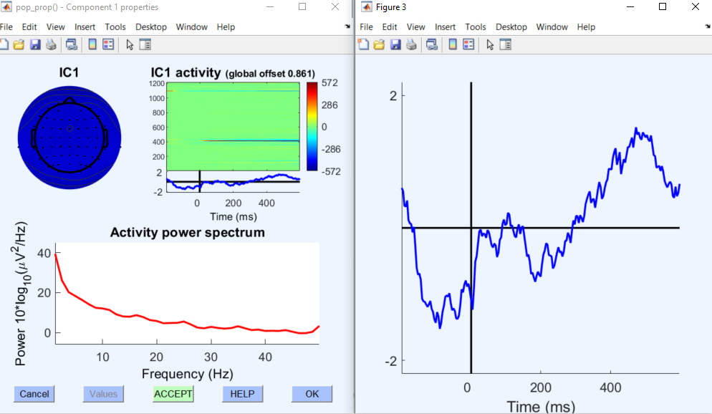

Exception in thread "AWT-EventQueue-0": java.lang.NullPointerException

at java.util.WeakHashMap.hash(WeakHashMap.java:298)

at java.util.WeakHashMap.get(WeakHashMap.java:396)

at java.util.Collections$SynchronizedMap.get(Collections.java:2584)

at sun.awt.SunToolkit.targetToAppContext(SunToolkit.java:399)

at java.awt.event.FocusEvent.getOppositeComponent(FocusEvent.java:221)

at java.awt.KeyboardFocusManager.retargetFocusLost(KeyboardFocusManager.java:2837)

at java.awt.KeyboardFocusManager.retargetFocusEvent(KeyboardFocusManager.java:2954)

at java.awt.Component.dispatchEventImpl(Component.java:4752)

at java.awt.Container.dispatchEventImpl(Container.java:2297)

at java.awt.Component.dispatchEvent(Component.java:4711)

at java.awt.EventQueue.dispatchEventImpl(EventQueue.java:760)

at java.awt.EventQueue.access$500(EventQueue.java:97)

at java.awt.EventQueue$3.run(EventQueue.java:709)

at java.awt.EventQueue$3.run(EventQueue.java:703)

at java.security.AccessController.doPrivileged(Native Method)

at java.security.ProtectionDomain$JavaSecurityAccessImpl.doIntersectionPrivilege(ProtectionDomain.java:74)

at java.security.ProtectionDomain$JavaSecurityAccessImpl.doIntersectionPrivilege(ProtectionDomain.java:84)

at java.awt.EventQueue$4.run(EventQueue.java:733)

at java.awt.EventQueue$4.run(EventQueue.java:731)

at java.security.AccessController.doPrivileged(Native Method)

at java.security.ProtectionDomain$JavaSecurityAccessImpl.doIntersectionPrivilege(ProtectionDomain.java:74)

at java.awt.EventQueue.dispatchEvent(EventQueue.java:730)

at java.awt.SentEvent.dispatch(SentEvent.java:70)

at java.awt.DefaultKeyboardFocusManager$DefaultKeyboardFocusManagerSentEvent.dispatch(DefaultKeyboardFocusManager.java:239)

at java.awt.DefaultKeyboardFocusManager.sendMessage(DefaultKeyboardFocusManager.java:266)

at java.awt.DefaultKeyboardFocusManager.dispatchEvent(DefaultKeyboardFocusManager.java:760)

at java.awt.Component.dispatchEventImpl(Component.java:4760)

at java.awt.Container.dispatchEventImpl(Container.java:2297)

at java.awt.Window.dispatchEventImpl(Window.java:2746)

at java.awt.Component.dispatchEvent(Component.java:4711)

at java.awt.EventQueue.dispatchEventImpl(EventQueue.java:760)

at java.awt.EventQueue.access$500(EventQueue.java:97)

at java.awt.EventQueue$3.run(EventQueue.java:709)

at java.awt.EventQueue$3.run(EventQueue.java:703)

at java.security.AccessController.doPrivileged(Native Method)

at java.security.ProtectionDomain$JavaSecurityAccessImpl.doIntersectionPrivilege(ProtectionDomain.java:74)

at java.security.ProtectionDomain$JavaSecurityAccessImpl.doIntersectionPrivilege(ProtectionDomain.java:84)

at java.awt.EventQueue$4.run(EventQueue.java:733)

at java.awt.EventQueue$4.run(EventQueue.java:731)

at java.security.AccessController.doPrivileged(Native Method)

at java.security.ProtectionDomain$JavaSecurityAccessImpl.doIntersectionPrivilege(ProtectionDomain.java:74)

at java.awt.EventQueue.dispatchEvent(EventQueue.java:730)

at java.awt.SequencedEvent.dispatch(SequencedEvent.java:128)

at java.awt.EventQueue.dispatchEventImpl(EventQueue.java:758)

at java.awt.EventQueue.access$500(EventQueue.java:97)

at java.awt.EventQueue$3.run(EventQueue.java:709)

at java.awt.EventQueue$3.run(EventQueue.java:703)

at java.security.AccessController.doPrivileged(Native Method)

at java.security.ProtectionDomain$JavaSecurityAccessImpl.doIntersectionPrivilege(ProtectionDomain.java:74)

at java.security.ProtectionDomain$JavaSecurityAccessImpl.doIntersectionPrivilege(ProtectionDomain.java:84)

at java.awt.EventQueue$4.run(EventQueue.java:733)

at java.awt.EventQueue$4.run(EventQueue.java:731)

at java.security.AccessController.doPrivileged(Native Method)

at java.security.ProtectionDomain$JavaSecurityAccessImpl.doIntersectionPrivilege(ProtectionDomain.java:74)

at java.awt.EventQueue.dispatchEvent(EventQueue.java:730)

at java.awt.EventDispatchThread.pumpOneEventForFilters(EventDispatchThread.java:205)

at java.awt.EventDispatchThread.pumpEventsForFilter(EventDispatchThread.java:116)

at java.awt.EventDispatchThread.pumpEventsForHierarchy(EventDispatchThread.java:105)

at java.awt.EventDispatchThread.pumpEvents(EventDispatchThread.java:101)

at java.awt.EventDispatchThread.pumpEvents(EventDispatchThread.java:93)

at java.awt.EventDispatchThread.run(EventDispatchThread.java:82)