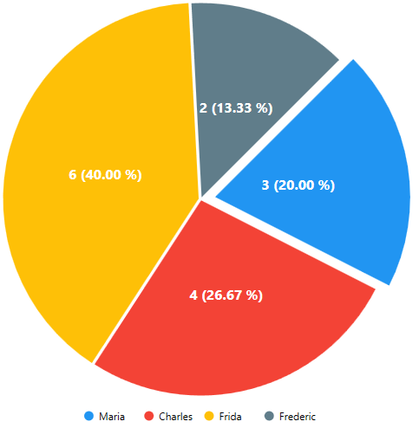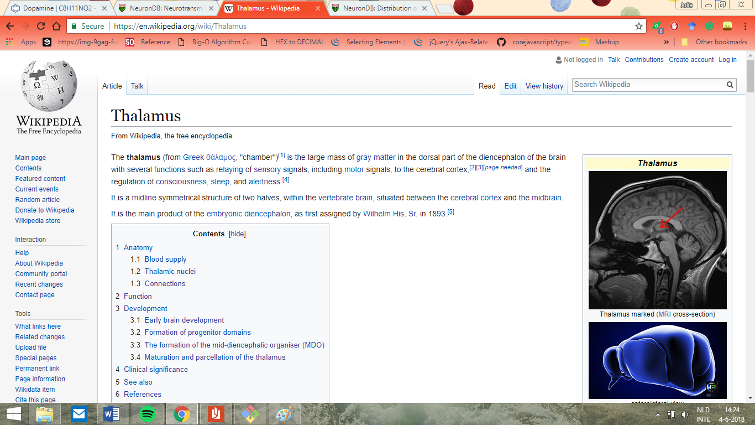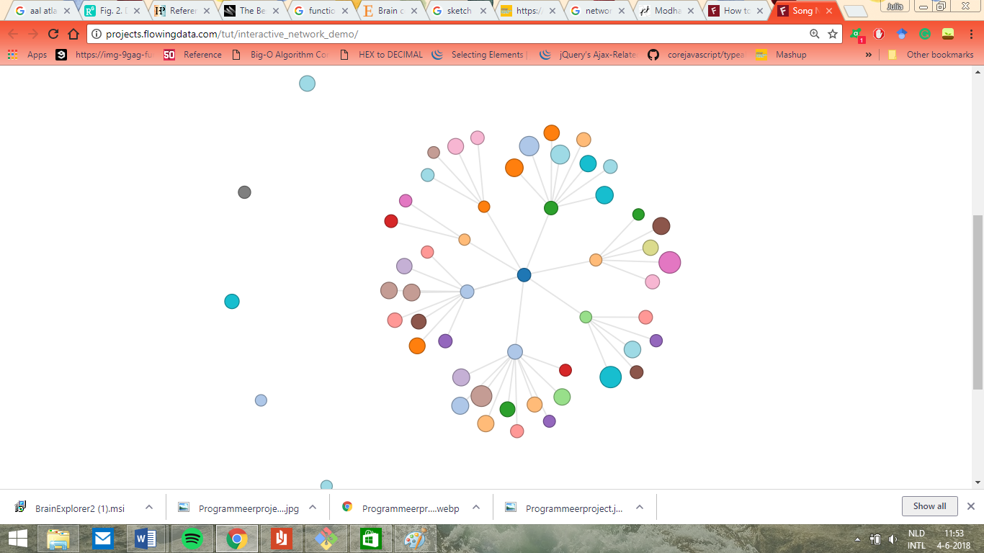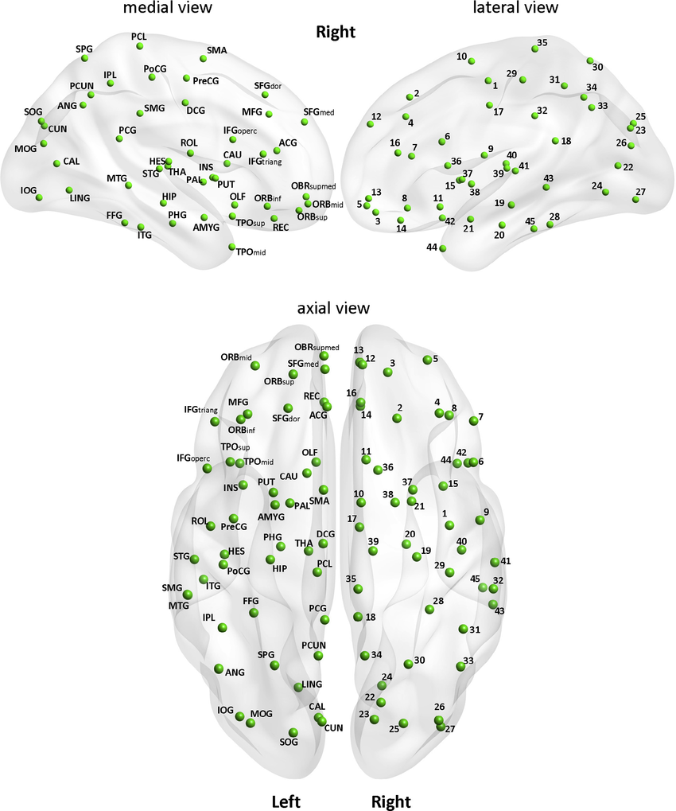

Webscraping information from Wikipedia about clicked brain area.

Piechart showing distribution of 5 neurotransmitters in the clicked area (will be displayed in pgmol / g wet tissue).

**On click**: show charts displaying information about the clicked brain area

**On click**: display areas connected with the clicked area with an interactive network visualization

**On hover**: display name of brain area